Introduction:
When an illegal drug lab is discovered, law enforcement will terminate the lab, dismantle, remove and properly dispose of the lab contents. Both 318 IAC 1 and the local health department prohibit occupancy of the property until it has been properly cleaned of any residual contamination from lab chemicals and is no longer hazardous to occupy. Addressing residual contamination from lab chemicals is the responsibility of the property owner. A Qualified Inspector must be used to test, clean and certify the property has been properly cleaned before it is reoccupied or sold.

Following are frequently asked questions to help property owners identify the signs of illegal activities, protect themselves and occupants from harmful exposure to methamphetamine lab chemicals, comply with regulations for addressing residual contamination, and find a Qualified Inspector.

What is methamphetamine?
Methamphetamine, or meth, is a highly toxic, powerful, addictive central nervous system stimulant that is illegally “cooked” in makeshift labs. Meth use causes an abnormal release of chemicals in the brain associated with feelings of well-being. When the drug wears off, these chemicals are so low that meth users eventually become incapable of experiencing pleasure without taking more meth. Some of the effects of meth on users include agitation, excited or impaired speech, decreased appetite, hyperactivity, paranoia, hallucinations, sudden and violent behavior, sores on the skin, rotted teeth, severe depression, memory loss, increased heart rate and body temperature, sleep deprivation, convulsions, seizures, stroke, and death.

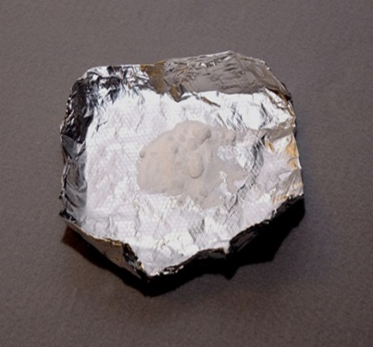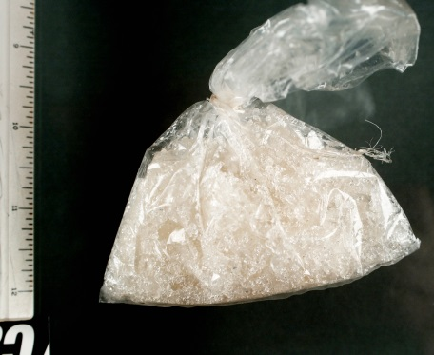
Meth may range in color from white to brown; pink to red; or in various shades of yellow or green. Meth can be found in the form of pills, capsules, powder, or chunks, and can be smoked, snorted, injected, or eaten. Common street names for meth include: "speed," "chalk," "ice," "crystal," "crank," and "glass."

For more information about the adverse effects of meth use, visit http://www.drugabuse.gov/publications/drugfacts/methamphetamine (revised January 2014). (Source: National Institute on Drug Abuse (NIDA) Research Report on Methamphetamine Abuse, 2013.)

How is meth manufactured?
The number of meth labs have dramatically increased over the past several years because meth recipes are more readily available, meth is relatively easy and inexpensive to make. The drug is easily made, or “cooked,” with relatively inexpensive over-the-counter ingredients such as pseudoephedrine, a common ingredient in cold medications, and other easily obtained hazardous chemicals such as acetone, anhydrous ammonia (fertilizer), ether, red phosphorus, and lithium.

To curb production of methamphetamine, Congress passed the Combat Methamphetamine Epidemic Act in 2005, which requires that pharmacies and other retail stores keep logs of purchases of products containing pseudoephedrine, and limits the amount of those products an individual can purchase per day. To prevent meth cooks from buying large amounts of these medications, Indiana joined the National Precursor Log Exchange (NPLEx™) in 2011, which tracks the sales of over-the-counter medications containing ingredients used to make meth. For information about NPLEx™, visit http://nplexservice.com/.

What are the health effects of meth labs?
Health effects caused by exposure to meth lab chemicals depend on three things: the lab process and the chemicals used; the amount of chemical and length of exposure; and the age and health of the person exposed. Chemicals may enter the body by being breathed, eaten, injected or absorbed through the skin. Exposure to high levels of contaminants found in meth labs can cause shortness of breath, cough, chest pain, dizziness, lack of coordination, chemical irritation, burns to the skin, eyes, mouth and nose, and in severe cases, death.

Cases have been reported where children living in a house or other structure that formerly contained a meth lab encountered lingering health problems. Exposure to meth residues may cause symptoms similar to those experienced by meth users.

Exposure to volatile organic compounds (VOCs) may cause symptoms such as nose and throat irritation, headaches, dizziness, nausea, vomiting, confusion and breathing difficulties. Benzene, a potential meth chemical, is a VOC known to cause cancer. Chemicals that are acids or bases will cause a burning sensation on the skin and in mucous membranes, and can cause severe eye damage. Exposure to hazardous metals and salts can cause a wide range of health effects, including respiratory irritation, decreased mental function, anemia, kidney damage, and birth defects.

What are signs of an illegal drug lab?
Alone, these signs may not mean that illegal drug activity is occurring. However, several of them happening together may indicate a problem:

- Strong chemical odors
- Unusual security systems or other devices
- Increased activity, especially at night
- Unusual structures
- Windows covered with plastic or tin foil
- Renters paying landlords in cash
- Excessive trash
- Discoloration of structures, pavement and soil

How do I recognize a meth lab?
Meth labs may be set up at campgrounds, rest areas, homes, motel rooms, cars, watercraft, garages, storage sheds, and vacant buildings. The most common chemicals used to make meth are over-the-counter cold and asthma medications that contain ephedrine or pseudoephedrine.

Other common chemicals and equipment found at meth labs may include:
- Red phosphorous
- Iodine
- Starter fluid (ethyl ether)
- Acetone, toluene, alcohol, or paint thinner
- Camp stove fuel (naphtha)
- Anhydrous ammonia (in propane tanks or coolers)
- Drain cleaner containing lye (sodium hydroxide)
- Lithium batteries
- Sulfuric acid, muriatic acid, or phosphoric acid
- Hydrogen peroxide
- Glass containers and/or cookware
- Plastic or rubber tubing
- Funnels
- Propane tanks (with corroded, bent or tampered valves)
- Coffee filters (with red stains or ephedrine residues)
- Camp stoves or hot plates
- Kitty litter

What do I do if I suspect illegal drug lab activity?
DO NOT ENTER a site that you think may have been used for cooking meth. If you suspect illegal drug lab activity, immediately notify the Indiana State Police Meth Tip Line at 1-800-453-4756. Visit www.IN.gov/meth/2336.htm for more information about the Indiana State Police Methamphetamine Suppression Section.

What do I have to do after illegal drug lab activity was found on my property?
- Contact your local health department to find out the steps to make your property safe again. To find the telephone number for your local health department, visit http://www.in.gov/isdh/24822.htm
- Failure to clean up your property leaves you open to liability for injury to others from exposure to toxic chemicals.
- A Qualified Inspector must test and decontaminate your property before you reoccupy it, allow anyone else to occupy it, or sell it.
- For more information about the inspection and cleanup of illegal drug labs contact the Qualified Inspector Program Director at (317) 234-1819, or send an e-mail to DrugLabCleanup@isdh.IN.gov. Visit the program’s website at http://www.in.gov/isdh/27487.htm

Who can clean my property?
- Only a Qualified Inspector can issue a Qualified Inspector’s Certificate of Illegal Drug Lab Cleanup to ensure a property has been properly cleaned.
- Qualified Inspectors who meet 318 IAC requirements have the training, experience, and equipment to clean the property safely and cost effectively.
- A list of Qualified Inspectors can be found at http://www.in.gov/isdh/27487.htm.

What will the Qualified Inspector do?
A Qualified Inspector will:
- Perform an initial assessment, which may include testing, to determine the level of contamination and what cleanup procedures need to be done.
- Work with you to determine the best and most cost effective way to decontaminate the property.
- Decontaminate the property or supervise the cleanup to ensure it meets all required standards.
- Properly dispose of all waste from the cleanup.
- Test the property to confirm it meets the state’s cleanup level of 0.5µg/100cm2.
- Give you a Qualified Inspector’s Certificate of Illegal Drug Lab Cleanup that certifies the property has been properly cleaned.

What does clean mean?
- Indiana’s approved cleanup level for controlled substances is 0.5µg/100cm2.
- Once the cleanup of the property is complete, the Qualified Inspector will test the property using standard sampling procedures and laboratory analysis.
- Cleanups involving removal of potentially contaminated materials (tear-outs) may not require testing.
- Demolition of the property does not require testing after the structure is completely removed.

Who pays for the cleanup?
Property owners are responsible for all cleanup costs. Check with your insurance carrier(s) to see if they will cover some or all of the costs.

