Perimeter Security

Campus Security
The best campus security tool is to have highly visible, uniformed, trained, sworn, etc. law enforcement officers and or SROs.
The absence of highly visible, sworn, uniformed, armed, etc. law enforcement is an invitation to those that may seek to harm students, staff, patrons, visitors, etc.
An excellent place to start when examining “Perimeter Security” is to consider the “Perimeter of the Campus.”

Signage on the Perimeter of Campus
Appropriate signage must be posted to instruct motorists to reduce their respective speed and be aware of bus traffic, pedestrian crossings, student drop off traffic, etc. These signs need provide drivers with the appropriate directions and time to reduce speed to the appropriate speed limit.
The signage must also provide the appropriate directions for the various vehicles that approach and enter the campus. Examples of campus areas may include but not be limited to school bus drop off, student parking areas, faculty parking areas as well as the administration and academic center, emergency vehicle traffic, ECA event locations, delivery areas, etc. To the extent possible, your goal may be to segregate traffic to prevent accidents that may be caused by mixing drivers seeking access to various locations on campus.
Fencing of Campus Perimeter
The campus perimeter must have barriers to secure campus perimeter. The fencing must be constructed with the appropriate architectural design (in terms of material, height, etc.) Any gates must also consider the various types (width, height, etc.) of traffic that will be accessing the campus (i.e., emergency vehicles, school bus, etc.).

On Campus Traffic
Signage on campus must direct the various drivers that have accessed the campus. Examples may include but not be limited to student parking areas, faculty parking areas, bus drop off, ECA traffic, emergency vehicles pathways, delivery areas, directions to the administration and academic centers, etc. “Speed Limit,” “No Parking,” ADA “Handicap,” and other appropriate signage must be present.
Lighting
Lighting must be strategically placed to illuminate signage as well as all the various vehicular traffic areas. Lighting must illuminate all access and perimeter areas of the academic centers, ECA areas, utility buildings, modular classrooms, etc.
Campus Fencing
Campus fencing must segregate the campus “pedestrian traffic” as well as all types of vehicular traffic. Fencing must be constructed to ensure that the barriers meet the appropriate width and height considerations.
Access to Utility Facilities
Utility facilities must be secure and well illuminated. The perimeter security of these areas must be alarmed, well illuminated, and checked regularly.
All ECA areas must be secured with fencing that provides appropriate access to emergency vehicular traffic. All ECA parking must be clearly designated and well illuminated.
Academic Facilities
Signage
Signage must be present to direct all visitors to the main entryway (I.e., students, staff, patrons, commercial vendors, etc.). The signage must direct all forms of pedestrian traffic to the appropriate singular entryway.
Main Entryway
Developing a singular main entry way to funnel visitor traffic is a security must. Establishing a main entryway with multiple levels of access is best.
The “Main Entryway” with a line-of-sight ability to monitor all visitors approaching the area is strongly suggested. Those monitoring the main entryway should have the ability to monitor all visitors approaching the perimeter of the facility. A camera system may assist in this process.
Monitoring those individuals approaching the academic facility, modular buildings, etc. represents the first level of a multi-level security system.
It is important for visitors initially be scrutinized prior to allowing first entry. Before allowing visitors into the facilities, a second level of inspection must be conducted. A procedure to scrutinize visitors at a greater level at the second stage entry way will be necessary. It is important not to allow visitors to enter on visual and or verbal recognition only. Various security procedures may be utilized to clear the first level.
Level one checks may include government identification, verification of purpose of the visit, offender checklist, etc. Level two may include scrutiny and involvement of the SRO.

Perimeter Security: Other Entryways
Indiana had a firsthand wakeup call as the shooter shot his way into a middle school in a Richmond Indiana. Glass in windows and or doors in the Indiana schools are seldom “bulletproof.”
UL Protection Levels 1-8, “may provide some ballistic protection.” The veracity of this protection system may

range from withstanding a 9mm handgun to some protection against an assault with a 12 Gauge shotgun. As school administrators and architects examine a school’s needs, they will need to determine the level of protect that is appropriate. Typically, glass that is utilized in most Indiana schools cannot withstand a round from small caliber handgun. It took the Richmond shooter seconds to enter a locked back access door.
Consider Adding More Security to Entryways
Educators, SROs, architects, etc., may consider a project of adding a secure “bulletproof” exit capabilities to classrooms. As was the case in Virginia Tech the hallway attacker shot and forced his way into a classroom. Providing secondary emergency exits to classrooms may very well be a practice that could increase the security of Indiana schools when a shooter able to enter a classroom door.

A View of Perimeter Lockdowns

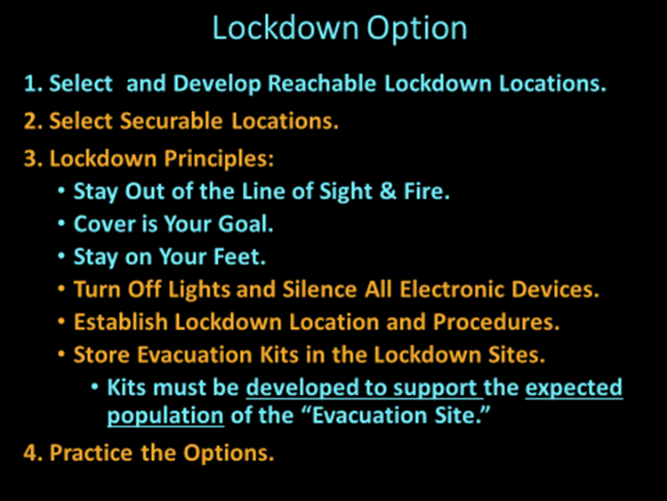

As set out in the “Lockdown” videos (posted on the ISP homepage), “Perimeter Lockdowns” have been utilized for more than twenty years in Indiana Schools.

Shelter-in-Place
Sandy Hook Elementary and Richmond Dennis Middle
If educators and law enforcement are concerned enough to call for a “Perimeter Lockdown,” ISP believes that a “Shelter-in-Place” strategy should be utilized.
Rather than simply placing a glass panel or window between a perceived threat and the occupants of the facility, the “Shelter-in-Place” strategy secures students and staff behind substantial and secured classroom/office doors. The movement of students throughout the facility is prohibited.
If the traditional “Perimeter Lockdown” is utilized, the threat simply needs to shoot out the glass door or panel to gain immediate access to students and staff occupying the halls and unlocked classrooms.
The shooters in the Sandy Hook Elementary {288} and Richmond Dennis Middle School {289} utilized this strategy to gain access to the school buildings. They simply shot out the glass panels to gain entry, into the schools.
It should be underscored that ISP’s recommendation is to establish a single “Shelter-in-Place” strategy which prohibits students and staff from freely moving about the facility in a “Lockdown” situation. In the “Shelter-in -Place” lockdown approach, students and staff are secured behind substantial locked and secured doors throughout the facility. This type of lockdown calls for prohibiting students and staff from moving freely about the school building while the “Shelter-in-Place” lockdown is in effect.
If it is important enough call for a “Lockdown” then it is important enough to shelter students in a secure location (Rather than to rely on glass panels or doors to provide a haven against perimeter threats).

