Completing a Program Modification Request (PMR)
Once logged in, you should see the following screen:
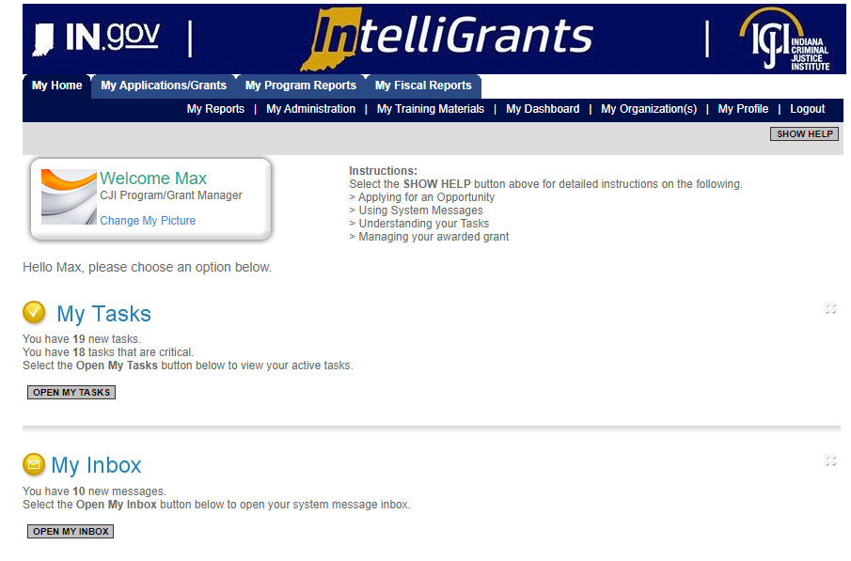
There are two ways to access your grant:
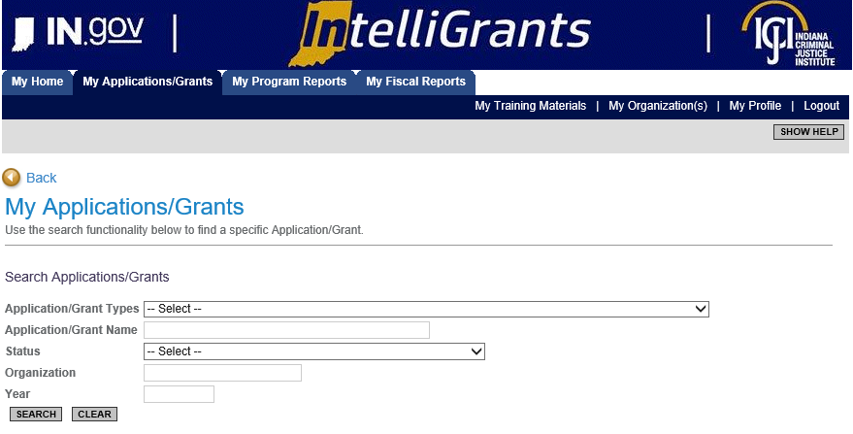
#1 – Navigating to “My Applications/Grants” (tab at the top of screen)

- Once you have clicked on “My Applications/Grants” then utilize the search fields to find a particular grant. SUGGESTION: Clear out fields first (Click on CLEAR button) as IntelliGrants keeps results of your last search in the fields.
- Example: I cleared out the search fields (clicked CLEAR button) then I typed in the particular grant I am wanting to review, VOCA-2020. After I have either utilized the Application/Grant Type or Application/Grant Name then I click SEARCH.
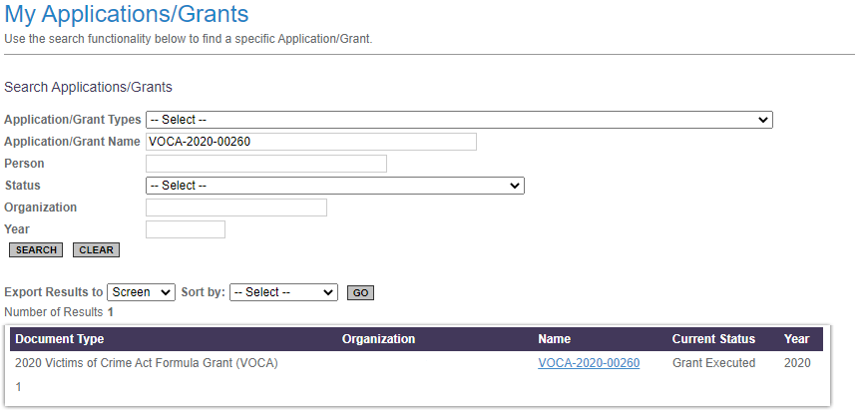
- To review the grant, you will want to click on the Grant Name. For this example it would be, VOCA – 2020 – 00260. This should take you to the Document Snapshot Page.
#2 – Utilizing the “My Organization” feature (right side of screen)
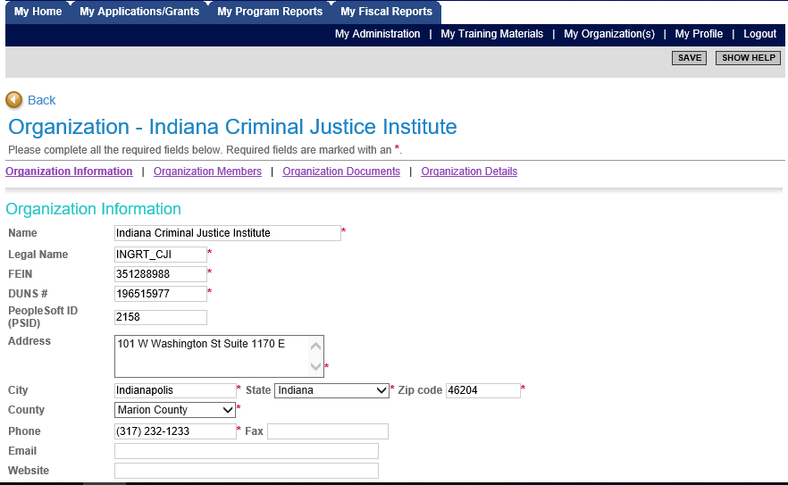

- Once you have selected “My Organization” then you should see your agency’s information prepopulate. To navigate to a particular grant select “Organization Documents”.
- “Organization Documents” should pull up all the documents that your organization has initiated. You will want to select the particular grant you wish to initiate a report.
- Example: Make sure you select the Grant Name. Once you click on the Grant name it will take you to that Grant’s “Document Snapshot” page.

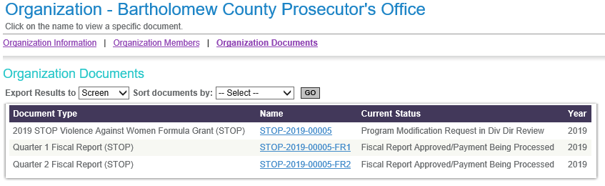

Once you have reached the Document Snapshot page, please follow the instructions below to request a Program Modification Request:
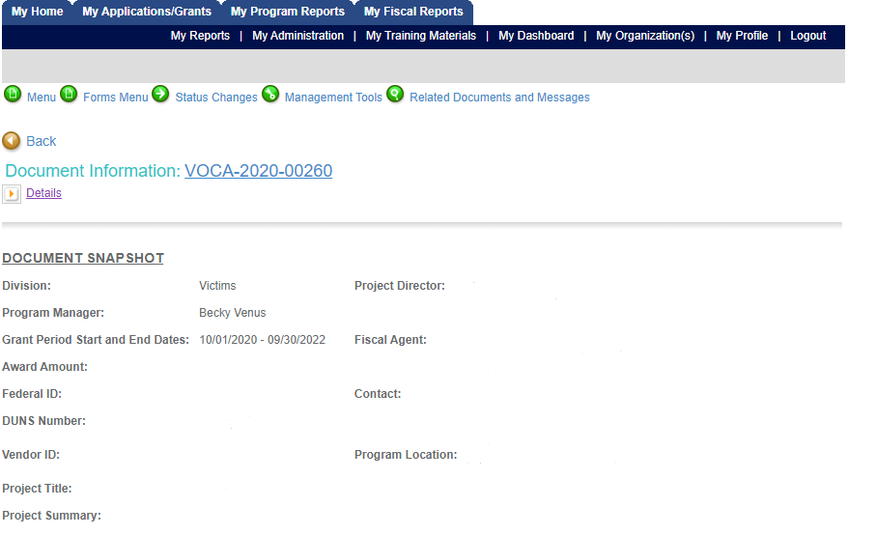
The Subgrantee Administrator and Subgrantee Project Director are able to initiate a Program Modification Request. The Grant must be in Grant Executed status to start the Program Modification Request process.
Helpful Tip: You can check the status of a particular grant by clicking on “Details” and look under the “Current Status” column. If your grant is in anything but Grant executed then you will not be able to initiate a PMR.
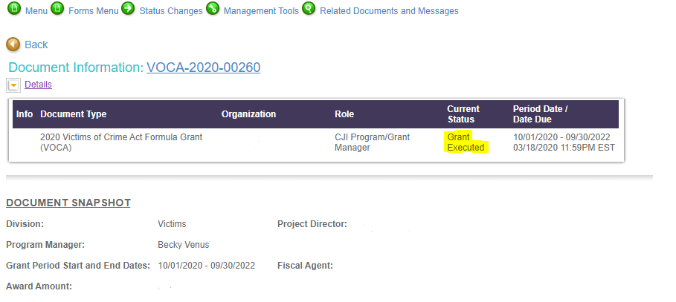
Step 1: Navigate to the Status Changes link (green button at top of screen) – hover over the link and you will see the following two options. Select APPLY STATUS under Program Modification Request in Process.
Step 2: Once you have applied the status your grant will be moved to Program Modification Request in Process. You will need to find your way to the Program Modification Request form – which can be found under the Forms Menu.
NOTE: If this is not your first PMR, there will be a number (2, 3, 4, etc) you will need to click on the most recent number to edit the form.
Step 3: Fill out the Program Modification Request Form for the modifications you wish to complete. You will need to select the Budget Revision or Change of Scope checkbox and any other checkbox that corresponds to what you are wanting to do, or you will not have access to edit those pages. A Justification text box will then appear above the attachments where you will explain with as much detail as possible what you are wanting to modify. You may also attach anything that will help explain your justification; i.e. job description, budget changes, lease, etc.
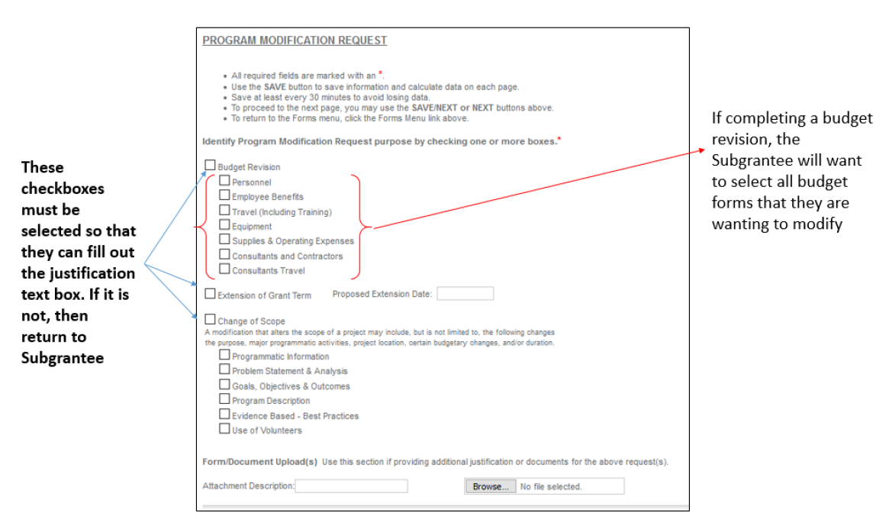
NOTE: At this point in the PMR, you will not be able to edit your budget forms or any other form. You have to submit your justification to CJI for approval before you can complete this step.

Step 4: After you have filled out the program modification request form, click the SAVE button at the top of the page. Once you have saved your changes, navigate to the STATUS CHANGES button and click SUBMIT under Program Modification Request Submitted.
Step 5: Once submitted your Modification Request will be sent to your assigned Grant Manager, they will review your request. Your grant manager will either approve it, return the justification for additional explanation or deny the request.
NOTE: You will receive notifications from IntelliGrants if it is approved, denied, or sent back for modifications.
Step 6: If the justification is approved, then you will receive an email stating you may now modify the forms that you selected on your Program Modification Request Form.
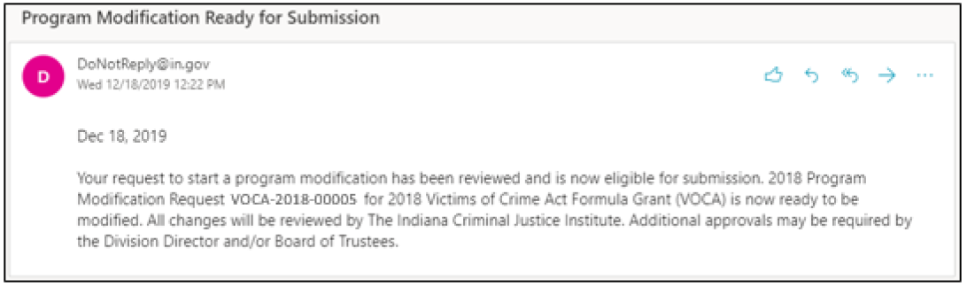
Step 7: At this stage, the appropriate budget and/or programmatic pages can be modified to reflect the modification. After completing the modifications, click the Apply Status button under the Status Changes link.
Helpful Tips:
- Your award amount and match amount must match the amount on your Signed Grant Agreement. This can be found on the Budget Summary form.
- You can only move up to 10% of grant funds per PMR unless you have received special exception from your Grant Manager and the Victims Services Division Director.
- Do not move items that you did not mention in your justification.
- Do not move more than what you have expended on a certain line item. If you do this it will cause that line to go into the negative on your next fiscal report and you will have to complete another PMR. You can view the amount expended by looking at your latest submitted fiscal report. The Remaining Balance of your most recent fiscal report will be what is available to move on that line.
- Once you are finished making changes, IntelliGrants will make you re-save the Budget Summary form and Budget Narrative. If you do not save these after you have made all your changes then you will receive a global error.
Step 8: Once you have submitted your modifications, your assigned grant manager will review all the changes made and take the changes to the Victim Services Division Director. The Victim Services Division Director will either send it back for modifications, approve the modifications, or deny your request.
Step 9: After your Modification has been approved your grant status will be “Grant Executed.” At this time, you will be able to initiate and submit a program/fiscal report or Personnel Name Change.

