Requesting a Personnel Name Change
Once logged in, you should see the following screen:
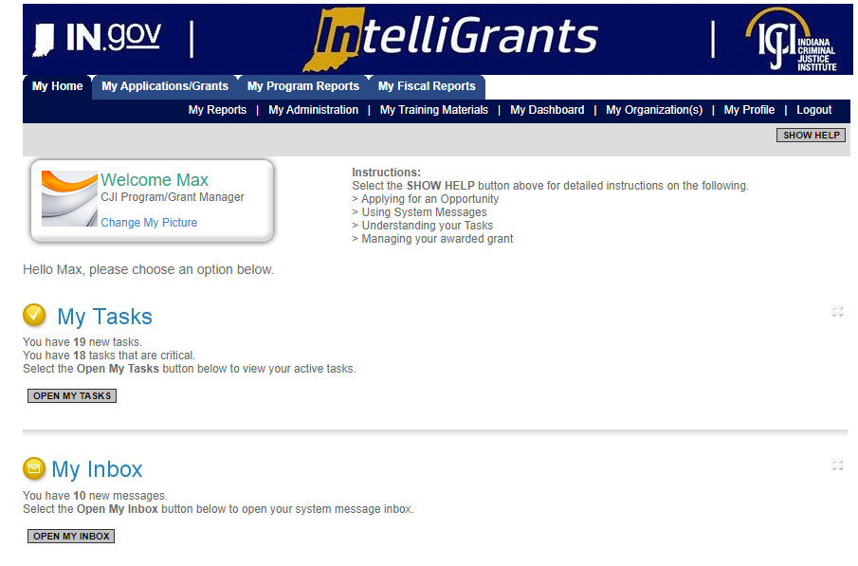
There are two ways to access your grant:
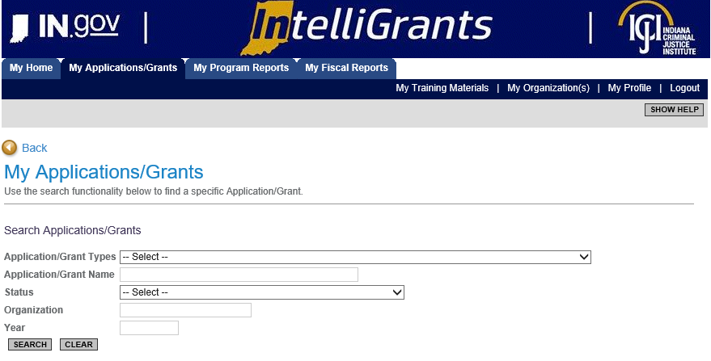
#1 – Navigating to “My Applications/Grants” (tab at the top of screen)

- Once you have clicked on “My Applications/Grants” then utilize the search fields to find a particular grant. SUGGESTION: Clear out fields first (Click on CLEAR button) as IntelliGrants keeps results of your last search in the fields.
- Example: I cleared out the search fields (clicked CLEAR button) then I typed in the particular grant I am wanting to review, VOCA-2020. After I have either utilized the Application/Grant Type or Application/Grant Name then I click SEARCH.
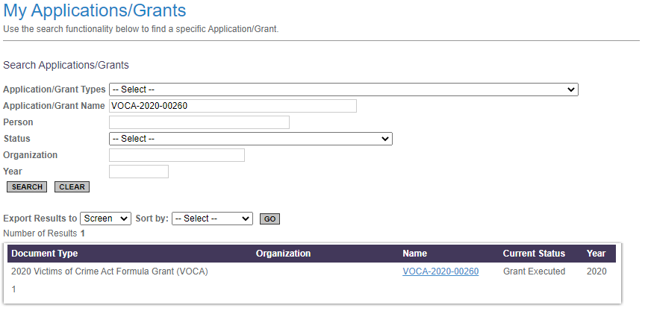

- To review the grant, you will want to click on the Grant Name. For this example it would be, VOCA – 2020 – 00260. This should take you to the Document Snapshot Page.
#2 – Utilizing the “My Organization” feature (right side of screen)
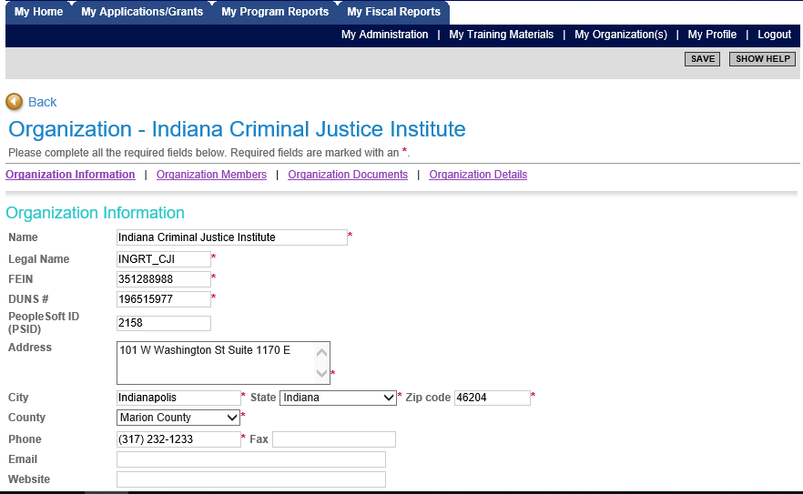

- Once you have selected “My Organization” then you should see your agency’s information prepopulate. To navigate to a particular grant select “Organization Documents”.
- “Organization Documents” should pull up all the documents that your organization has initiated. You will want to select the particular grant you wish to initiate a report.
- Example: Make sure you select the Grant Name. Once you click on the Grant name it will take you to that Grant’s “Document Snapshot” page.
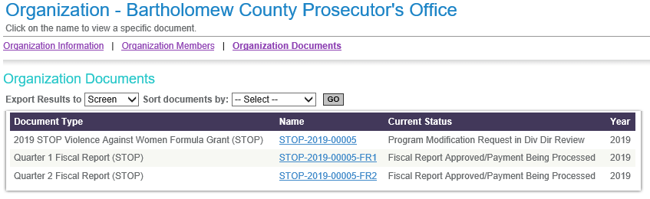

Once you have reached the Document Snapshot page, please follow the instructions below to request a Personnel Name Change:
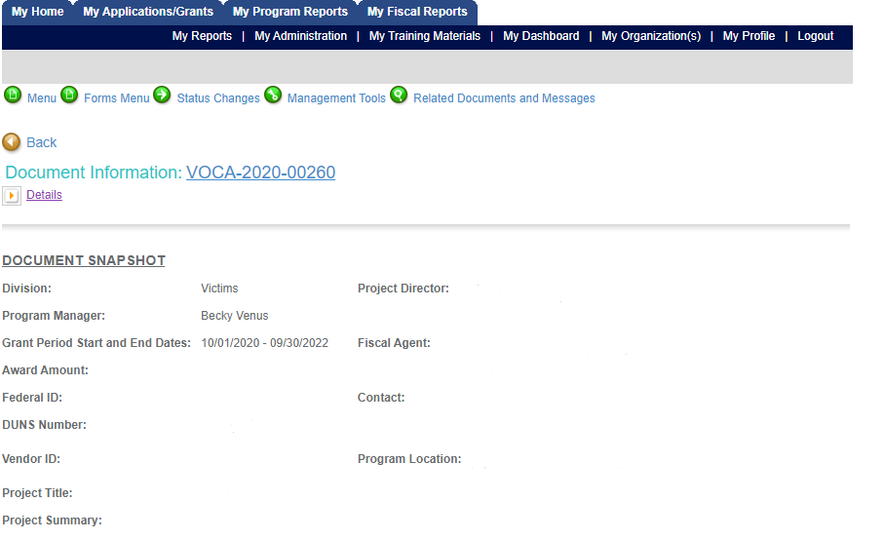
Step 1: Check to make sure your Grant is in “Grant Executed” Status. This status allows you to request a personnel name change. If it is in any other status this option will not be available to you. To check you status click on the “details” button at the top of the document snapshot screen. You can locate which status you grant is under the “status” column.
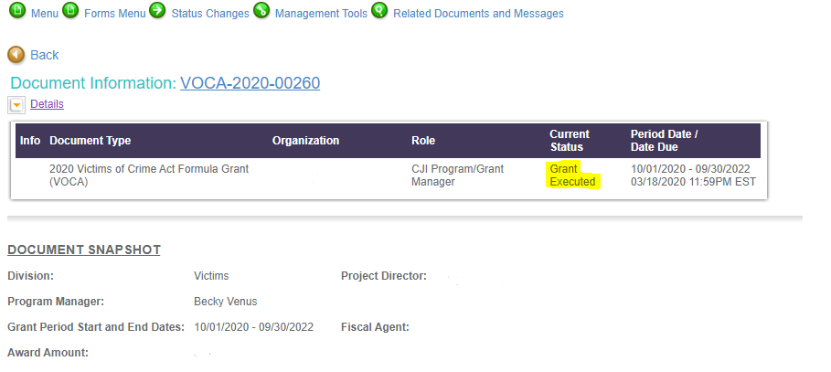
Step 2: Once you have confirmed your grant is in “Grant Executed” status then you can navigate to the Status Changes button (green button at the top of document snapshot). You can hover over this button and you will see two options, Personnel Name Change Requested and Program Modification Request in Process. Select “Apply Status” under Personnel Name Change Requested.
Step 3: After changing the status of the document, the name fields on the personnel form can be edited. This form is located under the Forms Menu.
Step 4: Modify the lines the need to be edited.
NOTE: You must include end date for the employee that is leaving and start date for the employee taking over that position. Also, please follow the personnel name change 10 day rule!
Example of Name Change:
John Doe (left 3/25/2020); John Smith (start 4/21/2020)
or
John Doe (left 9/20/2019); John Smith (10/1/2019-4/1/2020); Jane Smith (start 4/21/2020)

Step 5: After updating the Personnel form, click the SAVE button at the top of the screen and save all your changes.
Step 6: Hover over the Status Changes button and select SUBMIT under “Personnel Name Change Submitted/In Review”.
After you submit, your request will be sent to you assigned Grant Manager. If you encounter any issues while completing a personnel name change please reach out to your Grant Manager or the CJI Helpdesk.

NOTE: If you created a name change by mistake you can cancel the Personnel Name Change Request by accessing the Status Changes button and select APPLY STATUS under Personnel Name Change Cancelled.

