**LCPA Call**

2/1/23

**Diversity Equity & Inclusion: Brandy-Janai Carter – Chief Equity and Inclusion Officer for DCS -** [**brandi-janai.carter@dcs.in.gov**](mailto:brandi-janai.carter@dcs.in.gov)

* Support for our Foster care system
* “Calling people in not calling people out”
* Previously in DCS legal department for past 7 years
* Goals for 2023
  + Strategic planning and ways to be more inclusive and focused on diversity and equity and including working with the families when being served.
  + Want community providers to be educated on being aware of what are needed services for families.
  + Planning a foster care appreciation month – May 2023
    - Work groups
    - Address stable housing
    - Pilot in central Indiana
    - Develop tools for foster parents to deal with unique situations, i.e., hair care, transgender teens, etc.
    - Build on conversations
    - Find ways to address achieving permanency for youth who have been in the system a long time
    - Increase diverse talent in our field to represent families to understand and be empathetic and provide support
    - Work with providers to be more culturally aware
    - Identify disproportionality in children served
* Essay contest – send information to foster homes

• Black History Month Essay Contest

* + - THEME: “Black Resilience”

• Open to all children in elementary, middle and high school

• Monetary prize and plaque awarded to the 1st, 2nd and 3rd place winners

* + • Questions: Gretchen.grier@dcs.in.gov

**LCPA Field Audit Team Updates: Rebecca Chauhan – Deputy CFO DCS, report to CFO DCS**

* Explanation & Overview of 2023 Fiscal Audit
* Update on Status of Fiscal Audits
  + Have sent out letters explaining specific information for your agency
  + Focus on validating payment to foster parents
  + Not auditing administrative cost
  + Not IRS
  + Routine audit conducted every few years
  + Beginning Marche 2023, covering period 4/223022 through 3/2023
  + Sending template for information audit. Complete templates and send back
  + Information on what is owed to foster parents and what was paid to the foster parents
  + Required by Federal funders
  + Want audit to be a positive experience
  + LCPA providers are up next for auditing
  + Questions? Reach out to Residential Licensing Specialist and they will get you the person to contact

**2023 LCPAs and High Acuity Youth: Crystal Byrne**

* **Intensive Foster Care RFI (David Reed)**
  + Analysis of Responses Continues
  + Still reviewing proposals
  + Hope to use ideas to improve foster care
  + Appreciate providers taking time to submit proposals
  + Important goal for DCS
  + Local offices appreciate the work being done by providers
  + Wanting to use foster care system as DCS first response
  + Want to support LCPA’s when placing children in foster care
  + Questions
    - how many proposals were received – approx. 14
* **High Acuity Youth Weekly Staffing with LCPAs (Kim Henry) Clinical Service Specialist**
  + Youth involved with our Escalated Tx Needs Teams
    - Bring up high acuity children for collaborative discussions with providers
    - Providers will be receiving emails from Kim Henry or Lyon Mercaeant-Koohns
    - Discussions will assist in finding homes for youth
    - Work out details to place youth
    - These youth will be those with high acuity needs recommended for Foster Care
* **DCS Foster Care Recruitment (RFF) (David Reed)**
  + Committee has begun Reviewing Responses
    - 24 submissions being evaluated
    - Thank you to Rebecca and her team
  + Award Notification: 02/28/2023
    - DCS will be notifying providers
* **DCS Nurse Consultants (Jennifer Hannon) - Registered Nurse,** 
  + Role & impact on our High Acuity Youth
    - Consultants for FCM to assist and support when there are medical needs for youth.
    - Can reach out with medical questions, i.e., definitions, what are medical records saying.
    - Assist with understanding of medical records and assist FCM
    - Attend meeting in CFTM
  + Most complex cases that involve medical risk –
    - Children with cerebral palsy, muscular dystrophy, multiple medical diagnosis
    - Can arrange case conferences through social workers to get everyone involved, including doctors to give DCS a better picture of what is being reviewed/assessed
  + If LCPA have youth with a lot of medical needs and have a lot of appointments or large records can assist with understanding and/or coordinating services
* Discharge Notifications – (Crystal Byrne)
  + May 2022 implemented a centralized system Residential Providers to report urgent discharge notifications prior to youth completing treatment
  + Since implementing for residential programs, have team of staff to respond
  + Specific field of information for each child that led to need for discharge and recommendations
  + Has provided a lot of data to learn and build programs moving into 2023/2024
  + Would like to discuss a similar process for foster care services
  + Want to capture this data from LCPA and therapeutic foster care provider and foster parents
  + If have thoughts or ideas or internal form/system, please share

**Foster Care Licensing: Nicci Chenowith - Foster Care Consultant Supervisor**

* + Overdue Annuals –
    - Currently have 325 Overdue Annuals for LCPA foster parents in past year approximately
    - Have provided data information to be transparent of the reports we’ve seen. To identify barriers to find solution focused ideas to improve foster care.
    - There are resource homes, some may have multiple checklists not submitted
  + Foster Care Consultant will communicate with providers throughout month of February
  + Please look over when receive and work with consultant
  + Want to see improvement by first of March
  + What are barriers with homes to get a better picture of what issues are needing addressed
  + Annual Updates –
    - 2/2022 rolled out updated annual review process in policy effective 2/1/2022
    - Have experienced confusion and have been asked for more guidance or tools
    - Have developed a template when to use annual report and when to use SAFE update

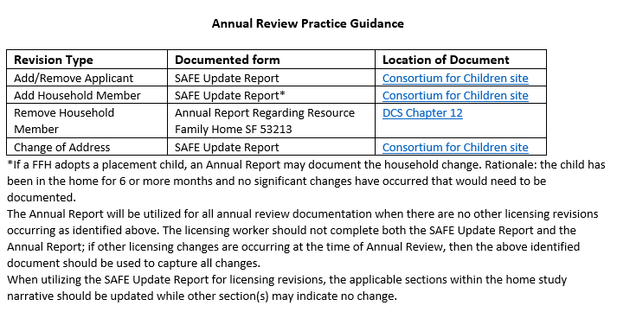

* + SAFE Refreshers –
    - Dates for SAFE training (attached) – dates will be provided for trainings throughout 2023. 4 refreshers
    - SAFE training dates:
      * April 13, Refresher
      * May 8-9, 2-day
      * May 10, interview Day
      * May 11, Supervisor
      * June 8, Refresher
      * July 17-18, 2-day
      * July 19, Interview Day
      * July 20, Supervisor
      * September 19, Refresher
      * Oct. 23-24, 2-day
      * Oct. 25, Interview Day
      * Oct. 26, Supervisor
  + CCDF Voucher Process –
    - this item will be added to the March 2023 provider meeting agenda
  + Placement Line –
    - Foster Care Unit have placement line and have a process for both workday and after hour placement requests.
    - Placement Line map to identify DCS staff assigned in areas of the state.
    - Please respond with agency guidelines during hours or after hours and to the requests and review what is being requested

**LCPA Licensing: Blake Hudson & Rick Steigerwalt – Residential Licensing Supervisors**

* LCPA Audits
  + Have completed limited reviews so far. Will monitor and report on any trends
  + Residential Licensing Specialist will contact LCPA’s and coordinate if conducting in person or virtual audits.
* Team Updates
  + Have 5 positions posted
    - LCPA Manager – interviewing applicants
    - Clinical Specialist – interviewing applicants
    - 3 Residential Licensing Specialist positions –
      * Amy Burdette starting 2/6/2023 – Southeast Region of the state – Has experience with DCS and as provider
      * Marion Co. Region Residential Licensing Specialist – working through hiring process will announce next month
      * 3rd Residential Licensing Specialist position- still identifying the region this person will be working
    - Will have some agency reassignments of the Residential Licensing Specialist. Residential Licensing Specialist will reach out to providers
* Working with Foster Care Unit and collaborating on address outstanding Annual Reports

**DCS LCPA Contact List –** use this link and send name of people to add for communication, invitations to meetings, etc.

* [DCS LCPA Contact List](https://forms.office.com/g/4uHWfEKZcW)

**..\..\..\..\..\..\..\OneDrive - State of Indiana\Desktop\Placement Line Regions Map (002).pdf**