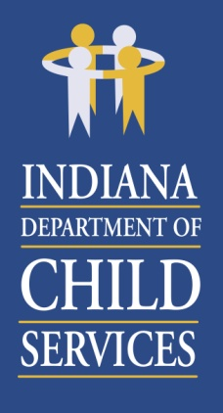
Region 14 Regional Services Council
February 18, 2020
8:30AM
Barth Co DCS
Training Room
4445 Ray Boll Blvd
Columbus, IN 47203

Agenda:

- Welcome & Introductions
- Approval of November 19, 2019 Minutes
- Preservation Services – Jason Nelson
- Regional Financial Status Report – Belinda Foreman
- Community Partners – Children’s Bureau
- Lifeline Youth & Family Services – Donna Bonath
- Public Comment & Adjourn

Thank you for your continued commitment to the Regional Services Council.

Next RSC Meeting Scheduled:
May 19, 2020 beginning at 8:30am

Location:
Barth Co DCS
4445 Ray Boll Blvd
Columbus, IN 47203

