Governor’s
Fellowship

Application for
2017-2018

A Message from Governor Eric Holcomb
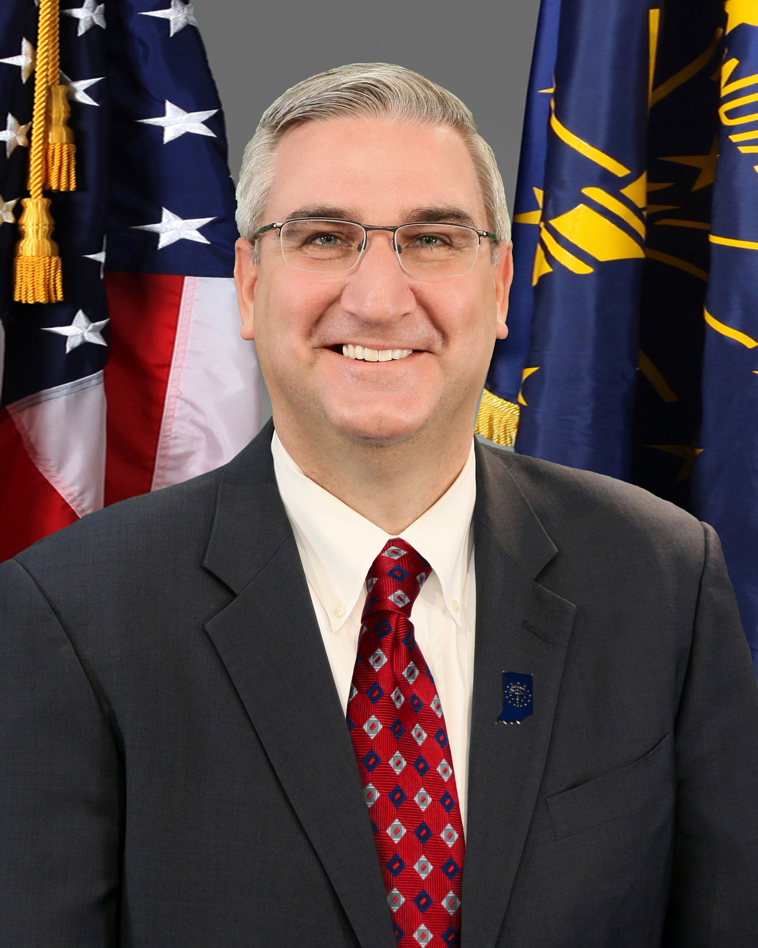

US News & World report recently named Indiana the #1 best state in the nation for government. This isn’t surprising given the number of skilled public servants dedicated to making Indiana the best state to work, live, play, and stay. If chosen to be a Governor’s Fellow, you will become a part of that team of hardworking individuals who share that common mission.

As a Governor’s Fellow, you will work alongside dedicated professionals on projects that positively impact the State while developing skills and relationships that will ultimately serve you well in whatever career path you choose. The work done by Governor’s Fellows is particularly rewarding and impactful since there are 6.5 million Hoosiers counting on our team to get it right. I hope you consider answering the call to serve and apply to be a part of the team.

What is the Governor’s Fellowship Program?

The Governor’s Fellowship provides a unique experience in Indiana State government. The program is highly selective, recruiting talented young women and men from across the state who will serve in various state agencies on a rotating basis over the course of twelve months. Fellows participate in the daily activities of state government, complete special projects, travel to observe how work in the Capitol translates into action throughout the State, and experience firsthand how policies are made.

Governor’s Fellows work in a variety of settings. Many of those who have participated as Governor’s Fellows over the past two decades have gone on to successful careers in both the public and the private sector – some serving at the highest levels of local, State and federal government. They have taken from their fellowship a solid understanding of the workings of government and have gained experience in a variety of areas. At the same time, fellows have been able to give back to the state through their year of public service.

ELIGIBILITY

The Governor’s Fellowship Program is open to college graduates who receive their bachelor’s degrees in either fall of 2016 or spring of 2017. While any such graduate may apply, special consideration is given to applicants from Indiana, and likely candidates will be a 3.0 or above grade point average.

SELECTION

The steering committee conducts an initial review of the applications; the most qualified candidates are then selected to interview with the committee at the State House in Indianapolis. After the interviews, the committee forwards its recommendations to the Governor based on applicant’s leadership skills, academic record, references, quality of essay and overall interest in State government. The Governor then makes the final selection of Governor’s Fellows. Recipients of the Fellowship will be notified as soon as possible following the Governor’s decision.

SALARY

Governor’s Fellows receive a competitive salary (approximately $24,000) plus full fringe benefits during the Fellowship year. The year of service corresponds with the State fiscal year, July 1, 2017 through June 30, 2018.

APPLICATION MATERIALS

To obtain an application please download it from the fellowship website at:

www.in.gov/gov/fellowship.

If you have questions concerning the fellowship program, please contact the Caroline McKinney at the Governor’s Office at (317) 232-4567. The completed application and all supporting materials (A current official college transcript, the required essay, and at least 3-5 letters of recommendation, and resume) should be mailed or emailed in one packet or one email to:

The Governor’s Fellowship Program
c/o Kevin Sears
Office of the Governor
State House, Room 206
Indianapolis, IN 46204-2797

Or

KSears@gov.in.gov

To be eligible for consideration, applications must be postmarked by May 12, 2017. Again, all application material must be mailed together to avoid loss of documentation. Material sent separately will not be accepted.

Visit our website at
http://www.in.gov/gov

Application for the Governor’s Fellowship Program
(Applications must be typed; may be photocopied)

Name Mr. / Ms. ___________________________________________________________
Current Address: _________________________________________________________
City, State, Zip Code: _____________________________________________________
Home Phone _____/___________________ Cell Phone _____/___________________
Permanent Address: _______________________________________________________
City State Zip Code: _______________________________________________________
Phone _____/_________________
Email Address ______________________________

***After May 12, 2017, which information should be used to contact you?***
(Circle one of the above) Current Address or Permanent Address

Education

A current, official grade transcript must be included in the application packet.
No other version will be accepted.

Undergraduate Institution __________________________________________________
Grade Point Average at Graduation ___________________________________________
Major(s) ________________________________________________________________
Minor(s) ________________________________________________________________
Degree’s Earned ___________________________ Date Conferred _________________
Other Institutions Attended _________________________________________________
Honors and Activities
(Please attach a separate document, if necessary)

______________________________________________________________________

______________________________________________________________________

______________________________________________________________________

______________________________________________________________________

Work Experience

Please account for the last two years of employment.
(A resume containing all requested information may be submitted for this portion of the
application. The resume must be received with application packet.)

Name/Location of Employer ________________________________________________
Dates of Employment ______________________ Position ________________________
Responsibilities __________________________________________________________
Name/Location of Employer ________________________________________________
Dates of Employment Position ________________ Position _______________________
Responsibilities __________________________________________________________

Hobbies and Special Interests

______________________________________________________________________
______________________________________________________________________
______________________________________________________________________
______________________________________________________________________

References
At least three, but no more than five, letters of recommendation must be submitted with the application. List the names and positions of references below. Letters of Recommendation should illustrate diversity in an applicant’s background.

Essay
Please include a brief typewritten essay in response to the following question: What do you see as the greats challenge facing the State of Indiana? What role can the government play in confronting the challenge? (approx. 500 words)

***COMPLETED APPLICATIONS must be received no later than May 12, 2017***
(including transcripts, reference letters and essay)

