SR 1
Small Structure Replacements
Lead Des. No. 1900068 over Wade Ditch
Des. No. 1900075 over Unnamed Tributary (UNT) to Wade Ditch
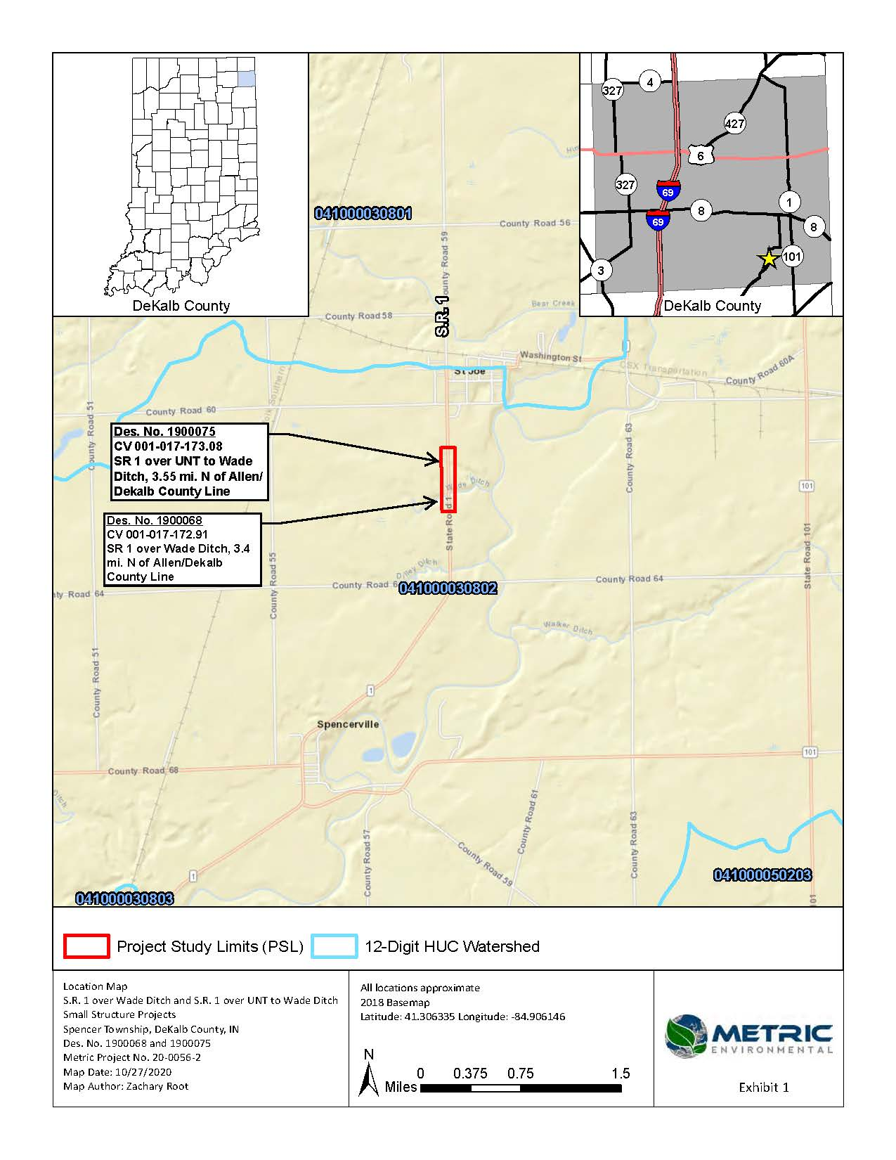

PROJECT DETAILS

PROJECT NUMBER: Lead Des. 1900068 and Des. 1900075
PROJECT STATUS: In Design
ANTICIPATED CONSTRUCTION START: Spring 2024
ESTIMATED CONSTRUCTION COST: Approx. $1.5M

The purpose of this project is to provide adequate structures to perpetuate vehicular traffic through the project area. Specifically, the purpose of the project is to provide structures each with a rating of 7 or better and a service life up to approximately 50 to 75 years.

The existing structure CV 001-017.172.91 will be replaced with an 84-ft.-long by 10-ft. span by 8-ft. rise RCB culvert which will be skewed 30 degrees left and sumped 6 inches below the flow line. After removal of the existing structure, the area will be excavated, and soil stabilization will be achieved with compacted aggregate over geotextile. Scour countermeasures consisting of Class I riprap over geotextile will be placed at the inlet and outlet of the structure. A special V-ditch will be created in the northwest quadrant of the project area.

The existing structure CV 001-017.173.08 will be replaced with a 58.5-ft.-long by 8-ft. span by 5-ft. rise RCB culvert which will be skewed 15 degrees right and sumped 6 inches below the flow line and will have 9.83-ft.-long wingwalls at the outlet. After removal of the existing structure, the area will be excavated, and soil stabilization will be achieved with compacted aggregate over geotextile. Scour countermeasures consisting of Class I riprap will be placed at the inlet and revetment riprap will be placed at the outlet of the structure, all of which will be underlain by geotextile. A 130-ft.-long special flat-bottomed ditch will be created in the northwest quadrant of the project area and a 75-ft.-long special flat-bottomed ditch will be created in the southwest quadrant of the project area.

The roadway over the structures will be replaced to full depth and the approaches will be milled and overlaid with asphalt. Wade Ditch, UNT to Wade Ditch, Wetland B, and Wetland D will be dewatered using a dewatering pump, temporary clean water sanding dikes, an energy dissipater, filter bags.

Approximately 3.01 acre of permanent right-of-way (ROW) will be required, as described in the ROW section of this CE document.

The maintenance of traffic (MOT) for this project will involve closure of SR 1 through the project area and a detour route as discussed in the MOT During construction section of this Categorical Exclusion (CE) document. Construction is expected to begin in Spring 2024 and to last about four months.

Approximately 84 linear feet (LFT) of Wade Ditch, 72.30 LFT of UNT to Wade Ditch, 0.0092 acre of Wetland B, and 0.0074 acre of Wetland D will be permanently impacted as a result of this project. A total of approximately 0.223 acre of tree removal will be required prior to April 1 in Spring 2024. The construction and riprap footprints have been minimized as much as possible in design to reduce wetland and stream impacts.

