Instructions for purchasing Westlaw online
- Log in to your IPDC’s Community Salesforce site at https://ipdc.force.com/login
- Your username is your email address followed by .ipdc. For example: janedoe@janedoelaw.com.ipdc <--don't forget to add .ipdc at the end of your email address.
- If you have forgotten your password or if this is the first time you are accessing the site, click “Forgot your Password.” Otherwise, jump to Step 4. Remember, your username is your email address followed by .ipdc. If you do not add “. Ipdc” at the end of your username. you will not receive a link from the system to re(set) your password.
- Once logged in, go to the tab labeled “On-demand training & publication for purchase” See Figure 1.

Figure 1
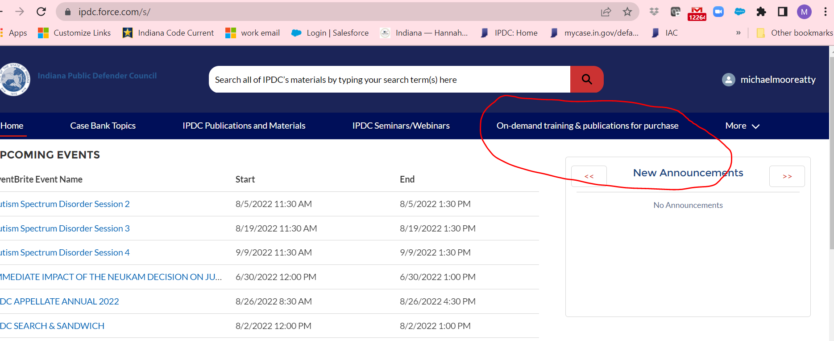

- Scroll down the page and choose the product, "Westlaw."
- Click the red button next to the Westlaw product. See Figure 2.

Figure 2
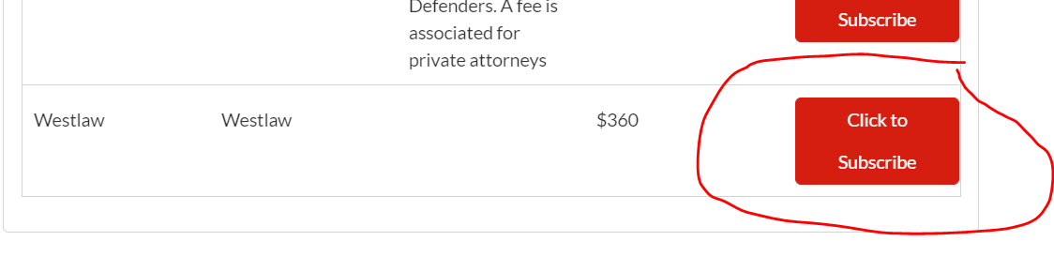

- Scroll back to the top of the webpage and choose the checkout option. See Figure 3.

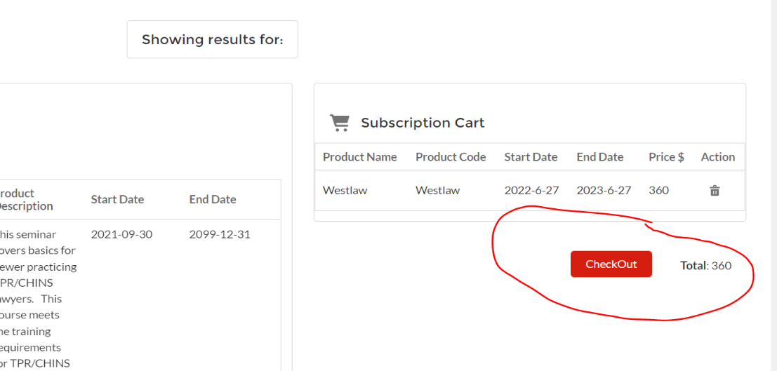
Figure 3

- You can pay for your yearly access to online legal research by using a credit card or check.
- If you need assistance with paying online, please contact me at JByrne1@pdc.in.gov
- You can renew your access next year by following these same instructions

