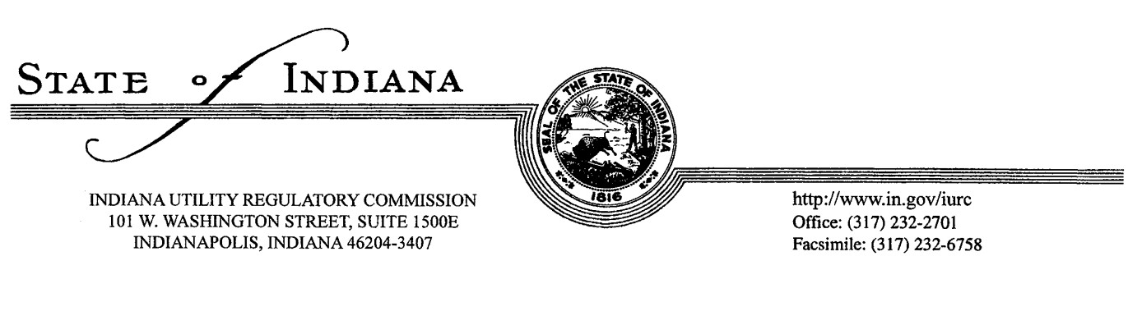

- What kind of training and education will best serve you to ensure compliance?
- What stakeholders could be involved in developing and delivering possible training?
- What utilities need to be included in training, education, and awareness? Why?
- What does the general public need to know about pipeline safety?
- What are the most effective methods of delivering pipeline safety information to the general public?
- Who are the stakeholders affected (directly and indirectly) by the Indiana One-Call Law?
- What does each stakeholder affected by the Indiana One-Call law need to know?
- What are the most effective methods for delivering important information about the One-Call Law to Stakeholders?
- What are the benefits of following the Indiana One-Call Law?
- Wat can you do as an individual stakeholder to ensure compliance?
- What type of benefit or reward can assist you in ensuring compliance?
- What can the Commission provide you so that you can best comply with the Indiana One-Call Law?
- What do stakeholders need in order to avoid repeat violations?

