Welcome to the 2024-2025 school year application portal. Parents may submit applications from March 1 – September 1.
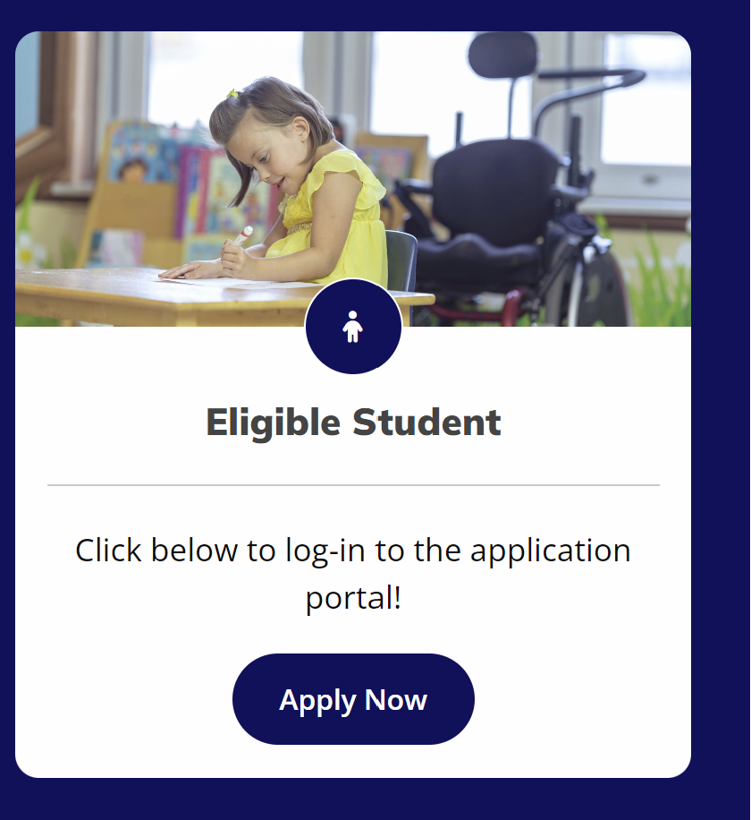

Before you Apply. Parents are encouraged to review Student Eligibility Checklist with Documents needed to apply.
You do not have to complete your application in one sitting; you may access and continue your work as frequently as needed before final submission. To save your work, click on the “Save Progress” button.
After you submit your online application, the Scholarship Accounts Division will begin to process your application once all documents have been received. Application review varies based on information received. All applicants are notified of the scholarship award via e-mail within 7-10 business days. The notification e-mail will provide instructions for accessing ESA providers, funding schedule, and estimated scholarship award based on your selections made in the application.

