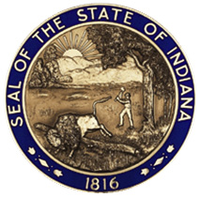

STATE OF INDIANA

Request for Proposal 10000178

Addendum #2

INDIANA DEPARTMENT OF CHILD SERVICES

Solicitation For:
Community-Based Family Preservation Services

Response Due Date: February 21, 2020

Summary of Changes
- The DCS Current Requests For Proposals webpage has been updated to clarify proposals are due on Friday, February 21, 2020 at 3:00 p.m. Eastern Time rather than Monday, February 21, 2020 at 3:00 p.m. Eastern Time.

