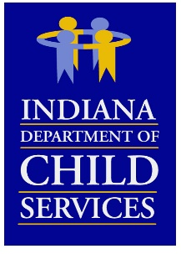
Regional Service Council
Region # 6

Meeting Date: Wednesday, October 19, 2022
Meeting Location: Virtual Meeting

Meeting Minutes

RM Liz Learned welcomed everyone to the meeting.

Christy Robbins went over the Community Partners report for the region. The region is right on target with the budget at 25%. CP is receiving more referrals from schools and the community which is what we are trying to achieve.
- Referrals from DCS – July: 54, Aug: 47, Sept: 55
- New Enrollments – July: 20, Aug: 20, Sept: 21
- Non-Enrolled – July: 6, Aug: 4, Sept. 10
- Clients Served July1 thru Sept 30th: One Adult: 62, Second Adult: 39 Children: 166. Total of clients served was 267.
- Discussed program successful outcomes
- RM Learned commented on the improvements made.
- Christy introduced their new supervisor, Amber Smith.

Iwona Morretino discussed service updates:
- Updated supervised parenting time service standard.
- Transportation will be a separate component.
- Milliman will be conducting a comprehensive community-based rate study.
- Launch a new service pre permanency service that was awarded to Lifeline Family Services.
- Request for information on intensive foster care services.
- Approved another provider which is Noble Transitions.
- RM Liz Learned thanked all the providers for all their hard devoted work.

Katie Kraft went over the financial budget:
- Target is 26.34%, region at 22.5%
- Down 13.69% from last year.
- Residential is up.

RM Liz Learned went over the successes of the region within the year. There were 73 so far this year for adoptions which improved those children’s lives. Discussed the Care Portal which will expanded in 2023. RM Liz introduced the new local office director in Fulton County, Erica Hagg. Each county discussed their county successes.

RM Liz Learned thanked everyone for their attendance and adjourned the meeting.

