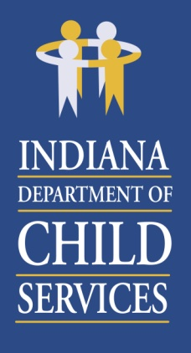

**Region 14 Regional Services Council**

**November 19,2024**

**8:30AM**

**Microsoft Teams Meeting**

**Agenda:**

1. Welcome & Introductions
2. Preservation Services – Jason Nelson
3. Regional Financial Status Report – Belinda Foreman
4. Community Partners – Firefly Children and Family Alliance
5. Public Comment & Adjourn

***Thank you for your continued commitment to the Regional Services Council.***

**Next RSC Meeting Scheduled:**

February 18, 2025, beginning at 8:30am

**Location:**

Microsoft TEAMS Meeting