Regional Service Council
Region 6
July 20, 2022
- Welcome-
- Liz Learned Regional Manager
- Iwona Morretino DCS Rep Regional Service Coordinator
- Kerri King Huntington Co LOD
- Julie Hobbs Wabash Co LOD
- Stacey Morgan Howard Co LOD
- Mary Werner Foster Care
- Regina Drummond QA
- Christy Robbins Community Partners Director
- Libby Martin LSSI
- Jan Williams YSB
- Joni Tushing Fiscal Ops
- Lisa Blanchard SCAN
- Bradley Samuel Fulton FCMS
- Janaei Smith Cass Co FCMS
- Barbara Hilton Howard Co. Prevent Child Abuse
- Christy Robbins SCAN
- Mafu Fuyana Practice Programs
- Katrina Tillman
- Donna Bryant GJR
- LaTasha Music Foster Parent

April minutes were read and accepted by and seconded by –Next Meeting

Financial – Joni
- 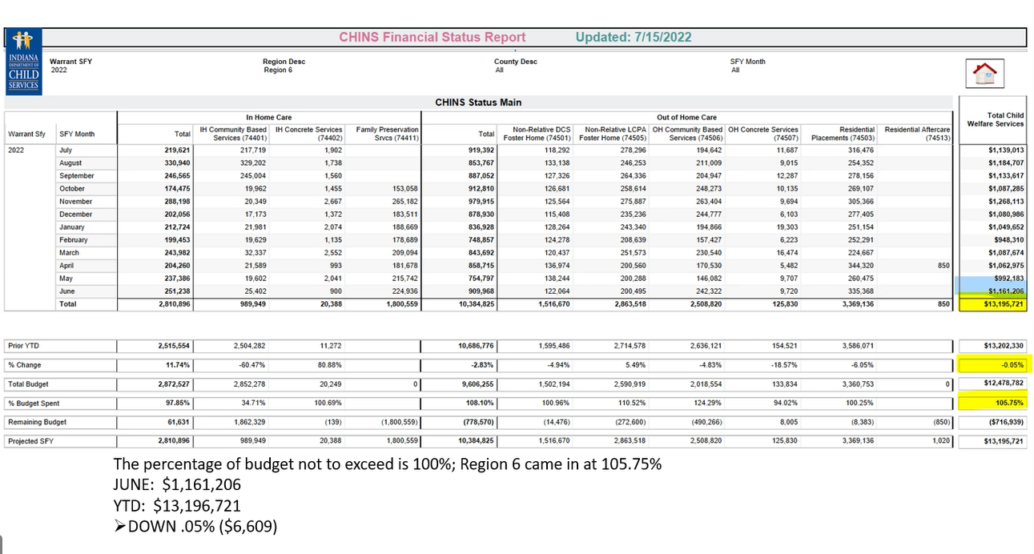
- 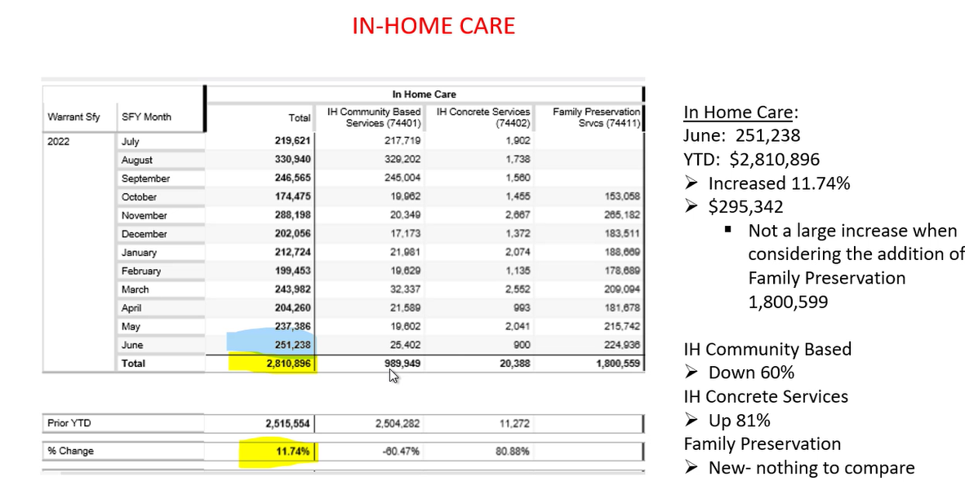
- 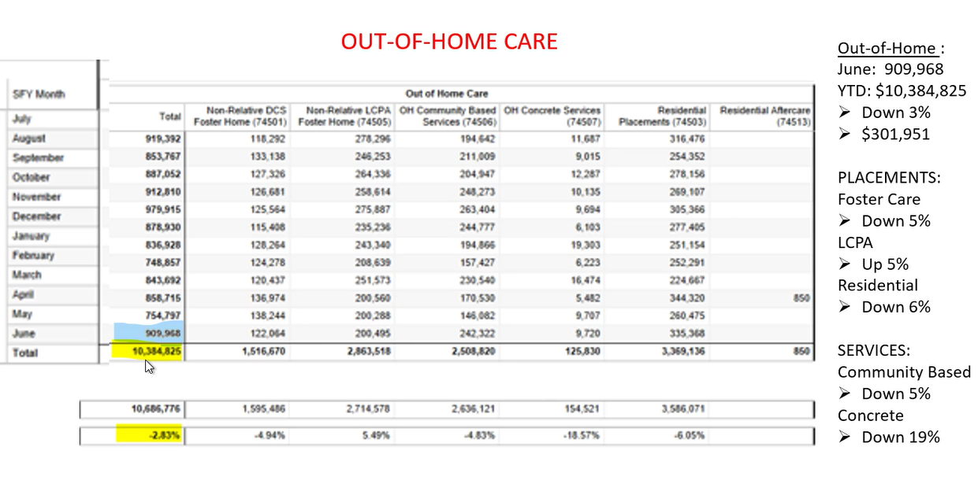
- 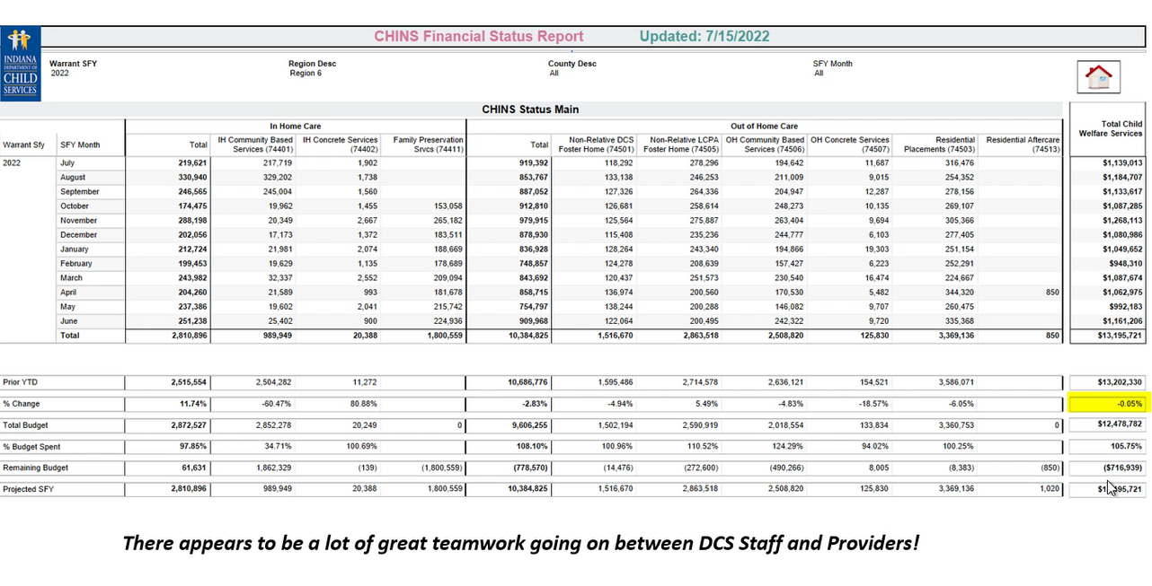

Services – Iwona
- Service Standard – Effective 9/1
  - Giving providers extra time to prepare their medical records systems and changes in billing process that we have
  - Effort is to refocus our attention to being thoughtful about matching the service level with the level of needs of the family.
  - New levels are
    - Standard supervision
    - Enhanced supervision
    - Therapeutic supervision
  - All the referrals will have to be switched on 9/1
  - Changes with supervised visits and requirements
  - Just made the announcements and are still training everyone
  - Gathering questions from providers
  - Q&A document
  - Discussing how to train providers and how to open opportunities how to get clarification.
  - Please reach out to Iwona if you would like training
- Additional opportunity to collaborate and receive feedback from partners
  - Held every other month, the third Tuesday.
    - Reminder that this is an invitation to all of our stakeholders.
    - Next forum is 9/20
- DCS Prevention Plan has been approved

SCAN – Christy Robbins
- DCS still highest referral source at 66%, has dropped.
Region 6 Practice Model Review Report Out – Regina Drummond and Team
Mary Werner – Foster Care
https://www.indianafostercare.org/s/
- Recruitment efforts
  - Miami and Howard Co
    - Booth at the fair
  - Continue to build licensed relatives
  - New Facebook group for foster care
  - Indiana Kids Belong has discounts for foster parents
  - Wabash County in-person event
- LCPA is higher because we need county foster homes
  - Word of mouth
  - R6 is good at looking at family placement first, when we don’t have relatives, we have to look at foster care
Adjourned Meeting

