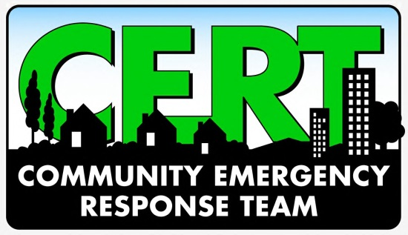
NEWS ADVISORY
(INSERT NAME) Community Emergency Response Team

(INSERT NAME) CERT to Join / Participate / Help / Host (EVENT/EXERCISE)
The (INSERT NAME) Community Emergency Response Team (CERT) will host/join/participate/help at (INSERT EVENT OR EXERCISE), providing security/manpower/traffic control for the event.
Location:
(INSERT ADDRESS OF EVENT)

Parking:
Media are encouraged to park in (INSERT)

Contact:
(INSERT CONTACT INFORMATION – INCLUDING NAME, CERT AFFILIATION, CELL PHONE NUMBER, AND EMAIL ADDRESS)

-30-
About CERT
The Community Emergency Response Team (CERT) program develops and trains teams in neighborhoods, workplaces and schools in basic disaster response skills, including fire suppression, urban search and rescue and medical operations. Administered by FEMA and the Indiana Department of Homeland Security, the CERT program provides an opportunity for citizens to take an active role in local emergency preparedness.

