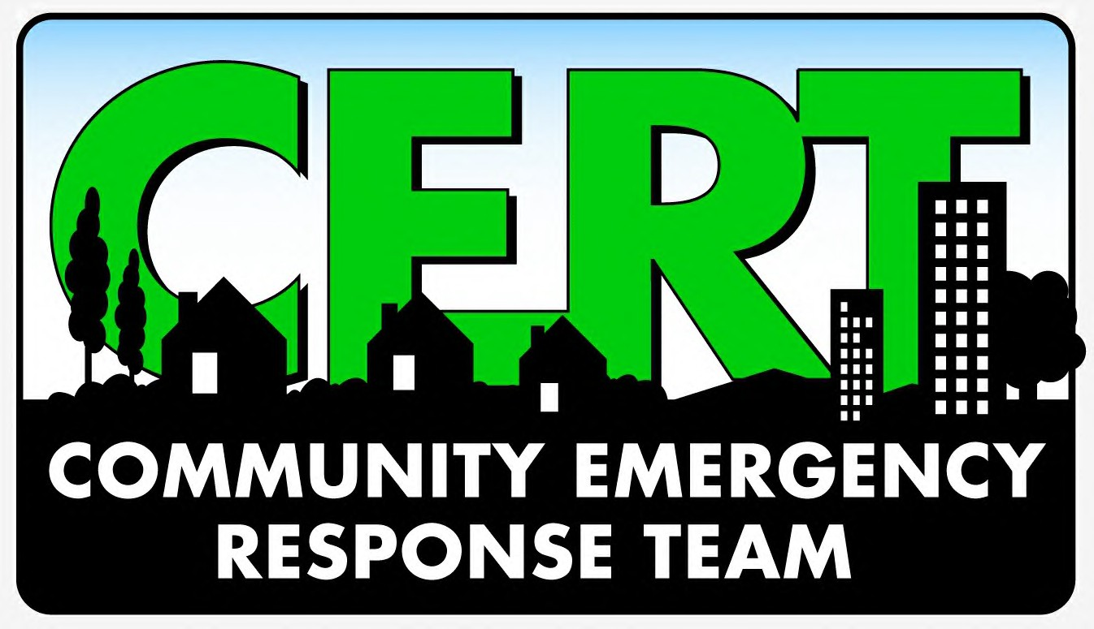
[INSERT NAME]

is made up of volunteers from the community, working together for the benefit and safety of the community

To discover how you can get involved today visit:

