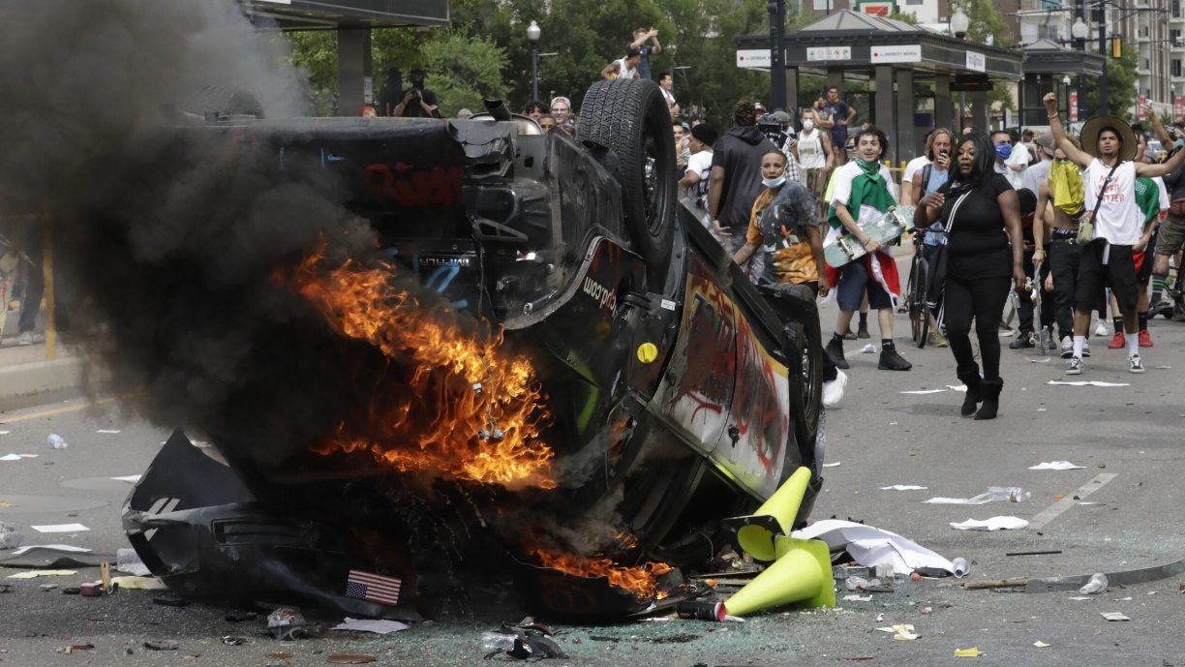

Civil Unrest Plan {Template}
[INSERT NAME OF COUNTY]

[INSERT MONTH] 2022

TABLE OF CONTENTS
DISCLAIMER 4
BACKGROUND 4
RECORD OF CHANGES 6
RECORD OF DISTRIBUTION 6
PLANNING AGENCIES 7
PRIMARY AGENCY 7
SUPPORTING COUNTY AGENCIES 7
LOCAL ORGANIZATIONS 7
NON-GOVERNMENTAL ORGANIZATIONS 8
SUPPORTING STATE AGENCIES 8
PURPOSE, SCOPE, SITUATION, AND ASSUMPTIONS 9
PURPOSE 9
SCOPE 9
SITUATION OVERVIEW 9
PLANNING ASSUMPTIONS 10
CONCEPT OF OPERATIONS 12
ACTIVATION AUTHORITY 12
INCIDENT PREPARATION 13
INCIDENT RESPONSE 18
ALL PERSONNEL ACTIONS 18
LAW ENFORCEMENT RESPONDING PERSONNEL 19
NON-LAW ENFORCEMENT PERSONNEL 20
CROWD CONTROL AND DISPERSAL 21
CROWD DETAINMENT AND ARREST 22
FORCE PROTECTION 22
RESCUE AND FIRE SUPPORT 23
TRAFFIC CONTROL 23
RESOURCE SUPPORT 24
MOBILIZATION OF PUBLIC SAFETY RESOURCES 24
MEMORANDA OF UNDERSTANDING 24
MUTUAL AID AGREEMENTS 24
DOCUMENTATION AND TIME-KEEPING 26
CONDUCT AN AFTER-ACTION REVIEW (AAR) IMPROVEMENT PLAN (IP) 27
INCLUSION, ACCESS, AND FUNCTIONAL NEEDS 28
ORGANIZATION AND ASSIGNMENT OF RESPONSIBILITIES 29
LOCAL LAW ENFORCEMENT SUPPORT AGENCIES 29
INDIANA STATE POLICE (ISP) 29
INDIANA NATIONAL GUARD (INNG) 29
UNIVERSITY POLICE DEPARTMENTS 29
FEDERAL AGENICES 29
DIRECTION, CONTROL, AND COORDINATION 31
COMMUNICATIONS 32
ADMINISTRATION, FINANCE, AND LOGISTICS 33
PLAN DEVELOPMENT AND MAINTENANCE 34
AUTHORITIES 35
LOCAL AUTHORITIES 35
STATE AUTHORITIES 35
FEDERAL AUTHORITIES 36
APPENDIX A – CIVIL UNREST CHECKLISTS 40
FACT GATHERING 46
FACT GATHERING 50
ASSESSMENT 50
APPENDIX B – PUBLIC SAFETY RESOURCES 52
PUBLIC SAFETY RESOURCES BASED ON COMMUNITY LIFELINES 52
SAFETY AND SECURITY 52
FOOD, WATER, SHELTER 54
HEALTH AND MEDICAL 56
ENERGY (POWER & FUEL) 58
TRANSPORTATION 62
HAZARDOUS MATERIALS 64
APPENDIX C – REFERENCES 66
APPENDIX D – ACRONYMS 68
APPENDIX E – DEFINITIONS 70

DISCLAIMER
This template was created by the Indiana Department of Homeland Security (IDHS) to assist Indiana county Emergency Management Agencies (EMAs) and their stakeholders in the development of their County Civil Unrest Plan.
This template provides sample language, sample charts, and layout diagrams to assist counties with identifying and documenting their specific needs regarding civil unrest planning. This template should be modified to follow each county’s organizational structure, capability, and capacity. This template follows DHS, NIMS/ICS, FEMA and other organizations and accredited state guidance.
IDHS welcomes feedback on this template. Our goal is to provide our county stakeholders with the most comprehensive product for our county EMAs and stakeholders.
REMOVE THIS PAGE PRIOR TO PUBLISHING COUNTY PLAN

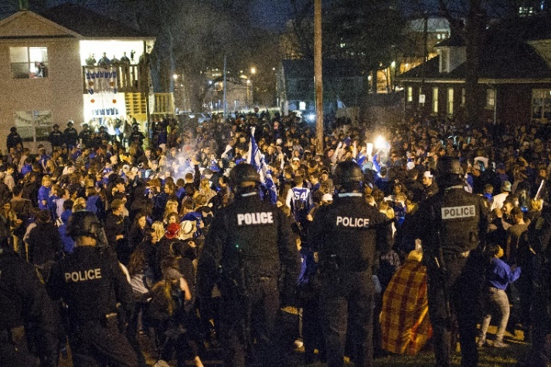

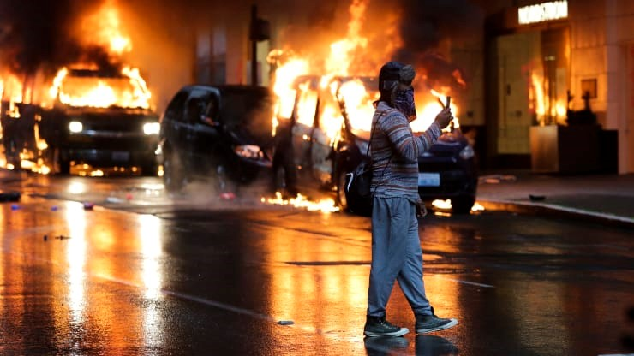
BACKGROUND
Under the rights guaranteed by the First Amendment to the United States Constitution, the public has the right to assemble in large numbers for the purpose of demonstrating their opinion. The government has the obligation to protect the public’s First Amendment right by maintaining order and protecting lives and property during such assembly demonstrations.
An assembly may be declared unlawful, pursuant to:
IC 35-45-1 Offenses against public order.
IC 10-16-7-11 Unlawful assembly; command to disperse.
IC 10-16-7-12 Riots and mobs; death, personal injuries, and property damage.
On such occasions, all persons present, including members of the news media, can be lawfully ordered to disperse. The law provides that police officers and Indiana National Guard (if activated and under direct order of the governor) may use force to disperse an unlawful assembly and may arrest violators.
Civil disorders and disturbances are human-caused events with the potential for causing damage. Although these events can be overlooked since they occur infrequently, they often occur at times of already heightened societal tensions. Civil disturbances can be mitigated through whole community planning responsibility among government officials, county officials, community leaders, business leaders, service organizations, faith-based leaders, and members of the community. Civil unrest is rated as a [Insert County HIRA Rating] Hazard for [Insert Name of County].
The State of Indiana Hazard Identification and Risk Assessment (HIRA) defines civil unrest as “a violent public disturbance of the peace that disrupts a community to the degree that law enforcement intervention is required to maintain public safety.”
Civil disturbances can be called a civil unrest, demonstration, protest, or riot among other names. When the magnitude of the disturbance reaches serious or major proportions, local resources must be mobilized. For the purposes of this plan, the term civil disturbance can be used interchangeably with any of the following terms:
Civil Disobedience | Civil Disorder
Civil Unrest | Unlawful Assembly
Riot | Spontaneous Event
Flash Mob | Demonstration
Assembly | Unnoticed Event

RECORD OF CHANGES
[Insert detailed information regarding any changes]
Change # | Change Description | Date Posted | Person(s) Responsible
1 | Initial iteration of plan | 2/2022 | County EMA

RECORD OF DISTRIBUTION
[Insert who received a copy of this plan]
Date | Agency/Department | Agency Representative | Method of Delivery
2/2022 | County Commissioners | John Smith | Electronic

PLANNING AGENCIES
The primary agency identifies the appropriate support agencies that fall under this plan and collaborates with each entity to determine whether it has the necessary resources, information, and capabilities to perform the required tasks and activities within each phase of emergency management, including activations in the [Insert Name of County] County Emergency Operations Center (EOC) and impacted areas. Though an agency may be listed as a primary agency, it does not control or manage those agencies identified as supporting agencies. The agencies listed below are part of the Whole Community Planning Committee for this plan.

Primary Agency
[Insert Name of County EMA Agency]

Supporting County Agencies
[Insert names of supporting county agencies]

Local Organizations
[Insert names of supporting local organizations]

Non-Governmental Organizations
American Red Cross of Indiana | Indiana Voluntary Organizations in Disaster (INVOAD)
[Insert names of supporting non-governmental agencies]

Supporting State Agencies
Indiana Department of Homeland Security (IDHS) | Indiana National Guard (INNG)
Indiana State Police (ISP) | [Insert names of supporting state agencies]

PURPOSE, SCOPE, SITUATION, AND ASSUMPTIONS

Purpose
Civil unrest may occur as a period of social upheaval, following sporting events, or during periods of heightened community tension. Law enforcement, fire and emergency medical services, emergency management personnel, and potentially a wide variety of other agencies will be called to respond to these incidents, placing themselves at higher than anticipated levels of risk.
This plan details the general concept of operations, responsibilities, and anticipated resources for responding to and managing a civil disturbance event. It is applicable to all locations and to all agencies, organizations, and personnel with public safety responsibilities.

Scope
Effective incident management begins with a host of preparedness activities conducted well in advance of any potential incident. Preparedness involves an integrated combination of planning, training, exercises, personnel qualification and certification standards, equipment acquisition and certification standards, and publication management processes and activities.
This plan is applicable to [Insert Name of County] departments with emergency public safety functions, including county departments having routine interaction with the public and departments performing other critical services.

Situation Overview

Demographics
According to the [Insert Census Reference], the [Insert Date of Reference] population estimate for [Insert Name of County] is [Insert Population Number]. [Add other pertinent demographic information].

Vulnerabilities
[Insert Name of County] has multiple, accessible, redundant warning and notification systems to reach the public. Factors to consider are the type of incident, the vastness of the population, and the terrain in areas of [Insert Name of County]. In some instances, the consequences of an incident along with terrain, and the geographical area, may impact the effectiveness of notification systems.
[Insert Name of County] recognizes that civil unrest incidents may exhaust local resources. The County will continue to develop Memorandums of Understanding (MOUs), Memorandums of Agreement (MOAs), and contract amendments with private vendors to increase response capabilities and available resources.
[Insert Name of County] recognizes that, despite a good faith effort, it may not have the capabilities or resources to reach every individual in terms of public warnings, notification, and/or support.
[Insert Name of County] is vulnerable to civil unrest and susceptible to placing all County assets at risk. There are no pre-identified hazard zones. The cause and effects of civil unrest range from local to international.
Critical operating facilities, such as City/County Hall, the Police Administrative Building, fire stations, and police stations are at risk of damage or destruction during a civil disturbance event.
All County owned assets may be considered vulnerable to damage or destruction because of civil unrest. Due to the extreme unpredictability of civil unrest events, no specific estimates can be made concerning potential losses.

Planning Assumptions
- In any disaster, primary consideration is given to the preservation of life, then incident stabilization, and property preservation. Additionally, time and effort must be given to providing critical life-sustaining needs.
- The County Emergency Operations Center (EOC) may or may not be activated in support of a civil disturbance event. County EOC activation will be determined based on the scope and scale of the event.
- The area surrounding a civil disturbance could provide a hostile environment in which first responder agencies and representatives of local Emergency Management must operate in support of the government response.
- The response to these scenes must be undertaken with caution, and in the most expeditious manner possible, while providing for the safety of the responding personnel.
- Damage control and disaster relief may be required from the State or Federal government, other local governments, and private organizations.
- Residents could be displaced, requiring shelter and social service needs. Sheltering activities could be short term or long-term depending on the severity of the incident.
- Vital infrastructure such as potable water supplies, electrical power, natural gas distribution systems, and sewer services could be compromised. Re-establishment of these vital resources will be critical.
- Vital vehicle and rail corridors could become blocked, interrupting transportation operations. Rerouting of transportation infrastructure will be critical.
- Communications infrastructure could be damaged causing disruption in telephone, radio, microwave, computer, and other communication services.
- The Information Technology department and other county departments will be responsible for the re-establishment, restoration, and continued operations of IT applications and infrastructure under respective charge. Re-establishment of communications infrastructure will be critical.
- Looting of businesses, residential, commercial, and institutional structures may ensue.
- Citizens may take law enforcement into their own hands and use lethal force, if necessary, to protect themselves or their property.
- Civil disturbance can spread from one neighborhood to the next within a relatively short amount of time.
- There will be an overwhelming interest from the media.

CONCEPT of OPERATIONS
OPERATIONAL PRIORITIES DURING RESPONSE AND RECOVERY OPERATIONS
1. Life safety, and health (highest priority)
2. Incident stabilization
3. Protection of property, economy, and the environment
4. Restoration of essential infrastructure, utilities, functions, and services
5. Unity of effort and coordination among appropriate stakeholders

Activation Authority
The activation of the County Emergency Operations Plan (EOP)/CEMP begins with the activation of the Base Plan. The activation of the Base Plan establishes the emergency operations framework and structure needed to deliver coordinated emergency support to local governments. The activation of this framework and structure provides the basis for activating the County Emergency Operations Center (EOC).
The following individuals have the authority to activate the EOP/CEMP and/or the EOC:
- Chairman of the Board of Commissioners (or their successor)
- County EMA Director (or their deputy)
The following are considerations for activating the EOC:
- An incident has occurred that has the potential for rapid escalation.
- The emergency will be of a long duration and requires sustained coordination.
- Major policy decisions may be required.
- The volume of local requests for assistance is increasing and expected to continue.
- Pre-deployment of county assets is occurring in anticipation of the emergency.
- Managing the situation requires urgent, high-level, nonroutine coordination among multiple jurisdictions, county departments, or other external agencies.
- [INSERT NAME OF COUNTY] shall communicate and collaborate with other state and local response/support agencies and integrate their response plans into the overall response.
- Activation of the EOC will be advantageous to the successful management of the event.

INCIDENT PREPARATION
Having primary and continency plans in place will help response agencies anticipate the unexpected. The plans should be flexible, scalable, and achievable. It should be created in the Incident Command System (ICS) structure to identify the mission and execution of plans and include command, control, and communications.

conduct Pre-event planning with stakeholders
Information should be shared relating to the date, type, and location of the event. Capacity should be determined for each stage of the plan. Rules of engagement with all responding agencies should be determined for each stage of response to a demonstration regarding exhibitions of civil disobedience, property damage and physical violence.
The following agencies should all be involved during the planning process:
- Response agencies and mutual aid support (Police/Sheriff, Fire, EMS).
- County or, if necessary, State Emergency Operations Center (SEOC) personnel to help coordinate and manage a scene off-site with resources and communications.
- District attorney or prosecutors for offense criteria and prosecution.
- Fire department for fire suppression, shelter assistance, first aid, and decontamination for pepper spray, tear gas, or hazmat agents.
- Public works for barricades, trash and bonfire material removal, and property collection.
- Animal control to take control of dogs and other animals belonging to individuals arrested.
- Emergency medical services to assist with first aid and treatment and transport of those with medical emergencies.
- Juvenile or youth unit to detain and transport juveniles involved, as necessary.
- Transportation department to discuss evacuation routes.
Intelligence gathering
Upon receipt of a credible threat of a civil disturbance, [Insert Name of County] will act according to the scale and scope of the event.
The [Insert Name of Lead Agency] is the lead agency during a civil disturbance event and will coordinate the overall County response. If any County department or agency obtains knowledge of a credible civil disturbance threat, this information will be provided to the [Insert Name of Lead Agency], who will share the information with other County departments and County, State and Federal agencies, as necessary.
The intelligence gathering process includes contacting organizers and possible counter-protesters to accommodate a peaceful assembly. Have a film team photograph and film the event before, during, and after to memorialize it. A catalogued film of the event at various phases is valuable to show due diligence and appropriate steps followed in addressing a hostile situation. The film may be used to aid in prosecution, defend against lawsuits and assist during debriefings to critique the response.
Although law enforcement has many streams for gathering information and intelligence, there are several non-public safety County departments that can be essential force-multipliers. Many non-public safety County departments, such as the Departments of Public Works, Water & Power, Building & Safety, and Housing, have personnel in the field in public places that routinely enter private residential and commercial buildings to conduct inspections.
County department personnel can be an information gathering resource by communicating out of the ordinary field information to the appropriate public safety departments.
Staffing plans for each position
Include all staffing plans in the Emergency Operations Center and in the Incident Command Post (ICP) including the incident commander, operations, planning, logistics, and administration/ finance sections).
Identify communication, staging and transporation needs
Communications should address dedicated radio channels for the event and identify channels for specialized teams to use. Additional planning for communications with adjacent jurisdictions, counties, and the State Emergency Operations Center (SEOC) should be considered. Staging areas for vehicles and personnel should be close to the event. In the case of a march or movement of the venue, consider using buses or shuttles to transport personnel, rather than march. Rooms for rest periods and meals, as well as restroom facilities, should be identified near the event.
pre-identify a public information officer
The Public Information Officer (PIO) will act as a liaison with the community and media before, during and after the event.
Incident Action Plan (iap)
The IAP document establishes incident goals, operational period objectives, and the response strategy. If a planned event is a repeated, annual, and peaceful occurrence, a previous version of an IAP may be used as a starting point.
Dates, locations, and staffing issues need to be updated by contact with the event organizers. Situational awareness should be maintained through reviewing informational flyers about the event, social media posts, weather reports and current events that may impact alternate, contingency and emergency planning. News reports of similar events will be helpful in the planning stages as well.

The Civil Unrest IAP should include the following at a minimum:
- ICS command structure.
- Crowd control methodology and movements.
- Any Just-in-Time (JIT) training and briefings needed to include safety briefing.
- Create a communications plan to communicate between organizational and jurisdictional partners.
- Maps and locations of staging, hot, warm, cold zones, and rest areas.
- Personnel assignments with contact information.
- Trigger points for pronouncing an unlawful assembly, critical incident, or disaster.
- Traffic control or march re-route strategies.
- Scripting unlawful assembly warnings.
- Checkpoints for weapons or projectiles.
- Preparing for violence, arrests, and critical incidents.
- Provision of first aid services.
- Addressing transportation issues and shelter needs.
- Plans for evacuation or shelter in-place should be included.
- Media relations rules of engagement.
- Communicate, exercise, follow and adapt the plan as needed.

Activation of county Emergency Operations Center (EOC)
Assign supporting agency representatives to the EOC to assist with coordination. Establish a method for screening calls for service and determining response priorities. This includes determining if no response is warranted given the current circumstances.

Establish Unified Command with appropriate law enforcement and other partner agencies.
- Consider using Modified Area Command in areas of civil unrest. In this configuration, response assets are assigned to the Unified Command team and staged in a safe location.
- Response assignments must be coordinated by the Unified Command team using assigned resources.
- Responses within the unaffected areas are controlled by the normal dispatch process or jurisdiction EOC using resources not assigned to Area Command.
- Ensure Command Post security and remain flexible as location might be subject to change rapidly.
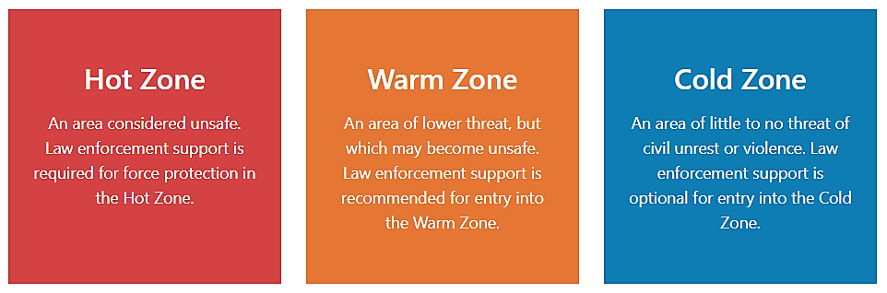
- Identify Hot, Warm and Cold zones. These must be dynamic and may be based on geographic area or specific to a single incident.
FIGURE 1. HOT, WARM AND COLD ZONES
- Maintain and communicate situational awareness across all levels of the response and with the Unified Command team.
- Establish fueling, maintenance and logistics support for apparatus and personnel assigned to the area of operations/incident staging area.
- Activate an Incident Management Team (IMT) early to help organize and coordinate activities.
- Be prepared to engage hazardous materials and EMS assets in the event of chemical dispersant use.
- Prepare to activate Continuity of Operations (COOP) plans and alternate facilities.

Modify operations based on perceived threat or risk
- Provider safety remains the highest priority and, when possible, should be addressed.
- Consider modified response protocols, including adding or removing response assets based upon the situation, area, need, perceived escalation, threat, etc.
- Size up and communicate the potential for any situation to get worse and the unmitigated or escalated impacts to life, property, infrastructure, etc.
- Rapid response to slow spread as much and as fast as possible.
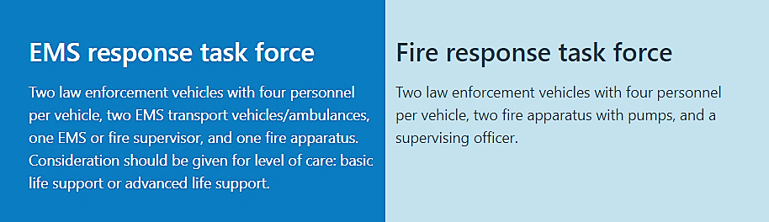
- Establish response task force for entry into Hot and Warm zones.
FIGURE 2. TASK FORCE EXAMPLE
- Work in teams of two or more and remain in contact with each other.

Maintain situational awareness
- Ensure current information is communicated to those that need to know.
- Leverage all possible sources of response area and regional intelligence, including potential locations of gatherings.
- Maintain channels of communication with law enforcement, fusion centers and other emergency response partners regarding threat information and intelligence.
- Ensure that intelligence is free flowing laterally and vertically.
- Monitor local media reports for situation awareness.

incident response

ALL PERSONNEL ACTIONS
- Review civil unrest-speciﬁc organizational and jurisdictional protocols and guidelines.
- Wear civilian clothes when reporting to and returning from duty.
- If issued by department, wear ballistic protection in accordance with National Fire Protection Association (NFPA) 3000, Standard for an Active Shooter/Hostile Event Response (ASHER) Program.
- Establish a family communication plan to share information with responder families.
- Provide emotional support for personnel and their families.
- Per NFPA 1500, Standard on Fire Department Occupational Safety, Health, and Wellness Program, ﬁre and EMS personnel should not be used for crowd control operations.
- Work in pairs or teams.
- Carry a radio and lights.
- Secure items such as scissors and stethoscopes on your person.
- Remove badges from uniforms and consider wearing casual uniforms.
- Keep personnel IDs, keys, wallet, etc., on your person or otherwise secured.
- Minimize carried equipment, such as harnesses, extra tools, pocket contents, etc.
- Always carry a radio (be sure to regularly charge/swap batteries).
- Chief and company oﬃcers shall maintain accountability of apparatus and staﬀ.
- Develop communications code words for secure communications of emergency actions (building or area evacuation, apparatus/station abandonment, etc.).
- Develop rally points should apparatus or stations need to be abandoned and pass on to members. These may change due to situational changes.

Law enforcement responding personnel
All responding personnel will observe the listed precautions prior to responding to any civil disturbance.
- Officers should not self-deploy to the scene of a civil disturbance. Officers who respond without the proper training and equipment may hinder law enforcement efforts. The Incident Commander (IC), or his/her designee, will take the lead in the incident and direct the responsibilities of the appropriate support personnel.
- Conduct personnel safety and operation briefing, whenever possible, before deploying with special emphasis on situational awareness.
- Ensure that all responders can communicate with each other and the incident command and/or 911 Center.
- Ensure that the concept of team integrity is understood by all and that it is everyone’s duty to see that it is complied with. The buddy system will be used at all times.
- Assign a safety officer the duty to also monitor non-emergency response people and vehicles near the scene of the response. Ensure that the safety officer is to report any threatening or suspicious actions taking place nearby to the incident command post, EOC or 911 Center immediately.
- Ensure that all drivers understand that they will park their vehicles so that they can exit the area without making any turning maneuver.
- Make sure that someone has the duty to communicate to spectators at the scene if commands need to be given.
- Ensure that all un-needed equipment is secured inside the vehicle and that a security detail will always remain with the vehicle.
- Ensure that all personnel are prepared to do both an audio and a visual inspection of the area before exiting their vehicle and that this inspection of the area continues throughout the response phase.
- Ensure that all personnel are aware of any legitimate order to initiate leaving the area if the incident scene turns threatening. Orders may be issued for both hasty retreat and an accelerated withdrawal. The use of “plain English” should be used to avoid misunderstandings between different agencies or departments.
- Instruct all personnel turn off lights and sirens a predetermined distance from the incident so as not to attract other people to the area.
- Make sure all non-law enforcement personnel understand that they are to make no verbal or physically aggressive actions toward the crowd at the scene.
- Make sure all responding non-law enforcement personnel understand that they should take no action which might be considered a police action by the crowd.
- Make it understood that a loss of communication with the incident command post or communication center for five minutes will result in the initiation of actions to withdraw from the area.
- Reinforce the concept that the team’s first responsibility is to protect each other.
- If there is any known mechanical problem with a vehicle which might cause a breakdown necessitating towing, that vehicle will not be used to respond to the area of disturbance.

Non-law enforcement personnel
- Respond to sites in the area of a disturbance via a staging area.
- Whenever possible enter the area of the disturbance with a police escort.
- Keep in contact with the incident command post or communication center. Loss of communication for five minutes is justification for withdrawal from the area, even if the mission is not complete.
- Respond in teams as per the initial briefing. Under no circumstances break up or isolate teams.
- Under no circumstance do members of a “buddy team” separate.
- Do not use or call for more resources than the minimum needed for the response.
- Do minimum overhauls, or maintenance of equipment at the scene. Do all required maintenance at the staging area, or after the return to base.
- If a vehicle becomes immobilized request assistance immediately.
- Throughout the response always have a planned escape route available by which to leave the scene.
- All personnel, in addition to the site safety officer, are responsible for monitoring the scene for possible trouble and reporting it to the incident commander.
- Under no circumstances will equipment or personnel be committed to sites from which there is only one exit.
- Personal protective equipment (PPE), as prescribed by OSHA, or other agency, will be worn all times.
- Note, but do not react to, any incident that is the responsibility of law enforcement.
- Under no circumstances will the response team confront hostile groups, or individuals, even if failure to do so will mean that the mission cannot be carried out. The failure to complete the mission in the face of a hostile crowd is not a sign of failure.
- Conduct safety briefings at the response site as the situation changes.
- Do not use lights and sirens when leaving the area until clear of the area of disturbance.
- Protect vehicles and equipment at all times.

Crowd Control and Dispersal
[Insert County Name] crowd control mission objectives are to:
- Protect life.
- Restore and maintain order arrest violators.
- Protect vital facilities.
- Protect property.
[Insert Law Enforcement Agency Name] will exercise all appropriate measures to maintain crowd control and dispersal. These tactics may include but not limited to dispersal orders, skirmish lines, mobile field forces, air support operations, mobile sound vehicles, and/or arrests.

CROWD DETAINMENT AND ARREST
The on-scene Law Enforcement Incident Commander will rapidly deploy forces and utilize equipment as necessary to restore order.
The [Insert Law Enforcement Agency Name] will plan for the anticipation of a mass arrest requiring transportation, booking, and processing during a preplanned or unplanned event. If an unlawful act is committed, [Insert Law Enforcement Agency Name] will direct officers to take the appropriate action.

FORCE PROTECTION
The [Insert Law Enforcement Agency Name] Incident Commander will immediately identify and secure critical or sensitive locations within the disturbance area (e.g., hospitals, communication centers, firearms establishments, public utility centers, religious institutions).
If [Insert Law Enforcement Agency Name] requests force protection while conducting fire/life safety missions during a civil disturbance event, force protection will be provided by additional members of the [Insert Law Enforcement Agency Name] or [Insert Additional Mutual Aid Agreements or Protocols].
Upon receipt of the mission request, the [Insert Law Enforcement Agency Name] Unified Commander or Incident Commander will ensure continuous support for the duration of the event and will conclude only after agreed upon by both [Insert Law Enforcement Agency Name] and [Insert Fire Department Name]. if appropriate.
If necessary and feasible [Insert Name of County] Public Works facilities will deploy its Security Services personnel to facilities and attempt to protect facilities and employees and keep unauthorized persons from the facilities until local law enforcement arrives.

RESCUE AND FIRE SUPPORT
[Insert Name of County Rescue and Fire Support] will continue to operate within the Task Force concept. [Insert Name of County] resources will be coordinated by Area Command and Control. Resources will be grouped into Medical Task Forces when responding to medical incidents. Specialized resources such as Urban Search and Rescue, Hazardous Materials Task Forces will be used, as necessary. Force protection necessary to allow for safe operations is required by law enforcement when responding into areas of civil disturbance. Fire resources will engage fires and other incidents requiring fire apparatus in a cursory manner with life safety being the optimum goal.
[Insert Name of County Rescue and Fire Support] members will function in teams of two or more during civil disturbances. The guidelines for operating within the operational area are detailed in the Hazardous Materials Handbook and the Tactical Alert Manual.

TRAFFIC CONTROL
When employing traffic control the following tactics may be used by [Insert Law Enforcement Agency Name] (sample tactics below):
Fixed Post Strike Teams to control traffic at specific intersections and location. Bicycle Strike Teams to provide a mobile traffic force that can respond quickly in crowded situations.
Motor Strike Teams to provide rapid mobile response to reinforce fixed postpositions or to redeploy and establish new traffic control tactics as needed.
[Insert Law Enforcement Agency Name] will provide a plan for emergency vehicle ingress/egress routes and will establish and maintain a perimeter around the closed area (limited access or no access).
The [Insert Name of County] Department of Transportation will provide traffic control at secure locations identified by [Insert Law Enforcement Agency Name]. [Insert Name of County] Department of Transportation will identify traffic corridors that should be used for public travel, emergency evacuation egress, or public safety vehicle ingress and egress, as well as any other route designations needed.
[Insert Fire Department Name] directs traffic as a secondary function of rescue and fire support. [Insert Fire Department Name] will make appropriate ingress and egress for emergency and incident support vehicles recommendations to [Insert Name of County] Department of Transportation. In collaboration with the [Insert Law Enforcement Agency Name] and the [Insert Fire Department Name] will make boundary recommendations for an evacuation area to [Insert Name of County] Department of Transportation.

RESOURCE SUPPORT
During an incident, requests for resource support originate from the site Incident Command (IC), Area Command (AC), or Unified Command (UC) and are directed to the local emergency management agency (EMA). As local resource capabilities become overwhelmed, the local jurisdiction’s EMA requests support from the State EOC based on the projected needs of the local Incident Action Plan (IAP). A request exceeding county capability can be fulfilled by surrounding counties, district assets, using mutual aid, federal assistance, or other appropriate means.
State resources may also be requested by local jurisdictions for activation in exercises, testing, or training. Participation in these activations allows for the continued development and improvement of public safety programs and resources.

MOBILIZATION OF PUBLIC SAFETY RESOURCES
During a civil disturbance, [Insert County Law Enforcement Agency Name] is the lead agency. However, other county entities play a role in supporting law enforcement efforts by accomplishing a wide range of tasks at various points of the incident to bring order to the area of concern.
Individual departmental resources will be coordinated through their respective DOCs. Overall coordination of County department and agencies will be done through the County EOC. If the EOC is activated, [Insert County Law Enforcement Agency Name] will provide updates to the EOC Manager.
[Insert any local mobilization protocol here]

Memoranda of Understanding
[List Existing Memoranda Here]

Mutual Aid Agreements
[List Existing Agreements Here]

Indiana Intrastate Mutual Aid Program (IC 10-14-3-10.8)
[Insert Name of County] participates in the Indiana Intrastate Mutual Aid Program also known as the Indiana Intrastate Mutual Aid Compact which has the following two (2) purposes:
- Provide for mutual assistance or aid among participants for purposes of preparing for, responding to, and recovering from any incident, disaster, exercise, training activity, or planned event that requires additional resources.
- Establish a method by which a participant may seek assistance or aid that:
- resolves many of the common issues facing political subdivisions before, during, and after an incident, disaster, exercise, training activity, or planned event, any of which requires additional resources; and
- ensures, to the extent possible, eligibility for available state and federal disaster assistance or other funding.
A participant that is impacted by any incident, disaster, exercise, training activity, or planned event that requires additional resources may request mutual assistance or aid from any other participant.
This request shall be made by the chief executive of the requesting participant to the chief executive of a provider participant. If the request is made orally, the requesting participant shall provide the provider participant with written confirmation of the request not later than seventy-two (72) hours after the oral request is made. A request must provide the following information:
- A description of the incident, disaster, exercise, training activity, or planned event.
- A description of the assistance or aid needed.
- An estimate of the length of time the assistance or aid will be needed.
- The specific place and time for staging of the assistance or aid and a point of contact at that location.
- A statement that the request for assistance is being made through the intrastate mutual aid compact.
A provider participant shall provide assistance or aid to a requestor participant subject to the following:
- The provider participant may withhold resources the provider participant determines to be necessary to provide for the provider participant's own protection.
- Personnel of the provider participant shall continue under the personnel's local command and control structure but shall be under the operational control of the appropriate officials within the incident management system of the requesting participant.
- Law enforcement officers rendering assistance or aid under this section have the same powers and duties as law enforcement officers of the requesting participant, but only for the period the law enforcement officers are engaged in activities authorized by the requesting participant and are subject to the law as if the law enforcement officers were providing services within the law enforcement officer's own jurisdiction.
Additional details of the compact outlined in IC 10-14-3-10.8.

Defense Support of Civil Authorities (DSCA)
A process through which United States military assets and personnel can be used to assist in missions normally carried out by civil authorities or local jurisdictions. These missions are primarily activated and used in response to large natural and human- made disasters. DSCA is the overarching guidance of how the United States military can be requested by a federal agency and the procedures that govern the actions of the military during employment. The provision of DSCA is codified in Department of Defense Directive 3025.18.
The Defense Coordinating Officer (DCO) is the functional process manager of DSCA. If military assets and personnel are needed, the [Insert Name of County] Emergency Management Agency will request resources through the State Emergency Operations Center (SEOC).

iNDIANA nATIONAL gUARD (inng)
Upon the identification of a potential civil support mission, a no-notice event, or when directed by the Governor or the Executive Director of the Indiana Department of Homeland Security (IDHS) and, when possible, prior to an imminent disaster, the Indiana National Guard (INNG) will mobilize and stage personnel necessary to support incident priorities as detailed in mission assignments. Upon completion of the specific mission assignments, National Guard forces may be assigned new missions or be redeployed for refitting and reconstitution in preparation for follow-on assignments or deactivation. IDHS processes any official request for INNG assistance.

DOCUMENTATION AND TIME-KEEPING
During an emergency or incident, it is important to keep records specific to staff assignments and costs related to the response to and recovery from the emergency/incident. Each department has their own internal processes for ensuring proper documentation of actions; incident specific cost tracking, personnel time- keeping and record retention of these documents.
In accordance with standard cost accountability practices for unique events, man-made and/or natural disasters, all County departments are required to document their financial costs of labor, materials, and equipment utilized in addressing the event.
Each County department, proprietary and Council controlled, operates their respective accounting practices within local guidelines and the Federal Code of Regulations Title 44 of the Stafford Act to maximize potential reimbursement eligible costs and minimize ineligible costs.

Conduct aN AFTER-ACTION review (aar) and create IMPROVEMENT PLAN (Ip)
After event conduct an AAR and Strengths, Weaknesses, Opportunities, and Threats (SWOT) analysis addressing response costs, gaps, and successes. Develop Improvement Plan (IP) to identify gaps, strategies for correction, and address continuity planning, if necessary.

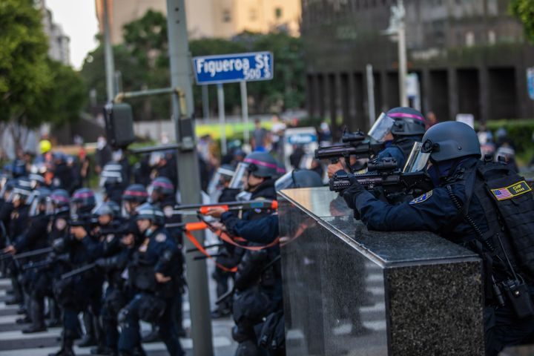

INCLUSION, ACCESS, AND FUNCTIONAL NEEDS
[INSERT NAME OF COUNTY] works with public, private, and non-profit organizations to build a culture of preparedness and readiness for emergencies and disasters that goes beyond meeting the legal requisites of people with disabilities as defined by the most current version of the Americans with Disabilities Act (ADA) or for individuals with access and functional needs.
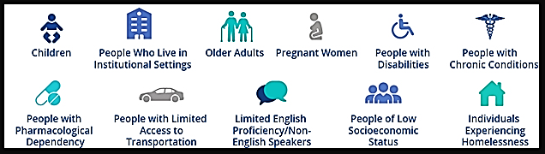
[INSERT NAME OF COUNTY] integrates the Federal Emergency Management Agency’s (FEMA)’s access and functional needs guidance, which identifies an individual’s actual needs during an emergency and awareness of not using negative labels such as “handicapped,” “crippled,” or “abnormal.”
This planning guidance is inclusive as it also encompasses people with temporary needs or those who do not identify themselves as having a disability. This includes women who are pregnant, children, older adults, individuals with limited English communication, people with limited transportation access and those with household pets and service animals. Additional awareness which helps ensure inclusive emergency preparedness planning include addressing the needs of children and adults in areas such as:
SELF-DETERMINATION – Individuals with access and functional needs are the most knowledgeable about their own needs.
NO “ONE-SIZE-FITS-ALL” – Individuals do not all require the same assistance and do not all have the same needs.
EQUAL OPPORTUNITY, INTEGRATION AND PHYSICAL ACCESS – All individuals must have the same opportunities to benefit from emergency programs, services, and activities.
NO CHARGE – Individuals with access and functional needs may not be charged to cover the costs of measures necessary to ensure equal access and nondiscriminatory treatment.
EFFECTIVE COMMUNICATION – Individuals must be given information that is comparable in content and detail to the information given to those without functional needs.

ORGANIZATION AND ASSIGNMENT OF RESPONSIBILITIES

LOCAL LAW ENFORCEMENT SUPPORT AGENCIES
When the civil disturbance takes place within the boundaries of the County, [Insert County EMA Name] will operate in a support role and primarily monitor the civil disturbance. The [Insert Name of Lead Agency] Operations Center will be activated and be utilized for coordinating with all other relevant departments. A request must be sent from EMA and [Insert Name of Lead Agency] to be present in the [Insert Law Enforcement Agency Name] Operations Center. [Insert Name of Lead Agency] will send a representative to be present in the County’s EOC, if activated.

Indiana state police (ISP)
Indiana State Police (ISP) acts to prevent loss of life, injuries, and property damage as a result of traffic collisions by enforcing the Indiana Vehicle Code and other laws to prevent crime. In the event of traffic and emergency incidents, ISP promotes safe and efficient movement and people and goods. The ISP also has the duty to “protect the public, their property, State employees, and the State’s infrastructure”; which as needed involves collaboration with Local, State and Federal public safety agencies.

Indiana National Guard (INNG)
The Indiana National Guard (INNG), comprised of both Army and Air National Guard, provides trained and disciplined forces in response to domestic emergencies and special situations. If summoned by the Governor of Indiana, the INNG will assist local authorities in dispersing the unlawful assembly and may arrest persons taking part, as a last resort, as stated in IC 10-16-7-12.

University Police Departments
University Police Departments follow the NIMS emergency management protocols. In the event of a civil disturbance in the region, those campuses located within [Insert Name of County] will respond in accordance with their standing procedures.

FEDERAL AGENICES
Although [Insert Name of County] has no authority to assign responsibilities to Federal departments, many Federal departments have primary or support responsible for providing certain services to [Insert Name of County]. Those Federal departments are listed in the following, along with the services they are responsible for providing in the event of a civil disturbance.

Federal Bureau of Investigations (FBI)
To coordinate the Federal response, the FBI and FEMA have been assigned lead agency responsibility for crisis and consequence management, respectively, in response to a domestic terrorist threat or incident. The FBI is the lead agency for crisis management response to acts of domestic terrorism, which includes measures to identify, acquire, and plan the use of resources needed to anticipate, prevent, or resolve a threat or act of terrorism. State and Local governments provide assistance, as required.

Department of Defense (DOD)
The DoD supports Local, State, and Federal government agencies in planning for and responding to domestic emergencies. Local units may respond under the immediate response doctrine when necessary to save lives, prevent human suffering, or mitigate great property damage. Many units execute MOUs for mutual support of emergency services with Local jurisdictions or municipalities. Upon the declaration of an emergency or major disaster by the President, the Secretary of Defense, or his Executive Agent provides federal military support. For most domestic emergency responses requiring US DoD assets, the Defense Coordinating Officer (DCO) controls all US DoD response elements.

United States Department of Homeland Security (DHS)
DHS maintains one vital mission: to secure the nation from the many threats we face and ensure a homeland that is safe, secure, and resilient against terrorism and other hazards. DHS prevents terrorism and enhances national security, secures, and manages Federal borders and ensures resilience to disasters.

Federal Emergency Management Agency (FEMA)
FEMA is the lead Federal agency for consequence management, which entails both preparedness for and dealing with the consequences of a terrorist incident. Although the affected State and Local governments have primary jurisdiction for emergencies, a terrorist attack could create havoc beyond their capability to respond. FEMA coordinates consequence management activities including measures to alleviate damage, loss, hardship, or suffering caused by the incident; to protect public health and safety; to restore essential government services; and to provide emergency assistance. Final authority to make decisions on- scene regarding the consequences of the incident (rescue and treatment of casualties, protective actions for the affected community) rests with the Local Incident Commander.

DIRECTION, CONTROL, AND COORDINATION
The first-arriving agency, when two or more share jurisdiction, will be the leading law enforcement agency (LEA) in a civil disturbance incident. Upon notification to this agency communication will be established to ensure that:
- All responses are coordinated.
- Information is provided to all parties involved as it becomes available.
- The release of information at the local level will be coordinated and accomplished through designated Public Information person.
- The County will coordinate all State resources which are committed to a civil disturbance through the Emergency Operations Center (EOC).
The level of county response will be dictated by the requesting jurisdiction and will be done on a request-only basis.
This plan may be activated when elected officials proclaim a local emergency, or if there is a pre-determined activation. A pre-determined activation precedes a disaster or event that the County has identified, in advance, as one that requires an immediate response. Disasters requiring pre-determined activations are those events that pose an immediate threat to public safety.
The support response to civil disturbances will be directed by [INSERT NAME OF COUNTY] Emergency Management. Responding personnel may receive direct instruction from the on-scene Incident Commander.
Activation of the EOC is not necessarily automatic or necessary with all civil disturbance incidents. In advance of or simultaneous with the County plan activation, County departments and agencies will also activate their departmental civil disturbance plans.

COMMUNICATIONS
The following is a list of identified potential alternative communications, assuming that landline, wireless communication devices, and internet are primary sources of communication. Any of these can be primary forms of communications. Any of these can be used alone or in conjunction with other communication systems. One or all, may be operable at any given time within the state.

Communication Methods
[ADD, CHANGE, OR REMOVE ACCORDING TO COUNTY PROTOCOLS]
- Data including: WebEOC, Email, Text, social media, and Cisco Jabber
- Integrated Public Alert and Warning System (IPAWS)
- Emergency Alert System (EAS)
- Wireless Emergency Alerts (WEA)
- National Oceanic and Atmospheric Administration (NOAA) All-Hazard Weather Radio
- Highway Advisory Radio Stations
- Indiana Department of Transportation (INDOT) Signage
- Amateur Radio
- Alternative Local Emergency Management Agency (EMA) Website
- Non-traditional avenues: Private Sector Partners and Translation Services
- Government Emergency Telecommunications Service (GETS)
- 800 MHz Radio System
- Mutual Aid repeater system
- Indiana Law Enforcement Emergency Network (ILEEN)
- Satellite Radio/Phones
- Broadband Global Area Network (BGAN)
- Radio Emergency Associated Communications Teams (REACT)
- Military Affiliate Radio System (MARS)
- Runners

ADMINISTRATION, FINANCE, AND LOGISTICS
The operations will be coordinated by the Emergency Management Director. The emergency management staff will operate from the established Emergency Operations Center.
The Emergency Operations Center maintains an Emergency Notification Call-Up List. The staff will operate as the situation warrants.
Each department is required to have documented internal administrative procedures in place to track financial costs related specifically to the response and/or recovery of an incident. These procedures must include tracking all expenditures specifically related to the incident, including personnel costs such as straight and overtime payroll costs related specifically to the incident.
Departments are also required to document internal administrative procedures for requesting, fulfilling, and tracking internal, department to department, field to department, and department to EOC resource requests. Each department is responsible for the tracking of their own resources, including the tracking of personnel.
If an incident meets designated thresholds for Proclamation or Declaration of a State and/or Federal Emergency or Disaster, the County Administrator or designee, acting as the County’s Authorized Agent, will develop a method for collecting financial documentation from departments as needed for submission as part of the County’s reimbursement application process.

PLAN DEVELOPMENT AND MAINTENANCE

Plan Development
[Insert Name of County Primary Agency] is responsible for the program and technical content of this plan. The designated agency personnel are the primary point of contact for planning collaboration.
The primary agency identifies required planning committee members and provides the committee with contact information and expectations of planning needs. The primary agency ensures compliance with FEMAs Comprehensive Preparedness Guide (CPG) 101 standards including the FEMA 6-Step Planning Process and the Whole Community Planning Model. The primary agency will make recommendations regarding including other stakeholder involvement and review to ensure the Whole Community Planning Model is included.
The primary agency approves all program and technical content changes during the development, review, and scheduled update of the plan.

Plan Maintenance
The primary agency oversees plan maintenance, formatting, and grammatical editing of the plan, and is responsible for ensuring the planning schedule is accurately published and timelines followed. The primary agency is also responsible for scheduling planning meetings, arranging logistics, and creating and distributing planning meeting agendas and subsequent meeting minutes. Moreover, the primary agency is responsible for facilitating planning meeting group discussion, as needed to achieve meeting objectives.
The primary agency maintains current and historical planning checklists and copies of current and previous plan versions with tracked changes. The primary agency will also electronically distribute the plan as specified in the Record of Distribution and electronically file the plan in WebEOC, if approved.

AUTHORITIES

LOCAL AUTHORITIES

Indiana Code 36-1-3, Home Rule
The policy of the State is to grant units all the powers that they need for the effective operation of government as to local affairs.

[ADD OR CHANGE TO COUNTY DETAILS OR PROTOCOLS]

LOCAL EMERGENCY MANAGEMENT ORDINANCES
Local emergency management (EM) ordinances are an extension of Indiana Code 10-14-3, at the local jurisdictional level. These local statutes spell out additional, jurisdictional-specific, or area-specific requirements the state law does not address. The local EM ordinances also provide the local emergency management director with the authority to act before, during, and after an emergency or disaster, and define the necessary requirements for establishing and maintaining an effective emergency management and public safety program for a given jurisdiction.

LOCAL COMPREHENSIVE EMERGENCY MANAGEMENT PLANS (CEMP) / OR EMERGENCY OPERATIONS PLANS (EOP)
These documents are the multi-discipline, All-Hazards plans modeled after the state EOP and the National Response Framework (NRF) for local jurisdictions within the state of Indiana. The plans provide for a single, comprehensive framework for the management of emergency and disaster events within a given jurisdiction. Local Comprehensive Emergency Management Plans (CEMPs) or Emergency Operation Plans (EOPs) outline structure and mechanisms for coordinating local preparedness and response activities. The CEMP/EOP also acts as a general reference point for local agencies to develop contingencies to meet the needs of their communities during emergency or disaster events.

State authorities

Indiana Code 10-19-2
The Indiana Department of Homeland Security was established, and the governor shall appoint an executive director.

Indiana Code 10-14-3. Emergency Management and Disaster Law
This Indiana Code is the primary guideline for establishing and coordinating local emergency management programs and provides information on the disaster declaration process, emergency planning, and other pertinent requirements for successful public safety programs.

Indiana Code 10-14-5. Emergency Management Assistance Compact
The purpose of this compact is to provide for mutual assistance among the states entering into this compact in managing any emergency or disaster which is duly declared by the governor of the affected State, whether arising from natural disaster, technological hazard, man-made disaster, civil emergency aspects of resources shortages, community disorders, insurgency, or enemy attack.

Indiana Code 10-16-7-12. Riots And Mobs
This code gives members of the Indiana National Guard the power to disperse an unlawful assembly and/or arrest persons taking part in the unlawful assembly when working under the direct order of the Governor.

Executive Order 17-02, January 9, 2017
Establishes and clarifies duties of State agencies for all matters relating to emergency management and designates the Executive Director of the Indiana Department of Homeland Security as the State Coordinating Officer for all emergency and disaster prevention, protection, mitigation, response, and recovery operations for the State of Indiana.

FEDERAL AUTHORITIES

National Incident Management System (NIMS), October 2017
NIMS provides a consistent nationwide template for partners to work together to prevent, protect against, respond to, recover from, and mitigate the effects of incidents.

Robert T. Stafford Disaster Relief and Emergency Assistance Act, August 2016
The Stafford Act is a United States federal law that provides a means of natural disaster assistance for state and local governments.

Sandy Recovery Improvement Act, 2013
The Sandy Recovery Improvement Act is a law that authorizes changes to the way FEMA delivers disaster assistance.

Post-Katrina Emergency Management Reform Act, 2006
The Post-Katrina Emergency Management Reform Act provides FEMA guidance on its mission and priorities, including its partnership with state and local governments.

Occupational Safety and Health Administration (OSHA), Hazardous Waste Operations and Emergency Response (HAZWOPER), 29 CFR 1910.120, 1986
This OSHA standard includes safety requirements employers must meet in order to conduct five specific types of hazardous waste operations.

Robert T. Stafford Disaster Relief and Emergency Assistance Act, 42 United States Code (USC) 5121 Et Seq., November 23, 1988
This federal law establishes and provides direction for federal and state government entities affected by emergencies and disasters and the means and methods necessary to declare and seek reimbursement and monies to support recovery efforts.

44 Code of Federal Regulations. Emergency Management and Assistance, Chapter 1
This Code governs the policies, procedures, and programs regarding State and local emergency management assistance required and provided by the Federal Emergency Management Agency (FEMA).

Homeland Security Act Of 2002, November 25, 2002
This Act establishes the United States Department of Homeland Security and organizes existing agencies and departments at the federal level into an overall structure to support the protection of the American Homeland.

Presidential Policy Directive 5, February 28, 2003
This Presidential Executive Order establishes and directs the development of the National Incident Management System (NIMS) for the purpose of managing and coordinating major natural or human-caused hazards at the federal, state, and local jurisdictional levels. Additionally, NIMS is now a requirement for all state and local entities receiving federal preparedness assistance through grants, contracts, or other activities.

Presidential Policy Directive 7, December 17, 2003
This Presidential Executive Order establishes a national policy for federal departments and agencies to identify and prioritize critical infrastructure and key resources in the United States with the purpose of protecting these locations from terrorist attacks.

Presidential Policy Directive 8, December 17, 2003
Presidential Policy Directive 8 establishes policies to strengthen the preparedness of the United States to prevent and respond to threatened or actual domestic terrorist attacks, major disasters, and other emergencies by requiring a national domestic all-hazards preparedness goal. PPD 8 establishes mechanisms for improved delivery of federal preparedness assistance to State and local governments, and outlining actions to strengthen preparedness capabilities of federal, state, and local entities.

National Preparedness Goal
The National Preparedness Goal reflects a whole community approach which focuses on the capabilities necessary to prevent, protect against, mitigate, respond to, and recover from the threats and hazards which pose the greatest risk to the Nation.

National Disaster Recovery Framework
The National Disaster Recovery Framework describes context for how the whole community works together to restore, redevelop, and revitalize the community following a disaster. The intended audience for this document is individuals, families, communities, the private and nonprofit sectors, faith- based organizations, local, state, tribal, territorial, insular area, and Federal governments.

National Mitigation Framework
The National Mitigation Framework describes the benefits of being prepared by understanding risks and what actions can help address those risks. The intended audience for this document is individuals, families, communities, the private and nonprofit sectors, faith-based organizations, local, state, tribal, territorial, insular area, and Federal governments.

National Prevention Framework
The National Prevention Framework describes how the whole community plays an important role in assisting with the prevention of imminent terrorist attacks. The intended audience for this document is individuals, families, communities, the private and nonprofit sectors, faith-based organizations, local, state, tribal, territorial, insular area, and Federal governments.

National Protection Framework
The National Protection Framework describes the way which the whole community safeguards against acts of terrorism, natural disasters, and other threats or hazards. The Protection processes and guiding principles contained in this framework provide a unifying approach which is adaptable to specific Protection mission requirements, mission activities, jurisdictions, and sectors.

National Response Framework
The National Response Framework describes not only how the Federal government organizes itself to respond to natural disasters, terrorist attacks, and other catastrophic events, but also the importance of the whole community in assisting with response efforts. The intended audience for this document is individuals, families, communities, the private and nonprofit sectors, faith-based organizations, local, state, tribal, territorial, insular area, and Federal governments.

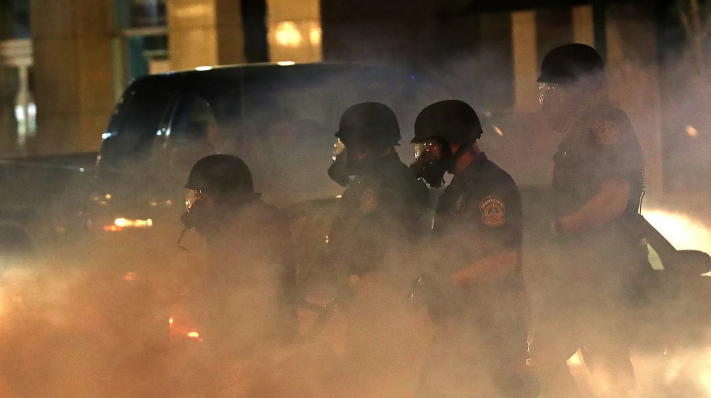

APPENDIX a – CIVIL UNREST checklists
CIVIL UNREST – PLANNING
EMERGENCY MANAGEMENT / INCIDENT COMMANDER
☐ | Ensure public officials are well informed regarding the potential for civil unrest.
☐ | Confer with local, state, and federal law enforcement to monitor the potential for civil unrest or disturbance.
☐ | Estimate needs for auxiliary forces.
☐ | Ensure the appropriate information network is in place to inform officials of potential civil unrest prior to an occurrence.
☐ | Coordinate with local broadcast media to ensure timely and accurate Emergency Alert System activation, if such an activation becomes necessary.
☐ | Negotiate mutual aid agreements. Obtain agreements with those jurisdictions, including reimbursement costs, if any.
☐ | Prepare to assist law enforcement with support resources.
☐ | Maintain resource listings.
☐ | Conduct hazard analysis of vital facilities and the impact of a civil unrest or riot incident on one or more of those facilities.
☐ | Determine the availability of shelters and obtain shelter agreements if the Red Cross (or designated lead agency) has not obtained.
☐ | Coordinate with Red Cross, public agencies and/or the Salvation Army for shelter operations. Confer and coordinate with other jurisdictions to shelter (as appropriate) county citizens.

CIVIL UNREST – RESPONSE
EMERGENCY MANAGEMENT / INCIDENT COMMANDER
☐ | Identify immediate action or response requirements.
☐ | Immediately carry out those action requirements necessary to preserve life and or property, including the deployment of required resources.
☐ | Activate the EOC as appropriate.
☐ | Organize or establish the EOC, based on operational procedure or guidelines.
☐ | Issue alert and warning based on procedure or guideline, as warranted.
☐ | Establish communications with responding agencies.
☐ | Through communications with responding agencies determine as quickly as possible:
☐ | The location of any established command post:
- Has incident command been established? If not, establish incident command.
- Has the incident commander been appointed or assumed command? Who is it?
- Have incident communications been fully established?
- What is the two-way radio frequency being used by incident command?
☐ | Number of killed or injured.
☐ | General boundary of the affected area.
☐ | The general extent of power or other utility disruption.
☐ | Immediate needs of response forces.
☐ | If voluntary evacuations of the population have begun.
☐ | Location of any triage area.
☐ | Location of any congregate care area established or ad hoc.
☐ | Evaluate overall county situation.
☐ | Establish communications with the state.
☐ | Establish communications with and request a liaison from electric, telephone and gas utilities as appropriate.
☐ | Establish ongoing reporting from the response forces services, private agencies, and utilities.
☐ | Establish command post(s) as needed.
☐ | Coordinate with Red Cross (or designated lead agency) the opening of appropriate number of shelters in the appropriate areas, based on shelter procedure or guideline.
☐ | On order, evacuate effected areas using available response forces.
☐ | Conduct first staff briefing as soon as practical after EOC / Command post activation.
☐ | Activate or establish rumor control through the public information officer (PIO).
☐ | Establish a battle rhythm.
☐ | Brief city/county/agency/utility executives.
☐ | Provide PIO with updated information.
☐ | Provide response forces with updated information, as appropriate.
☐ | Cause public information to be released, via the public information officer (PIO) as soon as practical.
☐ | Issue action guidance as appropriate.
☐ | Establish 24/7 staffing roster for the EOC and or command post.
☐ | Develop and post any required maps or diagrams.
☐ | Activate an events log.
☐ | Ensure all appropriate forms (ICS) are being used to track personnel and resources.
☐ | Review and follow resource procurement procedure or guideline.
☐ | Inventory additional resources that may be used or called upon for use.
☐ | Activate formal resource request procedure or guideline and resource tracking.
☐ | Coordinate all resource requests being forwarded to the state.
☐ | Activate financial tracking plan coordinated by the Finance Officer.
☐ | Activate damage assessment and follow damage assessment procedure or guideline.
☐ | If incident continues, develop a 12-hour incident action plan outlining actions that must be accomplished in the next 12 hours.
☐ | Conduct a "second shift" or relieving shift briefing if you are being relieved.
☐ | Discuss with and present to your relief, the incident action plan for the next 12 hours.

CIVIL UNREST – RECOVERY
EMERGENCY MANAGEMENT / INCIDENT COMMANDER
☐ | Gather damage assessment information (public, housing, business) from damage assessment teams.
☐ | Gather information from law enforcement regarding any potential for additional or prolonged incidents.
☐ | Obtain information from Red Cross (or designated lead agency) regarding number of sheltered and support necessary for continued operation.
☐ | Obtain from Red Cross (or designated lead agency) an estimated duration period for continued shelter operations, if any.
☐ | Obtain information from utilities regarding outages, length of repair, safety, etc.
☐ | Assess citizen / community needs for individual assistance and or public assistance.
☐ | Activate local unmet needs committee if appropriate.
☐ | Gather financial information from the Finance Officer.
☐ | As appropriate gather additional information to include:
 | - Personnel that responded and the time involved in the response.
 | - Time sheets or time logs.
 | - Supplies used.
 | - Contracts issued.
 | - Purchase orders issued.
 | - Any other expenditures.
 | - Damages to public buildings, equipment, utilities, etc.
 | - Loss of life or injury of any responder.
 | - Documents regarding economic impact.
☐ | Develop or generate reports for the following, as appropriate:
 | - FEMA
 | - State
 | - Local elected officials
 | - County/City /Town Managers
 | - Others requiring or requesting reports
☐ | Coordinate recovery organizations including federal and state agencies and private or volunteer relief organizations.
☐ | Establish donations management based on policy and procedure or guideline.
☐ | Local civil unrest issues are unlikely to lead to a Presidential declaration of disaster, however, if a Presidential declaration of disaster is made, file "Request for Public Assistance" to apply for assistance as soon as possible with the proper state or federal agency.
☐ | Ensure public officials are made aware of the assistance application process, if applicable.
☐ | Ensure the public is made aware, through the public information officer, of the assistance application process, if applicable.
☐ | Perform a planning and incident critique as soon as possible with all response organizations.
☐ | Review agency and self-performance.
☐ | Implement hazard mitigation or modify hazard mitigation plan accordingly.
☐ | Brief elected officials with updated information and disaster recovery progress.
[INSERT NAME OF]
FIRE AND EMS
RECONNAISSANCE & INFORMATION GATHERING
Fact Gathering | - Use of technology, stationary cameras, various forms of social media, and other methods are essential to the information gathering process of fire and EMS departments.  - Fact gathering occurs daily via information gleaned from common sources such as field resources, the Chain of Command, and other public safety communications.  - When necessary, the Command Staff will convene a meeting based on time sensitive information gathered from credible resources in the field, media, or other sources.
Assessment | - Any relevant information will be shared to ensure all public safety agencies within the region are informed.  - The ongoing assessment will be conducted by the Incident Commander, Area Commander, or Unified Commander.  - The assessment will be filtered via three coordinating services:  - The Area Commander  - The Agency Representative of assisting agencies.  - Media relations with a single point of contact established and scheduled media briefings.
Information Sharing | - Fact gathering, assessment, and information sharing will be completed.  - Any relevant information will be shared to ensure all public safety agencies within the region are informed.  - Fact gathering occurs daily via information gleaned from common sources such as field resources, the Chain of Command, and other public safety communications.
personnel preparation  personnel preparation (continued) | - Review civil unrest-speciﬁc organizational and jurisdictional protocols and guidelines.  - Wear civilian clothes when reporting to and returning from duty.  - Establish a family communication plan to share information with responder families.  - Provide emotional support for personnel and their families.  - Work in pairs or teams.  - Carry a radio and lights.  - Secure items such as scissors and stethoscopes on your person.  - Remove badges from uniforms and consider wearing casual uniforms.  - Keep personnel IDs, keys, wallet, etc., on your person or otherwise secured.  - Minimize carried equipment, such as harnesses, extra tools, pocket contents, etc.
INCIDENT RESPONSE | - If issued by department, wear ballistic protection in accordance with National Fire Protection Association (NFPA) 3000, Standard for an Active Shooter/Hostile Event Response (ASHER) Program.  - Per NFPA 1500, Standard on Fire Department Occupational Safety, Health, and Wellness Program, ﬁre and EMS personnel should not be used for crowd control operations.  - Minimize injuries to all affected citizens and protect property within the context of safety of Fire, EMS, and Law Enforcement personnel.  - Always carry a radio (be sure to regularly charge/swap batteries).  - Chief and company oﬃcers shall maintain accountability of apparatus and staﬀ.  - Develop communications code words for secure communications of emergency actions (building or area evacuation, apparatus/station abandonment, etc.).  - Develop rally points should apparatus or stations need to be abandoned and pass on to members. These may change due to situational changes.
Initial Stabilization | - A shell of Department resources will be assigned to the event to ensure critical needs are served.
Ongoing Information Gathering/ Assessment/ Sharing | - Department will gather and share information through Planning Section.  - In the unified command structure, any information gathered will be shared with other members of the unified command.  - As the information assessments continue to be approved, relevant information will be pushed out to the agencies and facilities affected by the information.
ASSESS TRANSITION TO RECOVERY / DEMOBILIZATION | - Based on the effect of the incident, the property or area will be returned to the jurisdiction authority (i.e., private property, streets, or national park).
INITIAL RECOVERY OPERATIONS | - Recovery centers will ensure that the impact area is clear of any fires, releases of hazardous materials, or imminent threat to life and property are accounted for
INFORMATION GATHERING AND ASSESSMENT SHARING | - Information gathering and damage assessment activities will be conducted to ensure accurate data is provided to the finance elements.  - Information sharing is conducted through digital reporting methods.
DEMOBILIZATION OF AGENCY RESOURCES | - The event will be demobilized in a clear and coordinated method similar to the mobilization process.
DEPARTMENT COMMAND AND CONTROL | - Command and Control remains with the Department throughout event.  - When an Area Command is established, the function of Command and Control of a dedicated set of resources will be performed at the Area Command Post until the event is demobilized.
DOCUMENTATION AND RECORD KEEPING | - The record keeping of civil disturbance incidents will be maintained at the Fire and EMS Department and a copy given to the incident Planning Section Chief.  - Audio recording of responses are archived within the dispatch center.  - At the conclusion of non-medical incidents, field resources complete a National Fire Incidents Report System report as a record keeping function.
TIME KEEPING | - Accurate digital documentation of response time and chronology of incidents is maintained for each incident. In addition, hard copy handwritten entries will be completed for each incident at the field level.  - At the conclusion of the incident, a historian becomes the documentarian and custodian of the incident.
FINANCIAL REPORTING | - In the event an incident is designated as a State and/or Federal emergency or disaster, the Department will collect and provide the County Administrator with the financial documentation needed for submission as part of the County’s FEMA public assistance reimbursement application process.

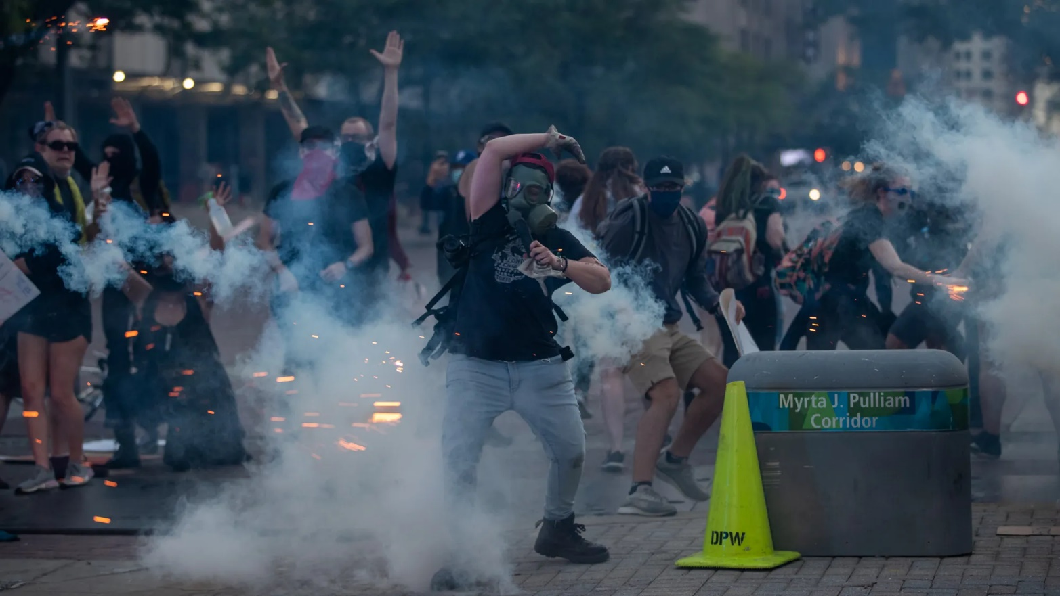

[INSERT NAME OF COUNTY]
EMERGENCY MANAGEMENT AGENCY (EMA)
RECONNAISSANCE & INFORMATION GATHERING
Fact Gathering | - EMA will monitor law enforcement communications.  - Monitor fire and EMS communications.  - Monitoring incoming intelligence bulletins from various sources.
assessment | - EMA will work with other departments to determine the scope of the incident and its impact on County functions, facilities, and residents.
INCIDENT RESPONSE | - EMA will activate the EOC to the appropriate level, as needed.
INFORMATION SHARING | - Information will be shared appropriately through EMA bulletins and conference calls.  - EMA will facilitate information sharing between departments.  - Direct staff in collecting and consolidating ongoing reconnaissance information from field units, the ICP, and other available information sources.
ASSESS TRANSITION TO RECOVERY / DEMOBILIZATION | - EMA will determine if County departments are needed or may be needed for the recovery process.  - Determine key incident thresholds that will affect the Department’s ability to begin demobilization and shift focus to recovery efforts.
INITIAL RECOVERY OPERATIONS | - Key objectives of short-term recovery are to restore homes, jobs, services, and facilities both quickly and efficiently.  - EMA will implement the Recovery Plan.
SITUATIONAL AWARENESS AND SHARING UPDATES | - EMA will continuously improve situational awareness by evaluating and disseminating updated information from field operations and relevant stakeholders
DEMOBILIZATION OF AGENCY RESOURCES | - EMA will evaluate long-term recovery needs and facilitate resource coordination between stakeholders
DEPARTMENT COMMAND AND CONTROL | - EMA will notify relevant stakeholders, including the Mayor, council members, and the SEOC.  - EMA will continue to monitor, as needed.
DOCUMENTATION AND RECORD KEEPING | - When the EOC is activated, or EMA personnel are assigned to a command post, all EMA personnel are required to complete an ICS-214 form.
TIME KEEPING | - The ICS-214 forms are collected by the EOC Planning Section Chief.  - The time spent on an incident is recorded on electronic time sheets as a separate line item.  - The EMA or EOC Finance Section Chief can then calculate and record the total hours and dollars spent on the incident.
FINANCIAL REPORTING | - The EMA or EOC Finance Section Chief is responsible for tracking disaster related response costs incurred by the Department.  - In the event an incident is designated as a State and/or Federal emergency or disaster, the EMA will provide the financial documentation needed for submission as part of the County’s FEMA public assistance reimbursement application process.

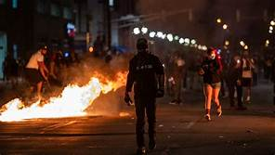

APPENDIX B – PUBLIC SAFETY RESOURCES

public safety resources based on community lifelines
[THE FOLLOWING TABLES PROVIDE OPTIONAL PLANNING SPACE FOR SUPPORTING AGENCIES AND RESOURCES BASED ON THE 7 COMMUNITY LIFELINES SECTORS AND THEIR SUB-COMPONENTS – NOT ALL OF THESE MAY BE APPLCABLE TO THIS PLAN OR YOUR JURISDICTION. REMOVE CATEGORIES BELOW, AS NECESSARY.]
During a civil disturbance, [Insert Name of Lead Agency] is the lead agency. However, other county entities play a role in supporting law enforcement efforts by accomplishing a wide range of tasks at various points of the incident to bring order to the area of concern.
Individual departmental resources will be coordinated through their respective agencies. Overall coordination of County departments and agencies will be done through the County EOC. If the EOC is activated, the primary agency will provide updates to the EOC Manager.

Safety and Security

Law enforcement and government services, as well as the associated assets that maintain communal security, provide search and rescue and firefighting capabilities, and support public safety. Includes impending risks to impacted communities, public infrastructure, and national security concerns.

Stabilization Target: Threats to life safety are no longer a concern for all response personnel and impacted communities. Government essential functions, including executive leadership, are operational. Sufficient search and rescue assets are on-scene to assist all citizens. Sufficient fire resources are available to support fire suppression efforts.

LAW ENFORCEMENT/SECURITY
[INSERT NAME OF PRIMARY AGENCY]
[Insert supporting law enforcement agencies/organizations]

Agency/Organization | Resource | Activation Trigger | Point of Contact | Deployment Timeframe

FIRE SERVICES
[INSERT NAME OF PRIMARY AGENCY]
[Insert supporting agencies/organizations]

Agency/Organization | Resource | Activation Trigger | Point of Contact | Deployment Timeframe

SEARCH AND RESCUE
[INSERT NAME OF PRIMARY AGENCY]
[Insert supporting agencies/organizations]

Agency/Organization | Resource | Activation Trigger | Point of Contact | Deployment Timeframe

GOVERNMENT SERVICES
[INSERT NAME OF PRIMARY AGENCY]
[Insert supporting agencies/organizations]

Agency/Organization | Resource | Activation Trigger | Point of Contact | Deployment Timeframe

COMMUNITY SAFETY
[INSERT NAME OF PRIMARY AGENCY]
[Insert supporting agencies/organizations]

Agency/Organization | Resource | Activation Trigger | Point of Contact | Deployment Timeframe

fOOD, wATER, shELTER

Support systems that enable the sustainment of human life, such as food retail and distribution networks, water treatment, transmission and distribution systems, housing, and agriculture resources.

Stabilization Target: All citizens, their pets, and service animals have access to food, water, and sanitation. Sheltering (including reception, capacity, and wrap-around services) is supporting the displaced population. Sufficient resources are in place to sustain agricultural requirements.

FOOD
[INSERT NAME OF PRIMARY AGENCY]
[Insert supporting agencies/organizations]

Agency/Organization | Resource | Activation Trigger | Point of Contact | Deployment Timeframe

WATER
[INSERT NAME OF PRIMARY AGENCY]
[Insert supporting agencies/organizations]

Agency/Organization | Resource | Activation Trigger | Point of Contact | Deployment Timeframe

SHELTER
[INSERT NAME OF PRIMARY AGENCY]
[Insert supporting agencies/organizations]

Agency/Organization | Resource | Activation Trigger | Point of Contact | Deployment Timeframe

AGRICULTURE
[INSERT NAME OF PRIMARY AGENCY]
[Insert supporting agencies/organizations]

Agency/Organization | Resource | Activation Trigger | Point of Contact | Deployment Timeframe

HEALTH AND MEDICAL

Infrastructure and service providers for medical care, public health, patient movement, fatality management, behavioral health, veterinary support, and the medical industry.

Stabilization Target: All citizens, their pets, and service animals have access to required medical and veterinary care. Emergency medical systems are capable of managing patient movement requirement. Public health services are accessible to all citizens. Medical supply chain capable of adequately resupplying medical care providers.

MEDICAL CARE
[INSERT NAME OF PRIMARY AGENCY]
[Insert supporting agencies/organizations]

Agency/Organization | Resource | Activation Trigger | Point of Contact | Deployment Timeframe

PUBLIC HEALTH
[INSERT NAME OF PRIMARY AGENCY]
[Insert supporting agencies/organizations]

Agency/Organization | Resource | Activation Trigger | Point of Contact | Deployment Timeframe

PATIENT MOVEMENT
[INSERT NAME OF PRIMARY AGENCY]
[Insert supporting agencies/organizations]

Agency/Organization | Resource | Activation Trigger | Point of Contact | Deployment Timeframe

MEDICAL SUPPLY CHAIN
[INSERT NAME OF PRIMARY AGENCY]
[Insert supporting agencies/organizations]

Agency/Organization | Resource | Activation Trigger | Point of Contact | Deployment Timeframe

FATALITY MANAGEMENT
[INSERT NAME OF PRIMARY AGENCY]
[Insert supporting agencies/organizations]

Agency/Organization | Resource | Activation Trigger | Point of Contact | Deployment Timeframe

ENERGY (POWER & FUEL)

Electricity service providers and generation, transmission, and distribution infrastructure, as well as gas and liquid fuel processing, and delivery systems.

Stabilization Target: Generators are providing temporary emergency power at critical facilities necessary to stabilize other lifelines. Fuel distribution is available for responders. Sufficient fuel distribution is available for citizens, including to support individuals dependent on power for life-sustaining medical care.

POWER GRID
[INSERT NAME OF PRIMARY AGENCY]
[Insert supporting agencies/organizations]

Agency/Organization | Resource | Activation Trigger | Point of Contact | Deployment Timeframe

FUEL
[INSERT NAME OF PRIMARY AGENCY]
[Insert supporting agencies/organizations]

Agency/Organization | Resource | Activation Trigger | Point of Contact | Deployment Timeframe

COMMUNICATIONS

Infrastructure owners and operators of broadband internet, cellular and landline telephone networks, cable services, satellite communications services, and broadcast networks (radio/television). These systems encompass diverse modes of delivery, often intertwined but largely operating independently. Services include alerts, warnings, and messages, 911 and dispatch, and access to financial services.

Stabilization Target: Citizens have access to commercial communications infrastructure to contact or be contacted by emergency services. Land mobile radio communications network is operational. Public safety answering points are available to the public. Citizens have multiple methods to receive alerts, warnings, and messages, direct access to 911 and dispatch, and have access to financial services.

INFRASTRUCTURE
[INSERT NAME OF PRIMARY AGENCY]
[Insert supporting agencies/organizations]

Agency/Organization | Resource | Activation Trigger | Point of Contact | Deployment Timeframe

RESPONDER COMMUNICATIONS
[INSERT NAME OF PRIMARY AGENCY]
[Insert supporting agencies/organizations]

Agency/Organization | Resource | Activation Trigger | Point of Contact | Deployment Timeframe

ALERTS, WARNINGS, AND MESSAGES
[INSERT NAME OF PRIMARY AGENCY]
[Insert supporting agencies/organizations]

Agency/Organization | Resource | Activation Trigger | Point of Contact | Deployment Timeframe

FINANCE
[INSERT NAME OF PRIMARY AGENCY]
[Insert supporting agencies/organizations]

Agency/Organization | Resource | Activation Trigger | Point of Contact | Deployment Timeframe

911 AND DISPATCH
[INSERT NAME OF PRIMARY AGENCY]
[Insert supporting agencies/organizations]

Agency/Organization | Resource | Activation Trigger | Point of Contact | Deployment Timeframe

TRANSPORTATION

Multiple modes of transportation that often serve complementary functions and create redundancy, adding to the resilience in overall transportation networks. This includes roadway, mass transit, railway, aviation, maritime, and intermodal systems.

Stabilization Target: Primary and emergency routes (air, rail, road, port) are clear of debris and accessible by normal or alternate means.

HIGHWAY, ROADWAY, MOTOR VEHICLE
[INSERT NAME OF PRIMARY AGENCY]
[Insert supporting agencies/organizations]

Agency/Organization | Resource | Activation Trigger | Point of Contact | Deployment Timeframe

MASS TRANSIT
[INSERT NAME OF PRIMARY AGENCY]
[Insert supporting agencies/organizations]

Agency/Organization | Resource | Activation Trigger | Point of Contact | Deployment Timeframe

RAILWAY
[INSERT NAME OF PRIMARY AGENCY]
[Insert supporting agencies/organizations]

Agency/Organization | Resource | Activation Trigger | Point of Contact | Deployment Timeframe

AVIATION
[INSERT NAME OF PRIMARY AGENCY]
[Insert supporting agencies/organizations]

Agency/Organization | Resource | Activation Trigger | Point of Contact | Deployment Timeframe

MARITIME
[INSERT NAME OF PRIMARY AGENCY]
[Insert supporting agencies/organizations]

Agency/Organization | Resource | Activation Trigger | Point of Contact | Deployment Timeframe

HAZARDOUS MATERIALS

Systems that mitigate threats to public health or the environment. This includes facilities that generate or store hazardous substances, as well as all specialized conveyance assets and capabilities to identify, contain, and remove pollution, contaminants, oil, or other hazardous materials and substances.

Stabilization Target: All contaminated areas are identified and secure. Pollutants, contaminants, and other hazardous materials and substances are removed.

FACILITIES
[INSERT NAME OF PRIMARY AGENCY]
[Insert supporting agencies/organizations]

Agency/Organization | Resource | Activation Trigger | Point of Contact | Deployment Timeframe

HAZMAT, POLLUTANTS, CONTAMINANTS
[INSERT NAME OF PRIMARY AGENCY]
[Insert supporting agencies/organizations]

Agency/Organization | Resource | Activation Trigger | Point of Contact | Deployment Timeframe

APPENDIX C – REFERENCES

[ADD, REMOVE, OR CHANGE TO COUNTY DETAILS OR PROTOCOLS]
- U.S. Fire Administration (USFA) – Civil Unrest Response: Operations
- ADRP 1-02. Terms and Military Symbols. 24 September 2013.
- JP 1-02. Department of Defense Dictionary of Military and Associated Terms. 8 November 2010.
- ADP 3-28. Defense Support of Civil Authorities. 26 July 2012.
- ADRP 3-28. Defense Support of Civil Authorities. 14 June 2013. ADRP 5-0. The Operations Process. 17 May 2012.
- FM 2-01.3. Intelligence Preparation of the Battlefield/Battlespace. 15 October 2009.
- FM 3-06. Urban Operations. 26 October 2006.
- FM 5-19. Composite Risk Management. 21 August 2006.JP 3-28. Defense Support to Civil Support. 31 July 2013.
- 32 CFR, Part 215. Employment of Military Resources in the Event of Civil Disturbances.
- DODD 3025.18. Defense Support of Civil Authorities (DCSA). 29 December 2010.
- DODD 5200.27. Acquisition of Information Concerning Persons and Organizations not Affiliated with the Department of Defense. 7 January 1980.
- DODI 3025.21. Defense Support of Civilian Law Enforcement. 27 February 2013.
- Executive Order 12333. United States Intelligence Activities. 4 December 1981.
- 10 USC, Subtitle A, Part I, Chapter 15, Section 331. Federal Aid for State Governments.
- 10 USC, Subtitle A, Part I, Chapter 15, Section 332. Use of Militia and Armed Forces to Enforce Federal Authority.
- 10 USC, Subtitle A, Part I, Chapter 15, Section 333. Interference with State and Federal Law.
- 10 USC, Subtitle A, Part I, Chapter 15, Section 334. Proclamation to Disperse.
- 18 USC, Part I, Chapter 67, Section 1385. Use of Army and Air Force as a Posse Comitatus.
- FM 3-13. Inform and Influence Activities. 25 January 2013.
- 10 USC, Chapter 18. Military Support for Civilian Law Enforcement Agencies.

APPENDIX D – ACRONYMS

[ADD, REMOVE, OR CHANGE TO COUNTY DETAILS OR PROTOCOLS]
ACRONYMS | FULL DESCRIPTION
ADA | Americans With Disabilities Act
CFR | Code of Federal Regulation
CONOPS | Concept of Operations
DHS | Department of Homeland Security
DSCA | Defense Support of Civil Authorities
EMA | Emergency Management Agency
EMAC | Emergency Management Assistance Compact
EMS | Emergency Medical Services
EOC | Emergency Operations Center
EOP | Emergency Operations Plan
FBI | Federal Bureau of Investigation
FEMA | Federal Emergency Management Agency
IAP | Incident Action Plan
ICP | Incident Command Post
ICS | Incident Command System
IMT | Incident Management Team
INNG | Indiana National Guard
ISP | Indiana State Police
LEA | Law Enforcement Agency
MOA | Memorandum of Agreement
MOU | Memorandum of Understanding
NIMS | National Incident Management System
PIO | Public Information Officer
PPE | Personal Protective Equipment
SEOC | State Emergency Operations Center
SOP | Standard Operating Procedure
USC | United States Code
VOAD | Voluntary Organization(s) Active in Disasters

APPENDIX E – DEFINITIONS

[ADD, REMOVE, OR CHANGE TO COUNTY DETAILS OR PROTOCOLS]
TERM | DEFINITION
Anarchist | A person who uses unlawful, violent means to cause disorder or upheaval.
Ballistic Protective Equipment (BPE) | Ballistic Vests, Ballistic Helmets and eyewear designed to help absorb the impact and reduce or prohibit penetration from projectile and blunt force objects.
Civil Disobedience | An unlawful, planned, or spontaneous demonstration by a group of people.
Civil Disorder | An unlawful event involving significant disruption of the public order.
Civil Unrest | Violent public disturbance of the peace by three or more individuals. Incidents of civil unrest often occur when groups or individuals whose sole purpose is to create shock or simply challenge the police to get the desired publicity for their cause.
Cold Zone | An area of little to no threat of civil unrest or violence. Law enforcement support is optional for entry into the Cold Zone.
Curfew | A curfew is a specific time of day at which, by rule, you must be at home.
Demonstration | A public display of feeling toward a person or cause.
Disorderly Conduct | Per IC 35-45-1-3, “Disorderly conduct” is defined as:  (a) A person who recklessly, knowingly, or intentionally: (1) engages in fighting or in tumultuous conduct; (2) makes unreasonable noise and continues to do so after being asked to stop; or (3) disrupts a lawful assembly of persons; commits disorderly conduct, a Class B misdemeanor.  (b) The offense described in subsection (a) is a Level 6 felony if it: (1) adversely affects airport security; and (2) is committed in an airport (as defined in IC 8-21-1-1) or on the premises of an airport, including in a parking area, a maintenance bay, or an aircraft hangar.  (c) The offense described in subsection (a) is a Level 6 felony if it: (1) is committed within five hundred (500) feet of: (A) the location where a burial is being performed; (B) a funeral procession, if the person described in subsection (a) knows that the funeral procession is taking place; or (C) a building.
Flash Mob | A group of people organized using social media to coordinate meeting at a specific location, at a specific time for entertainment, satire, or potential criminal activity.
Hazard Identification and Risk Assessment (HIRA) | The HIRA is an assessment that identifies hazards and threats that have historically caused, or possess the potential to cause, incidents that can overwhelm emergency response capabilities within the State of Indiana.
Hot Zone | An area considered unsafe. Law enforcement support is required for force protection in the Hot Zone.
Lawful Assembly | Free speech and assemblies protected by the First Amendment such as: speeches, marches, demonstrations, rallies, picketing, public assemblies, protests, and celebratory events.
Noticed Events | Public assemblies, demonstrations, or crowd events, which are planned for in advance and allows for prior notice, whether direct or indirect, to law enforcement.
Public Demonstration | A demonstration is an action by a mass group or collection of groups of people in favor of a political or other cause or people partaking in a protest for or against a cause of concern. A demonstration often consists of walking in a mass march formation and either beginning with or meeting at a designated endpoint, or rally, to hear speakers.
Riot | Any use of force or violence, disturbing the public peace, or any threat to use force or violence, if accompanied by immediate power of execution, by five or more persons acting together, and without authority of law, is a riot. (IC 35-45-1-2)
Spontaneous Events | Public assemblies, demonstrations, or crowd events, which occur without prior planning and/or without prior notice to law enforcement.
Tumultuous Conduct | Conduct that results in, or is likely to result in, serious bodily injury to a person or substantial damage to property. (IC 35-45-1-1).
Unlawful Assembly | Whenever five or more persons assemble to do an unlawful act, or to do a lawful act in a violent, boisterous, or tumultuous manner, such assembly is an unlawful assembly.” “Boisterous or tumultuous manner” has been interpreted by the courts to mean conduct which poses a clear and present danger of imminent violence. (IC 35-45-1-1)
Warm Zone | An area of lower threat, but which may become unsafe. Law enforcement support is recommended for entry into the Warm Zone.

