Emergency Support Function (ESF) #15 Annex External Affairs
[INSERT NAME OF COUNTY]
Emergency Operations Plan ESF Annex {Template}
[INSERT MONTH AND YEAR]

TABLE OF CONTENTS
DISCLAIMER 3
PLANNING AGENCIES 4
PURPOSE, SCOPE, SITUATION, AND ASSUMPTIONS 5
PURPOSE 5
SCOPE 5
SITUATION 6
PLANNING ASSUMPTIONS 12
CONCEPT OF OPERATIONS 15
GENERAL CONCEPT 15
OPERATIONAL PRIORITIES DURING RESPONSE AND RECOVERY OPERATIONS 15
ACTIVATION OF COUNTY EMERGENCY OPERATIONS CENTER 15
DEMOBILIZATION OF THE EOC 17
RESOURCE SUPPORT 18
ORGANIZATION AND ASSIGNMENT OF RESPONSIBILITIES 21
PRIMARY AGENCY RESPONSIBILITIES 21
SUPPORTING AGENCY RESPONSIBILITIES 21
EMERGENCY SUPPORT FUNCTION GENERAL TASKS 26
TABLE 4. ESF #15 PREVENTION TASKS 26
TABLE 5. ESF #15 PROTECTION TASKS 27
TABLE 6. ESF #15 MITIGATION TASKS 28
TABLE 7. ESF #15 RESPONSE TASKS 29
TABLE 8. ESF #15 RECOVERY TASKS 30
LIFELINE AND ESF OBJECTIVES AND TASKS TIMELINE 31
DIRECTION, CONTROL, AND COORDINATION 38
INFORMATION COLLECTION, ANALYSIS, AND DISSEMINATION 39
COMMUNICATION 40
APPENDIX A – COMMUNITY LIFELINES 42
APPENDIX B – AUTHORITIES 48
APPENDIX C – REFERENCE LIST 49
APPENDIX D – ACRONYMS 50
APPENDIX E – DEFINITIONS 53

DISCLAIMER
This template was created by the Indiana Department of Homeland Security (IDHS) to assist Indiana County Emergency Management Agencies (EMAs) and their stakeholders in the development of their County Emergency Support Function (ESF) annex.
This template provides SAMPLE language based off the State ESF Annex, but IDHS has tailored it for a more county-specific approach. We have included charts and layout diagrams to assist county Emergency Managers with identifying and documenting their specific needs for the update of their ESF Annex. This template is constructed off the State of Indiana’s Emergency Operations Plan and ESF Annex and follows FEMA CPG 101 guidance.
This template can be scaled up or down and modified to follow each county’s unique organizational structure, activation protocol, threat and hazard assessments, and current capability and capacity gaps. This template follows all federal, state and Emergency Management Accreditation Program (EMAP) guidance.
IDHS welcomes feedback on this template. Our goal is to provide our county stakeholders with best practices and the most comprehensive product for our county EMAs and stakeholders in their planning initiatives.

REMOVE THIS PAGE PRIOR TO PUBLISHING COUNTY DOCUMENT

PLANNING AGENCIES
Within each Emergency Support Function (ESF) annex, the designation of primary, supporting, or non-governmental agencies are identified as the whole community planning committee. These determinations are based on their authorities, resources, and capabilities to the ESF. The primary agency point of contact (POC) identifies the appropriate support agencies that fall under this plan. The primary agency POC collaborates with each entity to determine whether they have the necessary resources, information, and capabilities to perform the required tasks and activities within each phase of emergency management. This includes activations in the Emergency Operations Center (EOC) and impacted areas. Though an agency may be listed as a primary agency, they do not control or manage those agencies identified as supporting agencies. The agencies listed below are members of the Whole Community Planning Committee for this annex.

Primary Agency

[INSERT NAME OF PRIMARY AGENCY]

Supporting Agencies
[Insert supporting agencies/organizations]

PURPOSE, SCOPE, SITUATION, AND ASSUMPTIONS

Purpose
The purpose of the External Affairs Emergency Support Function (ESF #15) is to support the distribution of accurate, coordinated, timely and accessible information. This information must be available to affected citizens including but not limited to media, private sector, governments, individuals with limited English proficiency and those with access and functional needs. Effective and accurate communication promotes the health, safety, and welfare of humans and animals during the response phase of an event, as well as ensures credibility and public trust.

Scope
[INSERT NAME OF COUNTY] and the EOC recognizes 15 ESFs and this annex focuses on ESF #15.
- [INSERT NAME OF PRIMARY AGENCY] is the primary point of contact for ESF #15.
- The ESF #15 External Affairs Annex is intended to be an annex to the county Emergency Operations Plan (EOP).
- A Joint Information Center Manual is a companion document to this annex and outlines how the joint information system is implemented in [INSERT NAME OF COUNTY], of which ESF #15 is a vital component.
- ESF #15 encompasses all county departments and agencies that may require incident communications and external affairs support or whose external affairs assets may be employed during incidents requiring a coordinated state response.
- ESF #15 coordinates with the incident public information officer (PIO) regarding county actions to provide the required external affairs support to local incident response entities.
- ESF #15 integrates the components of public affairs, Congressional affairs, intergovernmental affairs (local, state, tribal, and territorial coordination) and the private sector.
- ESF #15 coordinates within the EOC, as well with other incident structures that ensure the coordinated release of information under the joint information system detailed in the National Incident Management System (FEMA, 2014). These structures include the incident public information officer, incident management assistance teams and joint information centers.
The incident PIO develops all external and internal communications strategies and products for the incident. Personnel who work under the auspices of External Affairs must be familiar with the provisions of ESF #15 in the event that the ESF is activated.
During an incident, local authorities share responsibility for communicating information regarding the incident to the public. These actions are a critical component of incident management and must be fully integrated with all other operational actions to ensure the following objectives are met:
- Delivery of incident preparedness, health, response, and recovery instructions to those directly affected by the incident.
- Dissemination of incident information to the public, including children; those with disabilities and other access and functional needs; and individuals with limited English proficiency populations.
The joint information system provides a supporting mechanism to develop, coordinate and deliver messages. County department and agency communicators develop, coordinate, and delivery information and instructions to the public related to:
- State assistance to the incident-affected area.
- State departmental/agency response.
- National preparations.
- Protective measures.
- Impact on non-affected areas.

Situation
- ESF #15 may be needed in any of the five phases of emergency management (prevention, protection, mitigation, response, and recovery). In the event that [INSERT NAME OF COUNTY] determines the need for ESF #15, [INSERT NAME OF PRIMARY AGENCY] will act as the primary agency to assist with implementation.
- ESF #15 will be responsible for implementing internal Standard Operating Procedures (SOPs) and/or Standard Operating Guidelines (SOGs) to ensure adequate staffing and administrative support for both field operations and coordination efforts in the EOC.
- ESF #15 personnel will coordinate with the incident PIO and JIC to initiate and manage the activation of public information assets to fulfill specific mission assignments that support emergency management.
- Effective response, as well as ongoing support efforts, will be contingent upon the availability of resources and the extent/impact of the incident upon the county.

Hazard and Threat Assessments
There are several plans and preparedness assessments the county uses to identify and evaluate local threats, hazards, risks, capabilities, and gaps. The National Preparedness Goal (NPG) has identified 32 core capabilities tied to the 5 Mission Areas of Protection, Prevention, Mitigation, Response, and Recovery. Table 1 provides a detailed list of each of the capabilities based on five mission areas. The highlighted capabilities are associated with this annex.

Mission Areas and Core Capabilities

Table 1. ESF #15 Mission Areas and Core Capabilities
PREVENTION | PROTECTION | MITIGATION | RESPONSE | RECOVERY
Planning
Public Information and Warning
Operational Coordination
Intelligence and Information Sharing |  | Community Resilience | Infrastructure Systems
Interdiction and Disruption |  | Long-Term Vulnerability Reduction | Critical Transportation | Economic Recovery
Screening, Search and Detection |  | Risk & Disaster Resilience Assessment | Environmental Response/Health and Safety | Health and Social Services
Forensics and Attribution | Access Control and Identify Verification | Threats and Hazards Identification | Fatality Management Services | Housing
 | Cybersecurity |  | Fire Management and Suppression | Natural and Cultural Resources
 | Risk Management for Protection Programs and Activities |  | Logistics and Supply Chain Management
 | Supply Chain Integrity & Security |  | Mass Care Services
 | Physical Protective |  | Mass Search and Rescue Operations
 |  |  | On-Scene Security, Protection, & Law Enforcement
 |  |  | Operational Communications
 |  |  | Public Health, Healthcare, and Emergency Services
 |  |  | Situational Assessment

Capability Assessment - Core Capabilities
The following table lists the response core capability actions that ESF #15 most directly supports.

Table 2. ESF #15 Core Capability Actions
CORE CAPABILITY | ESF #15 – EXTERNAL AFFAIRS | INCIDENT PIO
Public Information and Warning | External Affairs  - Gathers information from all EOC ESFs and provides to the incident PIO to allow for dissemination.  Public Affairs  - Gathers information on the incident.  - Monitors news coverage to ensure that accurate information is disseminated.  - Provides basic services, such as communications and supplies, to assist the news media in disseminating information to the public.  - Assists in the development of written materials for presentations and making congressional notifications.  Intergovernmental Affairs  - Promotes interaction and implements information sharing with local governments.  - Informs local elected and appointed officials on response efforts and recovery programs.  - Disseminates information with the assistance of state municipal leagues, county associations and tribal governments.  - Promotes interaction with tribal governments on all aspects of incident response operations.  - Ensures inclusion of tribes in all aspects of incidents requiring a coordinated Federal response that affect tribes and incident response operations.  Joint Information Center (JIC)  Participates in and supports incident information, public affairs activities, and media access to information regarding the latest developments.  Private Sector  - Coordinates between the incident PIO/JIC and ESF #14 regarding information needed for the private sector. | External Affairs  - Provides accurate, coordinated, and timely information to affected audiences during incidents requiring a coordinated Federal response.  - Provides communications support and advice to the leaders during an incident.  - Conducts communications planning.  Public Affairs  - Coordinates messages with local governments from a Joint Information Center (NJIC).  - Provides incident-related information through the media and other sources in accessible formats and multiple languages to individuals, households, businesses, and industries directly or indirectly affected by the incident, including those with disabilities and others with access and functional needs.  - Disseminates incident information to news media (i.e., official websites, social networking platforms) to ensure wide delivery of life-saving information.  - Maximizes the use of video and digital imagery to communicate during incidents.  - Handles appropriate special projects, such as news conferences and press operations, for incident area tours by government officials and dignitaries.  - Oversees media relations.  - Ensures effective communication of incident information to individuals with disabilities and others with access and functional needs using appropriate auxiliary aids and services, such as sign language and other interpreters; captioning of audio and visual materials; and accessible website communications.  Joint Information Center (JIC)  Serves as a central point for coordination of incident information, public affairs activities, and media access to information regarding the latest developments.  - Incident JIC: Is the physical location where all public affairs professionals involved in the response work together to provide critical emergency information, media response and public affairs functions.  - Virtual JIC: Is the technological means (i.e., secure or non-secure) that link all participants when geographical restrictions, incident management requirements and other limitations preclude physical attendance by public affairs leadership at a central location.  - Satellite JIC: Is a forward-deployed component of an incident JIC.  - Area JIC: Are multiple JICs that may be used when there are multiple Joint Field Offices (JFOs) to support the area command Unified Coordination structure and whenever multiple JICs are operating in support of the same or related incidents and jurisdictions.  Plans and Products  - Educates the public in the aftermath of an incident requiring a coordinated Federal response through news advisories, press releases, prepared materials, fliers and talking points.  - Develops new media products for dissemination, such as blog posts, messages for social media, update messages, video, and digital imagery.  Private Sector  - Provides strategic counsel and guidance to response leadership in actual or potential incidents.  - Conducts outreach and education.  - Promotes operational integration with the impacted private sector entity to support local economic response and recovery.  - Supports situational awareness by engaging the private sector in information sharing efforts.
Planning | - Conduct a systematic process engaging the whole community, as appropriate, in the development of executable strategic, operational and/or community-based approaches to meet defined objectives.
Operational Coordination | - Assist the incident PIO to establish and maintain a unified and coordinated operational structure and process that appropriately integrates all critical stakeholders and supports the execution of core capabilities. | - Establish and maintain a unified and coordinated operational structure and process that appropriately integrates all critical stakeholders and supports the execution of core capabilities

Planning Assumptions

[ADD, REMOVE, OR CHANGE TO COUNTY DETAILS OR PROTOCOLS]
- There will be a strong need for the general public to get disaster assistance information. The timely dissemination of accurate, accessible, well-coordinated emergency public information will reduce the impact to life and property as well as help to maintain public trust and confidence.
- The Public Information Officer (PIO) understands the relevant plans and procedures specific to the emergency public information function.
- Communication methods and systems relied upon to notify/inform the public are operational and tested on a regular basis.
- Effective communication methods to assist with notifying and disseminating information to the general public have been established. These communication methods include TV, radio, and print media, the Integrated Public Alert and Warning System (IPAWS) which includes the Emergency Alert System (EAS) and Wireless Emergency Alerts (WEAs), The State of Indiana website and social media accounts, Indiana 2-1-1 and other alert and notification tools. [ADD, REMOVE, OR CHANGE TO COUNTY DETAILS OR PROTOCOLS]
- Many disasters or emergencies occur rapidly, hampering the ability of response organizations, local, and state government to provide comprehensive information to everyone impacted at the onset.
- A disaster or emergency may create a significant demand for information from a wide variety of sources which may exceed capabilities. Some situations may require the provision of enhanced or supplemental public information resources.
- The interest generated by a disaster or emergency may lead to requests for information or visits from a variety of public officials, dignitaries, or VIPs. Such requests will require coordination and resources.
- A disaster or emergency may impact individuals’ ability to receive public information due to displacement, or limited access to television, phone, newspaper, the internet, social networks, etc.
- Some individuals depend on visual methods of communication to receive emergency messages.
- Regarding personal preparedness and protective action, some individuals will require advanced warning and/or emergency directives.
- Some individuals may require information through different methods and may need more time to process emergency messages before they decide to take protective action.
- Audience factors (i.e., personal perception, language, cultural beliefs, age, etc.) will impact what an individual hears, how they will interpret the emergency information, and how they will act on that emergency information.
- Public information efforts will rely heavily upon the cooperation of commercial media organizations.
- Extensive destruction of media communications facilities and loss of electrical power may severely disrupt the normal flow and dissemination of information in the disaster area.
- In the aftermath of a disaster, information is often erroneous, outdated, vague, difficult to confirm, and contradictory.
- Rumors or misinformation may be spread before, during, and after a disaster. This can cause unnecessary distress among the public, provoke counter-productive public actions, and impede response and recovery efforts.

CONCEPT OF OPERATIONS

General Concept
The role of [INSERT NAME OF COUNTY] during emergency response is to supplement local efforts before, during, and after a disaster or emergency. If the county anticipates that its needs may exceed its resources, the EMA Director can request assistance from other counties through mutual aid agreements and/or from the state government.
ESF #15 shall coordinate with the incident PIO, incident management teams and the other stakeholders within the joint information system to deploy public information resources to areas potentially impacted by emergencies or disasters. Assets and functions should be prioritized to manage and support the immediate and long-term needs of state and local jurisdictions.
The incident PIO shall activate; deploy and organize personnel and resources based upon:
- Pre-established policies, procedures, and practices
- Integration into the overall Emergency Operations Plan (EOP)/CEMP
- The level of support required by other county and local ESFs
ESF #15 shall ensure and promote a common operating picture (COP) through communicating with all ESFs, the EOC Operations Section and the incident public information officer, as well as the joint information center, if applicable.

Operational Priorities During Response and Recovery Operations
- Life, safety, and health (highest priority)
- Incident stabilization
- Protection of property, economy, and the environment
- Restoration of essential infrastructure, utilities, functions, and services
- Unity of effort and coordination among appropriate stakeholders

activation of county emergency operations center
The Emergency Operations Center (EOC) is the primary hub for [INSERT NAME OF COUNTY]’s emergency support and coordination efforts to gather and disseminate event information, respond to requests for assistance from counties and local departments, identify and coordinate priority actions, and allocate resources.
The activation of the EOC begins with the activation of the Emergency Operations Plan (EOP) Base Plan and, if directed, this annex. The activation of the EOP establishes the emergency operations framework and structure needed to deliver a coordinated emergency response.
In most cases, the decision to activate will be made by the Chairman of the Board of Commissioners (their successor), the [Insert County EM Agency Name] Director or their deputies. The following are considerations for activating the EOC:
- An incident has occurred that has the potential for rapid escalation.
- The emergency will be of a long duration and requires sustained coordination.
- Major policy decisions may be required.
- The volume of county requests for assistance is increasing and expected to continue.
- Pre-deployment of state or local assets is occurring in anticipation of the emergency.
- Managing the situation requires urgent, high-level, non-routine coordination among multiple jurisdictions, county departments, or other external agencies.
- [INSERT NAME OF COUNTY] shall communicate and collaborate with other response/support agencies and integrate their response plans into the overall response.
- Activation of the EOC will be advantageous to the successful management of the event.
The EOC is managed by the EMA Director and is the physical location where multi-agency coordination occurs whether it is at the primary or alternate undisclosed sites. The EOC can be configured to expand or contract as necessary to respond to the different levels of incidents requiring county assistance. The EOC has designated four activation levels as outlined in Table 3. Each elevated level assumes the requirements and conditions of the previous, lower activation level.
During an EOC activation, ESFs may be activated depending on the incident and activation level. During a disaster response, each county ESF representative in the EOC will remain under the administrative control of his/her agency head; however, he/she will function under the supervision of the EOC Manager. Notification of activation will be made via phone, email, and/or text message.

table 3. COUNTY EOC RESPONSE ACTIVATION LEVELS
LEVEL  NUMBER | NAME OF LEVEL | DESCRIPTION
IV | Daily Ops | Normal daily operations. Monitoring special events and weather alerts.
III | Active Emergency | A situation has or may occur which requires an increase in activation of the EOC, to include EOC Section Chiefs.
II | Significant Emergency | An incident that is likely to require the activation of mutual-aid agreements. Section Chiefs, Advisory Council or Policy Group are activated and all ESF agencies are alerted or required to report to the EOC.
I | Full Emergency | An incident that will likely require state and/or federal assistance

Demobilization of the EOC
Demobilization is the process by which facilities scale back their emergency operations as the objectives set by leadership are achieved. This usually entails the release of the ESF representation involved in response operations as objectives are accomplished and the need for their participation diminishes. Part of the demobilization process ensures that all paperwork, such as personnel evaluations, equipment time records, personnel time records, accident reports, and mechanical inspections have been completed and are accurate. Demobilizing the most expensive excess equipment and resources first saves funding.

Local Coordination
At the local level, there may be a Public Information Officer (PIO) staffed within an Incident management Team (IMT) or Emergency Operations Center (EOC) during an incident.
The State PIO cannot regulate local PIO messaging because Indiana’s Home Rule. It is important to coordinate, build, and maintain a relationship between the local PIO and State PIO. Having this coordination will better ensure unified messaging.
NOTE: It is important to not confuse an Incident Management Team (IMT) and a State Incident Management Assistance Team (IMAT).
The IMT is ran and staffed at a local level. Indiana’s State IMAT is staffed at a State level and can be requested by county EMAs to augment or replace their local IMTs during disasters.

Figure 1 – Incident Command Structure
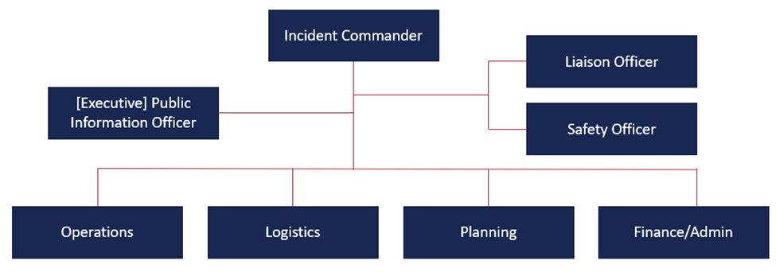
ESF #15 may coordinate with local PIOs to assist the local jurisdiction with information management. Rural jurisdictions may utilize the State JIC to provide the jurisdiction with direct PIO support.

Resource Support
During an incident, requests for resource support originate from the site Incident Command (IC), Area Command (AC), or Unified Command (UC) and are directed to the local emergency management agency (EMA). As local resource capabilities become overwhelmed, the local jurisdiction’s EMA requests support from the State EOC based on the projected needs of the local Incident Action Plan (IAP). A request exceeding State capability can be fulfilled using mutual aid, federal assistance, or other appropriate means. The State Resource Request Process as outlined in Figure 2, is designed to meet the varying needs of local jurisdictions throughout the life of an emergency event. The process may require alteration, activation of mutual-aid agreement(s), or assistance from federal agencies as needed.
State resources may also be requested by local jurisdictions for activation in exercises, testing or training. Participation in these activations allows for the continued development and improvement of public safety programs and resources.

Figure 2. State Resource Request Process
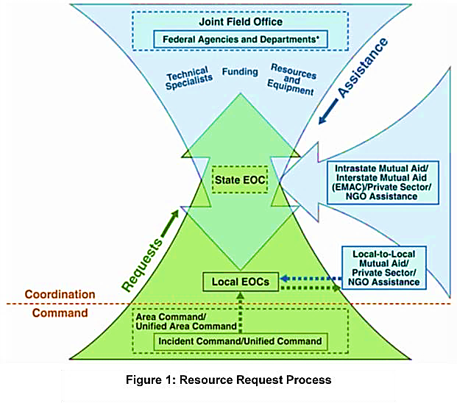

Inclusion, Access, and Functional Needs
[INSERT NAME OF COUNTY] works with public, private, and non-profit organizations to build a culture of preparedness and readiness for emergencies and disasters that goes beyond meeting the legal requisites of people with disabilities as defined by the most current version of the Americans with Disabilities Act (ADA) or for individuals with access and functional needs.
[INSERT NAME OF COUNTY] integrates the Federal Emergency Management Agency’s (FEMA)’s access and functional needs guidance, which identifies an individual’s actual needs during an emergency and awareness of not using negative labels such as “handicapped,” “crippled,” or “abnormal.” 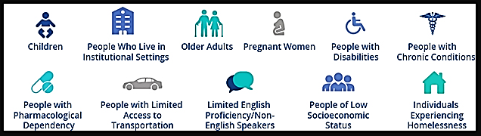
This annex planning guidance is inclusive as it also encompasses people with temporary needs or those who do not identify themselves as having a disability. This includes women who are pregnant, children, older adults, individuals with limited English communication, people with limited transportation access and those with household pets and service animals. Additional awareness which helps ensure inclusive emergency preparedness planning include addressing the needs of children and adults in areas such as:
SELF-DETERMINATION – Individuals with access and functional needs are the most knowledgeable about their own needs.
NO “ONE-SIZE-FITS-ALL” – Individuals do not all require the same assistance and do not all have the same needs.
EQUAL OPPORTUNITY, INTEGRATION AND PHYSICAL ACCESS – All individuals must have the same opportunities to benefit from emergency programs, services, and activities.
NO CHARGE – Individuals with access and functional needs may not be charged to cover the costs of measures necessary to ensure equal access and nondiscriminatory treatment.
EFFECTIVE COMMUNICATION – Individuals must be given information that is comparable in content and detail to the information given to those without functional needs.
For more information, please refer to the Indiana Access and Functional Needs Annex.

ORGANIZATION AND ASSIGNMENT OF RESPONSIBILITIES
This section describes how ESF #15 relates to other elements of the whole community. Basic concepts that apply to all members of the whole community include State, Tribal Territorial, Private Sector and Non-Governmental Organizations (NGOs).
Each primary and supporting agency shall maintain internal SOPs and/or SOGs or other documents that detail the logistical and administrative priorities deemed necessary to assist in overall prevention, protection, mitigation, response, and recovery operations.
Specific roles and responsibilities of primary and supporting agencies during an incident or event are described below. Tasks include but are not limited to:

Primary Agency Responsibilities
- Provide county public information resources to assist in critical functions and tasks before, during and after emergency events and disaster situations.
- Provide recommendations for maintaining a Joint Information System (JIS) and, if necessary, establishing a Joint Information Center (JIC) to support the gathering, verification, coordination, and dissemination of accurate, accessible, and timely information.
- Work with the incident PIO and support the coordination of release of information to the media, public, and partners.
- Provide training to essential personnel who may be called upon to work in potentially impacted areas.
- Manage the financial aspects of ESF #15.
- Work with state and local public information sources to determine the impact of the incident and public information resource gaps that may exist.
- Coordinate and implement emergency-related response and recovery functions, as required, under statutory authority.

Supporting Agency Responsibilities
- Support public information needs for prevention, protection, mitigation, response, and recovery operations when requested by [INSERT NAME OF COUNTY] or the incident PIO.
- Provide personnel, as needed, in the EOC and/or the JIC supporting overall coordination of public information resources and personnel during response and/or recovery operations.
- Assist the primary agency in the development and implementation of policies, protocols, SOPs, checklists, or other documentation necessary to carry-out mission essential tasks.
- Assist in developing situation reports and readiness assessments that will provide for an accurate COP.
- Participate in training and exercises aimed at continuous improvement of prevention, protection, mitigation, response, and recovery capabilities.
- Identify new equipment, technologies, or capabilities required to prepare for or respond to new or emerging threats and hazards.
- Provide information or intelligence regarding trends and challenges to [INSERT NAME OF COUNTY]’s public information capability.

EOC ESF #15 Responsibilities
Please see primary agency responsibilities above and additional responsibilities below:
- Activated and staffed in the EOC. [INSERT NAME OF PRIMARY AGENCY] fills this role.
- Must coordinate with the incident PIO. Encouraged to work with the IMAT PIO and IMT PIO.
- Liaisons between the EOC and JIC.
- Follows the ESF #15 EOC Just-in-Time Training checklist when arriving to the EOC.
- Provide training to essential personnel who may be called upon to work in potentially impacted areas.
- Manage the financial aspects of ESF #15.

Incident PIO Responsibilties
- The Incident PIO changes depending on the incident.
- In charge of incident-related messaging strategy and decisions at the county level. Should approve all messaging and products related to the incident, regardless of originating agency.
  - Makes decisions regarding the deployment of county PIO resources in accordance with the joint information system structure.
    - Note: This is not the EOC ESF #15 responsibility unless that person happens to be the Incident PIO at the time.
  - Oversees the IMAT PIO and joint information center staff. The ESF #15, out of co-ordinational need, dual reports to the EOC Operations Section Chief and incident PIO.

State IMAT PIO Responsibilities
- Reports to the IMAT Incident Commander (IC). In incidents where a JIC and the policy group are activated, control of the messaging reverts to the jurisdictional agency’s PIO, and the IMAT PIO fills a field PIO role. In this instance, the IMAT PIO must coordinate with the Deputy Incident PIO.
- Develops and releases incident information to the public, incident or event personnel, organizations, and agencies (as directed by the incident PIO, if applicable).
- Arranges tours for briefings or interviews.
- Monitors media reporting for accuracy.
- Needs authorization from the incident PIO to be on media.

Joint Information Center Responsibilities
- The Indiana JIC Structure identifies 29 different positions; however, it is not always necessary for a different person to take responsibility for each position. The JIC is flexible and scalable. The JIC positions are shown in Figure 3.
- Be the first and best source of information
- Develop, recommend, and execute public information plans and strategies on behalf of Incident Command, under the direction of the incident PIO
- Advise the Incident Command/Unified Command (IC/UC) concerning public affairs issues that could impact the response
- Gain and maintain public trust and confidence
- Continually gather information about the crisis or situation
- Write and communicate emergency public information regarding public protective actions, evacuations, sheltering, and other public safety messages
- Ensure the timely and coordinated release of accurate information to the public by providing a single release point of information
- Facilitate and manage control of rumors
- Monitor and measure public perception of the incident
- Sends out a situation update to media and partners

Figure 3 – Indiana Joint Information Center (JIC)

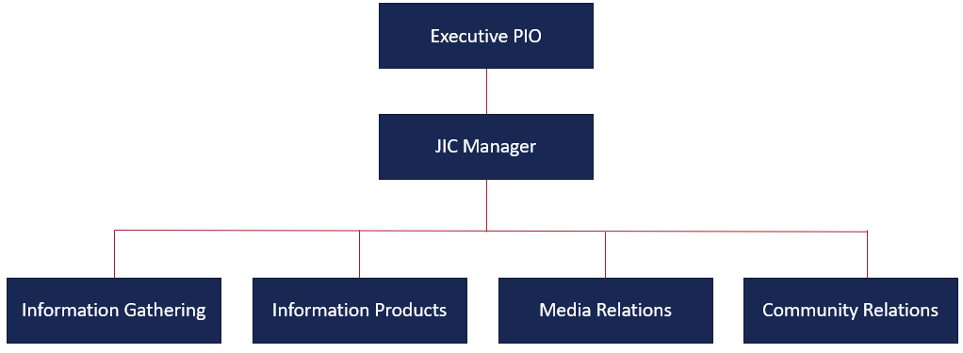

Figure 4 – Joint INformation Center (JIC) Positions

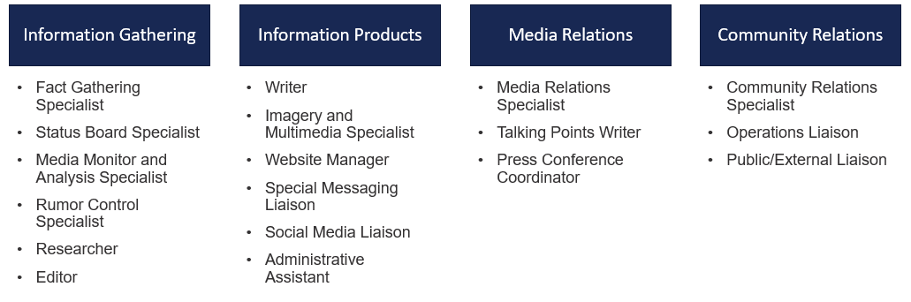

Figure 5 – State Emergency Operations Center Organizational Structure
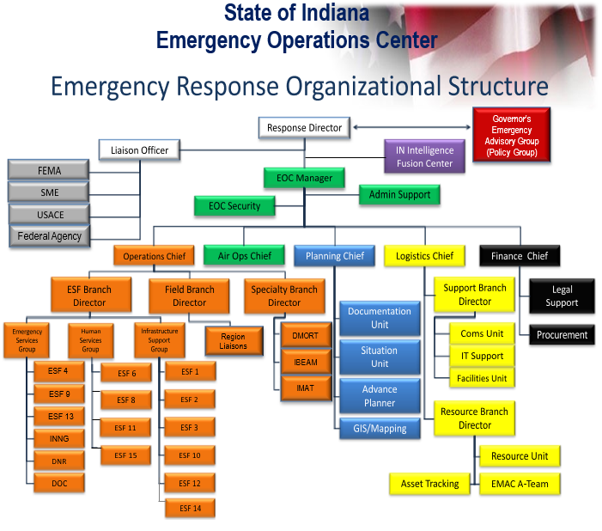

EMERGENCY SUPPORT FUNCTION GENERAL TASKS
The following tables are composed of essential tasks that may need to be completed by ESF #15 in all phases of emergency management. These tasks have been created as a guide to follow for the primary and support agencies of ESF #15. They have been developed as a tool to address potential challenges and unique risks that may be faced during times of emergency and disaster here in [INSERT NAME OF COUNTY]. It will be the responsibility of ESF #15 to ensure the tasks outlined here are accurate and reflect their overall ability to manage, support and deploy resources.
Please note, that the mission areas of Prevention and Protection have
replaced the Preparedness mission area.

Table 4. ESF #15 Prevention Tasks
ESF #15 – Prevention Tasks
1 | Initiate a time-sensitive, flexible planning process that builds on existing plans and incorporates real-time ESF #15 intelligence.
2 | Establish and maintain a unified and coordinated operational structure and process that appropriately integrates all critical stakeholders and supports the execution of core capabilities.
3 | Anticipate and identify emerging and/or imminent ESF #15 threats through observation and situational awareness.
4 | Make appropriate assumptions to inform decision makers and counterterrorism professionals actions to prevent imminent attacks on ESF #15 in the homeland.
5 | Continue to monitor changing trends in activity and aggressive behavior at the local, state, and national level and adjust prevention tasking as it applies to ESF #15.
6 | Establish and maintain partnership structures among protection elements to support networking, planning, and coordination.
7 | Present courses of action to decision makers to locate, interdict, deter, disrupt, or prevent imminent attacks on the homeland and imminent follow-on attacks.
8 | Share relevant, timely, and actionable information and analysis with local authorities through a pre-established reporting system.
9 | Identify possible ESF #15 terrorism targets and vulnerabilities. Ensure the security of equipment, facilities, and personnel through assessments of capabilities and vulnerabilities.
10 | Implement, exercise, and maintain plans to ensure continuity of operations.

Table 5. ESF #15 Protection Tasks
ESF #15 – Protection Tasks
Task # | Task Summary
1 | Develop, validate, and maintain SOPs or guidelines for both routine and emergency operations. Key operational concerns include but are not limited to:  - Identification and assessment of equipment, supplies, resources, and critical infrastructure.  - Alert and activation of personnel for work in field or EOC.  - Emergency communications and reporting procedures.
2 | Develop and conduct training and education programs for ESF #15 personnel. Program considerations include but are not limited to:  - The assessment of equipment, supplies, and resources.  - Working in an EOC during emergency conditions.  - WebEOC or other computer applications.  - National Incident Management System / Incident Command.  - Continuity of Operations.  - Mapping, GIS, and other computer applications.  - Emergency transportation and evacuation planning.
3 | Develop and maintain a roster of essential primary and support agency contacts for ESF #15 to be used in the event of emergency operations. Ensure critical information (address, telephone, cell, facsimile, etc.) is captured.
4 | Develop and maintain a database or system to collect information on essential resources and equipment.
5 | Develop lists of resource needs and work toward eliminating these shortfalls by funding, partnerships or taking other essential activities.
6 | Update mutual aid agreements, letters of understanding or contracts with departments, organizations or private entities that may offer rapid deployment of resources or services as they relate to short and long-term emergency public information needs.
7 | Train ESF #15 personnel on technical standards and specifications for essential pieces of equipment related to short and long-term emergency public information needs.
8 | Train ESF #15 personnel on routine and emergency safety standards for both field operations and EOC support.
9 | Exercise alternate public information facilities, equipment and assets for continuity of operations and essential public information services statewide.
10 | Train ESF #15 personnel on policies and administrative rules that relate directly to public information, this ESF and its ability to provide emergency assistance.

Table 6. ESF #15 Mitigation Tasks
ESF #15 – Mitigation Tasks
Task # | Task Summary
1 | Communicate areas that have been or are currently prone to significant hazards.
2 | Identify public information resources within [INSERT NAME OF COUNTY] and potential shortfalls or gaps that may exist.
3 | Identify potential partnerships or funding sources to reduce or eliminate resource shortfalls or gaps for public information issues and concerns.
4 | Establish partnerships with other county and local entities that share public information responsibilities.
5 | Identify needs for agreements, letters of understanding or contracts with departments, organizations or private entities that may offer rapid deployment of resources or services as they relate to short and long-term emergency public information needs.
6 | Identify, establish, and maintain essential pieces of equipment related to short and long-term emergency public information needs.
7 | Identify, establish, and maintain routine and emergency safety standards for all deployed public information personnel that comply with federal and state requirements and policies.
8 | Identify, establish, and maintain alternate public information facilities, equipment, and assets for continuity of operations and essential public information services.
9 | Develop informational messages and materials to share with local, state, public, and private sector partners about potential threats and future protective actions.
10 | Make recommendations, if appropriate, for those pieces of legislation, policies and administrative rules that relate directly to public information and hinder this ESF’s ability to provide emergency assistance.

Table 7. ESF #15 Response Tasks
ESF #15 – Response Tasks
Task # | Task Summary
1 | Activate SOPs or guidelines for emergency operations that consider:  - The assessment, staging, use, status and sustainability of facilities, equipment, supplies and other resources.  - The alert, notification, and activation of personnel for work in the field or within the EOC.  - Emergency communications and reporting procedures.
2 | In coordination with the incident PIO, assist in the activation of joint information system personnel for such mission essential tasks as:  - The assessment of equipment, supplies, and resources.  - Providing representatives to work in the Joint Information Center (JIC), if activated.  - Responding to the field for emergency operations.  - Working in an EOC during emergency conditions.  - Supporting local, district, or statewide Incident Command structures.  - Activating continuity of operations plans.  - Collect, analyze, and disseminate critical health, safety and welfare information for the public.
3 | Support the incident PIO in their mission to provide information to the public through all available means regarding agency’s involvement in the response activities.  Include press releases and press briefings, as deemed appropriate; and regular updates to posts on agency websites.
4 | Evaluate the ability to communicate with ESF #15 personnel and implement alternate communications if primary systems are down.
5 | Communicate with ESF #8 (Public Health and Medical Services), ESF #14 (Cross-Sector Business Infrastructure), ESF #13 (Public Safety), other ESFs as needed, as well as Long-Term Recovery to provide critical information to the incident PIO for distribution to the public.
6 | Work with ESF counterparts at the local, state, regional and national levels, as well as NGO’s and private businesses/industry, as needed.
7 | Post situation reports and critical information in WebEOC during activations.

Table 8. ESF #15 Recovery Tasks
ESF #15 – Recovery Tasks
Task # | Task Summary
1 | Work to aggressively eliminate shortfalls or resource gaps that were identified in response to an emergency or disaster.
2 | Establish partnerships and identify funding sources to address resource shortfalls or gaps for public information issues and concerns.
3 | Maintain open and ongoing communication with other federal, state, local and municipal entities in impacted areas.
4 | Assess agreements, memorandums of understanding, or contracts with departments, organizations or private entities that may have been utilized during the response and determine if those agreements need to be updated or revised.
5 | Assess the current technical standards and specifications for essential pieces of equipment related to short and long-term emergency public information needs and update based upon the lessons learned from the most recent emergency response.
6 | Assess the current level of training on emergency safety standards for public information personnel to determine the appropriate application and compliance with federal and state requirements and policies.
7 | Assess the current usage and application of alternate public information facilities, equipment, and assets for these essential services statewide to determine if there are issues that need to be addressed for future response operations.

LIFELINE AND ESF OBJECTIVES AND TASKS TIMELINE
Table 9. ESF #15 Tasks for Health and Medical
LIFELINE OBJECTIVE | ESF OBJECTIVE | SUPPORT NEEDED FROM | ESF-15 MISSION-ESSENTIAL TASKS | INCIDENT PIO MISSION-ESSENTIAL TASKS
TIMELINE: 24-72 HOURS
- To evacuate level 3 casualties  - To support temporary health and medical infrastructure in and around the impacted zone within 48 hours | To coordinate with incident PIO to activate public-information plans and assess initial resources within 25 hours | __ __ | Coordinate with incident PIO and/or JIC to provide critical health and medical information and provide updates from ESF-2 regarding best remaining communication systems | Provide critical health and medical information to the affected areas via the best remaining communication systems
 |  | __ __ | Coordinate information distribution from SEOC to incident PIO and/or JIC t regarding where health and medical treatment can be received | Ensure the public knows where health and medical treatment can be received
 |  | __ __ | Coordinate information distribution from SEOC to incident PIO and/or JIC regarding the status of the health and medical infrastructure | Advise the public of the status of the health and medical infrastructure
TIMELINE: BEYOND 72 HOURS
To resume health services |  |  | Coordinate information distribution from SEOC to incident PIO regarding any public-health related issues while moving towards recovery | Continually update the public about any public-health related issues while moving towards recovery

Table 10. ESF #15 Tasks for Communications
LIFELINE OBJECTIVE | ESF OBJECTIVE | SUPPORT NEEDED FROM | ESF-15 MISSION-ESSENTIAL TASKS | INCIDENT PIO MISSION-ESSENTIAL TASKS

TIMELINE: 0-24 HOURS
To transmit public information and warning messages to survivors in the disaster area within 12 hours of the incident | To establish contact with ESF 5 for situational assessments and have verified information ready and to the incident PIO for release within 6-12 hours | __ __ | Request information from each ESF, and coordinate with the incident PIO. | Prepare of statements to the media and the public
 | Work with the SEOC to gather information for the incident PIO to assist the PIO and joint information system in coordinating a message among local, state and federal public information officers (PIOs) and providing the necessary context for the incident PIO to determine how to best distribute that message within the first 24 hours | __ __ | As ESF 2 (Communications) is assessing the degree and types of communications capabilities that still exist within the affected area, ask members of the EAS community about the status of that system. If the infrastructure for public-safety communications has been seriously affected or rendered nonfunctional, it is highly unlikely the infrastructure that supports the EAS will have remained functional. | __ __
 |  | __ __ | If the EAS system remains totally functional, use it to the maximum extent. | __ __
 |  | __ __ | Contact ESF 2 to determine communications capabilities available. | __ __
 |  | __ __ | __ __ | Constantly coordinate with the governor’s designated public-affairs liaison
 |  | Governor | __ __ | Ask the governor to speak directly to the public, if possible, on a frequent and regularly scheduled basis.
 |  | __ __ | Develop messages for the public for review and distribution by the incident PIO. | Develop messages for the public. Using pre-scripted messages will be important but review them closely before dissemination to ensure they fit the “tone” of the incident at the time.
 |  | __ __ | Coordinate with on-scene public information teams as needed and directed by the Incident PIO. | Consider dispatching on-scene public-information teams or personnel, especially in populated areas. If this is done, frequent communications with the JIC and SEOC will be critical for providing the most up-to-date information to the affected populace.
 |  | __ __ | __ __ | Establish some means of disseminating information to the affected populace during the first 72 hours after the initial incident. This will be the single most important action the state can take to save lives, reduce further injuries, and provide some “calm.”
 |  | __ __ | Establish schedule for long-term ESF-15 operations. | __ __
 |  | __ __ | __ __ | Dispatch field PIOs who will be with the Indiana Building Emergency Assessment and Monitoring (I-BEAM) team or other various teams leaving for the impacted areas.
 |  | __ __ | __ __ | Disseminate critical lifesaving and life-sustaining information to all affected segments of society by all means necessary, including accessible tools, to expedite the delivery of emergency services and to aid the public in taking protective actions.
 | To establish a JIC and staff it within 12–18 hours. | __ __ | Assist the incident PIO with JIC setup logistics. | Set up with JIC.
 |  | All required departments and agencies | __ __ | Request a representative sent to the JIC.
TIMELINE: 24-72 HOURS
To ensure public updates are given regularly to reduce fear and provide rumor control | To activate public-information plans and assess initial resources within 24 hours | __ __ | Coordinate with other ESFs to gather information regarding rumors, security, shelters, and medical care locations and provide to the incident PIO. | Continually broadcast emergency public information to help control rumors and ease the public’s fear or panic, thereby decreasing the potential for civil unrest. Advise the public of locations of shelters and medical care.
 |  | __ __ | __ __ | Alert the affected public to the possibility of cascading events and protective actions to be taken.
 |  | __ __ | Collect information from media reports to assess need for rumor control. | Determine and implement rumor control strategy
 |  | __ __ | __ __ | Coordinate with local officials for assistance and the release of public information.
 |  | __ __ | __ __ | In addition to issuing public information, establish a legislative-affairs liaison to inform members of the county government about response actions.
 |  | All ESFs | Coordinate with all ESFs to gather information that should be shared with the public for ingress and egress routes, water fitness and availability, evacuations, government response updates, mass care, health and medical services, food, pet care and availability and restoration of utilities, and provide to incident PIO. | Distribute information regarding ingress and egress routes, water fitness and availability, evacuations, government response updates, mass care, health and medical services, food, pet care and availability and restoration of utilities.
 |  | __ __ | __ __ | Coordinate utilization of available means of communication at the JIC and to the public.
 |  | __ __ | __ __ | Coordinate with the governor’s public-affairs liaison continually.
 |  | __ __ | __ __ | Deploy public-information teams or personnel, especially in prioritized populated areas.
 |  | __ __ | __ __ | Legislative-affairs liaison: Continue to inform members of the general assembly and Congress about response actions.
 |  | __ __ | __ __ | Schedule briefings with local and state news outlets.
 |  | __ __ | __ __ | Continue to support external media.
 |  | ESF 7 | Request additional resources through EMAC or the federal government, as necessary. | __ __
TIMELINE: 24-72 HOURS
To ensure public updates are given regularly to reduce fear and provide rumor control | __ __ | __ __ | __ __ | Continue prioritization of needs and begin to assess priorities for recovery.
 |  | __ __ | Continually gather information on the locations of shelters and medical care. Include other information about survival, first aid and self-help. | Continually update the public on the locations of shelters and medical care. Include other information about survival, first aid and self-help.
 |  | __ __ | __ __ | Continually update the public about personal protection as well as local, state, and federal assistance becoming available.
 |  | __ __ | __ __ | Coordinate use of available means of communication at the JIC and to the public.
 |  | __ __ | __ __ | Continually update the public on actions the government is taking and how soon they can expect assistance.
 |  | __ __ | __ __ | Continue to coordinate with the governor’s public-affairs liaison.
 |  | Governor | __ __ | Ask the governor to continue holding frequent and regularly scheduled press conferences.
 |  | __ __ | __ __ | Use pre-scripted messages adapted to fit the “tone” of the incident at the time.
 |  | All ESFs | Continue to request information from each ESF for the preparation of statements to the media and the public. | __ __
 |  | __ __ | Continue to collect media reports regarding the need for rumor control. | Continue to assess the need for rumor control.
 |  | __ __ | __ __ | Continue to coordinate with local officials for assistance.
 |  | __ __ | __ __ | Continue to schedule briefings with local and state news outlets.
 |  | ESF 7 | Request additional resources through EMAC or the federal government, as necessary. | __ __

Table 11. ESF #15 General Tasks
OBJECTIVE | SUPPORT NEEDED FROM | MISSION-ESSENTIAL TASKS
TIMELINE: 0-24 HOURS
To deploy an ESF 15 representative to the state emergency operations center (EOC) within 2–6 hours of notification | __ __ | Deploy ESF 15 representative to the EOC and be briefed.
To maintain the common operating picture (COP) and contribute to the incident action plan (IAP) | __ __ | Provide situational information to the SEOC.
TIMELINE: 24-72 HOURS
To continue maintaining the COP and contributing to the IAP | __ __ | Communicate the status and existing capabilities of all ESF 15 agencies to prioritize needs.
 | __ __ | Participate in developing the incident action plan (IAP) to determine needs and priorities.
__ __ | __ __ | Continue to disseminate internal information through appropriate channels.
To develop a 7-day JIC schedule within 36 hours | __ __ | Set initial staffing plan to maintain long-term operations.
TIMELINE: 24-72 HOURS
To continue maintaining the COP and contributing to the IAP | __ __ | Provide situational information to the SEOC.
 | __ __ | Participate in developing the IAP, based on needs and priorities.
__ __ | __ __ | Continue to disseminate internal information.

DIRECTION, CONTROL, AND COORDINATION

Direction
[INSERT NAME OF PRIMARY AGENCY] is the primary agency for ESF #15; however, the Incident PIO changes depending on the incident. For example, during the 2016 Avian Influenza Outbreak, IBOAH was the Incident PIO, while IDHS served as the Incident PIO for the 2018 Floods.
If activated, the JIC will be the central point of contact for all news media regarding any subjects related to the incident. Partner PIOs and the size of the JIC will vary according to the emergency situation. If the JIC is not activated, the Incident PIO will be the primary point of contact, unless delegated.

Control
The Incident PIO is in charge of overall messaging, strategy, and JIC staff. The Incident PIO also jointly oversees the EOC ESF #15 and the IMAT PIO. Resource decisions should be made by the Incident PIO.

Coordination
External Affairs will coordinate with internal and external partners on a common operating picture. It is best practice for the EOC ESF #15, JIC staff, and Field PIO (IMAT or IMT) staff to coordinate and communicate together on unified messaging. There should be at least one conference call a day and regular communication amongst the EOC ESF #15, IMAT PIO and JIC staff during an incident. The State may support local jurisdictions and that is described in the Local Coordination section above.

INFORMATION COLLECTION, ANALYSIS, AND DISSEMINATION

Information Collection
The joint information system provides accessible information that is timely, coordinated, and accurate. External Affairs will coordinate with internal and external partners on information collection. Audiences are looking for information pertaining to the incident. Example information to collect may include but is not limited to:
- Assistance provided to the incident-affected area.
- Agency response and support.
- Protective measures.
- Impact on non-affected areas.
- Health risks and considerations.
- Complete picture of what survivors need to do to recover from the emergency.

Analysis and Dissemination
Messages should be unified and rumors should be controlled. Social media and media will need analyzed to ensure information is being conveyed accurately. Released information should be clear and void of any errors that could cause credibility issues such as misspelling and incorrect grammar.
Information must be available to affected citizens including but not limited to media, private sector, governments, individuals with limited English proficiency, and those with access and functional needs.
The responsibility to provide information regarding the incident is a shared task among local authorities. There are multiple means that information can be shared, and that can be found in the Communications section below.
If confronted by the public, it is important to show compassion and acknowledge uncertainty.

COMMUNICATION
ESF #15 shall ensure communication is established and maintained with the EOC and participating agencies to promote an accurate common operating picture (COP) through the use of situation reports and assessments. Such communication methods may include but is not limited to:

EOC ESF #15 Communication Methods

[ADD, REMOVE, OR CHANGE TO COUNTY DETAILS OR PROTOCOLS]
- Data
  - WebEOC, Microsoft Teams, email, text, and Cisco Jabber.
- Social media as directed by and coordinated with the Incident PIO.
- Landline telephone and cellular

State IMAT PIO Communication Methods
- Data
  - WebEOC, Microsoft Teams, email, text, and Cisco Jabber.
  - Social media as directed by and coordinated with the Incident PIO.
- Radio
  - 800 MHz System, 155 MHz System, High Frequency Radios, Amateur Radio (RACES) and satellite phone
- Landline telephone and cellular

JIC PIO Communication Methods
- Data
  - WebEOC, email, text, and Cisco Jabber
  - Social media as directed by and coordinated with the Incident PIO.
- Integrated Public Alert and Warning System (IPAWS) through EOC
- Emergency Alert System (EAS) through State EOC
- Wireless Emergency Alerts (WEA) through State EOC
- National Oceanic and Atmospheric Administration (NOAA) All-Hazard Weather Radio
- Indiana Department of Transportation (INDOT) Signage
- Amateur Radio
- Alternative Local Emergency Management Agency (EMA) Website
- Non-traditional avenues: Private Sector Partners and Translation Services
- Government Emergency Telecommunications Service (GETS)

APPENDIX A – COMMUNITY LIFELINES
[INSERT NAME OF COUNTY] has adopted the Federal Emergency Management Agency’s (FEMA) seven community lifelines into our prevention, protection, response, recovery, and mitigation activities. Lifelines are services that enable the continuous operation of critical government and business functions and are essential to human health and safety or economic security.
Stabilizing community lifelines is the primary effort during response activities.
ESFs deliver core capabilities to stabilize community lifelines for an effective response.
The seven community lifelines represent only the most basic services a community relies on and which, when stable, enable all other activity within a community. The lifelines are designed to enable emergency managers, infrastructure owners and operators, and other partners to analyze the root cause of an incident impact and then prioritize and deploy resources to effectively stabilize the lifeline. This construct maximizes the effectiveness of federally supported, state managed, and locally executed response.
Similar to the ESFs, other whole community organizations can work together to stabilize lifelines and meet disaster needs. The community lifelines do not directly cover all important aspects of community life that can be affected by an incident, including impacts to natural, historical, and cultural resources. For example, financial and economic issues important to the life and safety of affected individuals may also arise indirectly from impacts to lifelines during an incident. If disrupted, rapid stabilization of community lifelines is essential to restoring a sense of normalcy. Recent disasters have illuminated two underlying features of community lifelines that highlight opportunities to strengthen response planning and operations.
First, community lifelines are interdependent and vulnerable to cascading failures. For example, communications and electric power systems rely on each other to function; severe damage to one will disrupt the other. Most lifelines also rely on complex supply chains. Water and wastewater service depend on the resupply of a broad array of chemicals and—if power goes out—fuel for emergency generators. However, in a severe natural or human-caused incident, those supply chains themselves may be broken.
Second, community lifeline stabilization relies on businesses and infrastructure owners and operators who have the expertise and primary responsibility for managing their systems in emergencies. Accordingly, [INSERT NAME OF COUNTY] is working with developing planning coordination mechanisms needed to enable the private sector to play a larger, more comprehensive role in preparedness and response activities. The community lifelines are composed of multiple components that encompass infrastructure, assets, and services.

Table 12. Community Lifeline Components and Sub-Components

All community Lifeline Components AND SUB-COMPONENTS
Multiple components establish the parameters of and key assessment elements for each of the lifelines; component-level analysis is required to determine if each lifeline is stable
SAFETY AND SECURITY | FOOD, WATER, SHELTERING | HEALTH AND MEDICAL
- Hazard Mitigation  - Law Enforcement / Security  - Responder Safety  - Search and Rescue  - Fire Services  - Government Service | - Evacuations  - Food / Potable Water  - Shelter  - Durable Goods  - Water Infrastructure  - Agriculture Infrastructure | - Medical Care  - Patient Movement  - Public Health  - Fatality Management  - Medical Industry
ENERGY | COMMUNICATIONS | TRANSPORTATION
- Power (Grid)  - Temporary Power  - Fuel | - Infrastructure  - 911 & Dispatch  - Responder Communications  - Alerts, Warnings, Messages | - Highway / Roadway Motor Vehicle  - Mass Transit  - Railway  - Aviation  - Maritime  - Pipeline
HAZARDOUS MATERIAL
  - Facilities
  - Incident Debris, Pollutants, Contaminants
  - Conveyance

Table 13. Indiana Lifelines / ESF / Core Capabilities Cross-walk
LIFELINE SYMBOL | LIFELINE | COLLABORATIVE PLANNING TEAM |  | RELATED CORE CAPABILITIES
 | Safety and Security  Law enforcement, security  Search and rescue  Fire services  Government service  Responder safety  Imminent hazard mitigation | ESF 13*  ESF 4  ESF 5  ESF 7  ESF 9  ESF 14  ESF 15  INNG  Private security |  | Planning  Public Information and Warning  Operational Coordination  Environmental Response/ Health and Safety  Fire Management and Suppression  Mass Search and Rescue Operations  On-scene Security, Protection, and Law Enforcement  Situational Assessment
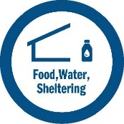 | Food, Water, Sheltering  Evacuations  Food, potable water  Shelter  Durable goods  Water infrastructure  Agriculture | ESF 6*  ESF 3  ESF 11  ESF 5  ESF 7  ESF 13  ESF 14  ESF15  INNG  VOAD |  | Planning  Public Information and Warning  Operational Coordination  Critical Transportation  Infrastructure Systems  Logistics and Supply Chain Management  Mass Care Services  Situational Assessment
 | Health and Medical  Medical care  Patient movement  Public health  Fatality management  Healthcare supply chain  Fire service | ESF 8*  ESF 4  ESF 5  ESF 7  ESF 14  ESF 15  INNG |  | Planning  Public Information and Warning  Operational Coordination  Environmental Response/Health and Safety  Fatality Management Services  Logistics and Supply Chain Management  Public Health, Healthcare, and Emergency Medical Services  Situational Assessment
 | Energy  Power (grid)  Temporary power  Fuel | ESF 12*  ESF 3  ESF 5  ESF 7  ESF 14  ESF 15  INNG |  | Planning  Public Information and Warning  Operational Coordination  Infrastructure Systems  Logistics and Supply Chain Management  Situational Assessment
* = COORDINATING UNIT

 | Communications  Infrastructure  Alerts, warnings, messages  911 and dispatch  Responder communications  Financial services |  | ESF 2*  ESF 5  ESF 7  ESF 14  ESF 15  INNG | Planning  Public Information and Warning  Operational Coordination  Infrastructure Systems  Operational Communications  Situational Assessment
 | Transportation  Highway, roadway  Mass transit  Railway  Aviation  Maritime  Pipeline |  | ESF 1*  ESF 5  ESF 7  ESF 14  ESF 15  INNG | Planning  Public Information and Warning  Operational Coordination  Critical Transportation  Infrastructure Systems  Situational Assessment
 | Hazardous Material  Facilities  Hazardous debris  Pollutants  Contaminants |  | ESF 13*  ESF 4  ESF 5  ESF 7  ESF 10  ESF 14  ESF 15  INNG | Planning  Public Information and Warning  Operational Coordination  Environmental Response/Health and Safety  Situational Assessment

Table 14. Organizations that support ESF #15 during response
ORGANIZATION | ESF 15
ESF 1: Transportation
ESF 2: Communications
ESF 3: Public Works and Engineering
ESF 4: Firefighting
ESF 5: Information and Planning
ESF 6: Mass Care, Housing, and Human Services
ESF 7: Logistics Support and Resource Management
ESF 8: Public Health and Medical Services
ESF 9: Search and Rescue
ESF 10: Oil and Hazardous Materials Response
ESF 11: Food, Agriculture, and Natural Resources
ESF 12: Energy
ESF 13: Public Safety and Security
ESF 15: External Affairs | X
Governor of Indiana

Colors Indicate Lifeline or Component Status
STABLE: Green
- Minimal or no disruption in services to survivors
- Note: Green components may still be severely impacted
STABILIZING: Yellow
- Disruption to services provided by component capabilities is causing limited impacts to response efforts and survivors.
- A solution to the disruption has been identified, and has it been converted into a plan of action, resourced, and implemented.
- Limiting factors may inhibit response.
UNSTABLE: Red
- Disruption to services provided by component capabilities is causing significant impacts to response efforts and survivors.
- Requirements and solutions are not identified and/or there is no plan to deliver the solutions.
- Significant limiting factors may inhibit response.
UNKNOWN: Grey
- Impacts are unknown and/or extent of situation or necessary response is unknown.

Assigning A Lifeline Status
Green
Assign lifeline statuses as incident circumstances evolve and through the course of response operations.
Grey
Stabilization targets will provide the baseline against which lifelines can be compared.
Green
The flowchart shows an example of how responders may think through assigning lifelines a color status.

Figure 6. Status Assignment Flowchart
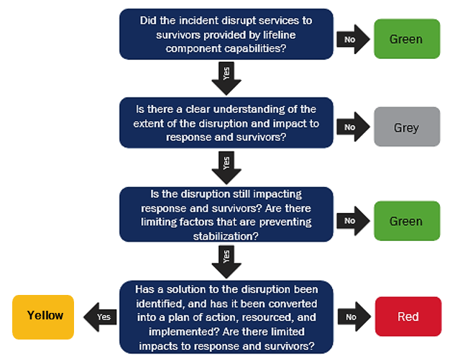

APPENDIX B – AUTHORITIES

Local Jurisdiction
Indiana Code 36-1-3, Home Rule
Indiana’s Home Rule grants municipalities the ability to govern themselves as them deem fit.

[ADD, REMOVE, OR CHANGE TO COUNTY DETAILS OR PROTOCOLS]

State
Executive Order 17-02, January 2017
The Director of IDHS shall act as the chairperson of the Governor’s Emergency Advisory Group.
Indiana Code 10-19-2, Department of Homeland Security Established
The Indiana Department of Homeland Security was established, and the governor shall appoint an executive director.

Federal
National Incident Management System (NIMS), October 2017
NIMS provides a consistent nationwide template for partners to work together to prevent, protect against, respond to, recover from and mitigate the effects of incidents.
Robert T. Stafford Disaster Relief and Emergency Assistance Act, May 2019
The Stafford Act is a United States federal law that provides a means of natural disaster assistance for state and local governments.
Sandy Recovery Improvement Act, 2013
The Sandy Recovery Improvement Act is a law that authorizes changes to the way FEMA delivers disaster assistance.
Post-Katrina Emergency Management Reform Act, 2006
The Post-Katrina Emergency Management Reform Act provides FEMA guidance on its mission and priorities, including its partnership with state and local governments.

APPENDIX C – REFERENCE LIST

[ADD, REMOVE, OR CHANGE TO COUNTY DETAILS OR PROTOCOLS]
REFERENCE | TITLE / DESCRIPTION
STATE | Disaster Declaration Process
STATE | IDHS EOC Operations Webpage
STATE | Joint Information Center Operations Guide
STATE | SEOC Just-in-Time Training Checklist – ESF #15
FEMA | FEMA’s ESF #15- External Affairs Annex, 2016
FEMA | FEMA Resource Typing Definition for Incident Management Team, 2019
FEMA | FEMA Resource Typing Definition for Public Information Officer (NQS), 2019
US-DHS | Homeland Security’s ESF 15 Standard Operating Procedures, 2019
ALL-HAZARDS INCIDENT MANAGEMENT | Incident Management Training and Consulting All-Hazards Incident Management Team Response and Planning Guide, Second Edition 2019

APPENDIX D – ACRONYMS

[ADD, REMOVE, OR CHANGE TO COUNTY DETAILS OR PROTOCOLS]
ACRONYMS | FULL DESCRIPTION
AAR | After-Action Report
ADA | Americans with Disabilities Act
ARC | American Red Cross
ARES | Amateur Radio Emergency Service
CEMP | Comprehensive Emergency Management Plan
CERT | Community Emergency Response Team
C-MIST | Communication Medical Independence Supervision Transportation
COOP | Continuity of Operations Plan
COP | Common Operating Picture
EAS | Emergency Alert System
EMA | Emergency Management Agency
EOP | Emergency Operations Plan
ESF | Emergency Support Function
FEMA | Federal Emergency Management Agency
FSSA | Family and Social Services Administration
GETS | Government Emergency Telecommunications Service
HSEEP | Homeland Security Exercise and Evaluation Program
IBOAH | Indiana Board of Animal Health
IC/UC | Incident Command/Unified Command
ICS | Incident Command System
IDEM | Indiana Department of Environmental Management
IDHS | Indiana Department of Homeland Security
IDNR | Indiana Department of Natural Resources
IDOA | Indiana Department of Administration
IDOE | Indiana Department of Education
IDOL | Indiana Department of Labor
IMAT | Incident Management Assistance Team
IMT | Incident Management Team
INDOT | Indiana Department of Transportation
INNG | Indiana National Guard
IN-VOAD | Indiana Voluntary Organizations Active in Disaster
IOSHA | Indiana Occupational Safety and Health Administration
IOT | Indiana Office of Technology
IPAWS | Integrated Public Alert and Warning System
IPSC | Integrated Public Safety Commission
IS | Independent Study
ISDA | Indiana State Department of Agriculture
ISDH | Indiana State Department of Health
ISP | Indiana State Police
IT | Information Technology
IURC | Indiana Utility Regulatory Commission
JFO | Joint Field Office
JIC | Joint Information Center
JIS | Joint Information System
MRC | Medical Reserve Corps
NGO | Non-Governmental Organization
NIMS | National Incident Management System
NJIC | National Joint Information Center
NOAA | National Oceanic and Atmospheric Administration
NWS | National Weather Service
PIO | Public Information Officer
POETE | Planning Organization Equipment Training Exercise
SEOC | State Emergency Operations Center
SOG | Standard Operating Guideline
SOP | Standard Operating Procedure
SPD | State Personnel Department
SPR | Stakeholder Preparedness Review
THIRA | Threat Hazard Identification Risk Assessment
VIPS | Volunteers in Police Service
WEA | Wireless Emergency Alerts
WebEOC | Web-based Emergency Operations Center

APPENDIX E – DEFINITIONS

[ADD, REMOVE, OR CHANGE TO COUNTY DETAILS OR PROTOCOLS]
TERM | DEFINITION
Amateur Radio | The Amateur Radio Emergency Service (ARES) is a division of the American Radio Relay League and consists of licensed amateurs who have voluntarily registered themselves and their equipment for public communications service to the federal, state, county or local level government as well as to nonprofit organizations. (Amateur Radio Relay League)
Emergency Alert System | The Emergency Alert System (EAS) is a nationwide emergency alert program. (FEMA)
GETS Card | The Government Emergency Telecommunications Service (GETS) provides a card to national security and emergency preparedness personnel that significantly increases the probability of completion for their phone calls when normal calling methods are unsuccessful. (Federal Communications Commission)
Incident Management Assistance Team (IMAT) | The State IMAT is available for assembly to respond to large state or federal level emergencies and disasters when response capability exceeds local and county resources. The State IMAT is designed to enhance and assist local and county capabilities when rapidly expanding incidents. It requires much larger scaled incident management capabilities but does not act as a replacement or to take over the incident management capabilities at the local level. (IDHS IMAT Guidance Document)
Incident Management Team (IMT) | Rostered ICS-qualified personnel manage incidents and support incident-related tasks by forming an IMT. Affected jurisdictions typically delegate authority to an IMT to manage disasters. (NIMS 2017)
Incident PIO | The PIO that is in charge of overall messaging, and member of the Incident Command Structure. Works closely with the Incident Commander and other important stakeholders.  The Incident PIO is assigned depending on the agency holding jurisdiction and subject matter expertise over a specific incident (e.g., IBOAH was designated as the Incident PIO during the Highly Pathogenic Avian Influenza Response in 2016) (FEMA; State of Indiana JIC Manual)
Integrated Public Alert and Warning System | The Integrated Public Alert and Warning System (IPAWS) is a modernization and integration of the nation’s alert and warning infrastructure. (FEMA)
Joint Information Center | Forms under Unified Command, reporting to the Incident PIO, to effectively manage communication resources and public messages when multiple organizations are involved in incident response or multi-agency event planning for major meetings and events. (FEMA)
NOAA All-Hazard Weather Radio | The NOAA all-hazard weather radio is a 24-hour a day, 7-day a week continuous broadcast of weather information. (NOAA)
Public Information Officer (PIO) | Disseminates community information to the public. (FEMA)
State Emergency Operations Center | Functions as a central coordination center for subject matter experts and key organization personnel who facilitate an effective, direct and coordinated response to the needs of the citizens in the event of a natural disasters or significant events. (IDHS SEOC)
Wireless Emergency Alerts | Wireless Emergency Alerts (WEA) is a public safety system that allows customers who own certain wireless phone models and other enabled mobile devices to receive geographically targeted, text-like messages alerting them of imminent threats to safety in their area. (Federal Communications Commission)

