Indiana Department of Veterans Affairs

*2024 Non-Profit Partner*

Solicitation

November 15, 2023

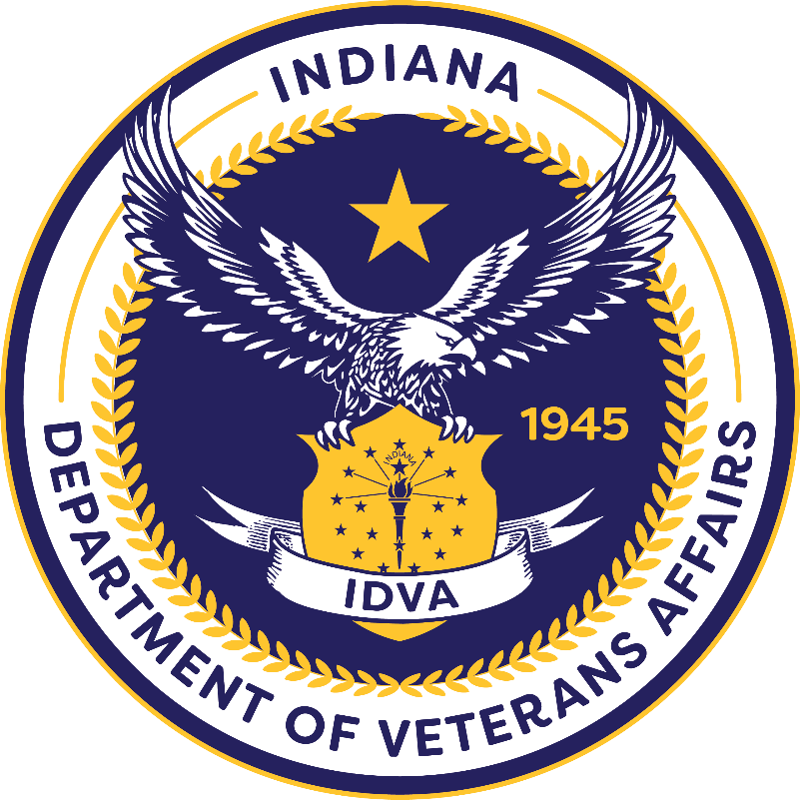

**Indiana Department of Veterans Affairs**

**2024 Non-Profit Partner Solicitation**

**Solicitation Release – November 17, 2023**

**Application Deadline: – December 15, 2023**

**Period of Performance: 12 Calendar Months**

The Indiana Department of Veterans Affairs (“IDVA”) is seeking applications for a non- profit organization to serve as the Non-Profit Partner of the Year (“NPP24”). The NPP24 will actively partner with IDVA for annual fundraising events. These events are intended to raise funds to be utilized by the NPP24 to enhance its service to Indiana Veterans.

All applications, procedures, and documentation should comply with the Indiana Code, the Indiana Administrative Code, and any applicable Indiana Department of Veterans Affairs’ policies.

**Contact Information**

Gabrielle Owens / General Counsel / [Gowens1@dva.in.gov](mailto:Gowens1@dva.in.gov) / (317) 232-3165

Brookelynn Deaton / Grant and Compliance Administrator / [BDeaton1@dva.in.gov](mailto:BDeaton1@dva.in.gov) /

(317) 601-0633

### All questions should be sent via the emails above.

Definitions 4

Eligibility and Requirements 4

Important Dates 5

Application Process 5

Letters of Support 6

Application Review 6

Award 7

Unallowable Costs of Non-Profit Partner 2024 Funds 7

# Definitions

* “Veteran” means an individual residing in Indiana who:
  + - * + Has served in any branch of the Armed Forces of the United States or their reserves, in the National Guard; and
        + Must not have received a dishonorable discharge.
* “Non-Profit” means an organization that has a 501(c)(3) tax-exempt status as proven by documentation from the Internal Revenue Service.

# Eligibility

An eligible applicant is an organization that serves Veterans and has a 501(c)(3) tax-exempt status and provides services to Veterans residing in Indiana or to entice Veterans to relocate to Indiana. The NPP24 must be financially able to provide the services proposed in its application. The organization must be in compliance with all state and federal laws and shall not have any liabilities to the State of Indiana including, but not limited to, the Indiana Department of Revenue or the Indiana Department of Workforce Development.

Additionally, the NPP24 must have the resources to serve as an active partner with IDVA including, but not limited to:

* + Assisting with the planning of multiple annual events;
  + Having personnel and/or volunteers to perform duties at each event;
  + Leveraging other partnerships to enhance the participation of and help ensure the success of each event; and
  + Utilizing all promotional avenues to promote and publicize each event.

# Requirements

The NPP24 will submit to IDVA a quarterly accounting of NPP-related money received and expended. NPP24 will report on, and account for, all expenditures during the quarter.

NPP24 will outline details of all transactions as well as the final amount of the donation after accounting for all expenses.

The NPP24 will provide a final accounting report for the whole year no later than 45 days after the end of the performance period.

# Important Dates

|  |  |
| --- | --- |
| **Steps in Process** | **Date** |
| Grant Solicitation Announcement | 11/17/2023 |
| Q&A Session | 12/06/2023 @ 11 AM |
| Applications Due | 12/15/2023 |
| Application Reviews Complete | 12/22/2023 |
| Award Notice | 12/29/2023 |

# 

# Application Process

The organization’s application must be accompanied by the following documentation:

* The name, address, and contact information, including email address, of the organization. (Application)
* The name, address, and contact information of the chief executive officer or the chief financial officer of the organization. (Application)
* Evidence that the organization is registered with the Indiana Secretary of State.
* A detailed explanation of the organization's mission, activities, and membership. (Narrative)
* A detailed description of all services provided to Veterans by the organization. (Narrative)
* A letter from the Internal Revenue Service affirming the organization's tax-exempt status under Section 501 of the Internal Revenue Code.
* A detailed explanation of the organization’s achievements during the past calendar year. (Narrative)

An application will not be considered eligible for approval until all required documents have been received by IDVA. IDVA may deny an incomplete application.

If there is a change to the organization’s application, or documentation contained therein, the organization shall notify the IDVA within ten (10) days of the change. The IDVA may revoke an organization’s eligibility for NPP24 if the changes affect the applicant's eligibility.

## Letters of Support

Letters of support are strongly recommended. These letters of support should be from individuals, businesses, institutions of higher education, or other organizations that serve Veterans. These letters of support need to be on the official letterhead of the supporting organization. If the letters of support are from individuals, there is no need for official letterhead; however, the individual’s contact information must be contained within the letter.

# Application Review

The IDVA will review all applications for completeness. Complete applications will be scored by a team of individuals. Scoring factors will include, but are not limited to:

* The organization’s geographic location;
* The number of Veterans in the organization’s service area;
* The organization’s ability to be an active partner with IDVA;
* The organization’s ability to meaningfully serve Veterans; and
* Letters of support.

# Award

After IDVA identifies the NPP24, the organization will be notified in writing. Organizations not selected will also be notified in writing. Organizations that are not selected cannot appeal IDVA’s selection.

**Unallowable Uses of Non-Profit of the Year Funds**

The NPP may not use funds from this partnership with IDVA to:

* Satisfy any federal, state, or local tax, fee, or fine;
* Purchase alcohol;
* Lobbying;
* Bonuses to employees or volunteers of the organization;
* Renovations or construction; or
* Purchase real property.