GetThere

Self-Registration

CREATE AN ACCOUNT

URL - https://wx1.getthere.net/DispatcherServlet?requestType=logininq&site=tnustravel

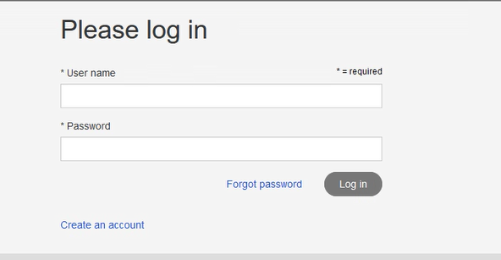

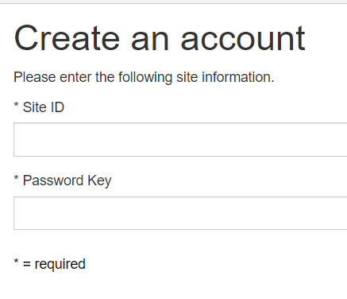

Enter Site ID and Password.

**Site ID** – indiana (case sensitive)

**Password** – newuser (case sensitive)

Complete the Username, Password, and Email address.

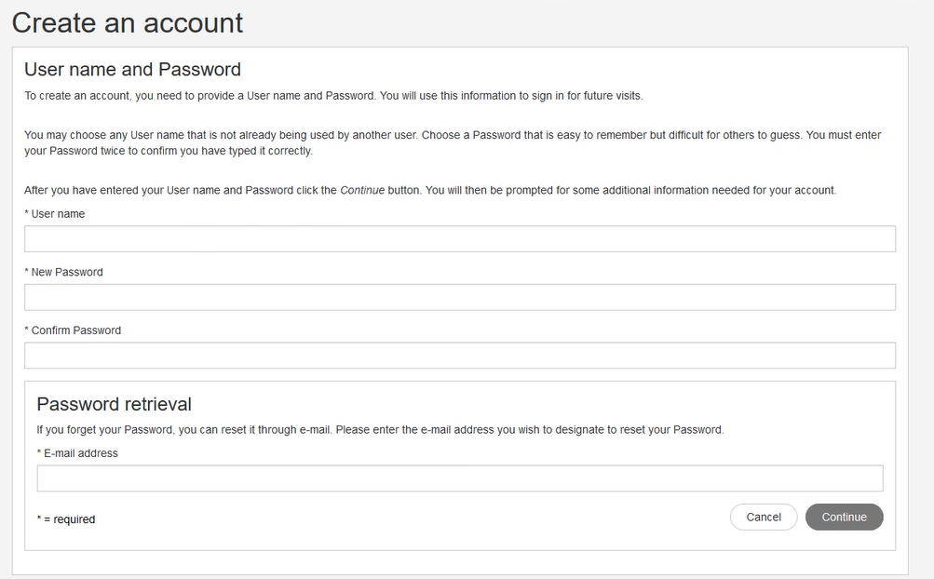

Fill in the profile information.

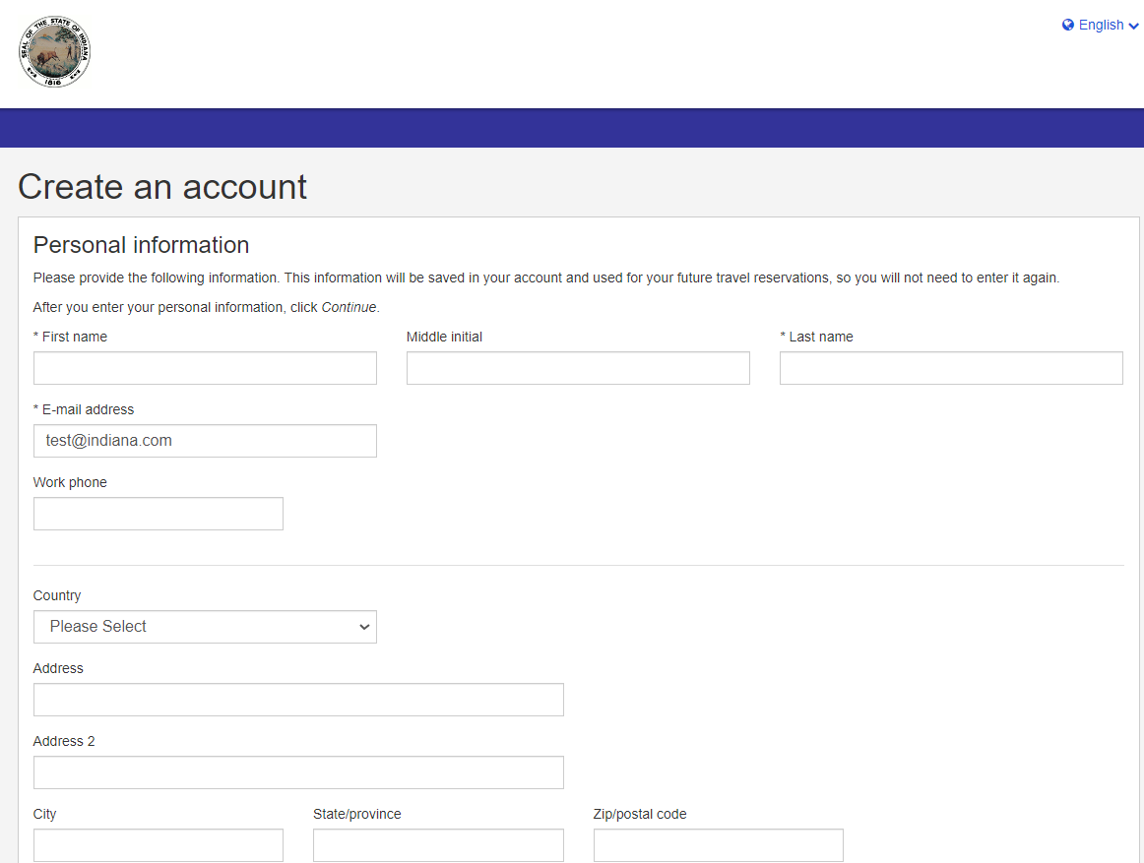

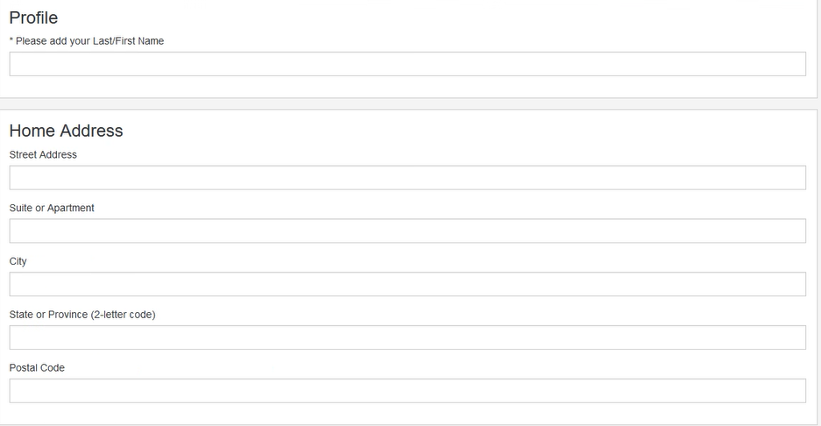

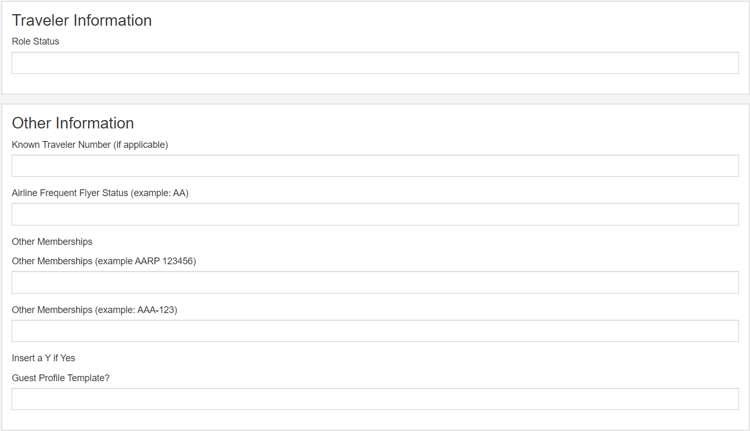

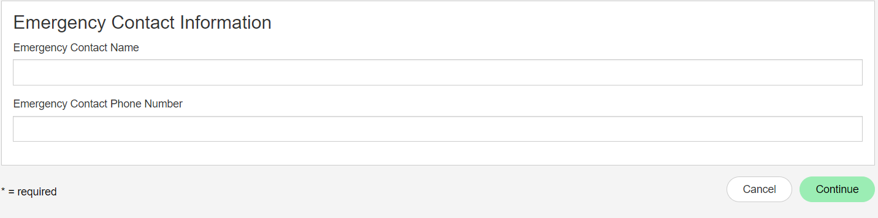

Once the profile is completed you will receive the confirmation below. Select Confirm to create your travel profile.

