**Consideration of Special Factors When an Indiana Student is Deaf or Hard of Hearing**

The intent of this form is to guide discussion among Individualized Educational Plan (IEP) team members who review a student’s needs based on language and communication skills and access. The result of this thoughtful discussion about the student’s communication access, social, and instructional needs will be documented and utilized in determining:

* Special education eligibility per 511 IAC 7-41-4 (b). Communication evaluation is to be conducted in the language or system utilized for the student’s instruction and/or student’s preferred mode of communication. Consideration of special factors per 511 IAC 7-42-6 (c).

***Indiana State Board of Education Special Education Rules Title 511 Article 7 511 IAC 7-42-6* developing an individualized education program**

|  |  |  |  |
| --- | --- | --- | --- |
| (c) | The Case Conference Committee (IEP team) must also consider the following special factors when applicable: | | |
| (2) | | The language needs of a student with limited English proficiency as those needs relate to the student’s IEP. | |
| (3) | | In the case of a student who is deaf or hard of hearing or a student who is deaf-blind, the student’s: | |
| (A) | | | language and communication needs; |
| (B) | | | opportunities for direct communication with peers and professional personnel in the student’s language and communication mode; |
| (C) | | | academic level; and |
| (D) | | | full range of needs; including opportunities for direct instruction in the student’s language and communication mode. |
| (5) | | The student’s need for assistive technology devices and services. | |

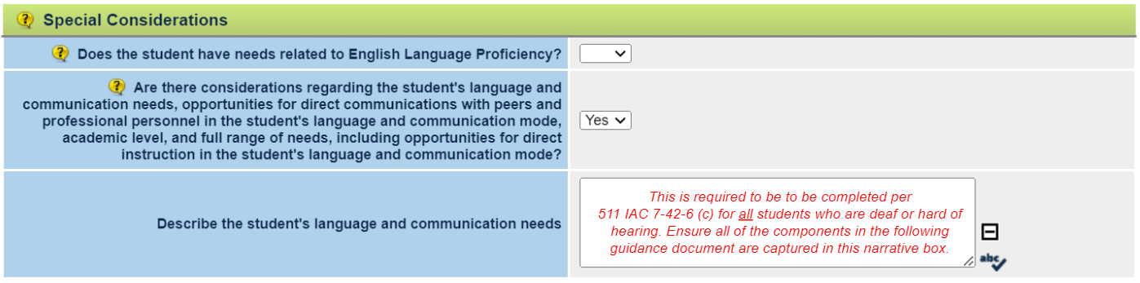*Screenshot from Indiana IEP*

|  |
| --- |
| **The language needs of a student with limited English proficiency as those needs relate to the student’s IEP and the child’s language and communication needs (511 IAC 7-42-6 (c) – (2), (3) (A));** |

|  |  |
| --- | --- |
| Language(s) used in the home environment (i.e., English, ASL, Spanish, etc.): | **Click here.** |

|  |
| --- |
| ***Expressive/Receptive Communication Continuum*** |
| To fill out the table below, please consider the following definitions/illustrations: |

|  |  |
| --- | --- |
| **V**: | Depends on visual information ASL/signs |
| **Va:** | Depends on ASL/signs; obtains some benefit from auditory information |
| **VA**: | Equally depends on and able to use ASL/signs and auditory information via spoken language |
| **AV**: | Depends on spoken language, sometimes needs sign to clarify spoken language |
| **A**: | Depends on auditory information via spoken language |

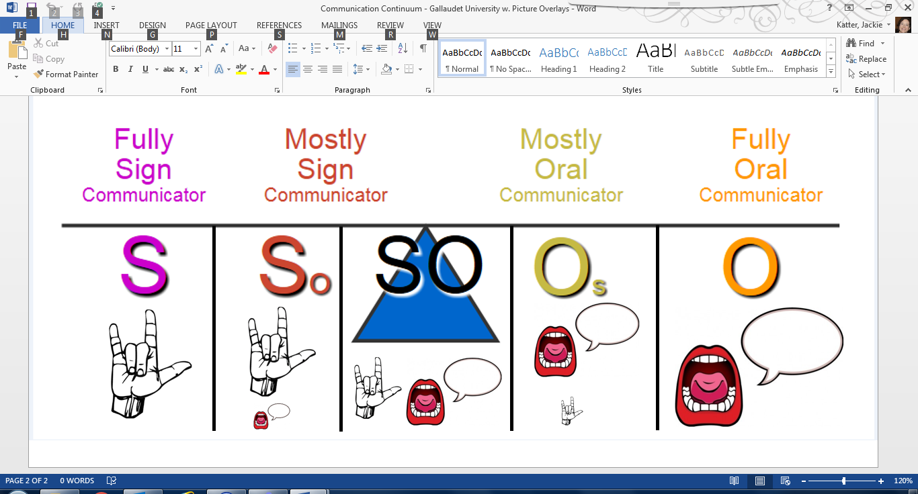

|  |  |
| --- | --- |
| **S:** | Uses signs/ASL only |
| **So**: | Uses signs/ASL; some oral communication |
| **SO**: | Equally able to use sign and oral communication |
| **Os**: | Uses oral communication; signs for clarification |
| **O**: | Uses oral communication only |

Please fill out the chart below using the following code(s):

|  |  |  |
| --- | --- | --- |
|  | **How the student understands:** | **How the student expresses:** |
| In the home with parent(s)/sibling(s): | **Choose an item.** | **Choose an item.** |
| In the classroom or childcare setting with teacher(s): | **Choose an item.** | **Choose an item.** |
| In the classroom or childcare setting with peer(s): | **Choose an item.** | **Choose an item.** |
| In social situations with hearing adult(s): | **Choose an item.** | **Choose an item.** |
| In social situations with Deaf adult(s): | **Choose an item.** | **Choose an item.** |
| In social situations with hearing peer(s): | **Choose an item.** | **Choose an item.** |
| In social situations with deaf peer(s): | **Choose an item.** | **Choose an item.** |

|  |
| --- |
| Document any additional communication needs or supports (e.g. pictures, cues, etc.): |
| **Click here.** |

(B) Opportunities for direct* communication with peers and professional personnel in the child’s language and communication mode;

*Direct language/communication/instruction occurs person to person, not through an additional source (e.g., educational interpreter, class note-taker, etc.)

|  |  |  |
| --- | --- | --- |
| Specify opportunities for direct* instruction. | **Click here.** | |
| Specify opportunities for direct* communication with peers. | | **Click here.** |
| Specify opportunities for direct* communication with professional staff and other school/childcare personnel. | | |
| **Click here.** | | |
| List strategies for increasing opportunities for direct communication/instruction as needed. | | |
| **Click here.** | | |

|  |
| --- |
| **(C) Academic level;** |
| Considering the mode or modes of communication used by the student, identify all supports needed by this student to participate in the general curriculum and extracurricular activities and benefit from other school services available to all students; this information assists with the development of specialized instruction as well as appropriate accommodations and modifications. |

|  |  |  |
| --- | --- | --- |
| 1 a. | What supports have been provided to this child previously or currently to acquire the age/grade-level academic skills and concepts included in the general education curriculum? | |
|  | 1 b. | What strategies are needed to increase the child’s proficiency in language and communication to acquire age/grade-level academic skills and concepts? |
|  | | **Click here.** |

|  |  |  |
| --- | --- | --- |
| 2 a. | What supports have been provided to this child previously or currently to acquire daily living/functional living skills? | |
|  | 2 b. | What strategies are needed to increase the child’s proficiency in communication and language development to acquire daily living/functional living skills? | |
|  | | **Click here.** |

**(D) Full range of needs**

Students who are deaf and hard of hearing require specialized instruction in skills related to their ability to effectively advocate for their access needs and successfully navigate their education and social interactions. These specialized skills are often referred to as the Expanded Core Curriculum (ECC) and include developmentally appropriate instruction in the hierarchy of skill development related to:

* *Audiology*: Skills related to understanding hearing levels, managing personal and school-owned hearing technology, and ability to manage, troubleshoot and maintain hearing technologies.
* *Communication*: Skills and training needed to develop expressive and receptive communication (e.g., American Sign Language, spoken language, articulation, auditory development, etc.), turn-taking, communication repair, and understanding non-verbal cues.
* *Functional*: Skills needed to develop understanding and awareness of new concepts, strengthen comprehension, and develop organization and study strategies.
* *Post-Secondary Training*: Access considerations regarding career opportunities, ability to advocate for self in a work or post-secondary environment, soft skills training, financial literacy.
* *Self-Advocacy and Determination*: Skills covered regarding identity, communication advocacy, accessing educational and community resources and supports, cultural awareness, using related services and technology.
* *Social-Emotional*: Skills related to self-awareness, self-management, personal responsibility, decision making, social awareness, social interaction including conversation skills, and conflict resolution.
* *Technology*: Skills needed to use, maintain, and troubleshoot various types of technology and support personnel (e.g., CART captioner, interpreter), including how and where to obtain technology support as needed.

|  |  |  |  |  |  |
| --- | --- | --- | --- | --- | --- |
| Has the team discussed the need for family education regarding understanding hearing levels, hearing | | | | | |
| technology, assistive devices, resources and strategies to develop language, and/or resources related to | | | | | |
| educational, health and transition processes? | | Yes |  | No |  |
| Comments: | **Click here.** | | | | |

|  |  |
| --- | --- |
| Free and appropriate public education (FAPE) is available to any child with a disability who needs special education and related services, even if the child has not failed or been retained in a course or grade and is advancing from grade to grade (§ 300.101(c)) *The disability of deafness often results in significant and unique educational needs for the individual child. The major barriers to learning associated with deafness relate to language and communication, which, in turn, profoundly affect most aspects of the educational process.* (US DOE Deaf Students Education Services Notice of Policy Guidance) The IEP team has considered the full range of needs, which is defined as encompassing academic, language, and social needs involving opportunities for direct instruction in the student’s language and communication mode as well as incorporated this information in the student’s IEP and reviewed annually. | |
| Comments: | **Click here.** |

|  |  |
| --- | --- |
| ***Assistive Technology Devices (511 IAC 7-42-6 (c) (5)) and Related Services (*511 IAC 7-43-1)** | |
| Identify all necessary assistive devices and environmental accommodations necessary to ensure access to and participation in the general education curriculum or required by the student to benefit from necessary specialized instruction. | |
| What personal devices are used by the child? (HA(s), CI(s), DM system) | **Click here.** |

|  |  |
| --- | --- |
| What age did child receive personal hearing technology? | **Click here.** |
| ***Documentation of discussion regarding personal hearing device usage as it relates to full access to direct and incidental language is recommended.*** | |

|  |  |
| --- | --- |
| What assistive technology/services are used/needed at home or within the community (HAT, | |
| captioning, VP, etc.)? | **Click here.** |

|  |  |  |
| --- | --- | --- |
| Additional factors impacting communication (e.g. vision, voice, AAC, trach, etc.): | | |
| **Click here.** | | |
| What assistive technology is used/needed at school to ensure access to full access to direct and | | |
| incidental language? | **Click here.** | |
| What assistive technology is needed to access educational tools (e.g., computers, software, testing, | | |
| technology tools, tablets, etc.)? | | **Click here.** |

|  |  |
| --- | --- |
| What training or technical assistance is needed for the student, the student’s family, and/or | |
| professionals regarding assistive technology (511 IAC 7-32-8)? | **Click here.** |

|  |  |  |  |  |
| --- | --- | --- | --- | --- |
| Does the student need sign language support to access spoken language? | Yes |  | No |  |
| Is the student fluent in a signed language or are they in the process of acquiring those skills? | | | **Choose.** | |

|  |  |  |  |  |  |
| --- | --- | --- | --- | --- | --- |
| Does the educational setting have access to an educational interpreter who meets the requirements of [511 IAC 18-1-1](http://www.in.gov/legislative/iac/iac_title?iact=511&iaca=18) by either being RID certified or an EIPA score of 3.5 or higher, and hold an Indiana Educational | | | | | |
| Interpreter Permit? | Yes |  | No |  |  |

*Note: A student cannot become fluent in American Sign Language and have full access to sign language through an interpreter alone.

Adapted from “Communication Considerations for Students who are Deaf or Hard of Hearing,” New Mexico, “IEP Communication Plan for Students Who are Deaf or Hard of Hearing,” Iowa, “Communication Plan for Child/Student Who is Deaf/Hard of Hearing,” Colorado, and “Student Language and Communication Profile Summary,” Laurent Clerc National Deaf Education Center, Gallaudet University - Revised 9/2024