[Your School’s Letterhead]
[Date]

[Parent/Guardian Name]
[Address]
[City, State, Zip Code]

Dear Parent/Guardian,
The health and wellness of all students within the (name of school or corporation) is a top priority. We want to ensure that our students are up to date with the State of Indiana’s required immunizations to help us provide a healthy environment within (school/corporation) and for our community. A review of your child’s immunization record shows they lack one or more immunizations (or an updated record of immunizations) required by the Indiana Department of Health. A list of the Indiana required and recommended school immunizations is below.
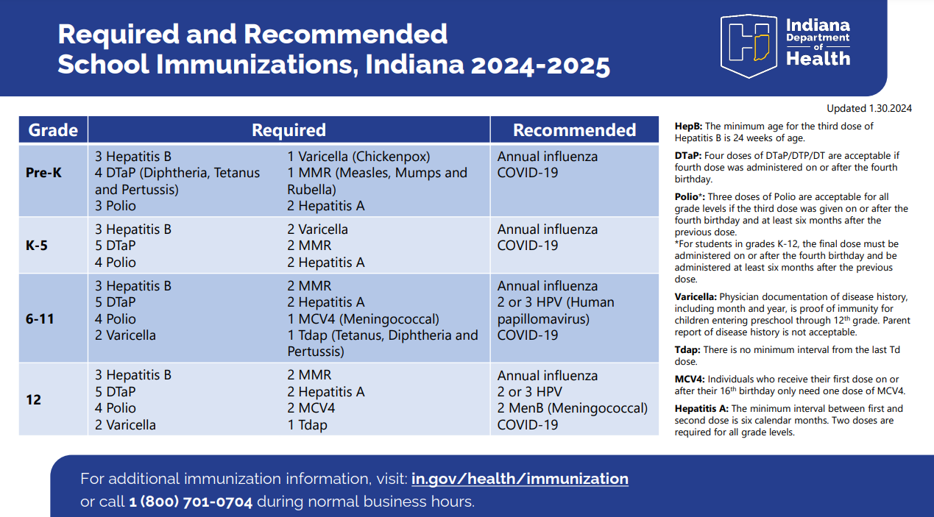
Important vaccination information
To comply with state requirements, please ensure that your child receives all necessary vaccinations before the first day of school. The deadline for submitting proof of immunizations is [insert deadline date]. Students who do not meet this requirement may be excluded from school until they are properly vaccinated. If your child has not received these immunizations, please see below for guidance on obtaining the required immunizations per Indiana State Code IC 20-34-3-2:
- Obtain immunizations at your child’s health care provider’s office
- Obtain immunizations at the (your) county public health clinic: (address and phone number of your county health department) for an appointment and for payment options
- List any other locations in your community that offer vaccines – for example, local pharmacies for those age 12 and older who have healthcare insurance, community clinic, etc.
- Provide the school’s health office with a Medical Exemption Form: https://www.in.gov/doe/files/medical-exemption-form-providers.pdf. The Medical Exemption Form must be completed and signed by your child’s health care provider. It must state in writing that the child has a medical contraindication to receiving a specific vaccine. Many contraindications to vaccination are not permanent, so a medical exemption should be obtained for the student each school year. As a true medical contraindication to immunization is vaccine-specific, a medical exemption must be written for each vaccine that is contraindicated.
- If you have a religious objection to vaccinations, the objection must be in writing, signed by the child’s parent, and delivered to the school. A religious objection must state that the objection to an immunization is based on religious grounds. To ensure the continued religious objection status for a student, parents must provide written documentation of the religious objection each school year. There is no state form for a religious objection. Medical exemptions and religious objections must be completed every school year, within 20 days of the school year’s start. Failure to comply within the first 20 days of the school year may result in exclusion proceedings per State Code IC 20-34-3-2 and MCCSC policy 5320.
Scheduling your appointment
We recommend scheduling your child’s vaccination appointment at least two weeks before the school year begins. Here are some steps you can take:
- Contact your pediatrician or healthcare provider as soon as possible
- Bring any existing immunization records to the appointment

Warm regards,
[Your Name]
[Your Title]
[School Name]
[School Contact Information]

