New Case Entry
- Log into I-Lead through the ISDH Gateway (https://gateway.isdh.in.gov/Gateway/SignIn.aspx). If you do not have access to I-Lead, please contact Abhishek Saini (asaini@isdh.in.gov) for credentials.
- On the left sidebar, click on “Enter new RA/Inspection”
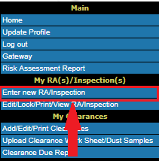
- This will take you to Page 1 of New RA/Inspection Entry, as seen below.
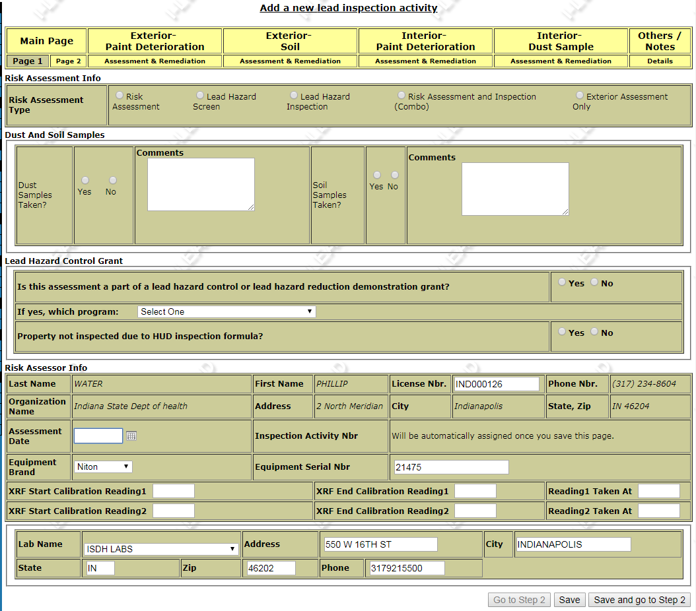
- Select the appropriate Inspection activity. If this is a property associated with an Elevated Blood Lead Level (EBLL), “Risk Assessment” or “Risk Assessment and Inspection (Combo)” should be selected.
- Select whether you’ve taken Dust and Soil samples. If you are performing a risk assessment, you MUST take dust and soil samples. If for some reason you don’t take a soil sample, record your justification for the decision (e.g. no bare soil, ground covered in snow, ground frozen) in the Comments box.
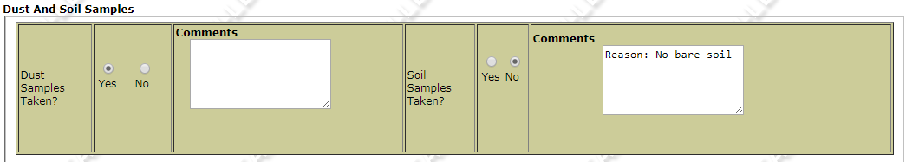
- Select whether or not the assessment is part of an LHC or LHRD grant. For the majority of users and cases, this will be answered “No.”
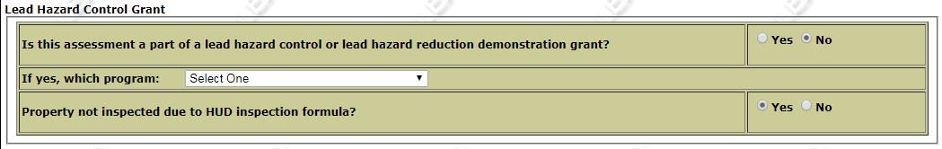
- Fill out the appropriate info in the Risk Assessor Info section. Your contact info, license number, XRF brand and serial number, and lab info should be autofilled. The only info you need to supply is the assessment date and the XRF calibration readings/times. When that is completed, click “Save and go to Step 2.”
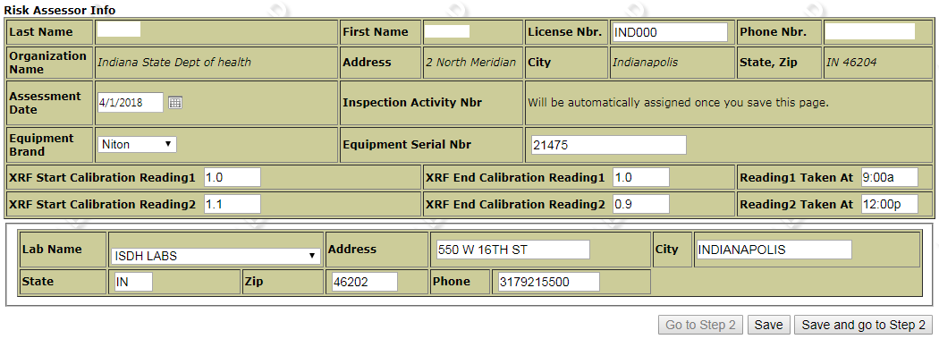
- Page 2 of the Main Page tab is for address and demographic info.
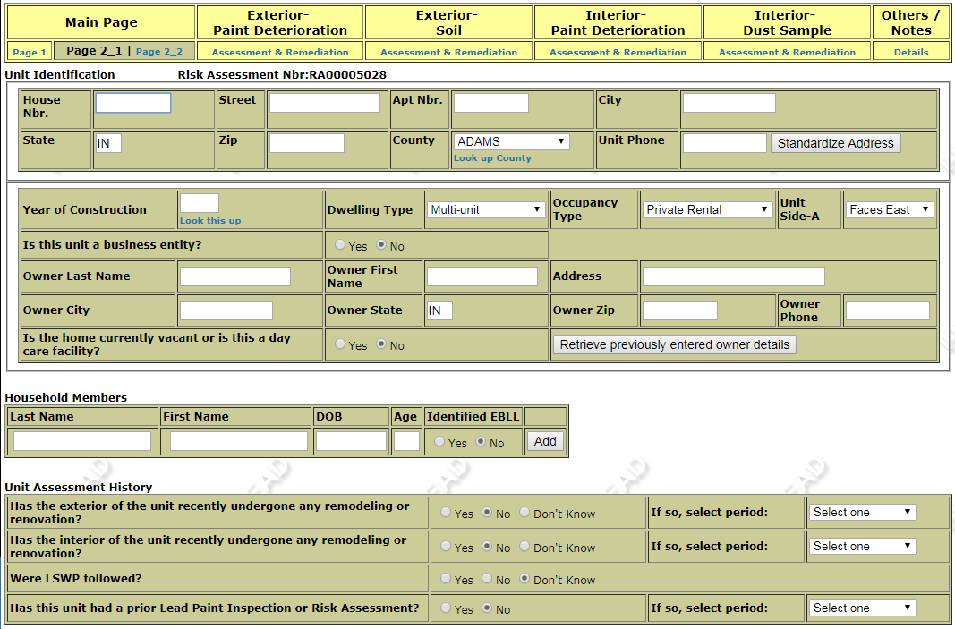
- Enter the Unit/address info. Put only the address number in the “House Nbr” box. All other street info goes in the “Street” or “Apt Nbr” boxes. Year of Construction can be found in your county’s GIS/Assessor Records. Under “Dwelling Type,” keep in mind that a building must have ≥5 individual units to be a multi-family dwelling. Duplexes are not considered a multi-family dwelling.
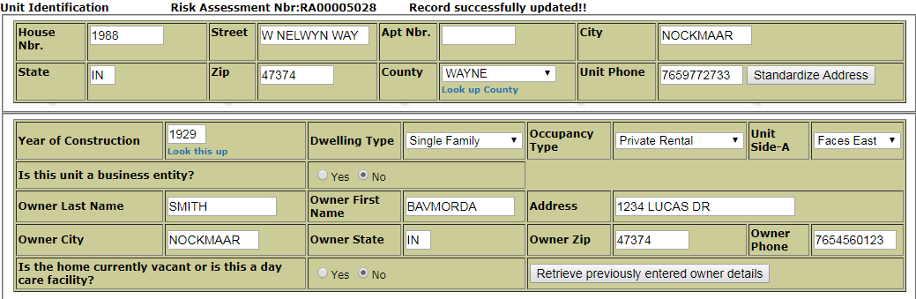

- Enter all Household Members, particularly any EBLL associated with the property. This gives both local health departments and ISDH a better tool for case management.
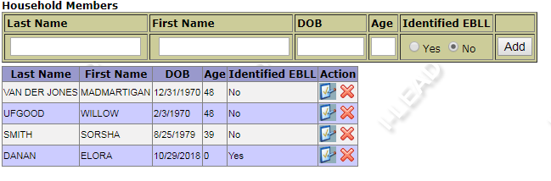
- Enter the inspection/renovation history of the unit. If you’re not sure, simply select “Don’t Know.” After that, click “Save and go to next page.”
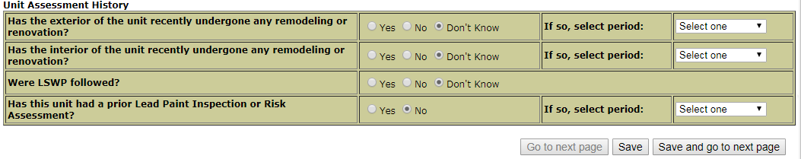

- The next tab will be “Exterior Paint Deterioration.” Any XRF readings, paint chip samples, or visual hazard verifications from the exterior of the home or the exterior of any accessory structure (e.g. barn, shed, detached garage) will go under this tab. Under Indiana law, you are ONLY required to enter lead hazards. However, if you have no hazardous readings/samples, ISDH would prefer you to enter your highest reading. This allows us verify that you completed the section.
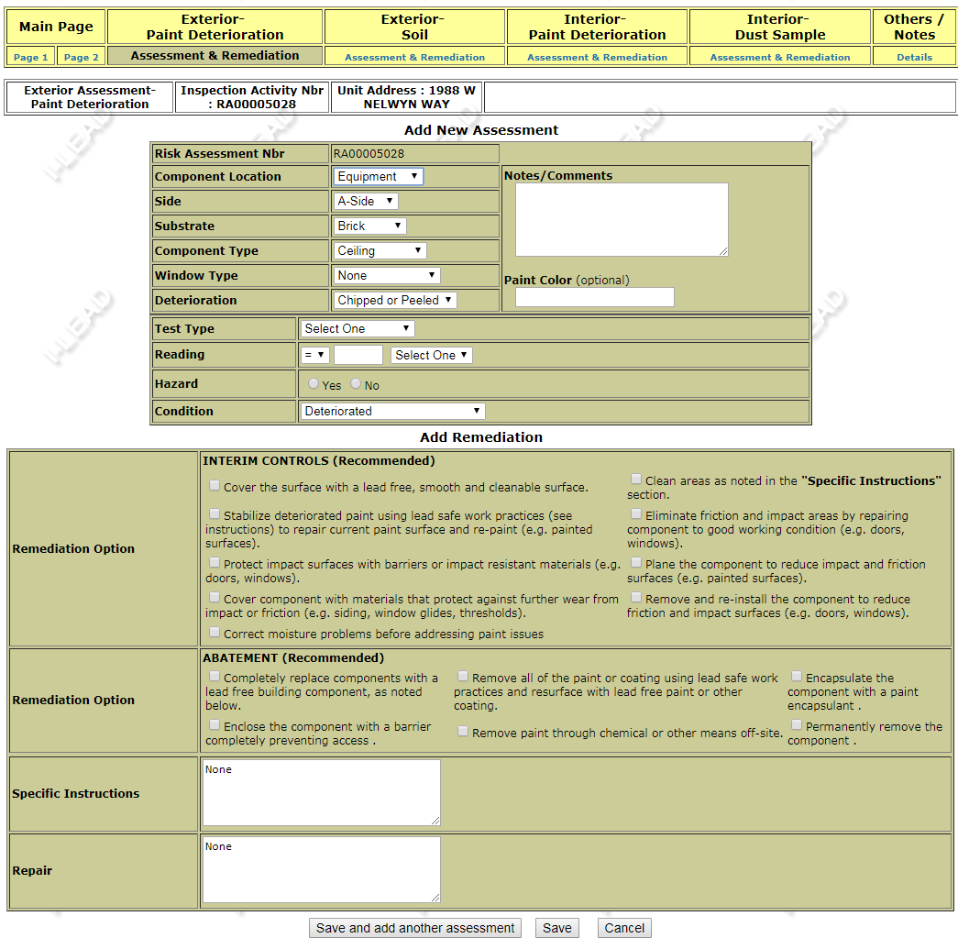

- For each reading/sample, enter a new assessment. Make dropdown selections for all applicable categories.
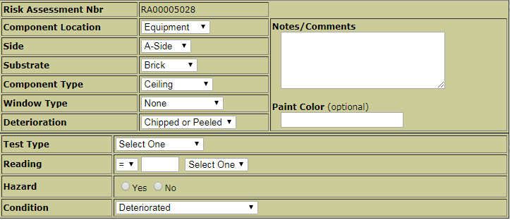
- If you select “Other” for any dropdown category, you will be prompted to specify your reason in the “Notes/Comments” box, as follows:
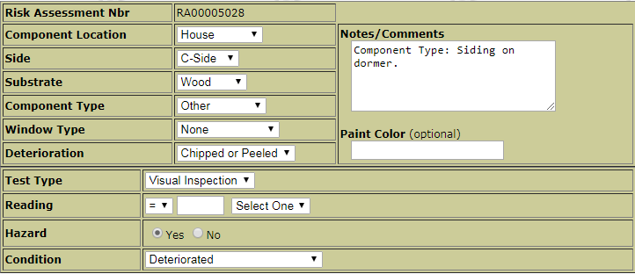
- After entering component information, you must select at least one interim control option and an abatement option. If you want a remediation option that is not listed, please write in the desired action in either the “Specific Instructions” or “Repair” box.
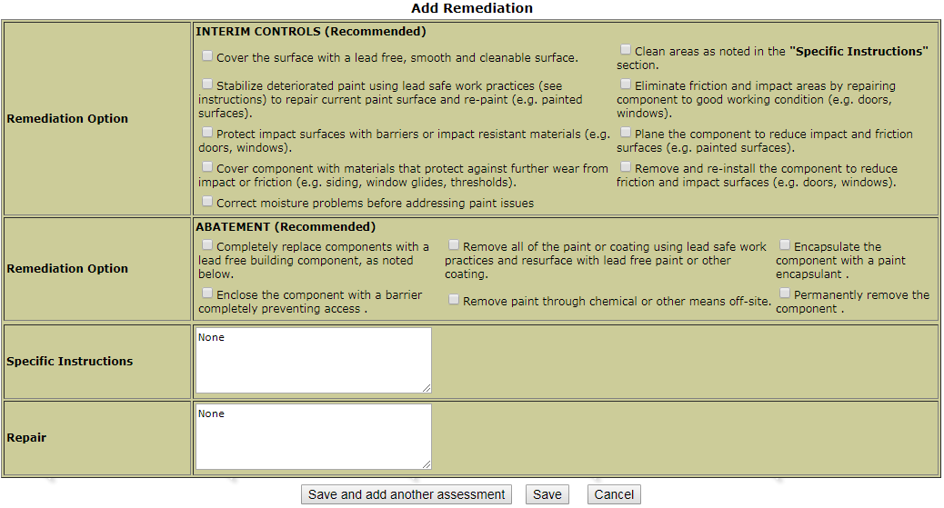

- Repeat this process for each individual hazardous component. NOTE: For exterior components with common construction, it is acceptable to note that the readings apply to all like components (e.g. siding, window sashes), as below:
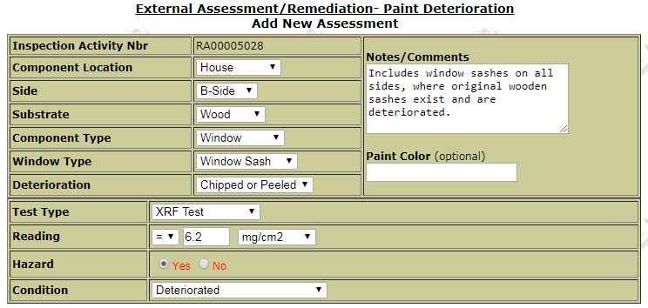
- When finished with the final component, click “Save, I am Done” and select “Exterior – Soil” from the tabs at the top of page. Click on the “Yes” radio button to confirm a soil sample was taken. If soil was not taken, select “No.” In this case please double check that your justification for not taking a soil sample was documented in the “Main Page – Page 1” section.
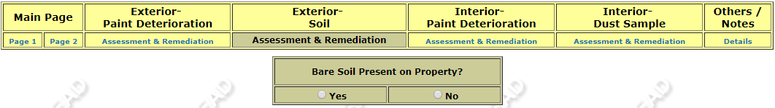

- This will take you to sample entry screen for soil:
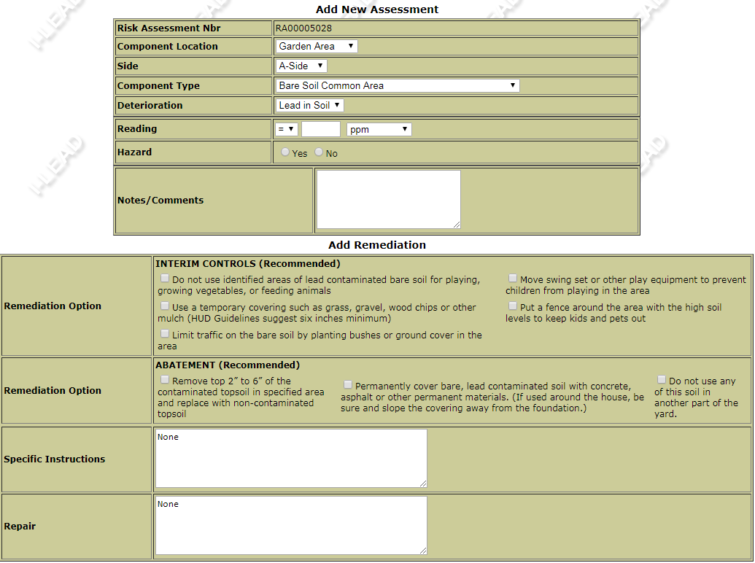
- Each sample should be entered separately. Select the appropriate info from the dropdown menus and enter the lab result for the sample. The system will automatically select whether the sample is a hazard based on the thresholds for play areas and non-play areas. NOTE: The system defaults to ppm as a measuring unit, but many labs use mg/kg. PPM, mg/kg, and ug/g are all a 1:1 conversion. 100 ppm is 100 mg/kg and 100 ug/g.
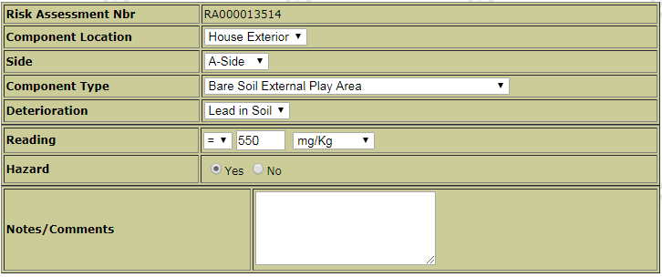

- If the sample is a hazard, select at least one Interim Control option and one Abatement option. If you want a remediation option that is not listed, please write in the desired action in either the “Specific Instructions” or “Repair” box.
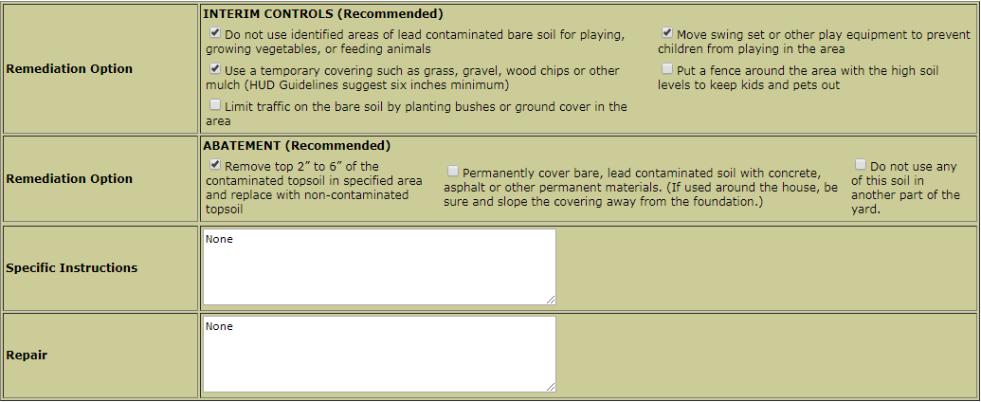
- Repeat for each sample. When you are finished with the last sample, click “Save” and select “Interior – Paint Deterioration” from the tabs at the top of the page to begin logging interior paint hazards.

- After clicking on the tab, you’ll be taken to the page for new component entry. Any XRF readings, paint chip samples, or visual hazard verifications from the interior of the home or associated interior common area (for apartment buildings) will go under this tab. Again, under Indiana law, you are ONLY required to enter lead hazards. However, if you have no hazardous readings/samples, ISDH would prefer you to enter your highest reading. This allows us verify that you completed the section.
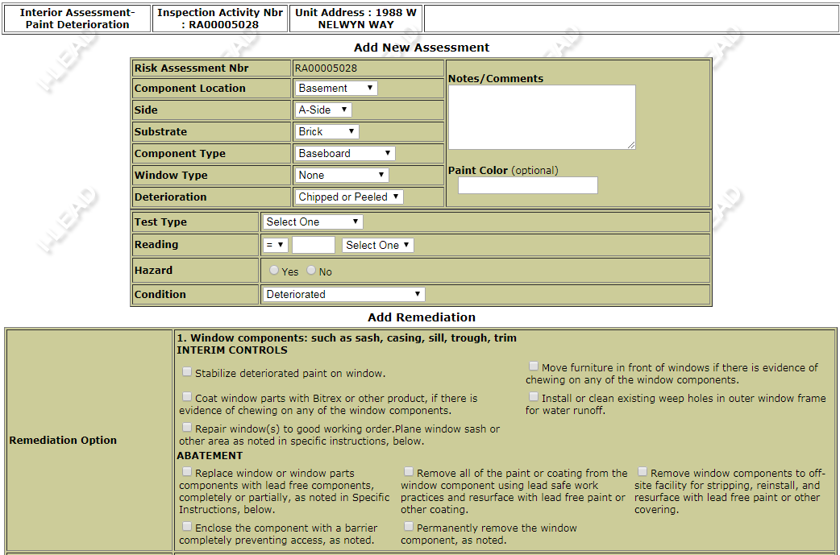
- Fill this section out in the same fashion as exterior component entry. Each hazardous testing combination in each room should be a separate entry. If all examples of a specific component in the room contain lead, you only need to enter one instance per component type (i.e. doors only need one entry, window frames only need one entry, window sashes only need one entry). NOTE: Window frames, sashes, sills, and troughs all should be entered as separate components. One blanket entry for “windows” is not sufficient.

- As in Exterior and Soil entry, you must select at least one interim control option and one abatement option per component entered. If you want a remediation option that is not listed, please write in the desired action in either the “Specific Instructions” or “Repair” box.
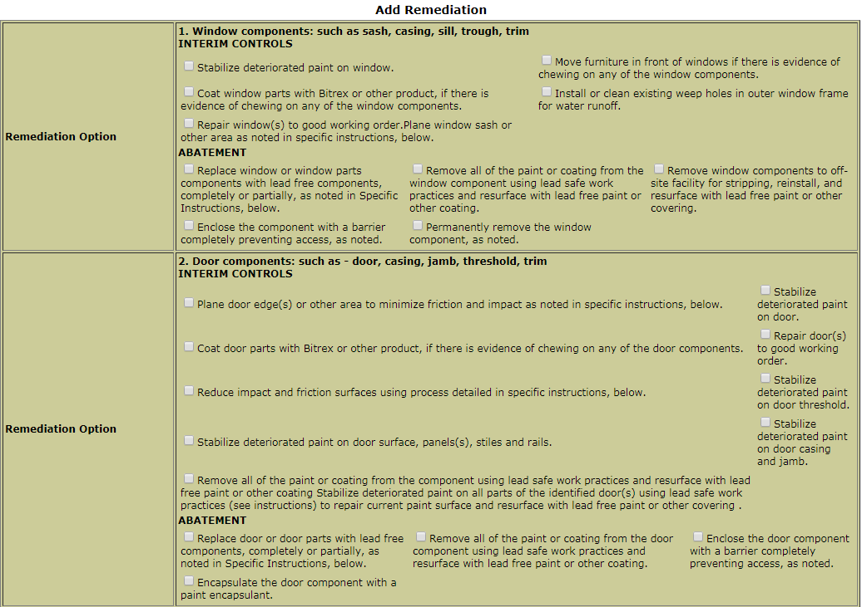
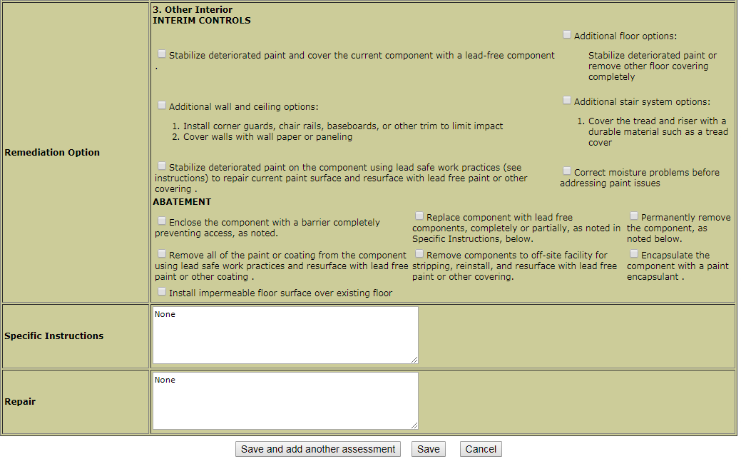

- Repeat for each interior paint sample. When you are finished with the last sample, click “Save” and select “Interior – Dust Sample” from the tabs at the top of the page to begin logging dust samples.
- This will take you to sample entry screen for dust samples:
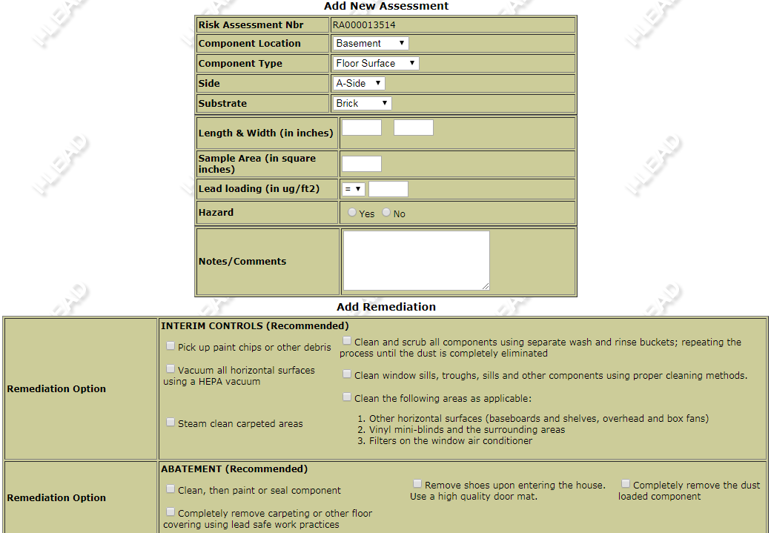

- Each sample should be entered separately. Fill in all appropriate dropdowns and fields. The system will automatically calculate the Sample Area after you enter the Length & Width. NOTE: After entering the sample result, the system will automatically designate its hazard status based on the thresholds for that component. The defaults are set to 40 ug/ft2 (floors), 250 ug/ft2 (sills), and 400 ug/ft2 (wells/troughs). If this investigation was performed as part of a HUD grant, manually select the appropriate radio button to reflect the lower thresholds.
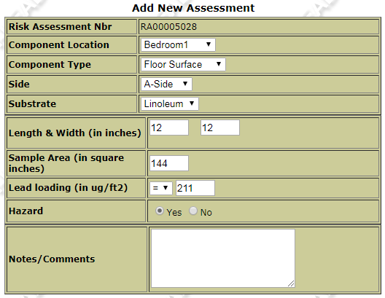
- As in all other tabs, you must select at least one interim control and one abatement option for each dust hazard. If you desire a remediation option that isn’t listed, write it into either the Specific Instructions or Repair box.
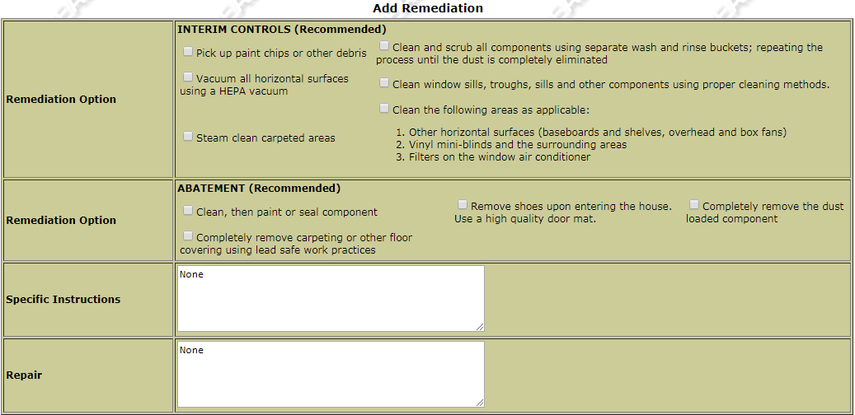
- Enter all dust samples, then click “Save” and move onto the final tab, “Others/Notes.”
- This is the tab you’ll use as a catchall for any samples/readings that don’t fit in the other categories or aren’t building components. These could be water samples, food samples, cosmetics, dishes, lawn ornaments, or play equipment, to name a few examples. Fill in the dropdowns and fields with the appropriate information, and select at least one interim control and one abatement option for each hazard.
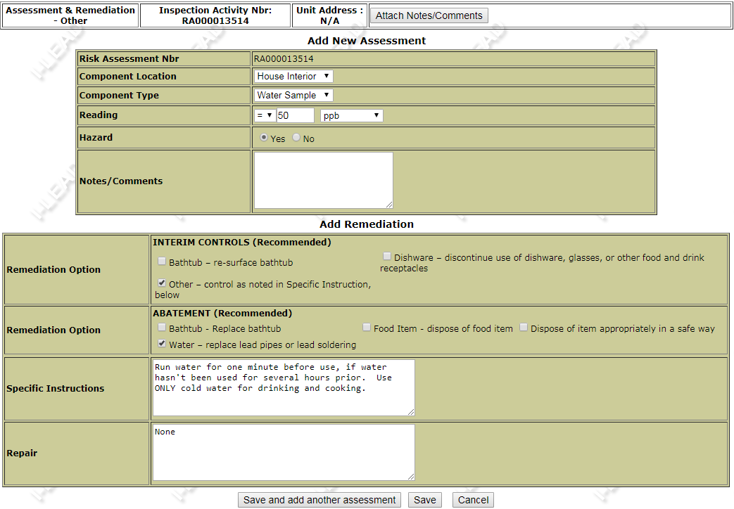
- After entering your final sample, click “Save,” then click “Attach Notes/comments” to enter any non-sample information.
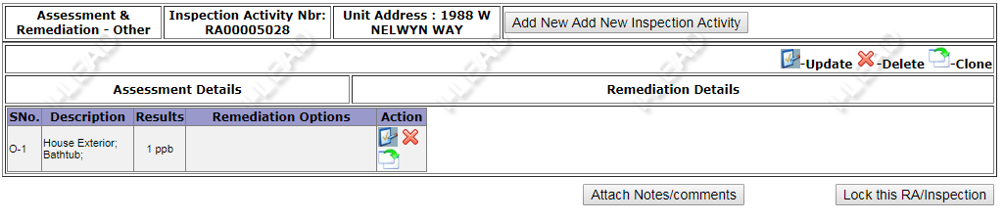

Below is an example of the kind of information you might include in this section:
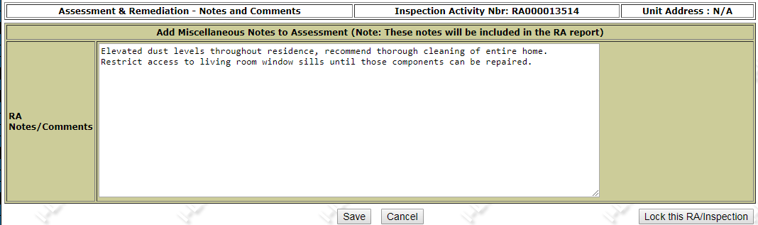
- After completing this section, click on “Lock this RA/Inspection.” You’ll be taken to a screen where you can upload any photos, inspection sheets, or other files pertinent to the investigation. The system will use the final photo you upload as the cover photo for your report. After uploading all your files, click “I have uploaded all attachments. Click to proceed to next step.” NOTE: You can upload as many files as you need, but each individual file must be <5mb.
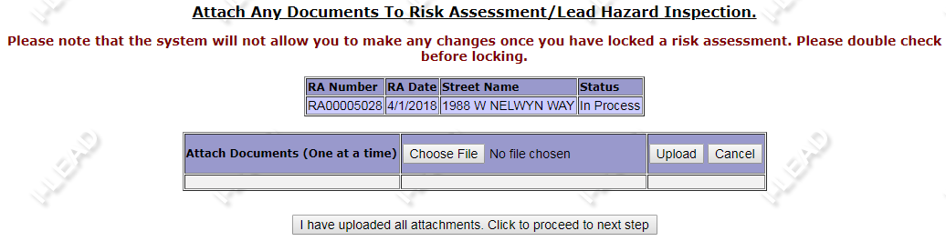
- On the next screen, select whether remediation is required and the appropriate time frame, and click “Submit and Lock RA.”
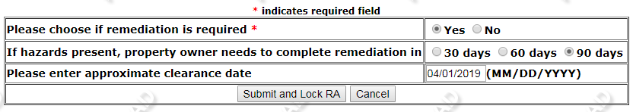

- This will take you back to I-Lead’s main screen. Click on the “Edit/Lock/Print/View RA/Inspection” to the left…
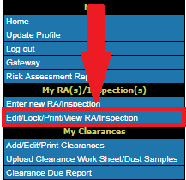
…and search for the address you just entered:
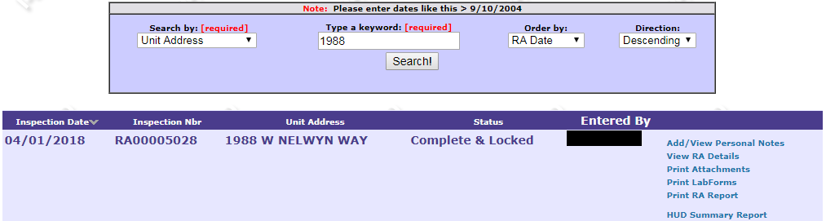
Click on “Print RA Report” on the right side and you’ll be taken to a screen that asks you if the risk assessment is a public request. NOTE: For the purposes of I-Lead, all investigations not associated with an EBLL are considered public requests.
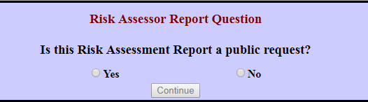
Select the appropriate button and and a report will be generated for you to print.

