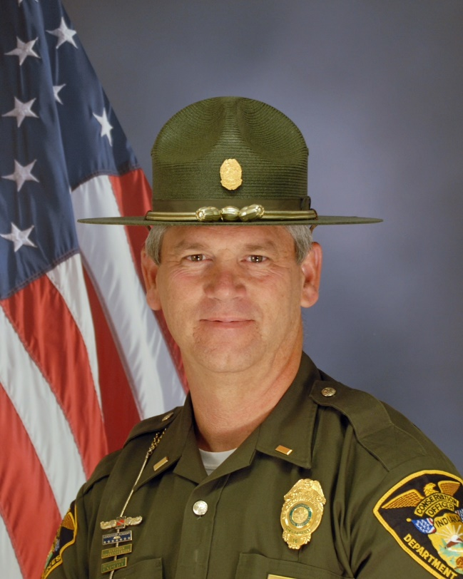

Presenter:

Captain Bill Browne became an Indiana Conservation Officer in 1987 and was assigned for 23 years to Fayette County before being promoted to Public Relations Lieutenant in 2011, then Captain in 2015.  In addition to his field patrol duties, he served the Division as a search and recovery diver and recorded over 30 body recoveries.  He has 4 lifesaving awards.  Captain Browne is a 2012 graduate of IMPD Leadership Academy.  Captain Browne developed and implemented the DNR Law Enforcement Division’s Peer Support program and Chaplain program in 2014.

Course Description:

All police officers live stressful lives and they all need help to overcome the adversities that this career can bring.  This presentation will take a look at how Indiana Conservation Officers have built, maintain and grow a peer support program to assist their officers in to day to day situations, as well as coping with critical incidents.  We will also discuss our Chaplaincy, how it was built, how we maintain it, the function of the Chaplains and their interaction with our Peer Support Team.

