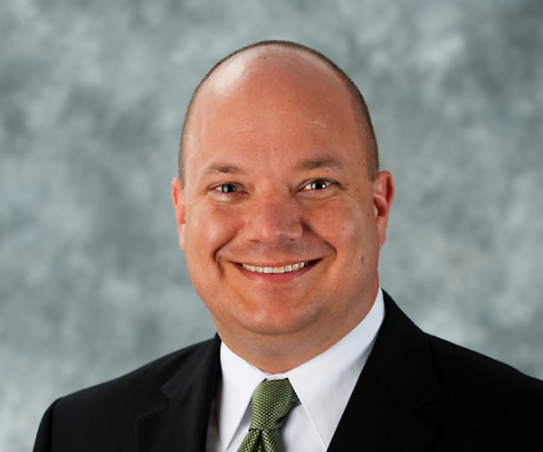

Presenter:

Michael Warren is an Instructor for Command Presence Training. He is the lead instructor for the Transformational Trainer Program.

Michael began his career in law enforcement in 1994 as an Emergency Dispatcher. He completed his full-time law enforcement career as a Law Enforcement Sergeant in April 2018. During his career Michael served in many different capacities. He has been a patrol officer, detective, DEA Task Force Officer, patrol sergeant, and the Training and Standards Sergeant. He was the primary use of force instructor for his agency and was responsible for developing and delivering the Civilian Pistol Safety class. Michael also teaches nationally for Police Technical and Below 100.

Michael earned his Bachelor of Science in Administration of Justice from Liberty University. He returned and earned his Master of Business Administration (MBA) and Master of Criminal Justice degrees from Liberty University. He graduated from the Michigan State University School of Police Staff and Command. He is a member of the International Law Enforcement Educators and Trainers Association.

Michael lives in Michigan with his wife and four children. In his “spare” time Michael is a huge baseball fan and an avid reader.

Course Description:

(See below)

