**INDOT Cultural Resources Office (CRO)**

**Submission Form for Project Review under the Minor Projects PA**

**Category B Projects**

**Instructions:**

* Applicants should first consult the Minor Projects PA in order to determine if the proposed project meets the conditions of the categories listed in Appendix A. Projects that meet the conditions listed in Appendix A and are limited to the existing road right-of-way do not need to be reviewed by INDOT-CRO. Questions regarding Category A applicability should generally be directed towards the appropriate INDOT District environmental staff, who will contact INDOT-CRO if necessary (for contact info see <http://www.in.gov/indot/2527.htm>). In unique circumstances or if the level of soil disturbance is unclear, applicants may contact INDOT-CRO (see the Cultural Resources Manual (CRM), Pt. 2, Ch. 3-2.1).
* The MPPA Submission Form has three sections (1, 2, and 3).
* All submissions to INDOT-CRO must include a completed Section 1.
* Most submissions to INDOT-CRO only require Section 1 to be completed.
* Section 1 may be completed by an INDOT Project Manager, INDOT Environmental Staff, Environmental or Design Consultant, Local Public Agency Official, or other person associated with the project. A qualified professional historian (QP) is not required to complete Section 1.
* If applicable, Section 2 and Section 3 must be completed by a QP.
* Consult the MPPA flowchart to determine if Section 2 or Section 3 need to be completed.
* Please provide all the information requested in the MPPA submission forms. INDOT-CRO will reject incomplete submissions.
* Please do not provide more information than what is requested in the MPPA submission forms. Providing information beyond what is required creates unnecessary project costs and delays.
* Applicants should email MPPA submissions to all of the following: the CRO Manager, History Team Lead, and Archaeology Team Lead (see CRM Pt 1, Ch. 3 for contact info).
* The submission form should be submitted to INDOT-CRO as a Microsoft Word file. Applicants may extract the applicable section(s) from this document and submit to INDOT-CRO.

**Important things to remember about the MPPA submission and review process:**

* All projects requiring right-of-way acquisition must be submitted to INDOT-CRO for review under either Category A or B using the MPPA Submission Form.
* After reviewing the applicant’s submission, INDOT-CRO may determine that the project cannot meet the conditions of the MPPA and must go through full Section 106.
* INDOT-CRO may request additional information in order to determine if the project meets the conditions of the MPPA.
* INDOT-CRO may require firm project commitments in order to approve the project under the MPPA. Resolution of these commitments often requires notes on the plans and sometimes requires unique special provisions (USPs).
* Submit project information for MPPA review as early as possible. This will help to ensure that Section 106 compliance does not cause delays to the project schedule.
* If the project scope or limits change for a project that was previously determined to meet the conditions of Category B, INDOT-CRO must review the revised project scope/limits in order to determine if the project still meets the conditions of the MPPA. INDOT-CRO should be notified of any changes to scope/limits ASAP in order to avoid delays to the project schedule.
* MPPA submissions should not include an Area of Potential Effects (APE). An APE is needed only if the project proceeds to full Section 106.
* For the purposes of the MPPA, INDOT-CRO prefers to take a conservative approach and assume that most of the properties rated ‘notable’ or ‘outstanding’ in the IHSSI as well as all IHSSI-surveyed historic districts are National Register-eligible. In rare cases, INDOT-CRO will determine otherwise if the project is unlikely to cause impacts to the resource and there is clear and overwhelming evidence that the resource is not eligible for the National Register of Historic Places (National Register) or that the resource has been demolished. QP consultants should work under the same assumption regarding the eligibility of ‘notable’ and ‘outstanding’ properties and IHSSI-surveyed historic districts.
* Detailed National Register evaluations and analyses should not be included in an MPPA submission.

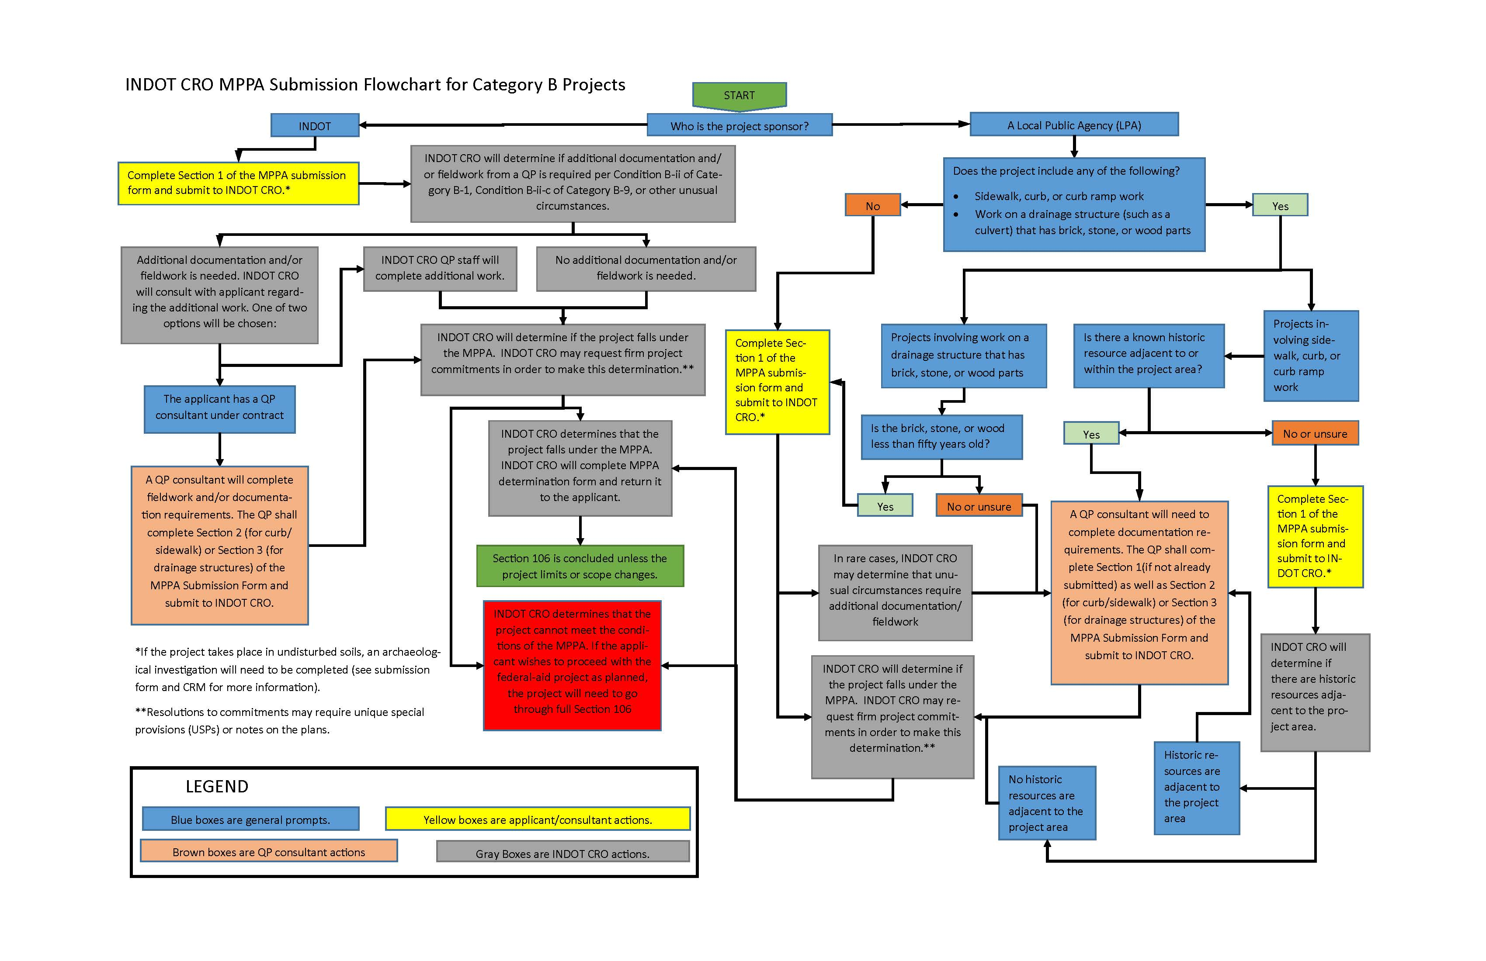

**SECTION 1: General Project Information**

* ***All MPPA Category B submissions must include a completed Section 1.***
* ***Section 1 may be completed by an INDOT Project Manager, INDOT Environmental Staff, Environmental or Design Consultant, Local Public Agency Official, or other person associated with the project. A qualified professional historian (QP) is not required to complete this section.***

**Date of submission:**

**Project Designation Number (Des. No.):**

**Name and contact information of applicant/consulting firm:**

**Route Number (if applicable):**

**Civil Township:**

**City/County:**

**Project Description:**

**If the project includes any curb, curb ramp, or sidewalk work, please specify the location(s) of such work:**

**For bridge or small structure projects, please list feature crossed, structure number, NBI number, and structure type:**

**For bridge projects, is the bridge included in INDOT’s Historic Bridge Inventory (**[**https://www.in.gov/indot/2531.htm**](https://www.in.gov/indot/2531.htm)**)?**

**Yes  No**

**If yes, did the inventory determine the bridge eligible for or listed in the National Register of Historic Places? Please provide page # of entry in Historic Bridge Inventory.**

**Yes  No**

**Inventory Page #____________**

**Please list the MPPA Category or Categories under which you believe the project falls (updated MPPA appendices can be found in the Cultural Resources Manual and the Cultural Resources Website** [**https://www.in.gov/indot/files/Minor%20Projects%20PA%20with%20Revised%20Appendices.pdf**](https://www.in.gov/indot/files/Minor%20Projects%20PA%20with%20Revised%20Appendices.pdf)**):**

**Will there be right-of-way acquisition as part of this project?**

**Yes  No  Don’t know**

**If yes, how much? ­­­­­­_________________________**

**Archaeology (check one):**

**All proposed activities are presumed to occur in previously disturbed soils.**

*\*INDOT-CRO will notify you if project area incudes undisturbed soils and requires an archaeological reconnaissance.*

**Project takes place in undisturbed soils and the archaeology report is included in submission**

**Project takes place in undisturbed soils and the archaeology report is forthcoming**

*\**For INDOT-sponsored projects, INDOT-CRO may be able to complete the archaeological investigation. I*f you would like to request that INDOT-CRO complete an archaeological investigation, please contact the INDOT-CRO archaeology team lead. See CRM Pt. 1 Ch. 3 for current contact information.*

**Please attach the following to this form:**

* 1. **General Location Map.** This map should allow the CRO reviewer to quickly locate the project.
  2. **Aerial photography map(s) of project area.** This map must include project limits. It may also include SHAARD data, but SHAARD data is not required.
  3. **If bridge or small structure project, please attach photographs of bridge or small structure.** Photographs can be found in inspection reports located in INDOT’s Bridge Inspection Application System (BIAS), as well as other project documents, such as engineering assessments or mini-scopes.

**In the email submission to INDOT-CRO, please also include:**

1. **A GIS polygon shapefile or KMZ file of the project area** (shapefiles are preferred). Shapefiles should use “NAD_1983_UTM” projected coordinate system. In addition, these files should contain the following *text* attribute field: DES_NO. The project designation number should be entered in this field.
2. **If the project takes place in undisturbed soils, attach the results of the archaeological investigation, if completed.** *Note:**The MPPA Submission Form may be submitted before the archaeology report. INDOT-CRO staff will process the above-ground portion of the form in advance of the archaeological portion of the form. However, a completed determination form will not be returned to the applicant until after the archaeology report has been reviewed and approved by INDOT-CRO.*

**SECTION 2: Minor Projects PA Category B-1, Condition B-ii Submission**

* ***Only complete this section if the MPPA flowchart indicates it is necessary.***
* ***This section must be completed by a qualified professional historian (QP) who meets the Secretary of the Interior’s Professional Qualification Standards as per 36 CFR Part 61.***
* ***In assessing properties that are adjacent to or contain locations where curb, curb ramp, or sidewalk work will occur, QPs should be on the lookout for the following properties:***

***-Previously un-surveyed historic districts that may be eligible for the National Register. If the QP identifies such a district, they should consult with INDOT-CRO before proceeding.***

***-Individual resources that were either previously un-surveyed or previously surveyed as “contributing” and that the QP believes merit a rating of “notable” or higher. If the QP identifies any such resources, they should follow the instructions found in Prompt 4 below.***

**Date of submission:**

**Project Designation Number (Des. No.):**

**Name and contact information of QP historian:**

**Date of fieldwork:**

**Prompt 1. List all National Register-listed districts and individual resources that are adjacent to or contain locations where curb, curb ramp, or sidewalk work will occur**.

**Prompt 2. List all IHSSI individual properties that meet ALL of the following conditions: 1) they are adjacent to locations where curb, curb ramp, or sidewalk work will occur; 2) they are rated “notable” or outstanding” (it is not necessary to include properties rated “contributing”); and 3) they are located outside of previously surveyed or National Register-listed historic districts.**

**Prompt 3. List any IHSSI districts that are adjacent to or contain locations where curb, curb ramp, or sidewalk work will occur and that are not listed on the National Register.**

**Prompt 4. List any properties *not* included in the answers to Prompts 1-3 and that meet ALL of the following conditions: (a) they are recommended eligible for the National Register by the QP historian; (b) they are adjacent to locations where curb, curb ramp, or sidewalk work will occur; (c) they are located outside of previously surveyed or National Register-listed historic districts. Please include a brief description of any such properties. A full evaluation is not needed.**

**Prompt 5. List all unusual features that are adjacent to or within any of the properties or districts included in the answers to Prompts 1-4 AND that are adjacent to locations where curb, curb ramp, or sidewalk work will occur (refer to Condition B-ii-b).**

**Prompt 6. For each feature identified in Prompt 5, indicate whether the feature will be impacted by the project. If the feature will not be impacted by the project, state that a commitment to avoid the feature shall be included in the environmental documentation for the project and entered into INDOT’s project commitment database (refer to Condition B-ii-b-1). Project commitments require coordination with the INDOT Project Manager and project designer. Please consult CRM Pt. 2, Ch. 3-3.1 for instructions regarding MPPA commitments.**

**Prompt 7. If any features identified in Prompt 5 cannot be avoided, describe the extent of anticipated impacts below. INDOT-CRO will review these impacts, consult with SHPO if necessary, and determine if the project meets the conditions of Category B-1 of the MPPA (refer to Conditions B-ii-b-2 and B-ii-b-3).**

**Please attach the following (in addition to the attachments required in Section 1 of this form):**

1. **Aerial photography map(s) of the project area that clearly indicates the locations of curb, curb ramp, and sidewalk work and includes SHAARD data.**
2. **Photographs**. All photographs must include a caption indicating the photograph’s location and orientation, theNational Register-listed or National Register-eligible resources that are being shown, and the unusual features that are being shown, as applicable.
   * 1. Photographs of locations where curb, curb ramp, or sidewalk work will occur adjacent to or within resources listed in the answers to Prompts 1-4. These photographs should clearly show the immediate area where curb, curb ramp, or sidewalk work will occur. They need not depict the properties adjacent to such locations.
     2. Photographs of each unusual feature described above. These photographs should highlight each unusual feature in some way, e.g. using the arrow comment tool in Adobe Acrobat. When these features will be avoided, a note should be made in the photograph caption.
     3. Photographs of any properties included in the answer to Prompt 4.

**SECTION 3: Minor Projects PA Category** **B-9, Condition B-i-c-2 or B-ii-b-3 Submission**

* ***Do not complete this section before consulting the MPPA submission flowchart. Only complete this section if the flowchart indicates it is necessary.***
* ***This section must be completed by a historian who meets the Secretary of the Interior’s Professional Qualification Standards as per 36 CFR Part 61.***

**Date of submission:**

**Project Designation Number (Des. No.):**

**Name and contact information of QP historian:**

**Please list feature crossed, structure number, and structure type:**

**Please provide an assessment of the structure’s integrity and significance, per Condition B-i-c-2/B-ii-b-3 of Category B-9:**

**Please attach the following (in addition to the attachments required in Section A of this form):**

1. **Aerial photography map(s) of the project area that includes SHAARD data.**
2. **Photographs of the drainage structure** **that clearly show the non-modern brick, wood, or stone components of the structure.** *Photographs do not need to be taken by a qualified professional historian.* Photographs may be found in inspection reports located in INDOT’s Bridge Inspection Application System (BIAS), as well as other project documents, such as engineering assessments or mini-scopes. If appropriate photographs are unavailable in BIAS or project documents, a field visit may be necessary.