How to Create an Inspection Master

This function is located in Inventory-> Masters

Description
This “HOW TO” manual describes how to Create an Inspection Master. A Master is equivalent to an Inspection Type. An Inspection Master must be created for each type of inspection. A master only needs to be created once. Please note that if you have as asset with two inspection types, for example Inspection Type Routine and Inspection Type Special you will need to create 2 Masters, one Master for Routine and one Master for Special. The Master allows you to specify the frequency in which to run that specific report type.

Steps

# | Description
1. | - Search for an Asset. Example I465-162-04452 CEBL.  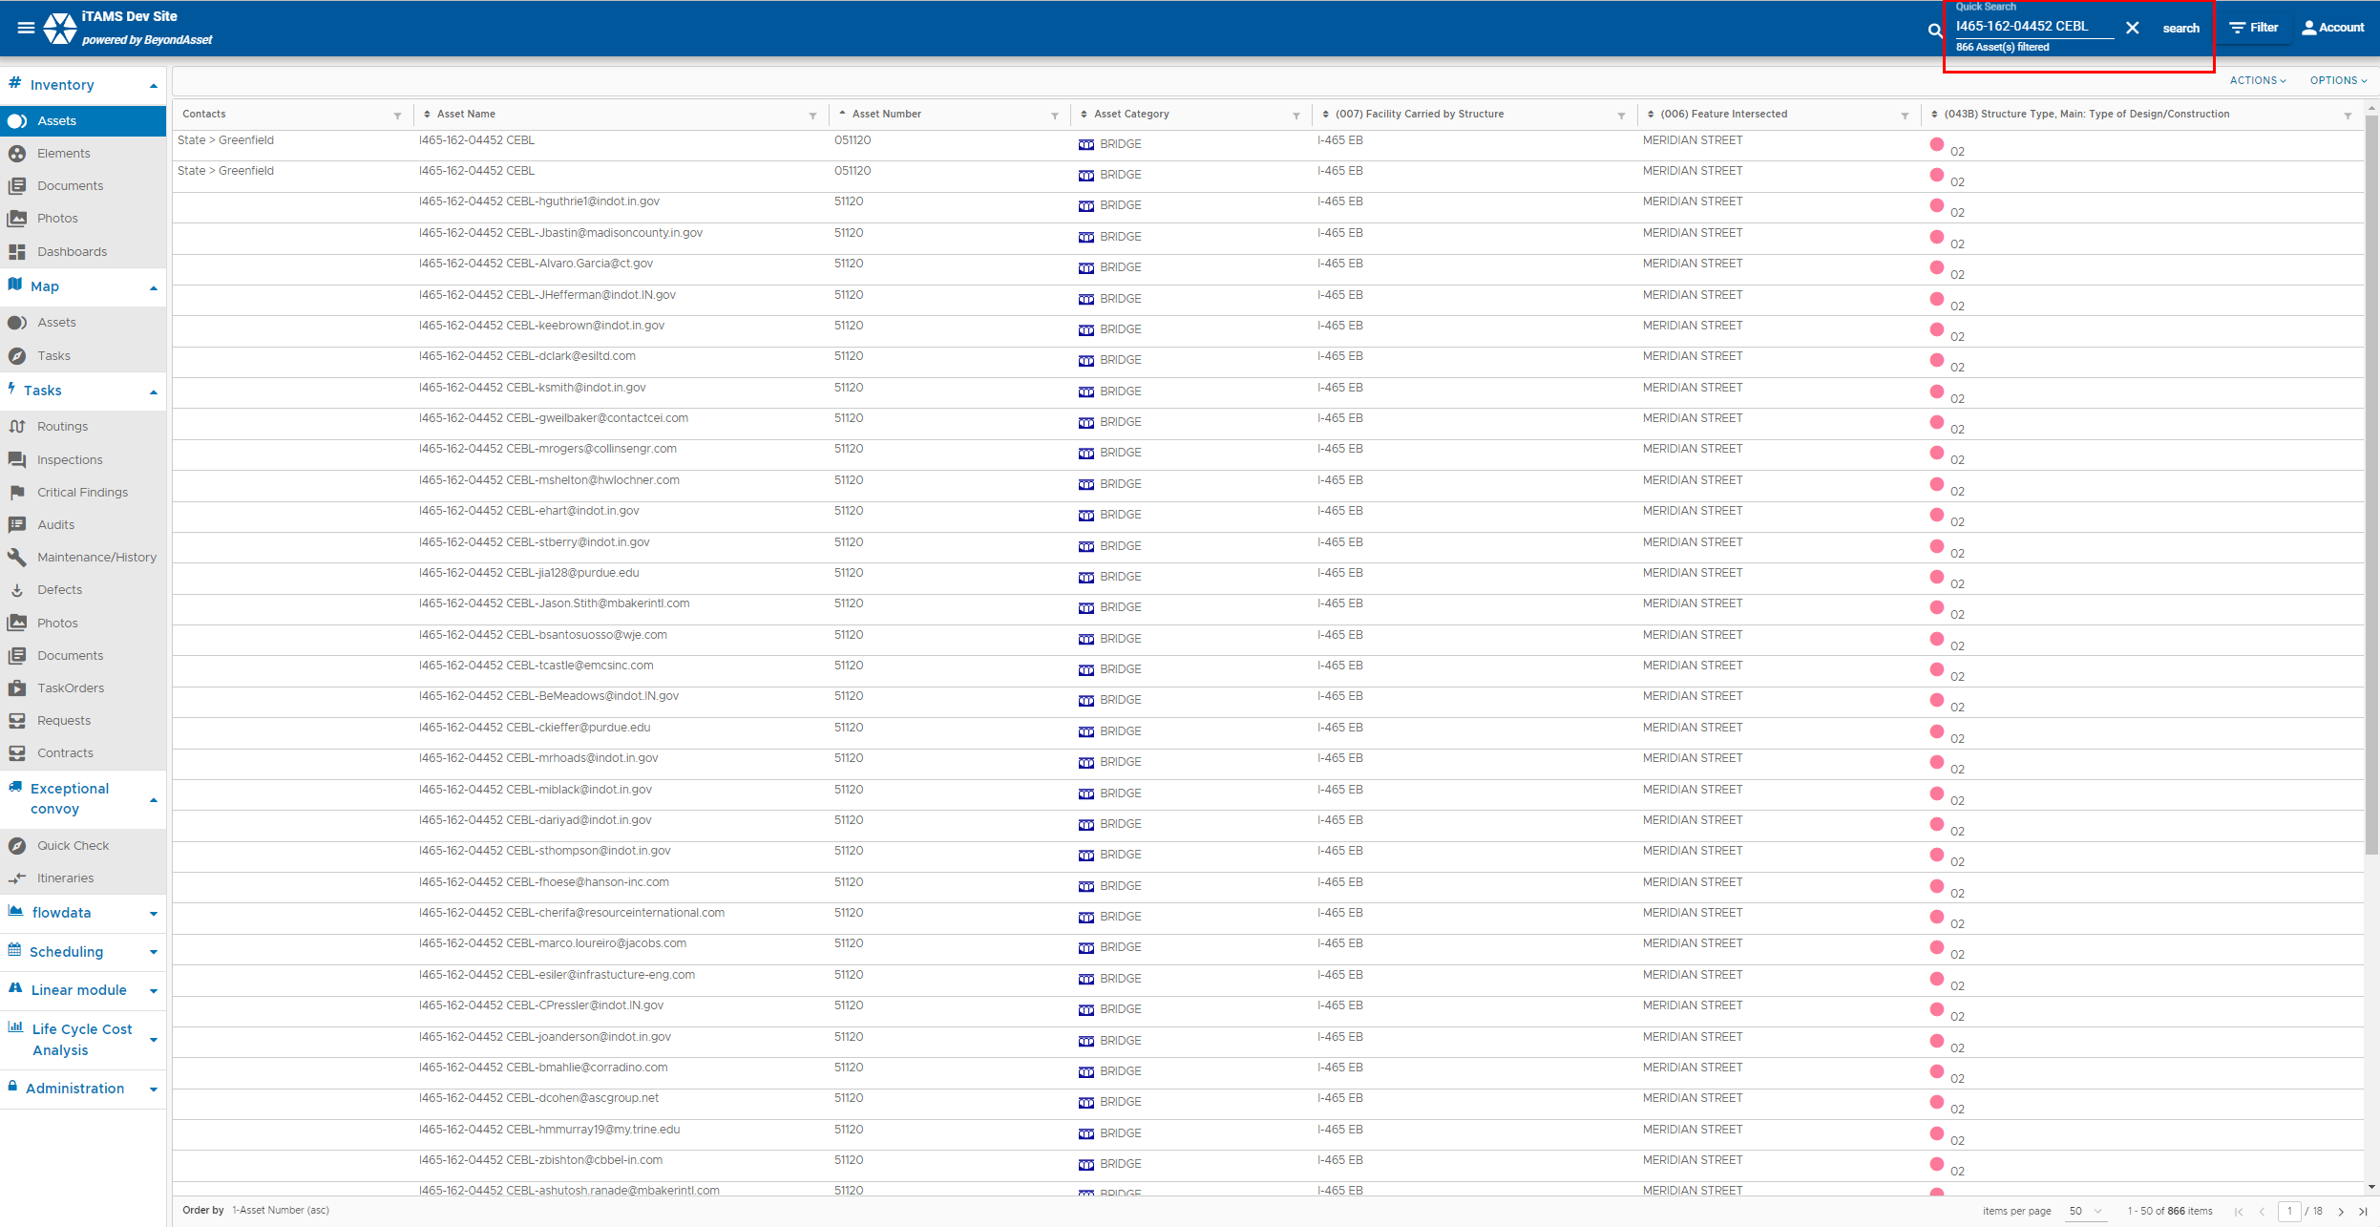  - Select an Asset. Click on the Masters tab to see what Master exist if any.  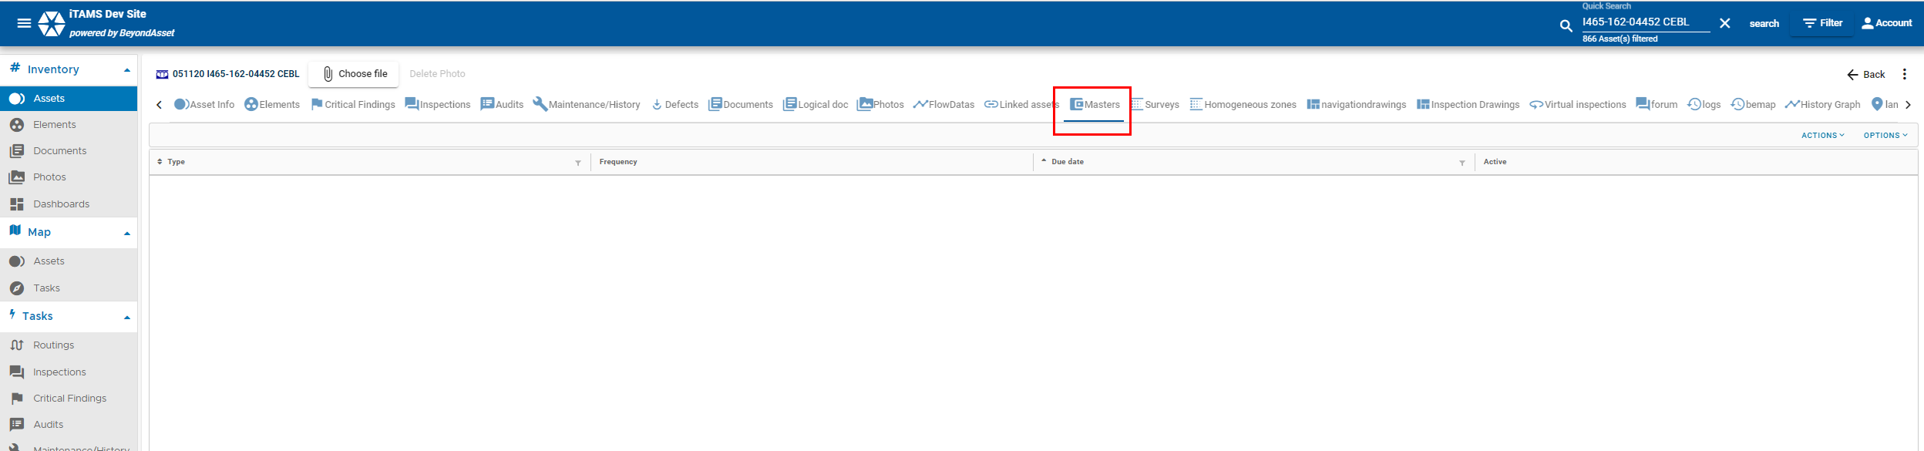  - If no Master exist, then you will have to create one in order to schedule an inspection. Once you create a Master for a particular inspection type, you will be continuously allowed to schedule inspections for that inspection type. You only create a Master once for each type of inspection.  - To create a Master, select the Masters tab. Go to Actions +Add.  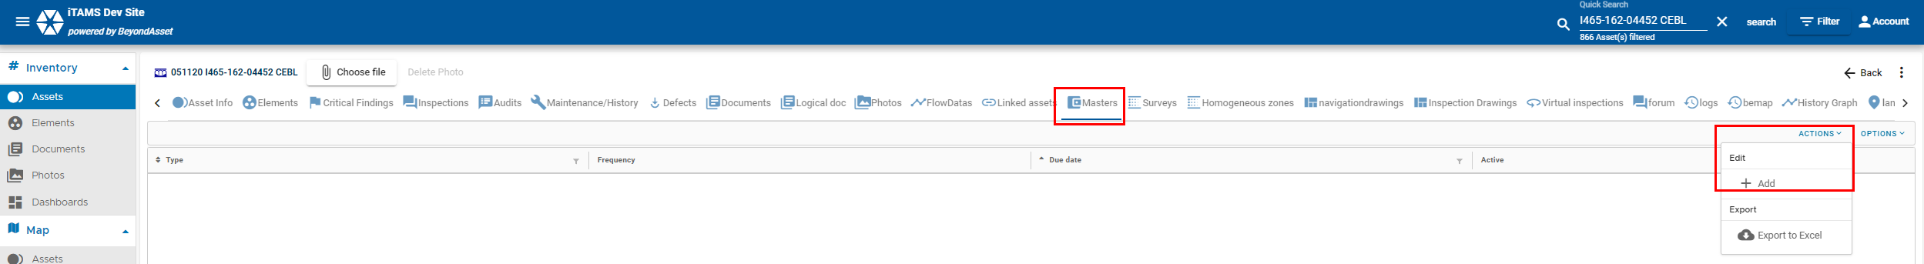  - Select the Type, Enter in the Frequency for the Type of Inspection, the Due date will automatically populate to the current date (you can change it if necessary), enter any comments, then click save (green checkmark in the bottom righthand corner).  