How to Load Inspection Document

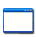 | This function is located under: Inspections->Documents->Tab

Description
This “HOW TO” manual describes the way to load inspection documents.

Steps
# | Description
1. | - To update an inspection, first select an Asset.  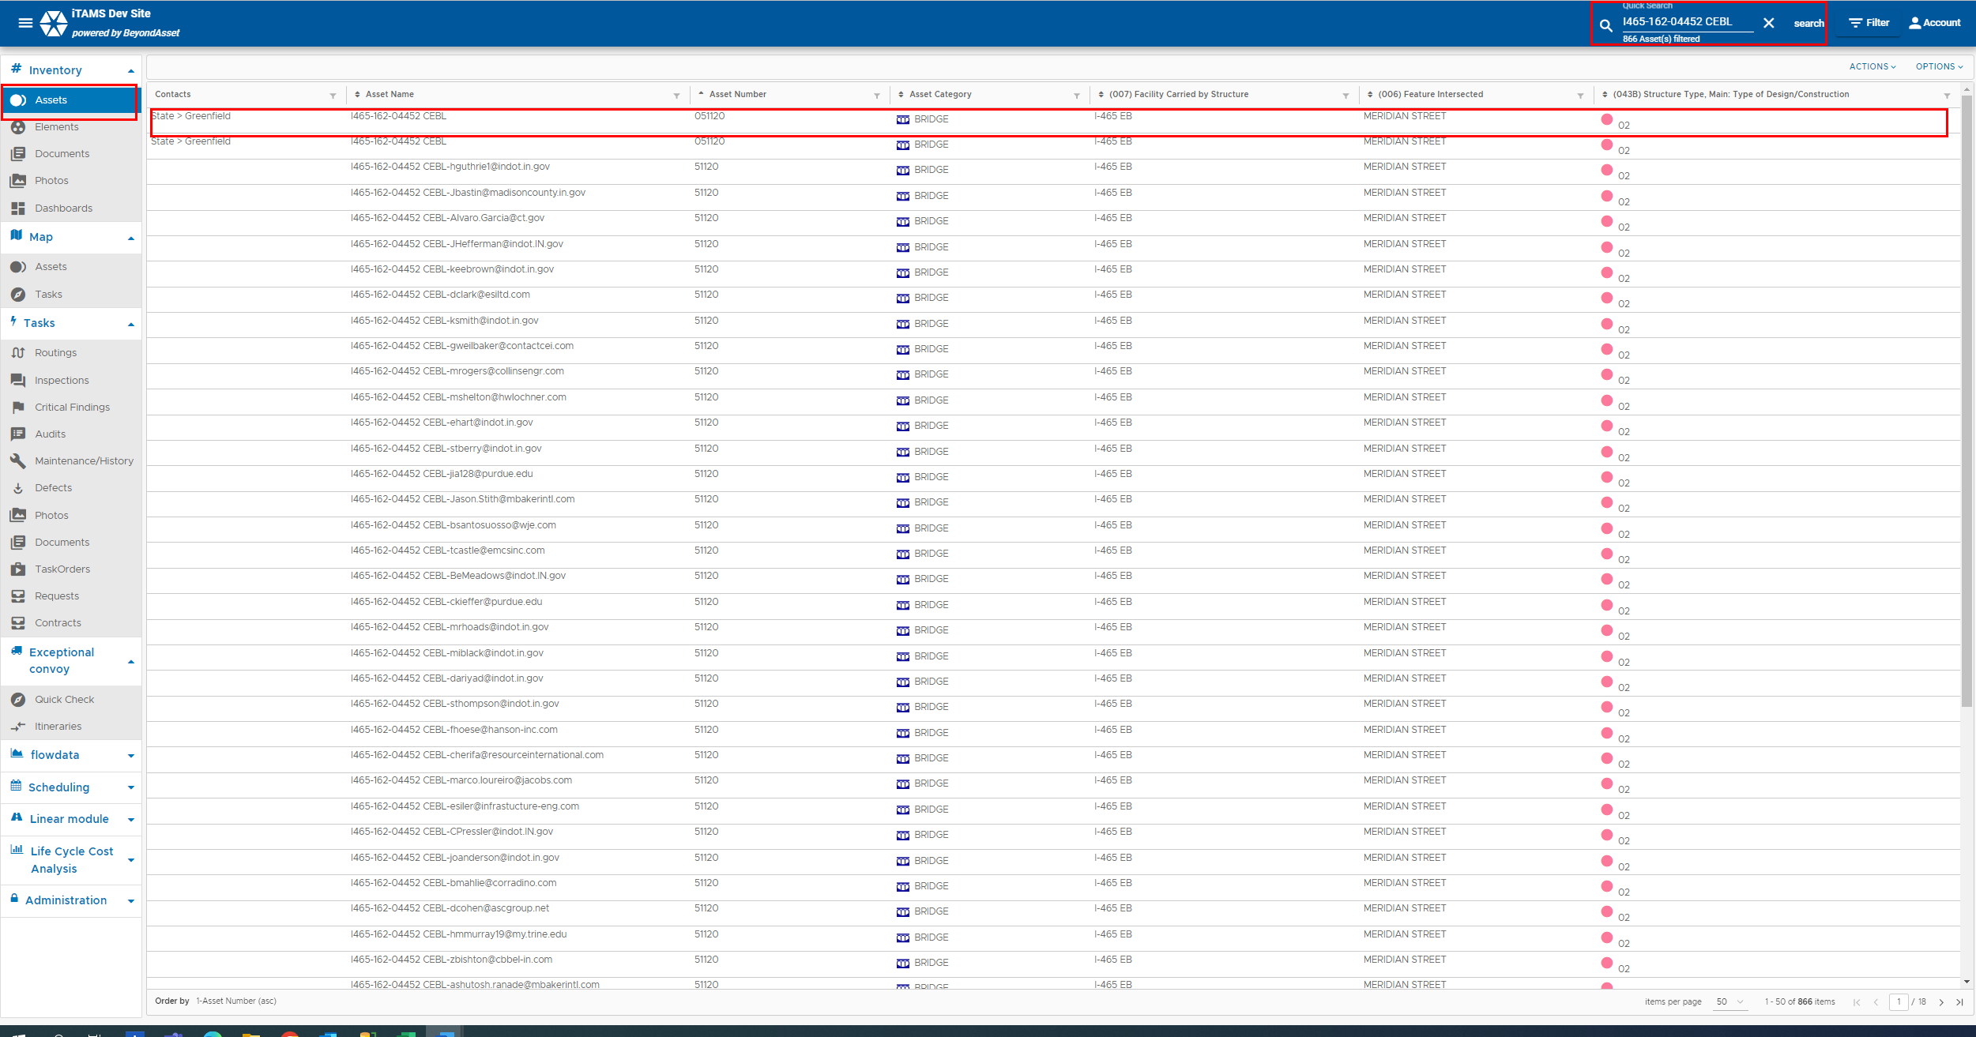

2. | Click on the Inspections tab.  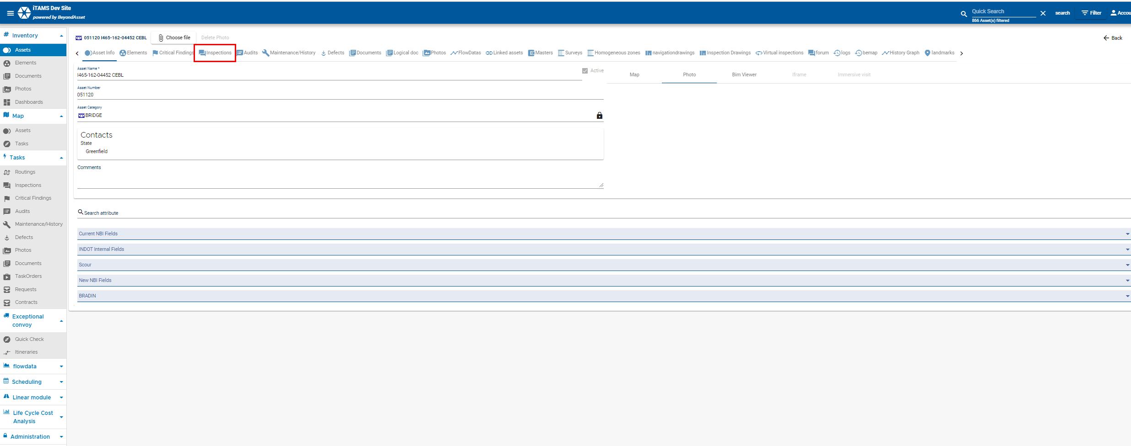
3. | Select the inspection from the list. Please note inspections with the status = approved or inactive will be filteres out from the page list by default. You will have to unfilter to see those records.  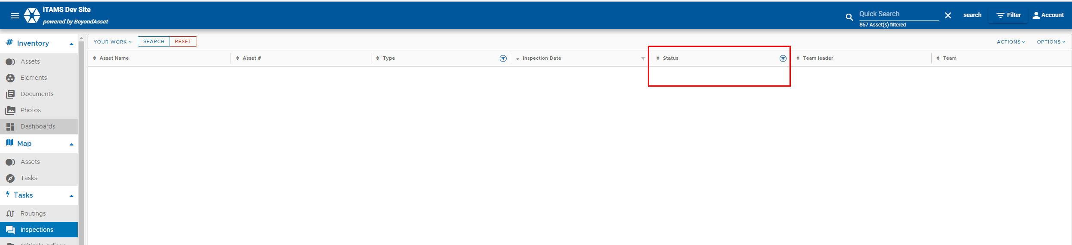  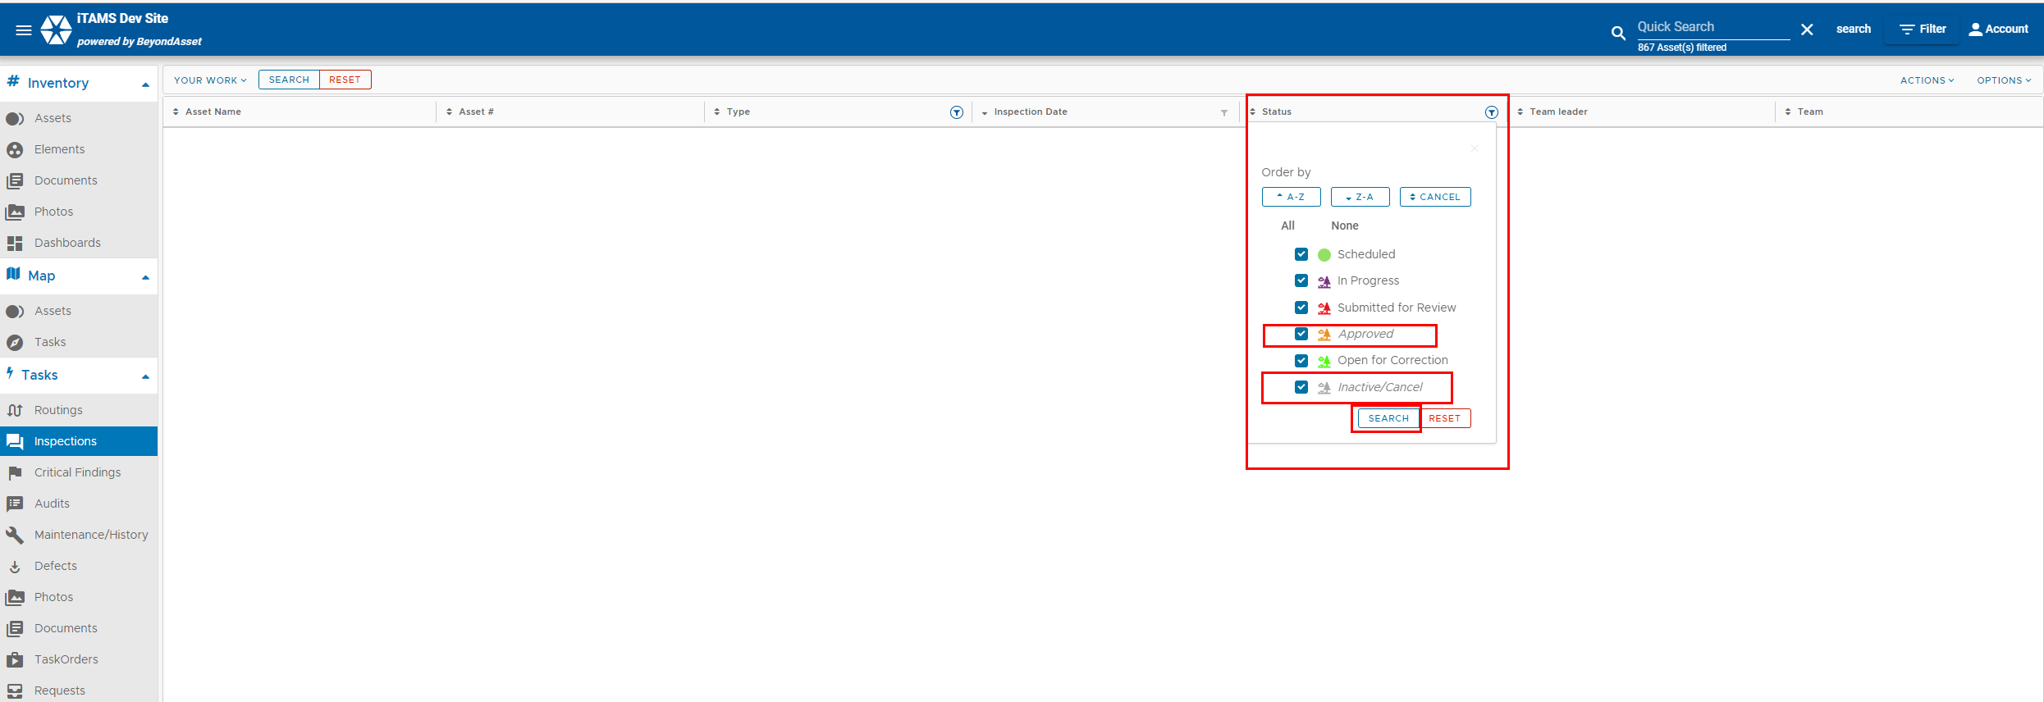  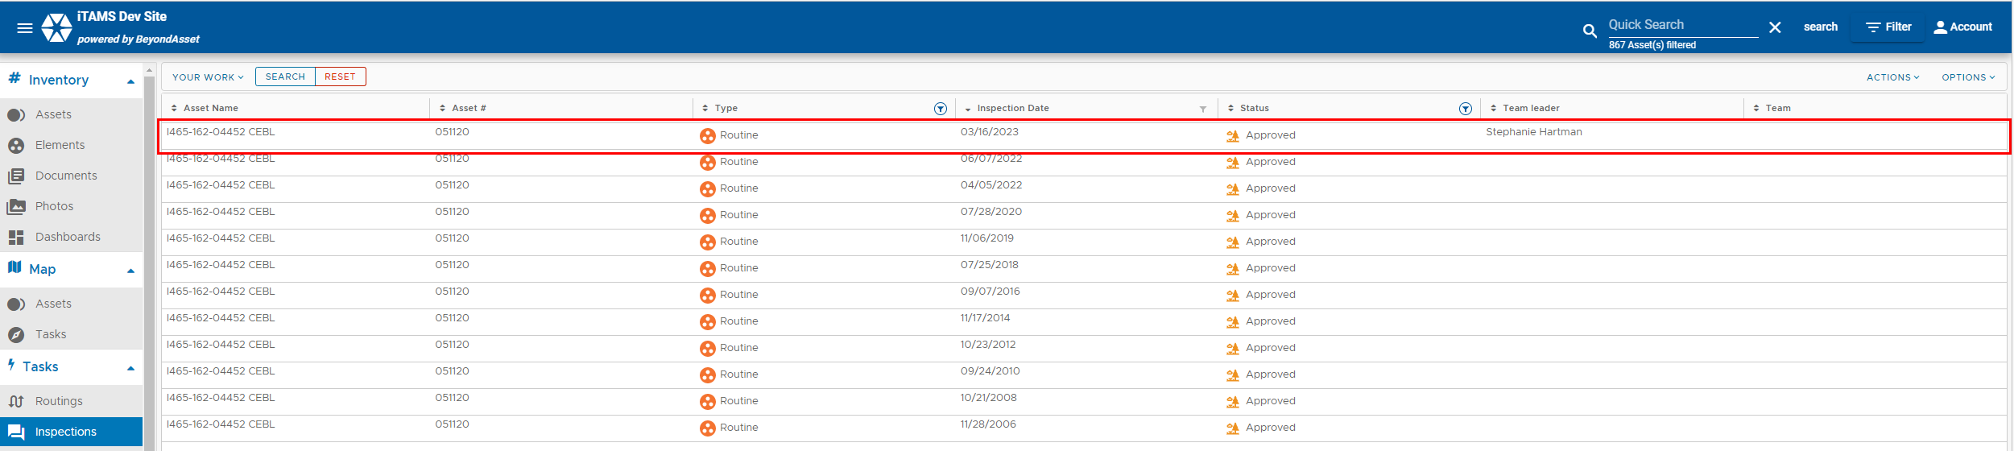

4. | Selet the the Documents tab.  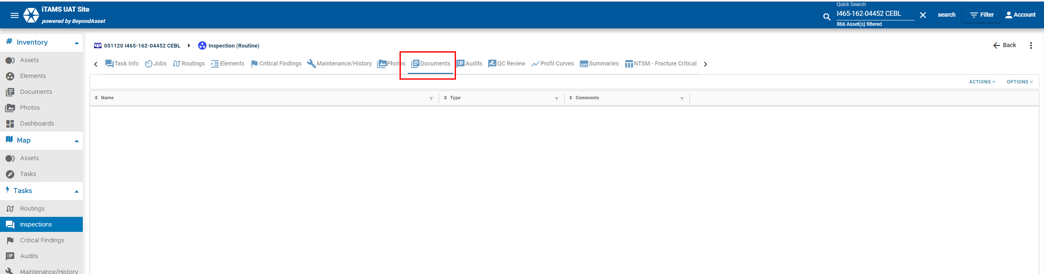
5 | Click Actions +Add  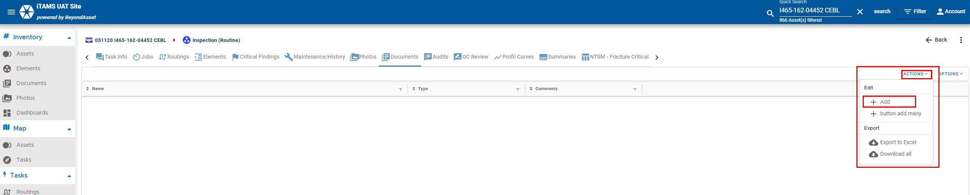
6 | Choose a file from your computer.  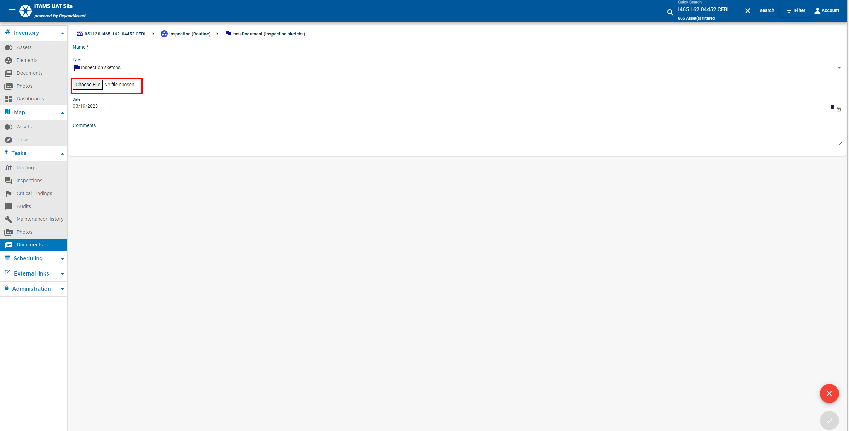  Click Save.

