How to Create an Inspection Job

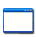 | This function is located under: Tasks->Inspections->Job

Description
This “HOW TO” manual describes the way to create an inspection job. A job allows you do document the from and to date and time on a job and the weather and temperature.

Steps
# | Description
1. | - To update an inspection, first select an Asset.  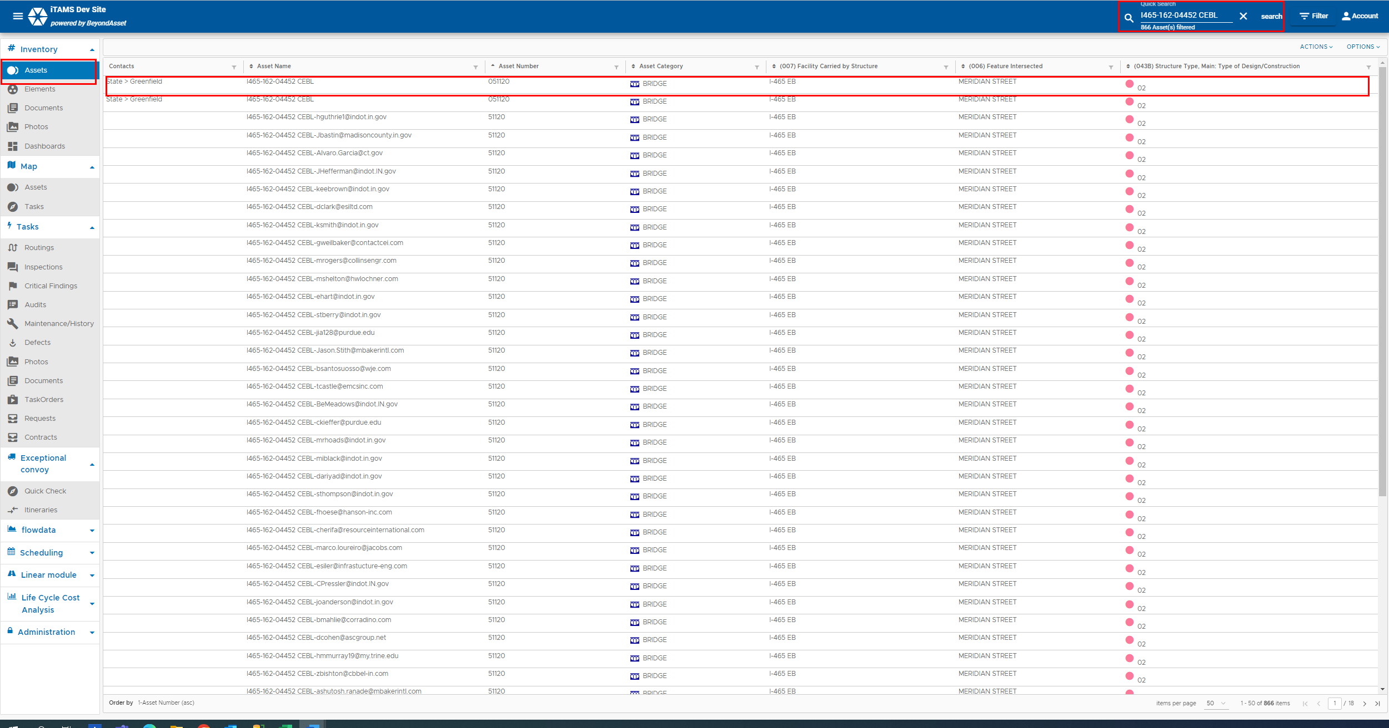

2. | Click on the Inspections tab.  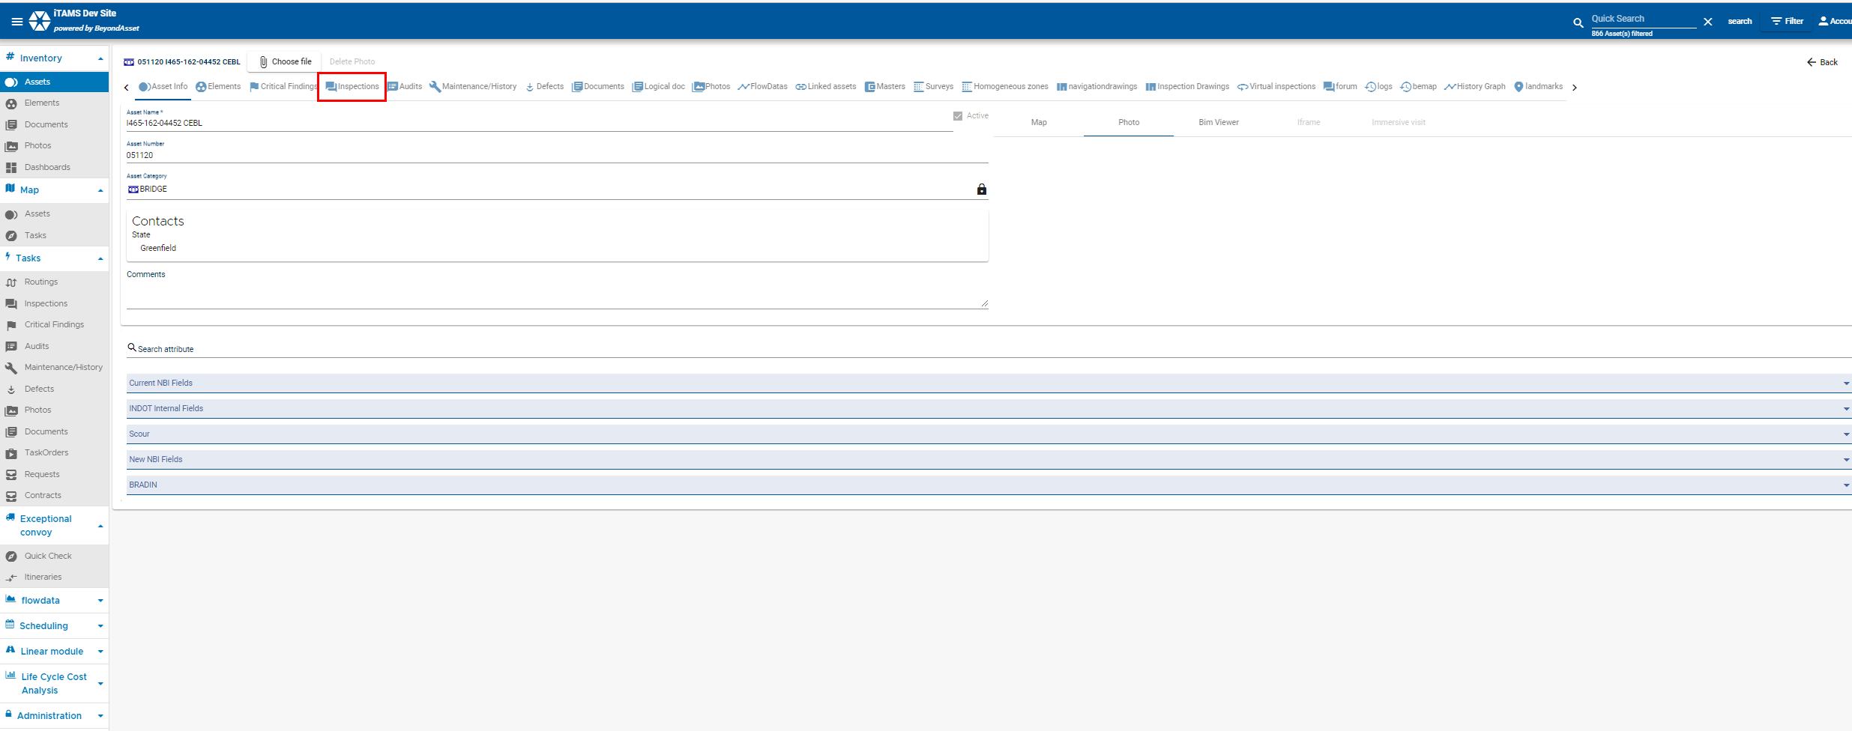
3. | Select the inspection from the list. Please note inspections with the status = approved or inactive will be filteres out from the page list by default. You will have to unfilter to see those records.  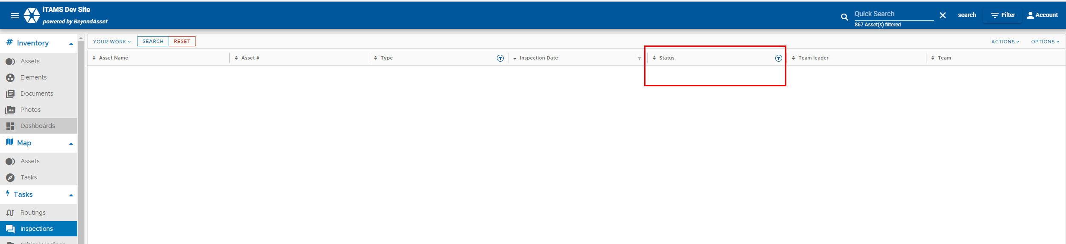  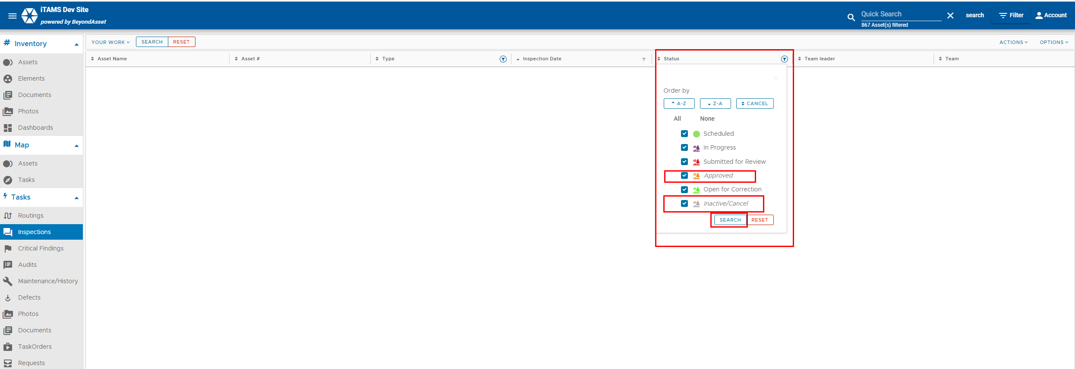  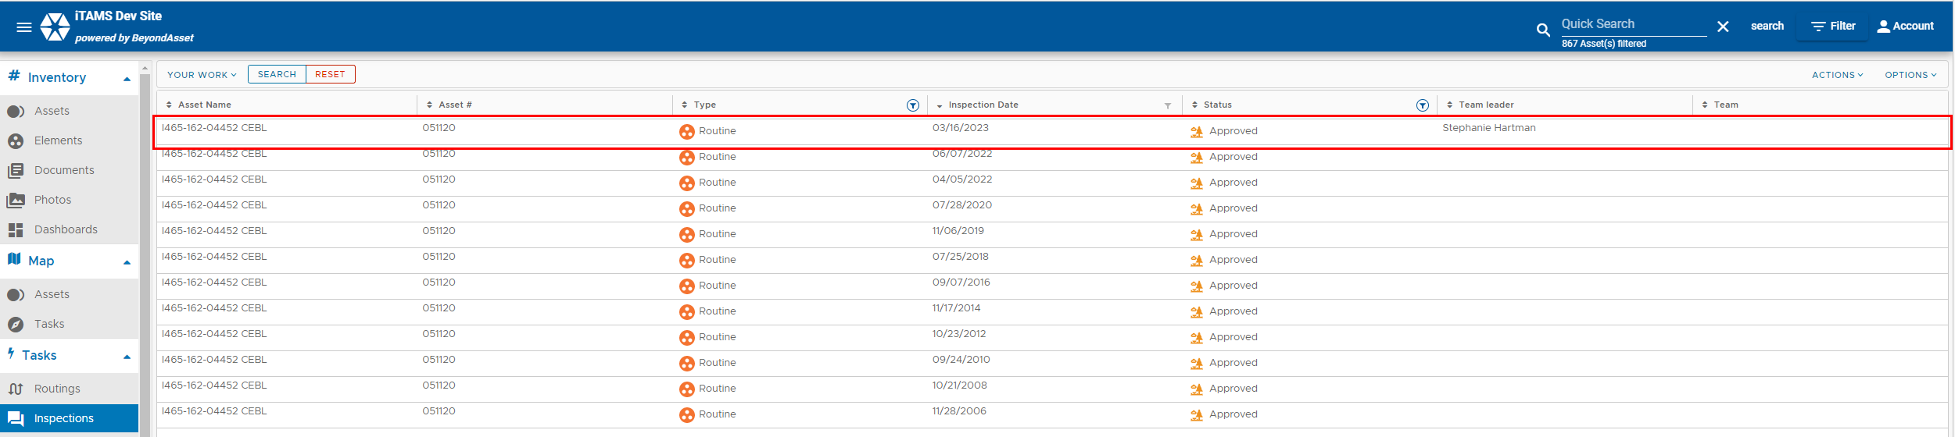

4. | Selet the the Job tab.  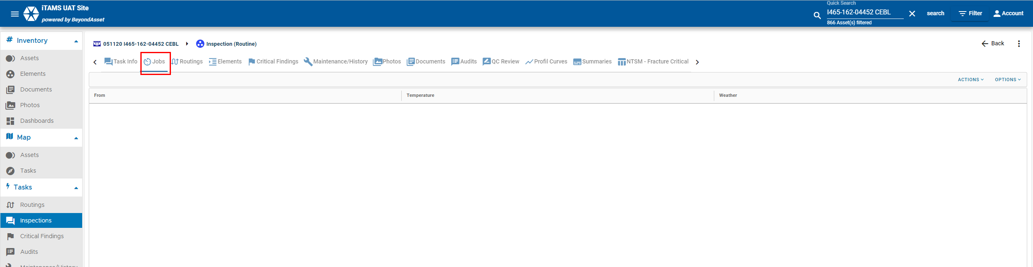
5 | Click Actions +Add  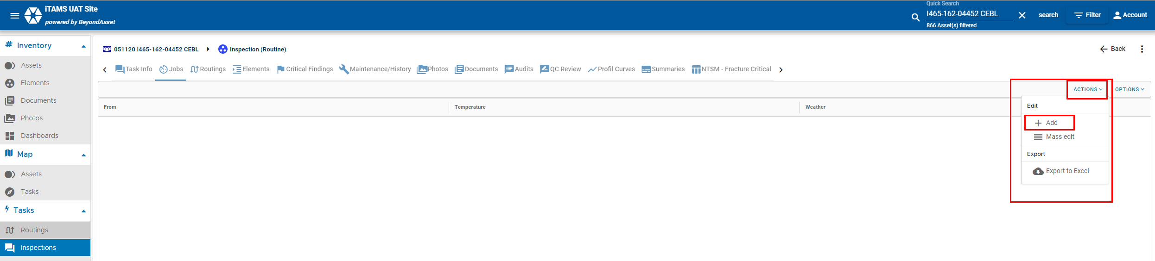
6 | Fill in the From and To Date and Time, Weather and Temperature, and Comments and Click Save.  