How to Route an Inspection

This function is in: Tasks->Inspections->Routings

Description
This “HOW TO” manual describes the way to route an Inspection from one user to another.
Workflow:
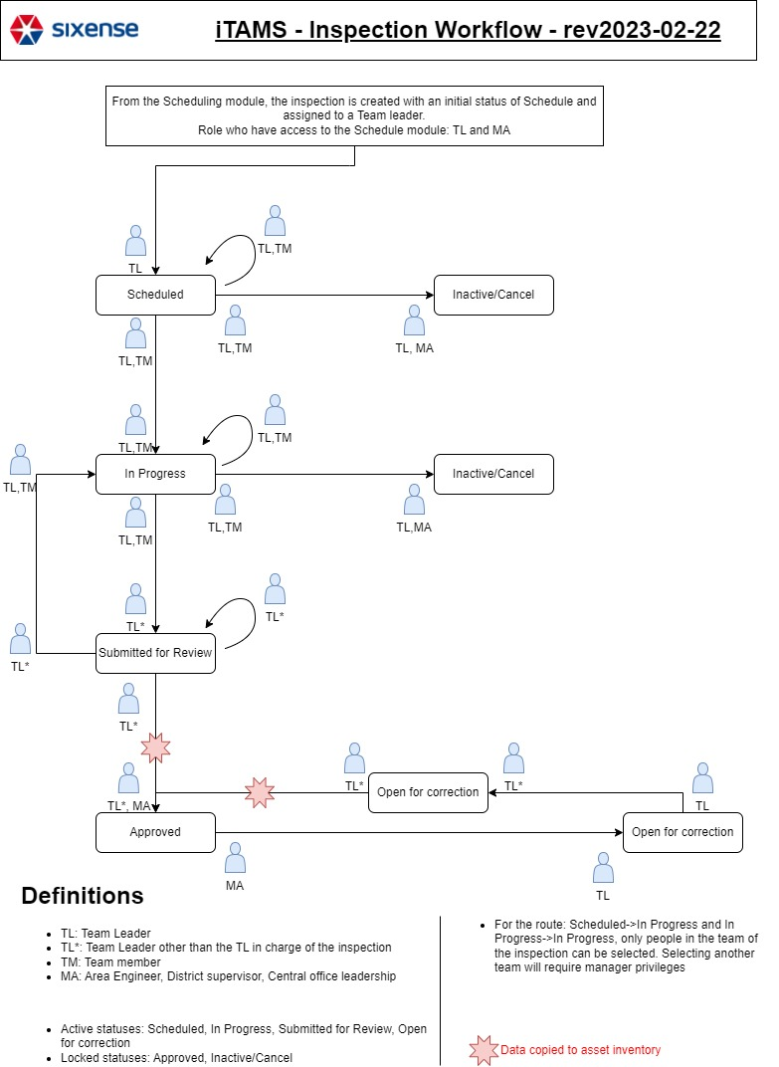

Steps
# | Description
1. | To route an inspection either choose a Asset from the list or use the Quick Search, the Filter functions.  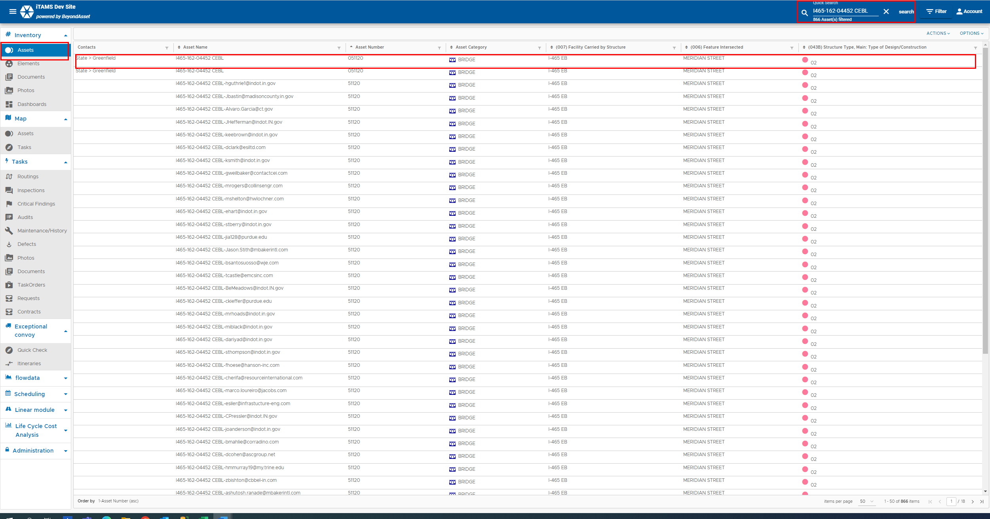

2. | Click on the Inspections tab.  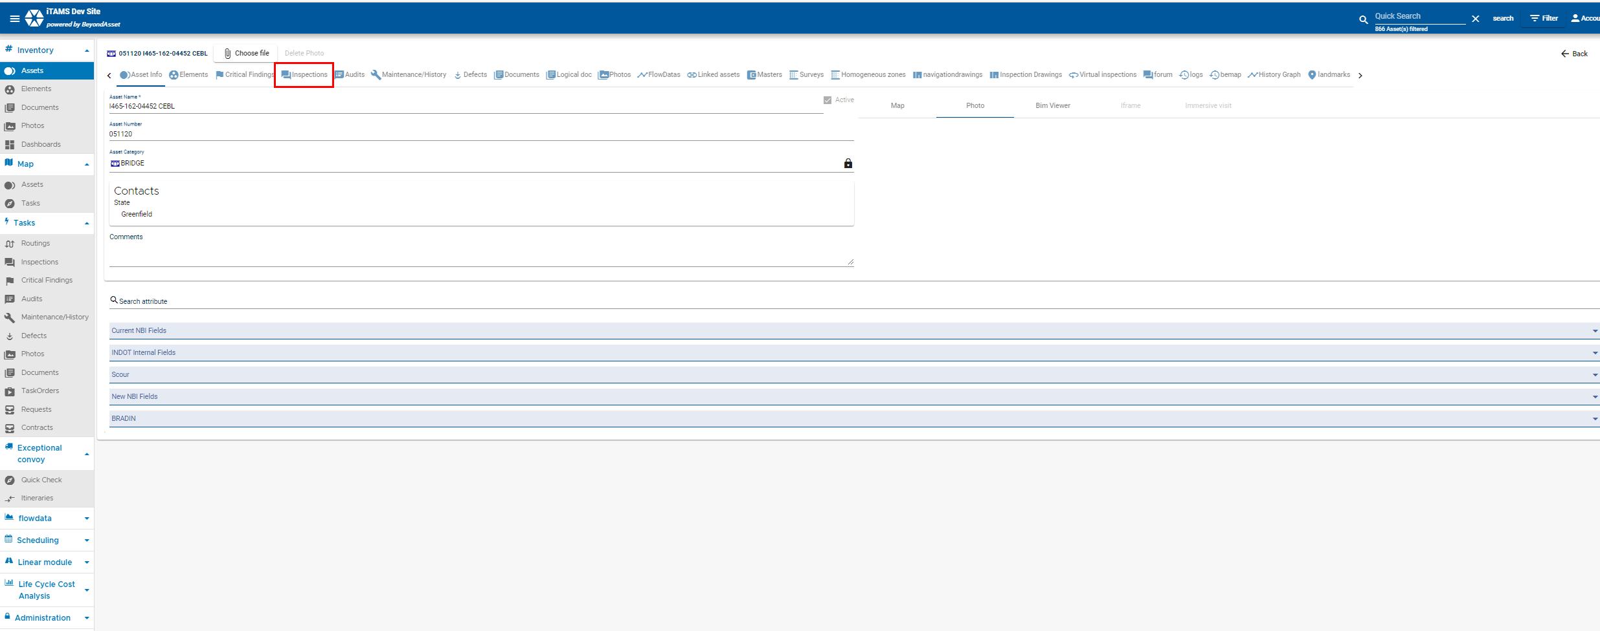
3. | Select the inspection from the list.  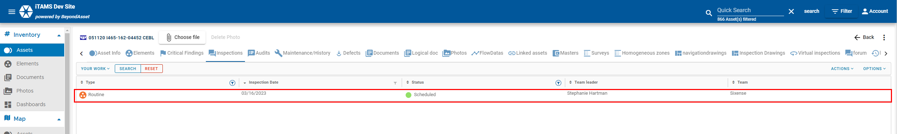

4. | Click on the Routings tab on the top navigation menu.  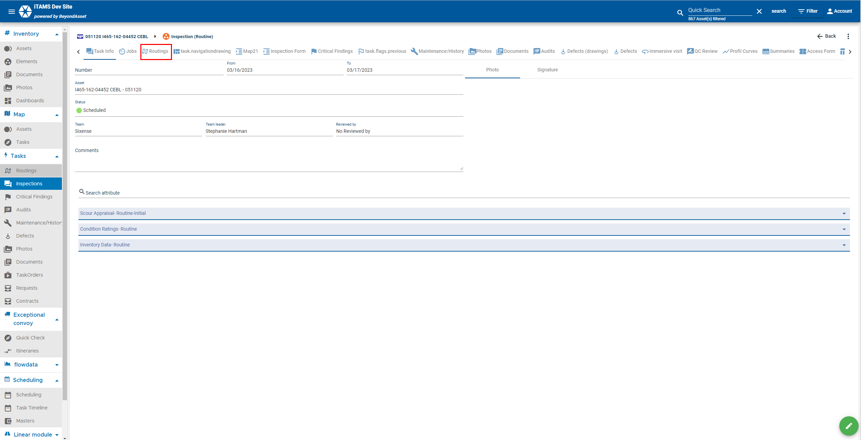  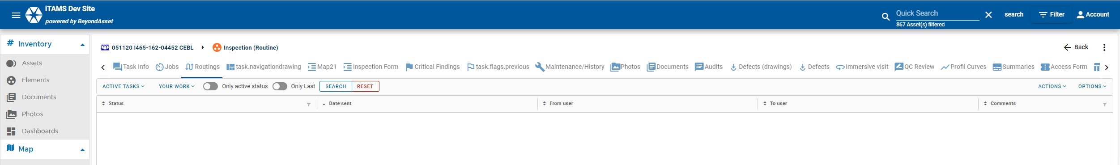
5. | - Click on Actions tab to create a routing.  - iTAMS creates the 1st routing when the inspection is scheduled.  - You can move the inspection from schedule to In Progress.  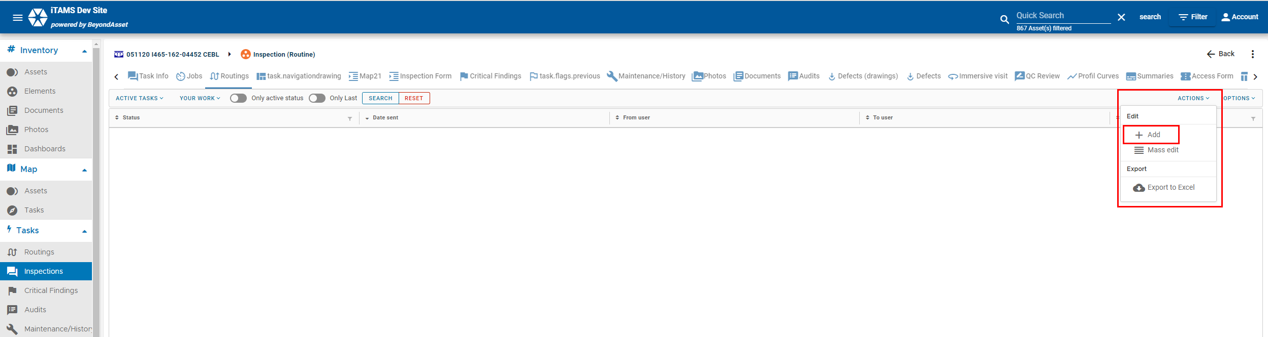

6. | Click on + Add from drop-down menu., it will automaticall change the status from Scheduled to In Progress. You can add comments, and seach for a user you want to send it to and cc.  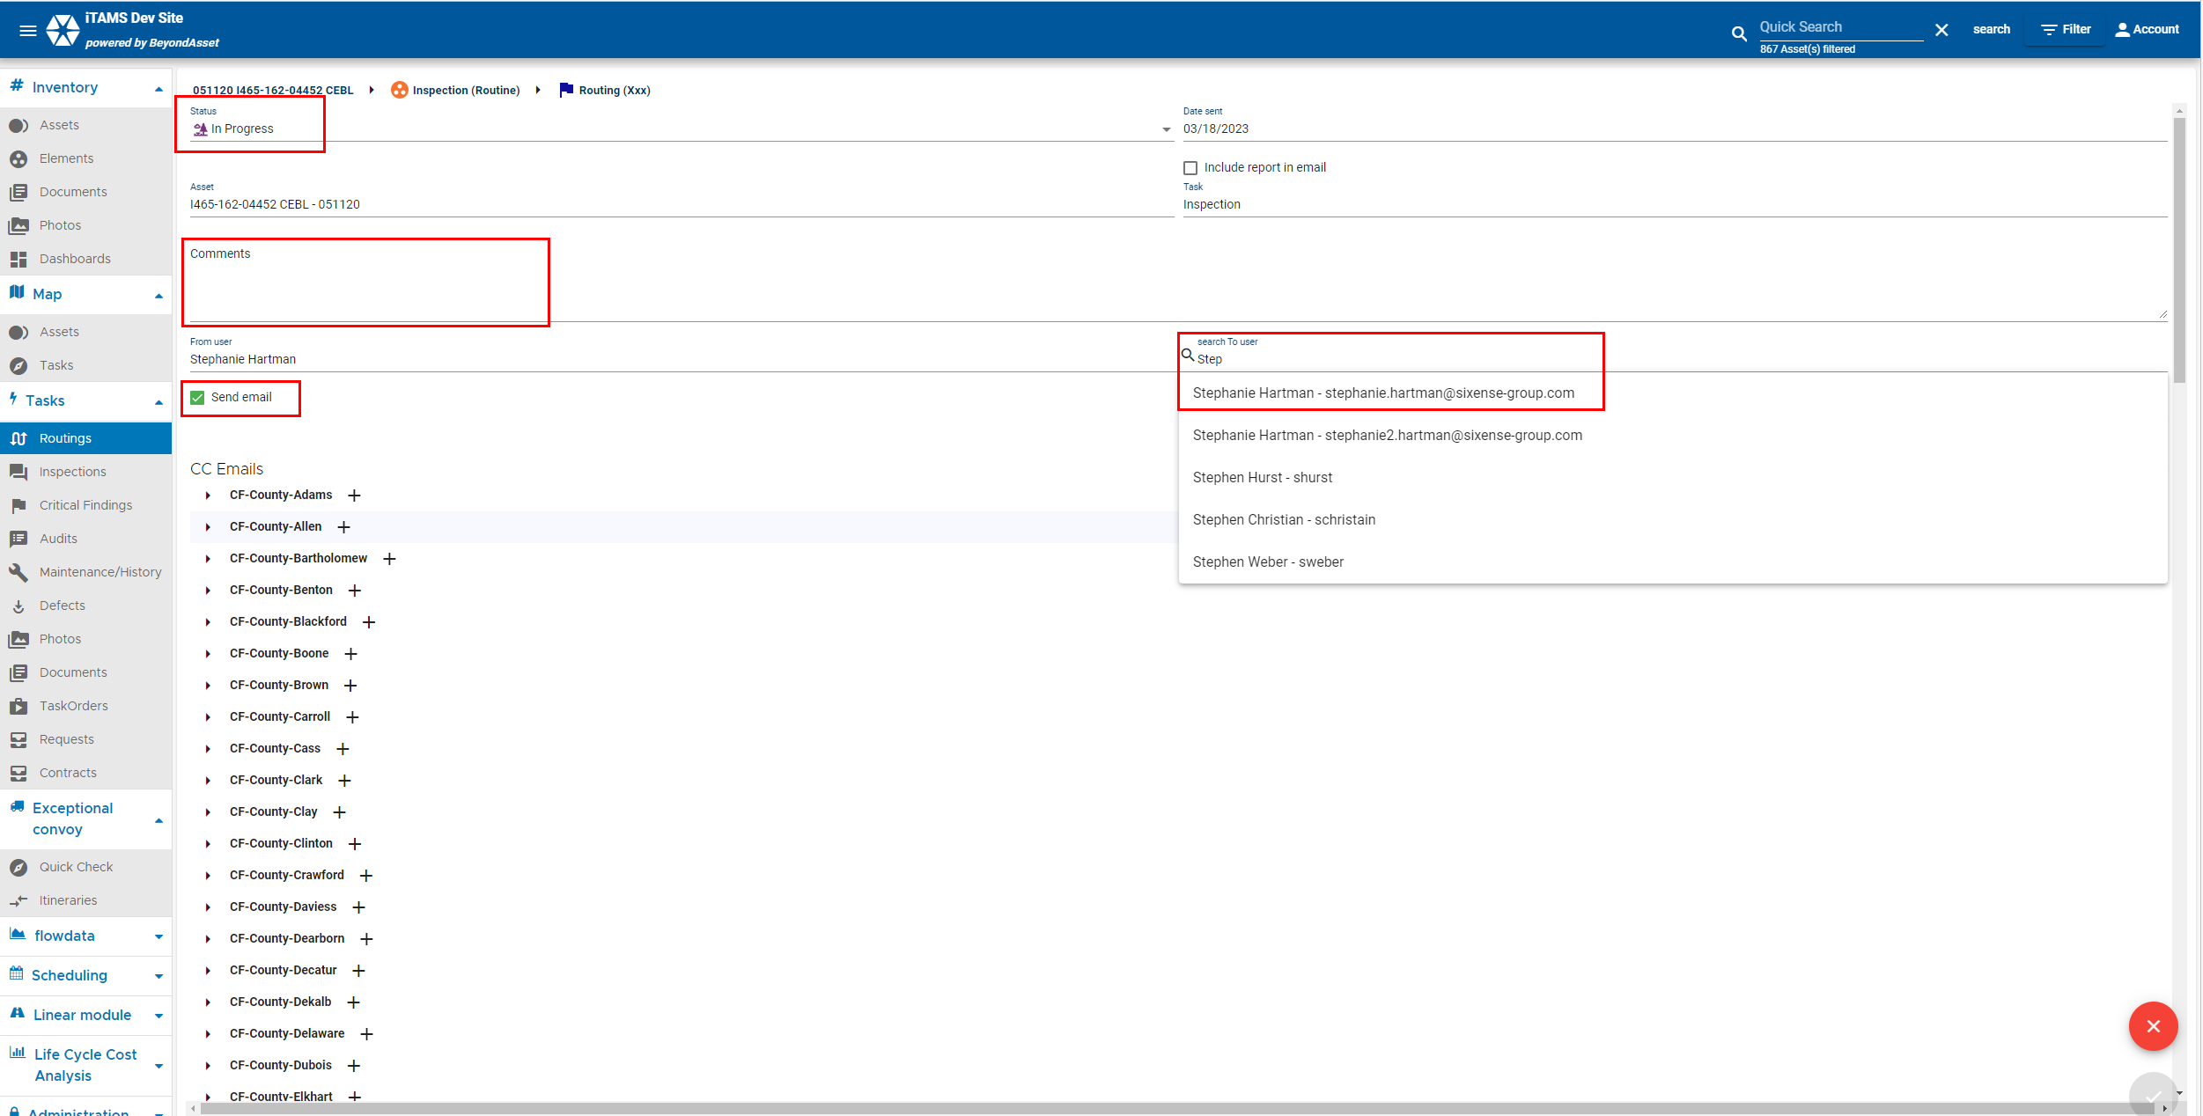
7. | - The Status will automatically populate following the business rules.  - Date sent, Asset and Task are automatically filled.  - The “Include report in email” box allows the user to include the report in the routing email. Add Comments specific to the routing (if any).  - You cannot update From user (this field is read-only and automatic).  - Select To user the inspection will be routed to. The drop-down list values depend on the business rules.  - Add CC Emails if you need to CC the routing to other users (s).  - Click on the icon to Save.  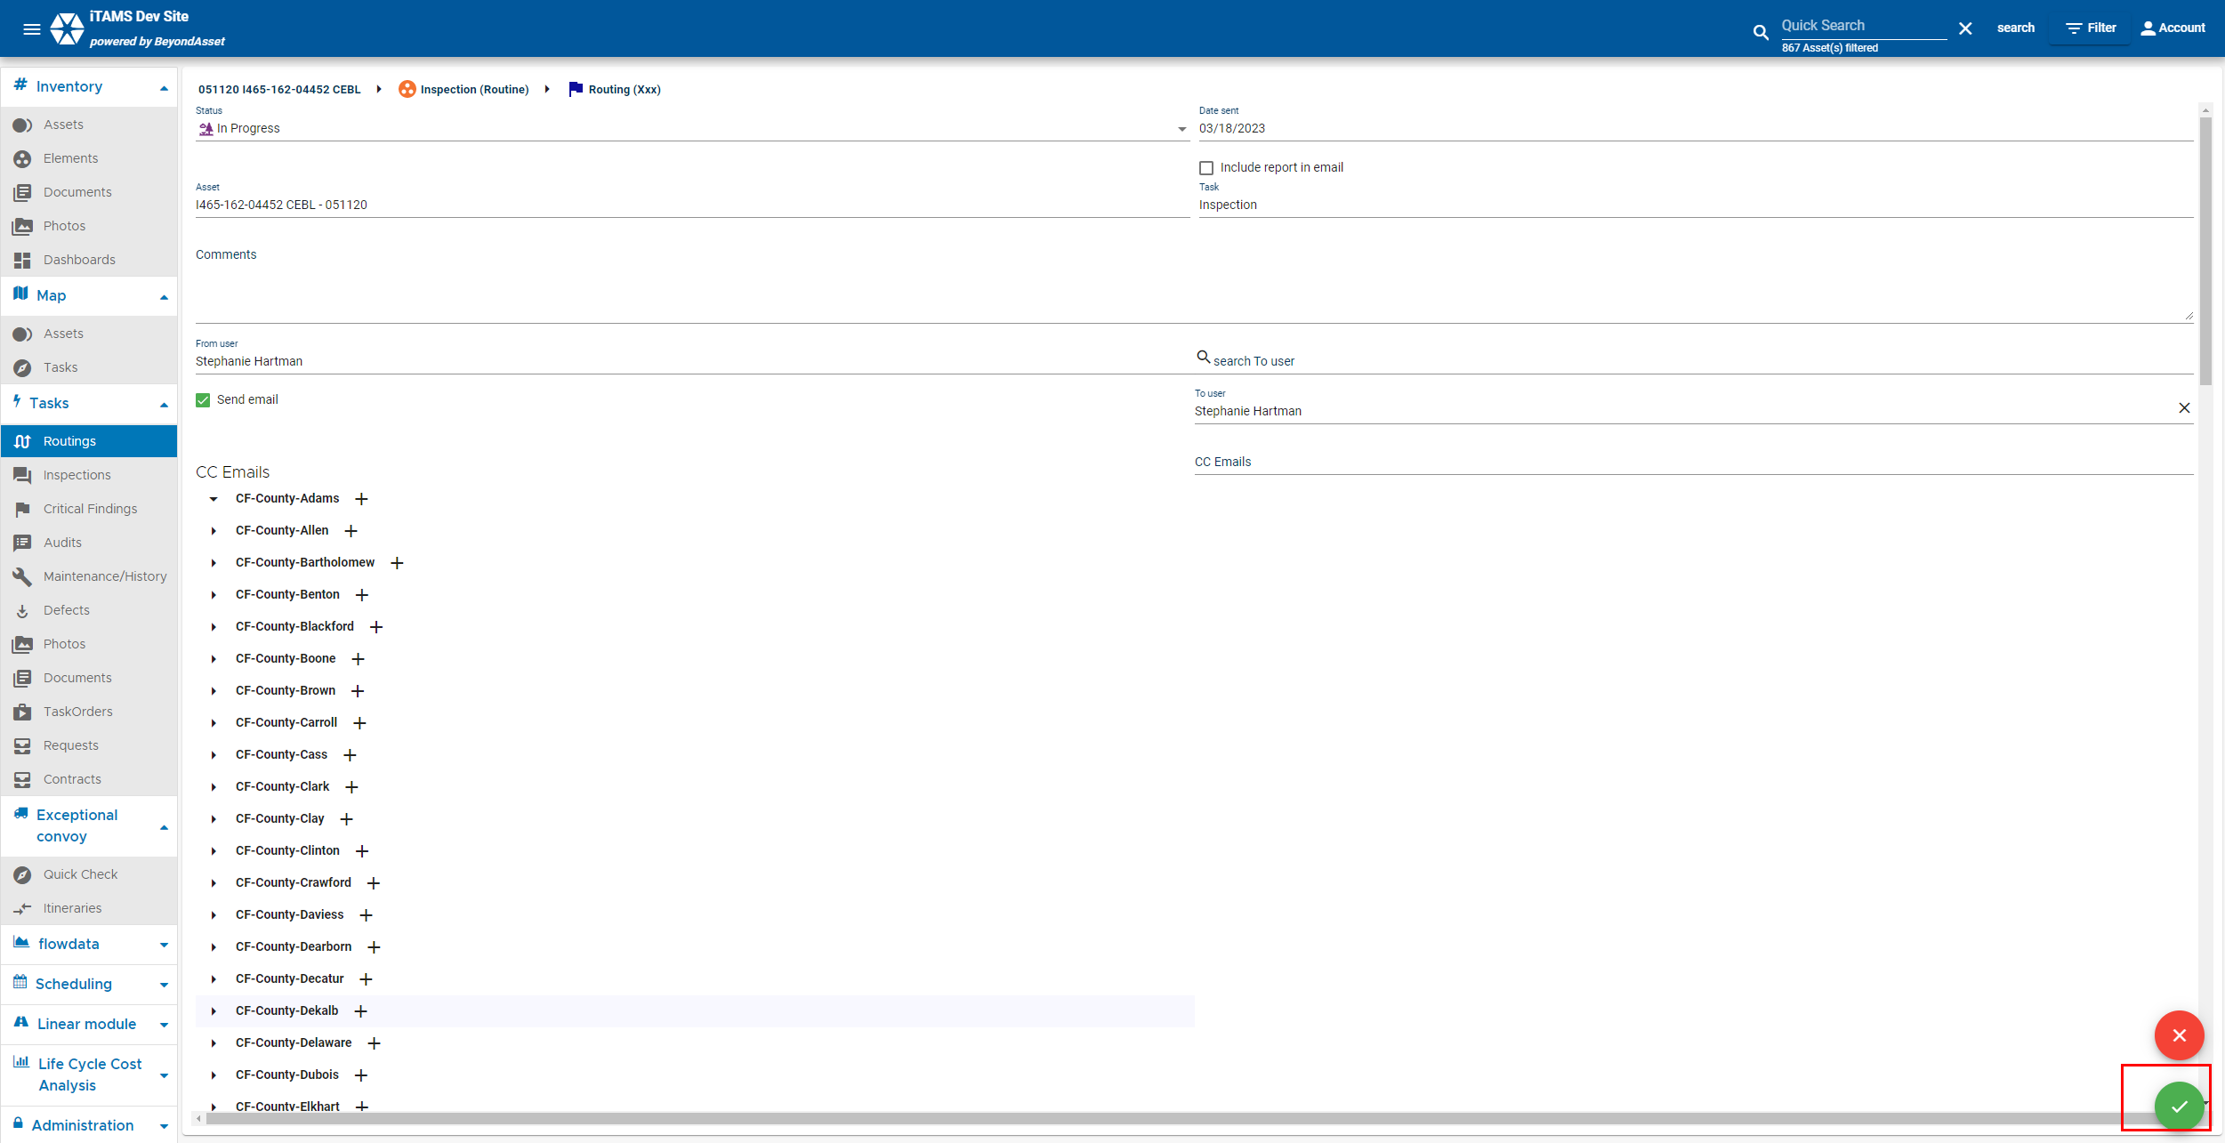

8. | Once completed the new routing will appear in the routing list.  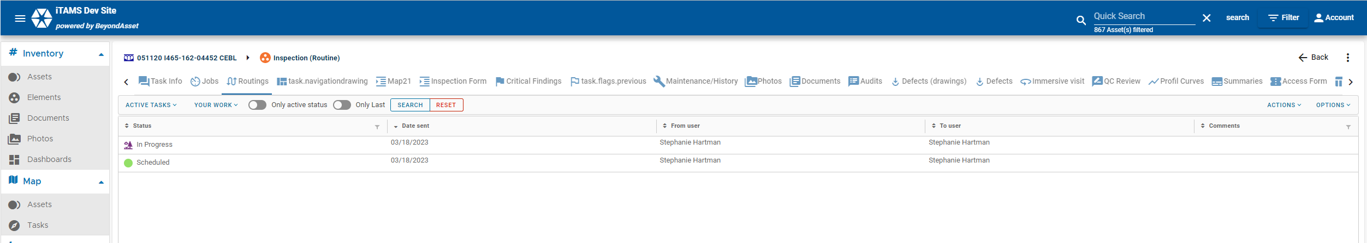
9. | Click on the In Progress Routing Record  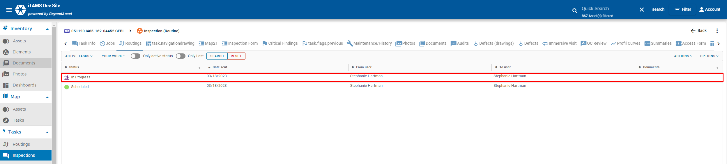  You can also click the green cirlge icon with the 3 lines and the + sign to reoute an Inspection  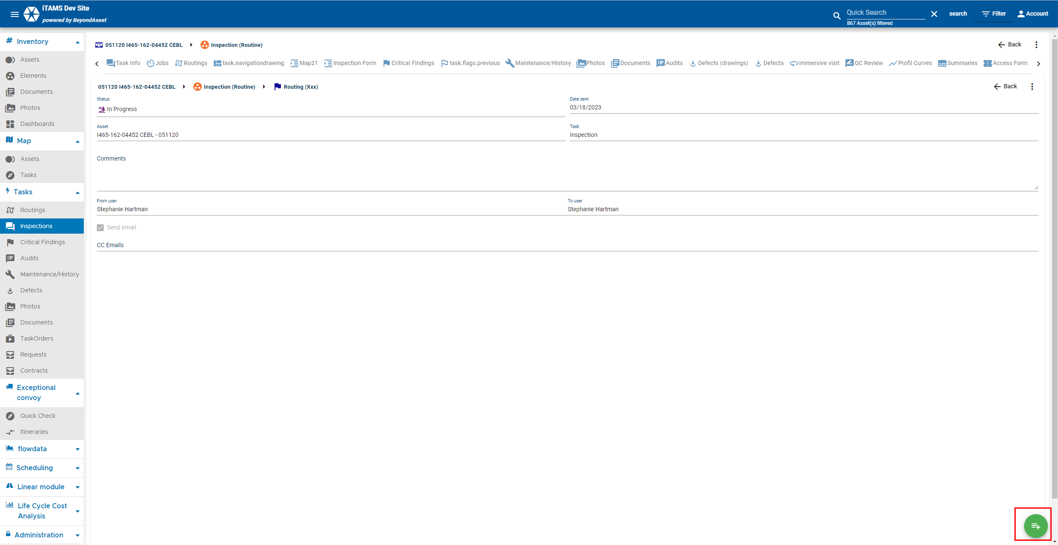  - The Status will automatically populate following the business rules. So you will see the status change from In Progress to Submitted for Review  - Date sent, Asset and Task are automatically filled.  - The “Include report in email” box allows the user to include the report in the routing email. Add Comments specific to the routing (if any).  - You cannot update From user (this field is read-only and automatic).  - Select To user the inspection will be routed to. The drop-down list values depend on the business rules.  - Add CC Emails if you need to CC the routing to other users (s).  - Click on the icon to Save.
10. | Once routed to Approved status:  - You can generate a report  - The type of report generated is based of the type of inspection, for example when the Inspection Type = Routine, the Report Type = Routine is generated  - The user can not generate the inspection report, but can download the last Inspection report file.  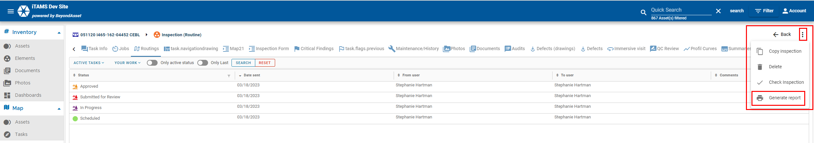  Click PDF icon.  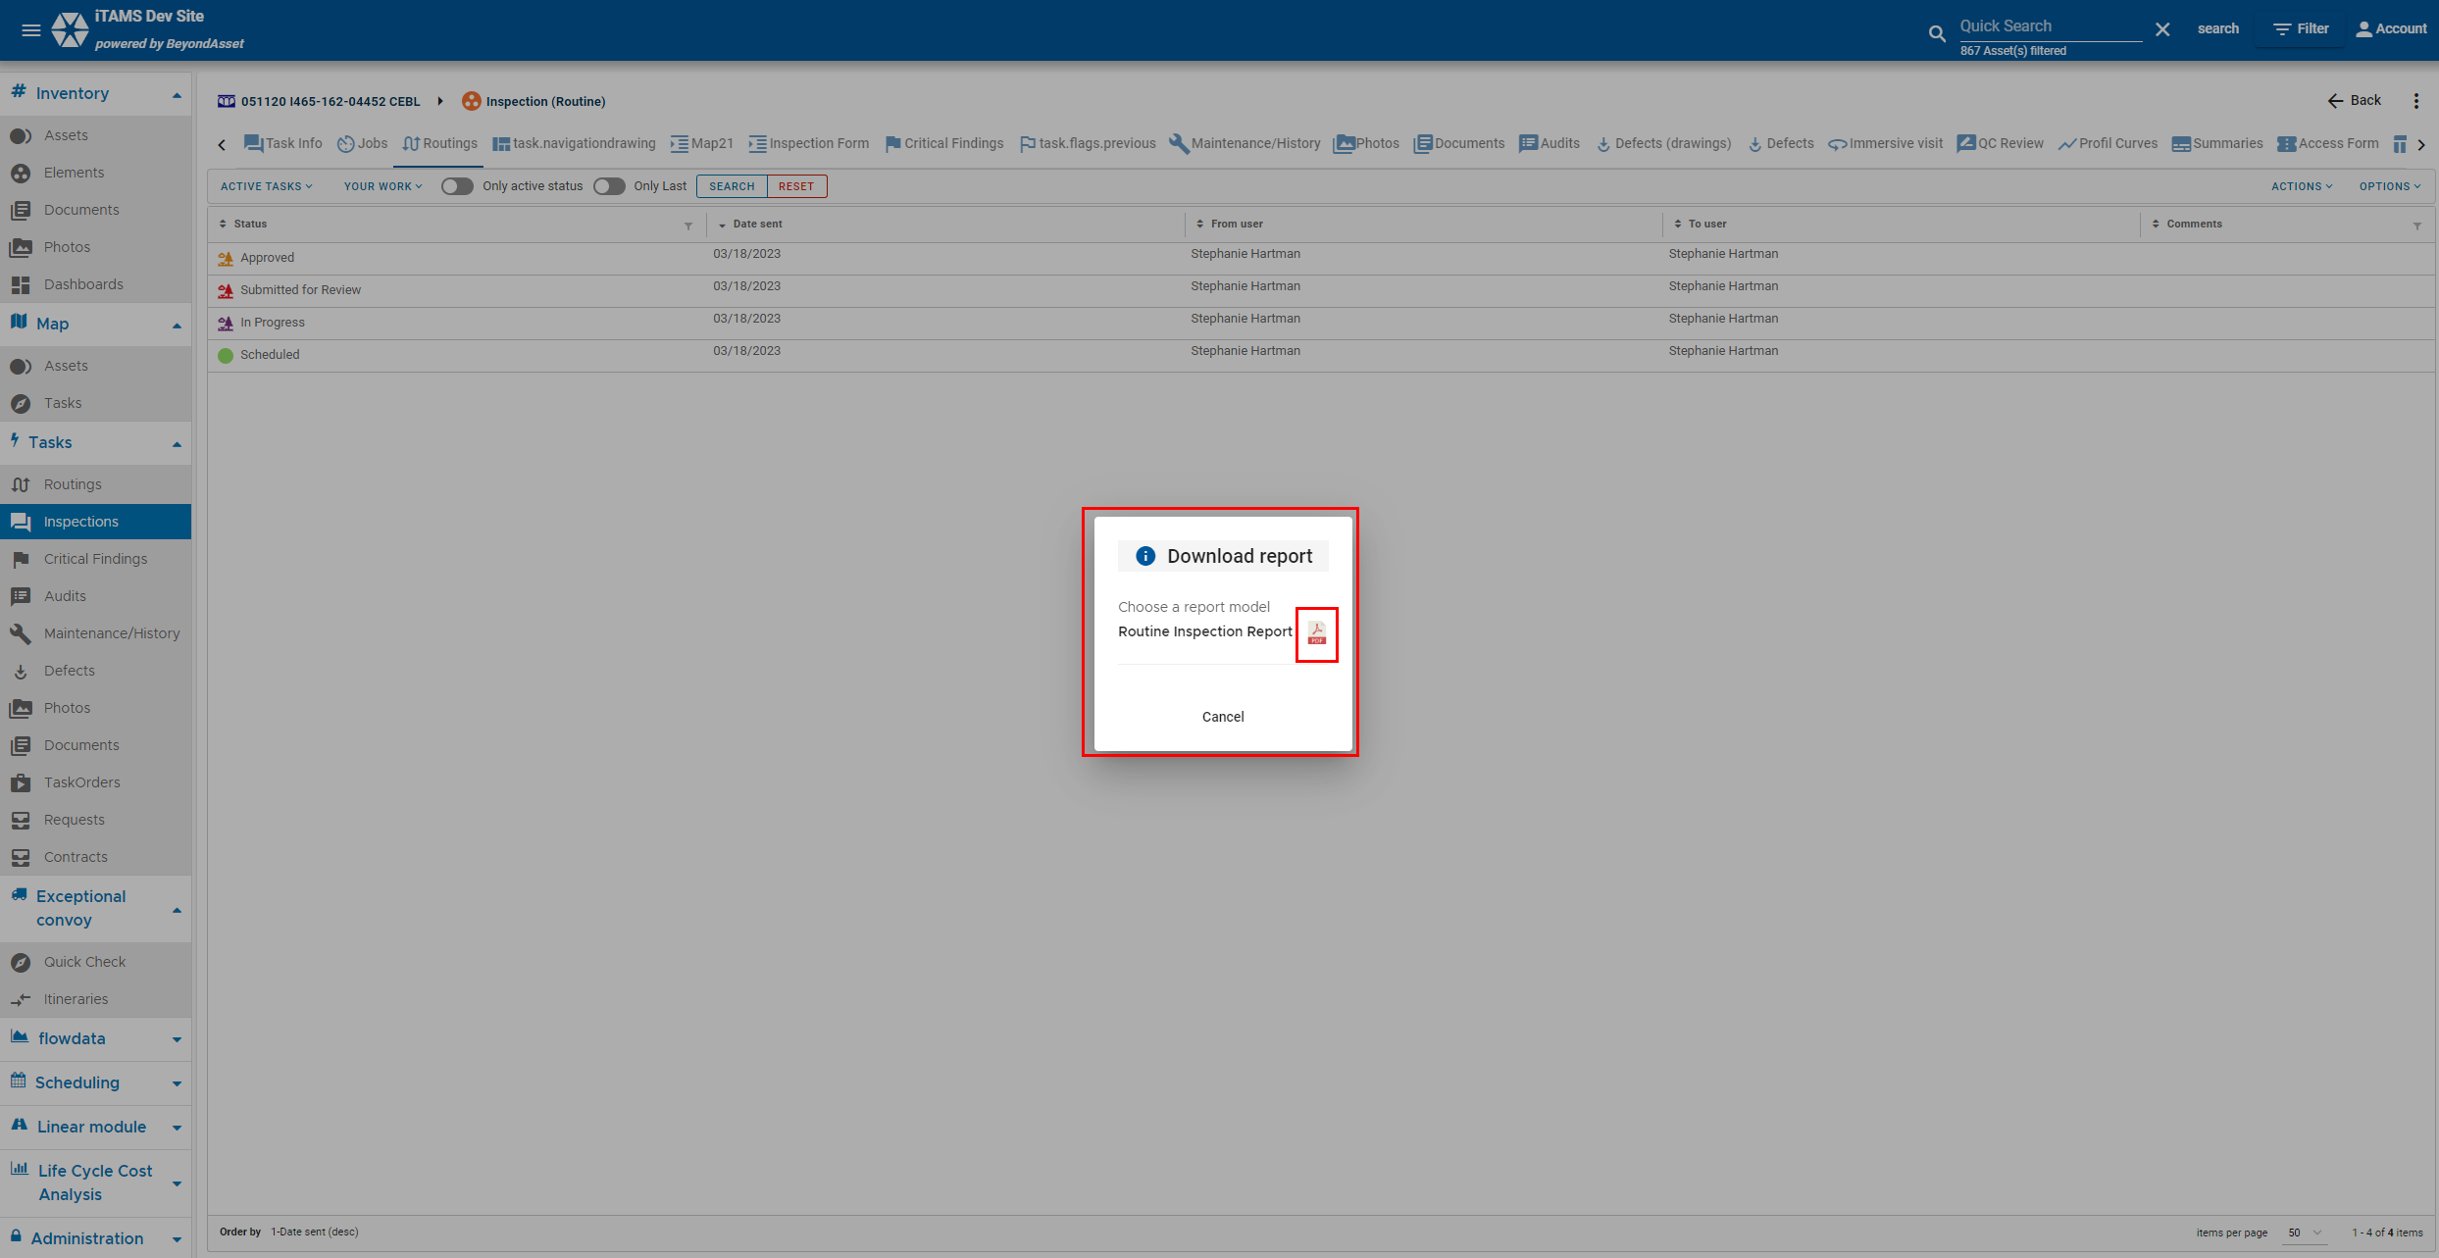  NOTE: Because we are working in UAT not all Values, Documents, and Phots will populate in the Reports at this time.

