### MATERIAL OPTIONS FOR RIGID BRIDGE DECK OVERLAYS

Reference: IDM 412-3.02(04) Rigid Overlays

## Current Guidance to be used for Contracts with Lettings on or After September 1, 2025

This BDA was revised in October of 2024. Guidance from the August 2020 revision should not be used for contracts with lettings on or after September 1, 2025.

Pay item changes were approved at the October 17, 2024 Standards Committee meeting. The pay item ‘Bridge Deck Overlay, Rigid’ was created to allow multiple material options for rigid bridge deck overlays. The pay item will be included in contracts letting on or after September 1, 2025.

This pay item allows the Contractor the option of installing either a Latex Modified Concrete or Silica Fume Modified Concrete overlay on each bridge within a contract without specifying a material as part of the bid. The previous practice of allowing material options via an alternate bid process didn’t allow the Contractor to utilize different material types for different bridges within a contract and increased the Contractor’s risk due to material prices fluctuating between bid letting and construction.

Designers should coordinate with the District Bridge Asset Engineer on a project-by-project basis to determine if a specific overlay material is preferred. If the district doesn’t have a preference, designers should use the ‘Bridge Deck Overlay, Rigid’ pay item to allow Contractors the flexibility to determine the most cost-effective overlay material for each bridge. If the district does have a preference, designers should use the appropriate “Bridge Deck Overlay, [Material]” pay item.

## Previous Guidance Applicable for Contracts with Lettings Before September 1, 2025

The BDA was revised in August of 2020 to reflect updates to CES and to correct the name of the silica fume modified concrete overlay material.

In the past, silica fume modified concrete (SFMC) bridge deck overlays fell out of favor with the Department due to cracking issues related to the material’s sensitivity to curing. Recent changes in admixtures and a number of successful installations throughout the state have brought SFMC overlays back as a feasible option for rigid overlays. These modern SFMC overlays are believed to have the same design life as latex modified concrete overlays.

The Department encourages designers to provide a SFMC overlay material as an option in latex modified overlay contracts. The Contractor is ultimately responsible for installing the highest quality at the lowest cost. Allowing the Contractor to pick the material they are most comfortable installing will result in higher quality and lower prices.

Follow the steps below to include an optional overlay materials in a contract.

### Instructions for setting up an Optional Bid for Bridge Deck Overlay Materials

**Latex Modified and Silica Fume Modified Concrete**

1. Include the following Material Notes in the plan set:

1. Include Recurring Special Provision 102-C-082 (contract specific provision) in the contract documents. Complete the provision as follows:

102-C-082 SCHEDULE OF PAY ITEMS FOR OPTION BIDS

*(Revised 06-10-13)*

The Standard Specifications are revised as follows:

SECTION 102, AFTER LINE 12, INSERT AS FOLLOWS:

*The Schedule of Pay Items is set up in three sections.*

*Section 0001, or Common Biddable Items, is the list of all pay items which are common to Section 0002 and Section 0003.*

*Section 0002, or Option Group OP1, is the list of all pay items required to perform the construction of a Latex Modified Concrete Overlay in accordance with the details shown on the plans for Str. No. XXX-XX-XXXXX.*

*Section 0003, or Option Group OP2, is the list of all pay items required to perform the construction of Silica Fume Modified Concrete Overlay in accordance with the details shown on the plans for Str. No. XXX-XX-XXXXX.*

*The bidder shall completely fill in and submit Section 0001 and Section 0002, or Section 0001 and Section 0003 of the Schedule of Pay Items. The Schedule of Pay Items thus submitted will be the one which will be compared to the Schedule of Pay Items submitted by all other bidders.*

*The work shall be constructed in accordance with the Schedule of Pay Items sections upon which award of the contract was based.*

1. Follow these steps to properly input the estimate into CES
   1. Insert all the pay items into CES either individually or through import from BidTabs
   2. Click on the “Categories” Tab inside the job file

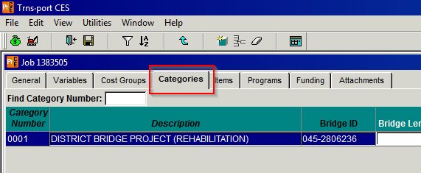

* 1. Right Click in the grey area below the existing category line and select “Add”

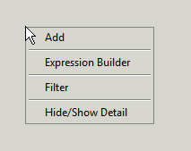

* 1. Enter 0002 in the Add Category Number window

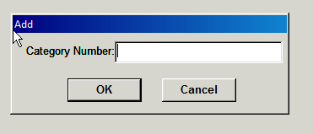

* 1. Enter “Latex Modified Concrete Overlay Option” in the Description Box

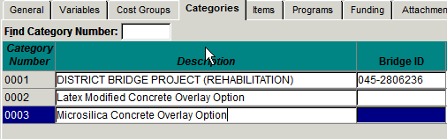

* 1. Repeat steps c. through e. to create Category Number 0003 with Description Silica Fume Modified Concrete Overlay Option
  2. Click on the “Items” tab to assign each item a Category Number

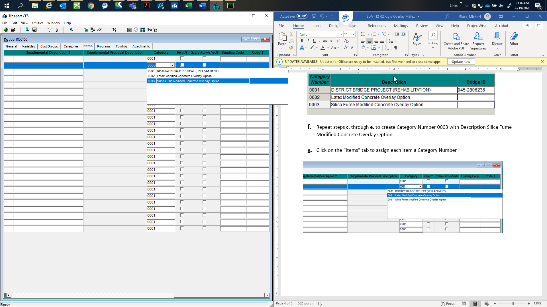

* 1. Assign each pay item as follows:

Bridge Deck Overlay, Latex Modified Concrete

Category: 0002

Bridge Deck Overlay, Silica Fume Modified Concrete

Category: 0003

All other pay items

Category: 0001**

** If pay items are imported from OMAN BidTabs software, all items are automatically assigned to Category 0001. If pay items are individually added to CES, the Category field will be blank. MAKE SURE EVERY PAY ITEM HAS A CATEGORY NUMBER!!

* 1. The Inflated Estimate Total and the Total Estimate in the Job Summary printout from CES will only sum the total of the option with the lowest bid. The Estimate Item Total will include all optional bid items and should not be used for the total project estimate.