Good News iTAMS Users!

All Old BIAS Bridge Inspection Reports from are now available in iTAMS under Inspection Level and Asset Level. To view the reports, please follow the instructions below:

Viewing under Inspection Level

- Log out from iTAMS
- Refresh Browser or clear cache
- Login to iTAMS: https://itams.sixense.co/login
- Enter asset # or asset name on the Quick Search
- Go to Inspection level
- iTAMS will show a list of completed inspections
  - Click the intended inspection report to download
- Click on the ellipsis or hamburger stack from the top right corner of the screen, as highlighted from the screenshot below

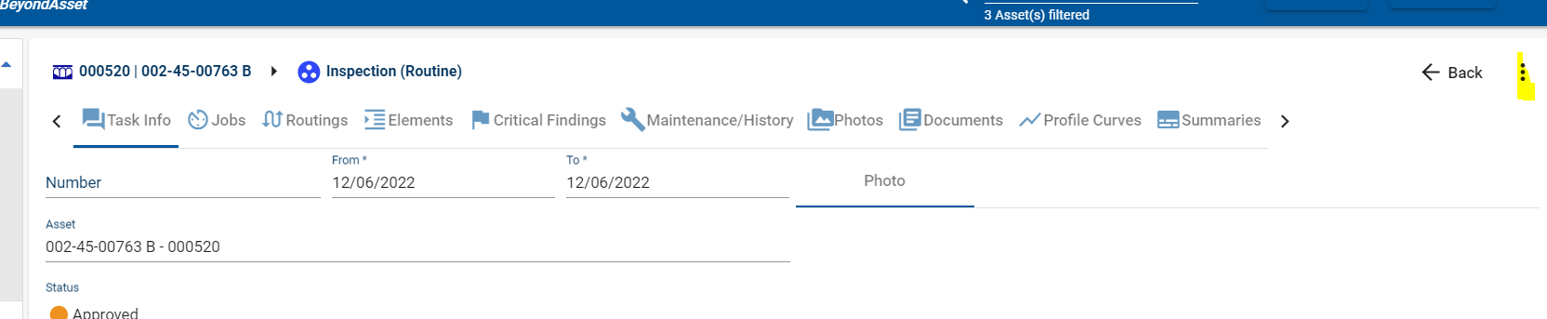

- A pop-up menu will appear, chose “Download last report file”

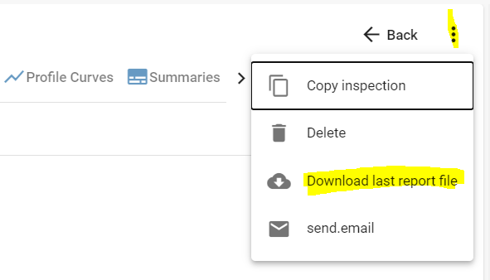

Viewing under Asset Level

- Log out from iTAMS
- Refresh Browser or clear cache
- Login to iTAMS: https://itams.sixense.co/login
- Enter asset # or asset name on the Quick Search
- Go to Asset level
- Click on Documents tab

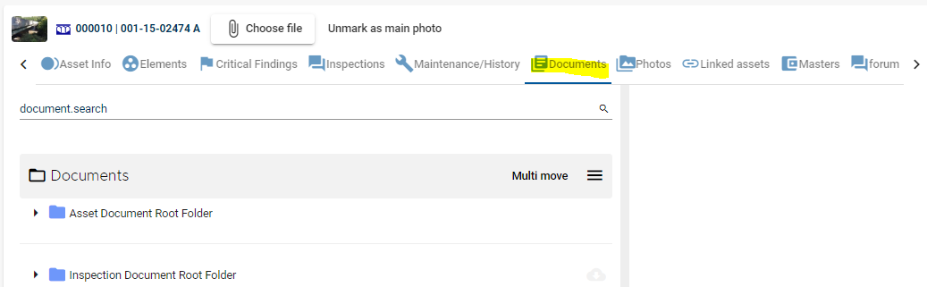

- Click for folder name, “Inspection Document Root Folder” to show list of approved inspections
  - Click the intended inspection report and keep on expanding until you see the pdf report
  - Then Click Download located on the top right corner of your screen

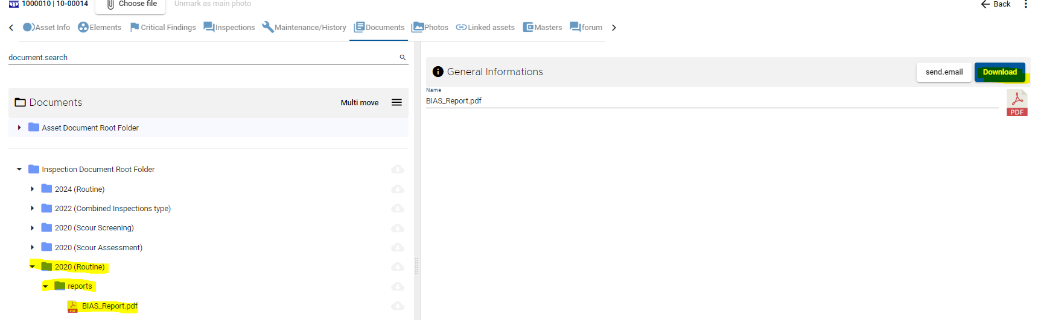

If you have any questions or concerns, please contact iTAMSHelp@indot.in.gov.

