Slide # 1 The Indiana State Police:
Unarmed Response to an Active Shooter Event 2021

The Abridged Version

INDIANA STATE POLICE
UNARMED RESPONSE TO AN ACTIVE
SHOOTER EVENT IN SCHOOLS
2021
Abridged
Slide # 1 The Indiana State Police

Unarmed Response to an Active Shooter Event 2021
The Indiana State Police offer this “Response Options” program as a free resource to educators across the United States. In the narrative, numerous suggestions are in bold print to emphasize salient lesson points. The Department has also added “bold gold print” to areas that may be of special interest to educators.
The program consists of both a PowerPoint and Presenter’s Notes. The PowerPoint sets out the “focus points” of the program and the Presenter’s Notes provide a narrative that offers additional information on each slide.
In today’s sociopolitical climate, it is important for presenters to underscore the foundation and intent of the Indiana State Police “Unarmed Response to an Active Shooter Event” program. The program is apolitical and focuses on prevention strategies and response options. The Department strongly suggests that the information provided is not the ultimate answer to an active shooter event. On the contrary, the information may be viewed as a resource that educators may utilize as they develop their own unique strategies and response options to prevent and or mitigate an “active shooter event.”
Presenter’s Note: Educators know their respective “School Communities” better than anyone. During the presenter’s opening statement, the speaker should underscore that this program does not provide all the answers. The information provided must only be viewed as a resource that may assist educators as they develop and craft their own “Comprehensive Safety Programs.”
Numerous active shooter programs are currently being marketed across the nation. Most programs present information that may very well fit the unique needs of many of Indiana’s school communities. The Indiana State Police Department strongly recommends that educators review the various “active shooter” programs. The review process may enable them to identify and select the components from the various programs that best fit their unique needs.
Presenter’s Notes: While the Department prefers prevention to response, it also understands that all “active shooter” assaults cannot be prevented. With that in mind, it is important to note that this program deals with prevention strategies and response options for the “unarmed” individual caught in one of these horrific events. It is important for the presenter to underscore that this program offers information and options rather than foolproof strategies. If an “active shooter” program claims to have all the answer with respect to “active shooter events,” ISP suggests that schools view that program with a skeptical and or objective eye.

Slide # 2 Disclaimer
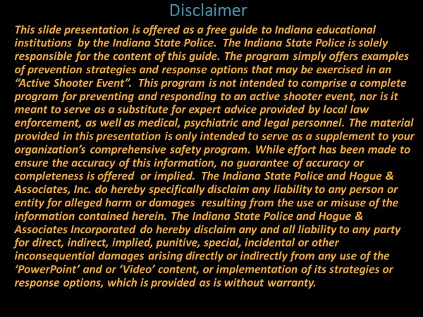

The Indiana State Police:

Slide # 2 Disclaimer
This slide presentation is offered by the Indiana State Police Department as a free resource to school corporations across the nation. This information may assist schools in developing their own “active shooter” or “active attacker” programs. It may also serve as a resource for reviewing a school’s current “active shooter” prevention and response programs.
This information is not intended to comprise a complete program for preventing and responding to an active shooter event, nor is it meant to serve as a substitute for expert advice provided by local and state law enforcement, as well as medical, psychiatric, and legal personnel.
While the Indiana State Police Department is solely responsible for the content of this presentation and the Department has made every effort to ensure the accuracy of this information, no guarantee of accuracy or completeness is offered or implied.
Presenter’s Note: The Indiana State Police Department and Dr. Richard Hogue of Hogue & Associates Incorporated do hereby specifically disclaim any liability to any person or entity for alleged harm or damages resulting from the use or misuse of the information contained herein. Unfortunately, ISP presenters must make it abundantly clear that this free program offers no guarantee of preventing an “Active Shooter Event,” nor does the program represent a “Comprehensive School Safety Program.” The response options are offered without warranty as well and should be viewed as resources to be considered. Again, educators should review several active shooter strategies and craft a program that meets their unique needs. Specifically, the program does not take the place of developing a “Comprehensive Safety Program” that addresses the vulnerabilities and risks identified by a “Comprehensive Threat, Vulnerability and or Risk Assessment.”

Slide # 3 Each School Presents a Unique Set of Challenges The Educator Becomes a Student of Safety

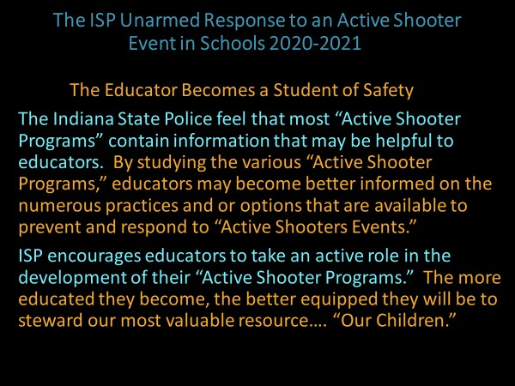

Slide # 3 Each School Presents a Unique Set of Challenges
The Educator Becomes a Student of Safety
Presenter’s Note: “Active Shooter Prevention and Response” is an everchanging science. The Indiana State Police strongly recommend that educators become “students” of school safety. They must constantly be seeking new information and utilizing that information to review their current safety practices. From each tragedy, new information comes. If educators do not learn from the mistakes of others, they are doomed to repeat the same mistakes repeatedly.
Educators are very capable of reviewing the data from previous active shooter events. The Indiana State Police encourage educators to review their current programs and practices in the light of the data garnered from previous active shooter events.
A good safety plan is never completed. It should be a fluid document that is constantly improved as new information is processed.

Slide # 4 The ISP:

Unarmed Response to an Active Shooter Event in Schools 2020 Each School Presents New and Unique Challenges
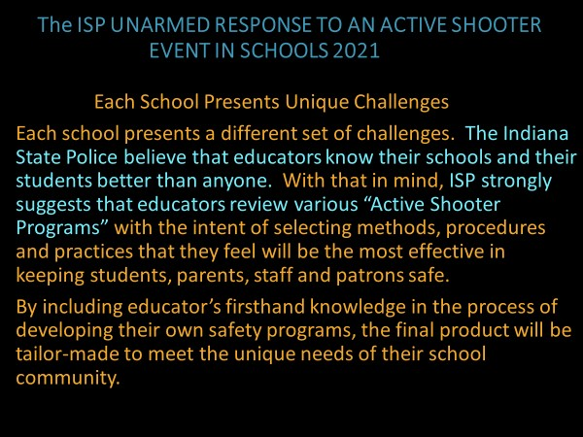

Slide # 4 Each School Presents Unique Challenges
Educators know their schools and school community better than anyone. The process of reviewing various “active shooter programs” should assist them in selecting and crafting the methods, procedures and practices that best fit the unique needs of their school community.
Presenter’s Note: Once the plan has been developed a regimen of training, practice and modification must be utilized to keep the plan current. The only impact, of a plan that sits on the shelf to gather dust, is to create a false sense of security. Training and practice programs are critical to responding appropriately. Staff development drills and exercises often identify areas in need of modification and revision. The Department believes a critical role in implementing any safety plan rests in ability of the organization to carry out the appropriate prevention and response procedures.

Slide # 5 The Active Shooter: Indiana State Police Definition

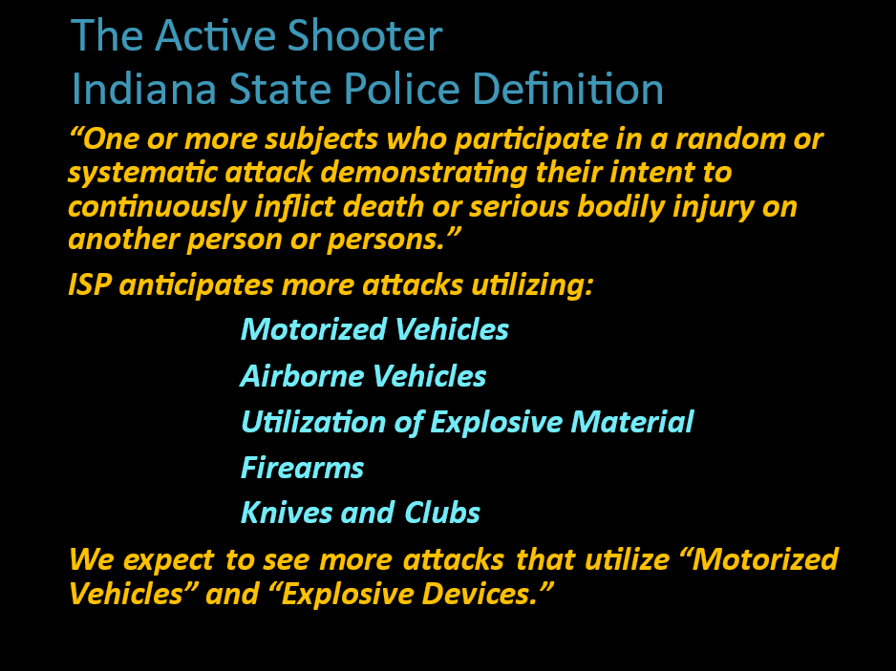

Slide # 5 The Indiana State Police Definition of an “Active Shooter”
This slide provides a broad definition of an “Active Shooter.” The definition has changed as active shooter events have evolved over recent years. The presenter may elect to make it clear that ISP expects the use of more motorized vehicles and explosive devices in future attacks.
These attacks tend to be carried out on “soft targets.” Venues that do not have effective preventative measures and or armed and trained law enforcement present the most likely targets.
Presenter’s Note: It may be underscored by the presenter that an attack may be carried out with more than one weapon. Dating back to Columbine, some of the attacks have combined the use of multiple weapons. In previous attacks, explosive devices have been deployed to injure students and staff as they evacuate the primary assault location. Explosive devices intended to injure first responders as they arrive have also been utilized in earlier attacks. The point being that a secondary attack location (SAL) must be considered as we construct our active shooter strategies (and evacuation sites). Prevention is always preferable to response. With that in mind, ISP presenters may wish, once again, to underscore that a “Comprehensive Safety Assessment” is a critical first step in developing an effective safety program. Simply, the “Comprehensive Safety
Plan” should be developed to address the vulnerabilities and risks identified in a
“Comprehensive Safety Assessment.”

Slide # 6 Overview of School Shootings
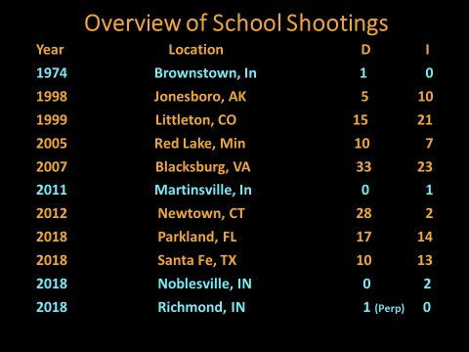

Presenter’s Notes: This slide underscores that Indiana is not immune to the active shooter phenomenon. An initial attack at an Indiana school happened many years ago. As the chart demonstrates, tragically assaults have revisited our schools very recently.
A narrative describing the active shooter events set out in the slide above has been provided below. In several of the attacks, the presenter may wish to underscore how the principles found in the “ISP Unarmed Response to an Active Shooter Event Program” were applied.
Brownstown, Indiana 1974
The 48-year-old assistant principal of Brownstown Central High School was killed by a student in the parking lot of the high school. From reports, the student arrived first and waited for the administrator to arrive and took his life with a firearm as he entered the building.
Presenter’s Note: This tragedy may very well underscore that school shootings have “hit” close to home in the past.
Jonesboro, Arkansas 1998
Presenter’s Note: An 11 and 13-year-old activated the school fire alarm with the intent of collecting students and teachers into a “killing field.” Once grouped outside the building, the pair killed a teacher and four Westside Middle School students. In the assault, an additional ten students were injured.
Presenter’s Note: This assault stands as an example that presenters may utilize to underscore that the ISP “Escape Option” calls for students to take a secure and predetermined path to a secure area. Some models suggest that participants may simply wish to “Run.” This tragedy may serve as a teaching moment to emphasize that the ISP URASE Model cautions individuals to escape intelligently. That means you must consider the location of the shooter and predetermine secure paths to a safe area before blindly exercising the “Escape Option.” Otherwise, you may very well run directly into the threat. The ISP model cautions not to run blindly.
Presenter’s Notes: If you do not know the location of the threat, the “Lockdown Option” may be your best choice. The Indiana State Police caution, “Never leave a safe and secure location for an unknown!” The “Lockdown Option” may very well be an excellent option!
Law enforcement response time is typically very brief. You may only need to stay safe for very brief period. This may once again be an opportunity for presenters to underscore that the strategy of evacuating victims into a consolidated killing field must be considered as active shooter response options are developed.

Presenter’s Notes: It took twenty-three years for school administrators, safety experts and legislators to come to the realization that schools must verify fire alarms to make sure they were not inadvertent and or simply a strategy to evacuate students and staff into a killing field. {418}

Indiana Fire Marshal Remedying the Situation
Presenter’s Note: See Indiana Fire Marshal Guidance:
- The Indiana Building Code (675 IAC 13)
- The Indiana Fire Code (675 IAC 22)
- NFPA 72 (675 IAC 28-1-28)
- Indiana Code 22-11-17
- Fire Marshal Guidance to Schools {388}
To mitigate the potential danger of an inadvertent fire alarm being used to bring students and staff into a killing, the Indiana Fire Marshall offers a potential safeguard against this threat. {388}

Littleton, Colorado 1999
Two Columbine High School students shot and killed 12 students and one teacher. Twenty-one additional people were injured by gunfire during the attack. While attempting to escape, three more individuals were injured.
The two shooters had crafted multiple bombs from propane tanks, pipes, etc. that failed. The assault had the potential to be much worse if the explosive devices had detonated. After executing numerous individuals, the two shooters committed suicide in the library. In addition to the poorly constructed explosive devices, the shooters utilized a pump-action shotgun, a semi-automatic handgun and two rifles.
Presenter’s Note: This tragedy gave rise to law enforcement’s response strategy of entering the facility as they arrive and hunting the perpetrator. Presenters may wish to explain the difference between simple response time and the time it takes to engage the threat. Response time may be very brief, but engagement time may be the response time plus the time it takes to locate the threat. That is why it so important for presenters to stress it is critical for law enforcement to be assisted in locating the threat. Presenters may wish to explain the difference between simple response time and the time it takes to engage the threat.
Law enforcement response time may be very brief. But we must also consider “engagement time.” {This is the time it takes for law enforce to engage the shooter. “Total Response Time” may be the response time plus the time it takes to locate the threat. (1.a Hogue “URASE”) School administrators must work with local law enforcement agencies to coordinate response time and develop policies that assist arriving law enforcement in locating the threat.” (1.a Hogue)
Presenter’s Note: Sadly, the perpetrators that carried out this event developed in plain sight. They had contact with law enforcement, mental health counselors, parents, and educators.
Red Lake, Minnesota (2005)
The 16-year-old shooter initially shot and killed his grandfather and a family friend at his home on the Red Lake Indian Reservation. The shooter proceeded to Red Lake Senior High School where he shot and killed an unarmed security guard. A second security fled unharmed.
Presenter’s Note: The Indiana State Police believe that one of the best deterrents to an active shooter event is an academy trained, sworn, uniformed and armed law enforcement officer. Partnering with law enforcement to bring police officers into schools is a critical step in “hardening” a campus. {425} The Indiana State Department has a free program by which school can invite Indiana State Troopers onto their respective campuses. Details on this program may be found on the Indiana State Police webpage under the “ISP Walkthrough Program.” {425}
After entering Red Lake Senior High School, he killed a teacher and five students. Law enforcement responded and engaged the shooter. He took his own life.
Presenter’s Notes: Reportedly, the shooter was prescribed the anti-depressant Prozac and underwent counseling. {426} Allegedly, the shooter’s doctor had increased his dosage of Prozac a few days prior to the attack.
Records indicate that the shooter had received psychiatric counseling. Reports indicate that a forensic review of his online traffic indicate numerous concerning posts. They paint a picture of trouble young man.
Examples of FBI Stressors: The shooter lost his family support system by age 10.

Blacksburg, VA (2007)
Reportedly, the 23-year-old shooter armed himself with a Walther P22 and a
Glock 19. He initiated his attack by killing two students at West Ambler Johnston Hall. {427} After the initial assault, he methodically changed his clothes and created multiple videos. The shooter also took the time to take multiple pictures of himself with weapons.
From Abler Johnston Hall he proceeded to Norris Hall. There he secured the doors with chains and proceeded to shoot and killed 30 more teachers and students.
His killing spree took the lives of thirty-two individuals before taking his own life. In addition to those killed the shooter shot 17 more students and teachers. The Blacksburg shooting represents the deadliest school shooting in the history of the United States of America.
Reportedly, the shooter had an extensive history of mental and or emotional behavioral concerns. {428} The shooter’s erratic behavior generated concern among his fellow student and teachers from high school through VT. It has been reported that he harassed female students.
His behavior became so disturbing that a psychiatric review was conducted. The court ordered assessment found the developing shooter to be “mentally ill and in need of hospitalization.” {429}
- Martinsville, Indiana
In the Martinsville shooting, it was alleged that a 15-year-old student, who was recently suspended, perpetrated the shooting.
The shooting was reported to have occurred at the entryway of Martinsville West Middle School. Utilizing a handgun, the shooter shot a classmate in the entryway of the middle school. It was reported that an earlier confrontation spurred the attack.

- Newtown, Connecticut
After killing his mother in their home, the 20-year-old perp then took multiple weapons from the home he shared with his mother and proceed to Sandy Hook Elementary School. At the elementary school, he killed 26 more students and staff. The death toll at the elementary school included twenty first-grade children between the ages of six and seven, a building administrator, four teachers and the school psychologist.
As law enforcement arrive the shooter took his own life. The total loss of life, including himself and his mother stood at 28. Two additional individuals survived their wounds.
It was reported that the shooter had locked himself in his bedroom for weeks without any contact with anyone. A follow up report by the state’s attorney indicated that he suffered from mental health issues.
“There were signs of problems throughout (the shooter’s) life, but they often weren’t fully addressed or identified by his family or school.” “He didn’t seek or participate in any mental health treatment after 2008, despite records indicating that he was “profoundly” impaired by anxiety and obsessive-compulsive disorder.” “There were repeated references to seizures in his medical records, but no evidence that he received a recommended neurological consultation.” “In seventh grade, he wrote about battles, destruction and war, with a level of violence his teacher found disturbing and “so graphic that it could not be shared.” Again, there was no evidence his teacher explored the source of the violent content with (the shooter) or his parents.” {430}
2018 Parkland, Florida
The alleged attacker was identified as a 19-year-old former student at Marjory Stoneman Douglas High School. Reportedly, the shooter attended Westglades and Cross Creek schools prior to attending Marjory Stoneman Douglas. It has been reported that he exhibited severe behavioral and emotional health issues throughout his educational career. Here again, the indicators seem to indicate that a storm was on the horizon. Reportedly, his behavior had led to his expulsion from MSD High School.
It was reported that the assailant activating the fire alarm during his attack. Some sources have reported that he may have utilized the fire alarm to establish a “killing field.” He utilized a rifle to take students as he encountered them. In the assault, 17 people were killed, and seventeen others were injured. The alleged shooter shot the students on the first and third floor of the complex.
The suspect joined with the crowd of fleeing children and exited the building. The suspect was arrested some distance from the campus. The alleged shooter has been charged and awaits trial.
“One of the biggest questions looming over the Parkland massacre is why a gun-obsessed, mentally disturbed teen who’d been in trouble for years was deemed fit to transfer from a specialized school for troubled children to a huge public school with far fewer mental health resources. Documents obtained by the South Florida Sun Sentinel shed some light on how that happened and raise questions about how the school district monitored him once he left the protective cocoon of Cross Creek, a Pompano Beach school for children with severe emotional and behavioral disorders.” {431}
2018 Santa Fe, Texas
Reportedly, after hearing what appeared to be gunshots, the fire alarms were activated between 7:45 and 7:50 am. The alleged shooter reported started taking victims in the fine arts and crafts area of the facility.
The suspect utilized a shotgun and a handgun. As is often the case in school shootings, several explosive devices were found around the school grounds. Ten individuals were killed and 13 (including the suspect) were injured.
The attack at Santa Fe High School in Santa Fe, Texas, was initiated on May 18, 2018. Ten individuals were fatally wounded, and thirteen others sustained serious injuries. {432} The suspect utilized a shotgun and a handgun. As is often the case in school shootings, several explosive devices were found around the school grounds.
On his Facebook site, the shooter posted,
“A photo of a shirt with the words "Born to Kill" on his Facebook page.[34] The Facebook page also included photos of his black duster coat with several buttons on it, with accompanying captions: "Hammer and Sickle=Rebellion. Rising Sun=Kamikaze Tactics. Iron Cross=Bravery. Baphomet=Evil. Cthulu=Power." {433}
Initially, the shooter was evaluated and moved to a mental health facility. {434} Most recently, the Santa Fe shooter was moved to a state mental health facility.
“The teen charged in a mass shooting at a Texas high school last year has been formally declared incompetent to stand trial.” {435}
Noblesville, Indiana 2018
In Noblesville West Middle School, two people were shot and injured. Suspect left the classroom and returned with a handgun.
As he returned, he allegedly, shot a female student and the classroom teacher. The teacher responded by wrestling the gun away from the shooter.
Richmond, Indiana 2018
At Dennis Intermediate School, the alleged 14-year-old shooter, shot his way in the school via a locked glass door. The suspect exchanged gunfire with law enforcement. During the exchange, he took his life. This may be an example for presenters to underscore that a “Perimeter Lockdown” may not be as secure as once thought.
It was reported that the alleged shooter had been receiving services at a mental health facility prior to the assault.
“He had been admitted to a mental health facility several months before the shooting, but the facility said, “nothing was wrong” when it released him to her, she added.” {438}

Slide # 7 The ISP Prevention and Response Model
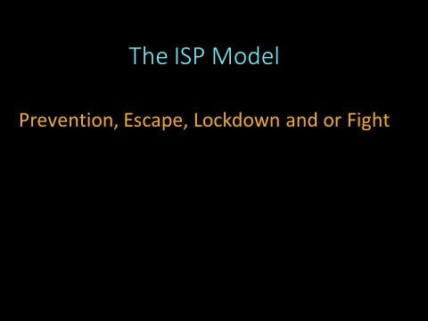

The ISP Prevention and Response Model
Presenter’s Note: In this point in the presentation, the presenter may wish to begin the discussion on the importance of “Prevention.” All too often, we find that the shooter exhibited behavior that was concerning to others. Sadly, we often hear classmates, teachers, administrators, counselors, etc. state that they are not surprised to learn that the shooter carried out one of these horrific events.
Once an attack begins, someone will be injured. As we review these events, we quickly see that the number of casualties once an attack is initiated is very rarely zero. Even when the shooter fails to take victims, the conclusion of the event may be the shooter turning the firearm on himself/herself.
The Indiana State Police prefer prevention to response. With that in mind, the ISP Model puts “Prevention” as the first phase of the model but underscores that the response options (Escape, Lockdown or Fight) may be exercised in any order. Again, the model is nonlinear.
An individual caught in an “active shooter event” may elect to “Lockdown” in a secure place waiting for the opportunity to exercise the “Escape” component of the model. Individuals may elect to exercise the “Escape” option until they find a secure location to “Lockdown.”
Presenter’s Note: Simply the options are not steps to be exercised in a specific order. They are options that may be exercised in any order depending on the changing conditions of the active shooter event. Again, the selection of the options to be exercised will be dictated by the circumstances or the external stimuli of the “active shooter event!”

Slide # 8 How Do Prepare for Prevention
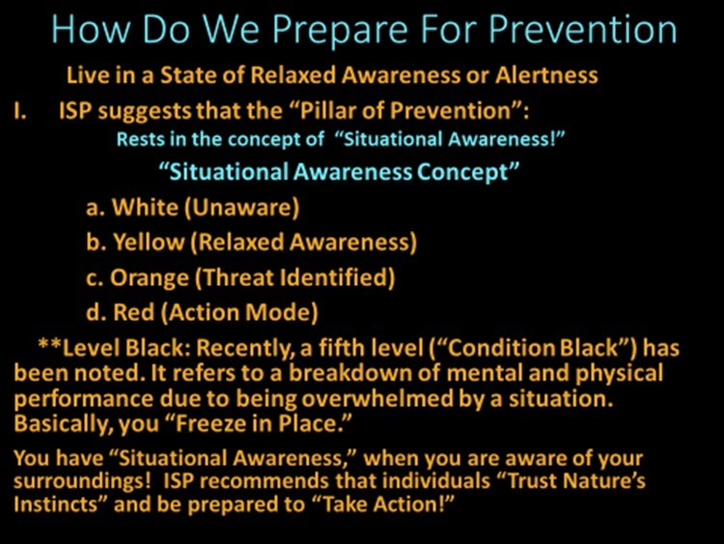

Slide # 8 How Do Prepare for Prevention Indiana State Police Levels of Awareness
White Level of Awareness:
You are unaware of your surroundings. You may be talking on your cell phone, listening to music on your earbuds and or just daydreaming.
Presenter’s Example: How many times have you had to dodge someone on the sidewalk talking on their phone or following someone weaving from lane to lane down the highway?

Yellow Level of Awareness:
Presenter’s Notes: You are aware of the stimuli (conditions or circumstances of your environment.). You are not panic stricken. You are aware and monitoring the changes in your environment.
Orange Level of Awareness:
Presenter’s Notes: As you monitor your environment, your instincts and your perceptions tell you something is wrong or “off” in your environment. Red Level of Awareness: You have identified a threat in your environment. You have made the decision to engage the threat.

Levels of Awareness
“White: Unaware and unprepared. If attacked in Condition White, the only thing that may save you is the inadequacy or ineptitude of your attacker. When confronted by something nasty, your reaction will probably be "Oh my God! This can't be happening to me."{403}
“Yellow: Relaxed alert. No specific threat situation. In Yellow, you are "taking in" surrounding information in a relaxed but alert manner, like a continuous 360-degree radar sweep. "{403}
“Orange: Specific alert. Something is not quite right and has your attention. Your radar has picked up a specific alert. You shift your primary focus to determine if there is a threat (but you do not drop your six). If the threat proves to be nothing, you shift back to Condition Yellow.” {403}
Red: You are in the fight mode. “Your mental trigger (established back in Condition Orange) has been tripped.” {403}

Black Level of Awareness
Black: The USMC uses "Condition Black," although it was not originally part of Cooper's color code. {404} According to Massac Ayoob, "Condition Black," in Cooper's youth, meant "combat in progress."{405} "Condition Black" is also used to mean "immobilized by panic" or "overwhelmed by fear" {405} The Department refers to the
“Black Level” when individuals are so overwhelmed, they are frozen and unable to act.
If you have trained yourself to be aware of the stimuli or conditions existing in your environment, you are “Situationally Aware!” This state is often referred to as a state of “Relaxed Alertness.”
Presenter’s Note: The presenter may wish to underscore the importance of being “Situationally Aware.” This state of “Heightened Awareness” is critical to responding appropriately. The simple goal here is to underscore the importance of being aware of one’s surroundings! Participants must understand that to prevent a threat they must see it developing.

1. Relaxed Alertness (Situational Awareness) or Relaxed Awareness
Presenter’s Note: Individuals will not be able to identify developing threats if they are not aware of the actions that may signal the emergence of danger.
Several examples of individuals “being unaware” may be useful in conveying the importance of being aware of one’s surrounding or environment.
Examples of being unaware in everyday life:
1. Every Day Event
- The battle with the “Cell Phone!”
The presenter may simply ask, “How many of you in the last 24 yours had to dodge someone walking and texting or reading a text while walking?
How many followed a car that sat through a light or changed lanes erratically while texting, answering a call, dialing, etc.?
- Earbuds
Being lost in listening to music, an audio book, etc. can quickly turn into a life threatening situation.

Supplemental Information Cooper’s Color Code of Awareness Levels of Awareness
White: Is often utilized to designate a level of awareness in which you are relaxed and totally unaware of things happening in the environment around you. {406}
Yellow: In this state of awareness, you remain relaxed, but are aware of what is happening in your environment. In this level of awareness, you are in a state of “relaxed alertness.” While you do not identify any specific threat, you are aware of the threats that could develop in your environment. Simply, you are aware of your environment and the actions of individuals around you. {406}
Orange: The next level is orange. In this state, threats have been identified and you are beginning to formulate actions. In orange, you have identified a potential threat and preparation has begun to deal with the situation. {406}
Red: At the “Red Level” you may remove yourself from the threat or engage the threat in the manner you have formulated. *
Col. Jeff Cooper’s Awareness Color Code System {406}
Presenter’s Note: Our goal is to maintain a state of “relaxed awareness” in our daily lives. This seems easy but it takes a constant mental effort. In this state we will be able to recognize potential threats in sufficient time to initiate an intervention and or formulate an appropriate response. The Indiana State Police strongly believe that “Prevention” is preferable to “Response.” Once an attack is initiated, someone will be injured. ISP’s goal is to prevent an attack.
As we review previous “active shooter events, it becomes clear that shooters develop overtime and exhibit several very specific behaviors. ISP hopes to utilize these behaviors to assist in identifying individuals that may be developing into a threat.
Trust Your Instincts
Instinct or innate behavior may be described as an unlearned response. A feeling that is based in response rather than an analyzed reaction. You may not be able to describe why an individual makes you feel uncomfortable but she or he does. This is a consistent response among family, friends and or acquaintances:
- “He made me feel uncomfortable!”
- “I knew something was wrong, but I did not know who to tell.”
- “He scared me, but I did not know why.”

Slide # 9 Keys to Prevention

ISP Prefers Prevenon to Response “Common Pre-Event Behavioral Keys”
- Shooters Share their Intent Others.
- Shooters or Threats Develop Overme.
- Shooters Develop in Plain Sight.
- Failure to Fit In (Shooters Become Isolated)
- Obsessed with Desensizing Acvies
- Extreme Fascinaon with Previous Acve Shooter Events
- Extreme Fascinaon with Weapons
Key Stressors or Triggers
  - Disciplinary Acon at School.
  - Significant Conflict with Classmates, Staff and or Parents.
  - Rejecon Resulng in Isolaon.
  - Perceived Mistreatment by Peer Group.
  - Loss of Social Support Systems, etc.

Slide # 9 Keys to Prevention
“Prevention is preferable to Response.”

- Shooters Share their Intent with Others!
As the Department reviews active shooter events, it quickly becomes apparent that developing shooters share subtle cues relative to their intent with others. They may make these comments to garner recognition from their peers or simply to be noticed by the members of a social group to which they want to belong. Often, adolescents see it as a pathway to garner attention from their peers. Regardless, developing shooter share their intent with others for a variety of reasons. It is one of the most common behaviors of developing shooters.

- Shooters or Threats Develop Overtime.
It my make a better story if shooter just seem to snap. However, the ISP has not found this to be the case. Shooters develop overtime and most often provide numerous cues to their intent far in advance of their assault on their school.
As far back as Columbine, the shooters displayed obvious clues to their nefarious intentions. In 1998, they threatened to blow up a fellow student with a pipe bomb. The parents of the intended victim reported to law enforcement. {407}
One of the shooters authored a story about an assassin:
“In a black trench coat who shoots down students and bombs the city.” {407}
“Sources suggest that an arsenal of weapons were amassing in their bedrooms: including knives, guns, cans full of gunpowder, coils of bomb fuse, and bombs: more than 100 of them, including pipe bombs, propane bombs and homemade grenades. “{407}
A year before the assault, the Columbine shooters were arrested for breaking into a van. They were placed into a diversionary program. {408} The diversionary counselor seemed taken in by one of the shooters as she wrote,
“`PROGNOSIS: Good. Dylan is a bright young man who has a great deal of potential. If he can tap his potential and become self-motivated, he should do well in life.''{408}

In the Virginia shooting, a state investigative report suggested,
“The Virginia Tech massacre might have been prevented if university authorities had heeded "clear warnings of mental instability" from the shooter. {409} “The report goes on to document in exhaustive and painstaking detail (the shooter’s) history of mental health problems, which were recognized in childhood.” {409} In a class assignment, “He wrote a paper in English class that expressed thoughts of suicide and homicide, and a desire to "repeat

Columbine," although he did not mention specific individuals or targets.” {409}
Some of the signs of trouble looming included Cho's playing with knives, uncooperative and disruptive behavior in the classroom, students who skipped classes to avoid being near him because they were afraid of him, disturbing or bizarre text messages sent to female students, and an involuntary commitment to a hospital for expressed thoughts of suicide. {409}
In the Sandy Hook tragedy, three words scream out from a storybook 10-yearold Adam Lanza wrote as a fifth grader. "Let's hurt children."
The Hartford Courant wrote,
“Three words scream out from a storybook 10-year-old (Sandy Hook Shooter) wrote as a fifth-grader. "Let's hurt children."
“The young (shooter) put those words in the mouth of Dora the Berserker (sic), one of the homicidal characters included in "The Big Book of Granny," which chronicles the evil adventures of gun-toting Granny and her son.” “The violent and chillingly prophetic story was a central part of the background investigation into (shooter’s) life, traced up until he committed the massacre at Sandy Hook Elementary School. (The shooter) and another boy wrote the book as a class assignment, but it was never handed in, investigators said.” {410}
“The book is included in the summary of the 11-month state police investigation released Monday by Danbury State's Attorney Stephen J. Sedensky III.” {410} “The eight chapters of Lanza's book take Granny and her son through a litany of dark episodes as they tote a bag carrying a handgun, an M-16, and a shotgun, firearms eerily like those he would use years later at the Sandy Hook school. Granny robs a bank with a bullet-spewing cane. She guns down soldiers at a Marine boot camp and travels back in time and murders The Beatles. She threatens to shoot and kill children in a classroom.” {410} “Granny kicks the boy into a burning fireplace, punches him in the face and shoots at him. After the bank robbery, the son shoots Granny in the head with a shotgun.} {410}
“Inside the Lanza home, Sedensky said investigators found a spreadsheet with information about mass murders, books and news articles about killing sprees and a computer game titled "School Shooting" in which a player controls a character who shoots students in classrooms.” {410}
“By the ninth and 10th grades, Lanza had taken to shutting himself inside his bedroom, spending hours on end playing such video games as "Call of Duty," "Grand Theft Auto," and "Combat Arms." {410} “"Those mental health professionals who saw him did not see anything that would have predicted his future behavior," Sedensky wrote.” {410}
Shooters develop over time! They do not snap!
The indicators are there. We simply fail to act on our intuitive feelings, or we fail provide the necessary supports systems to mitigate a developing tragedy.
3. Develop in Plain Sight.
The signs are obvious. Unfortunately, shooters develop in “Plain Sight.” Often, we just dismiss their actions as odd. Often, we do not know who to tell.
Occasionally we just do not want to get involved. Lastly, we fear retribution.

It is not unusual for school shooters to develop overtime and exhibit behavior that may generate concern in educators, students, parents, etc. The presenters may wish to review examples of school shootings in which shooters demonstrated threatening behavior far in advance of carrying out the attack. (i.e., Columbine,
Red Lake, Virginia Tech, Sandy Hook, Northern Illinois University, Umpqua
Community College, Parkland Florida, and Santa Fe). {See: Unabridged Information, Narrative in the Presenter’s Notes of Slide 10 and additional resources set out in the Glossary, Bibliography, Resources and Reference Material}.

Presenter’s Note: ISP holds the belief that school shooters do not just “snap.” Again, it is important to underscore that school shootings do not happen impulsively (as often reported). Active attackers typically develop gradually and in plain sight.
Shooters typically develop over an extensive period. They plan meticulously and more importantly they plan in plain sight. Often, they accumulate large quantities of weapons. They often demonstrate an obsession with previous active shooters and events. They may collect news articles and search the internet to garner information on previous active shooter events. Shooters have been known to create charts and detailed plans of their premeditated attack. They often see the attention that is lavished on previous attacker, and they want the same.
Presenters Note: Presenters may wish once again underscore that ISP does not name previous active shooter by name. The Department does not wish to offer any additional notoriety to these loathsome individuals.
4. Failure to “Fit in” (Isolation)
Presenter Notes: It goes without saying that even the best “school days” can be difficult at times. The need to be accepted or to “fit in” is a strong determinant in the developmental process of a “shooter.” From early elementary school, individuals strive to belong, to be recognized and or to be a part of the “group.” If individuals are excluded from the “group”, self-esteem, self-image and or selfconcept suffers dramatically. This may create a sense of alienation that can be magnified by hazing, teasing or in the extreme bullying. Often being the “odd person out” invites more intense bullying or teasing and the alienation becomes more ingrained.
As individuals seek to belong, the need for recognition may become an obsession. These individuals may seek a means to garner that recognition by extreme behavior. In addition, the desire to strike back at those they perceived to be responsible for the alienation or isolation grows. Adolescents may fantasize about getting even and attaining the recognition they so desperately desire. It is not uncommon for adolescents to fantasize about “getting even.” These fantasies may even have a violent focus.
However, typically the fantasy is just that, a fantasy and it does not become an obsession. However, in extreme situations, the threat begins to progress when the “developing shooter” begins to see a violent act as a realistic avenue to “getting even” and obtaining recognition. Thus, they see an end to the isolation they so desperately seek to escape. Shooters may develop when the fantasy of attaining recognition and bringing the isolation to an end becomes an obsession.
Presenter’s Notes: The developing shooter begins to view an “active shooter event” as a feasible avenue to strike back at those they hold responsible for their mistreatment. Here the presenter may wish to underscore why students would view a horrific act (such as a school shooting) as a logical remedy to their isolation. Presenters may wish to introduce the information on brain physiology here and repeat it as they discuss the “Desensitizing and Empathy” topics.
Info for Presenter’s Notes Repeated “in the next section”: Educators may not understand why their students act irrationally. Adolescents often make decisions impulsively with dangerous results. The biological explanation for this behavior rest in the development physiology of the adolescent brain. The area of the brain responsible for rational thought process develops more slowly than the area of the brain that stewards emotional behavior such as aggression, anger, and fear (Amygdala). Simply, the developmental time clock for area of the brain that assists in reasoning ticks much more slowly than the area of the brain that helps student see the consequences of their actions. Research has also shown that exposure to drugs and alcohol during the teen years can change or delay these developments. These brain differences do not totally prevent young people from make good decisions, but these developmental issues may make them act more impulsively. It also doesn't mean that they shouldn't be held responsible for their actions. However, an awareness of these differences can help parents, teachers, advocates, and policy makers understand, anticipate, and manage the behavior of adolescents.

5. Obsessed with Desensitizing Activities
Presenter’s Note: A brief discussion of the adolescent brain may be appropriate. It is not unusual for law enforcement to describe the active shooter’s post attack behavior as detached, devoid of emotion, etc. The adolescent mind often does always grasp the consequences of their actions. With that said, we must understand that adolescents are impulsive, and they process information very differently than adults.
Supplemental Information on the Physiology of the Brain
Educators may not understand why their students act irrationally. Adolescents often make decisions impulsively with dangerous results. The biological explanation for this behavior rest in the developmental physiology of the adolescent brain. The area of the brain responsible for rational thought processing develops more slowly than the region of the brain that stewards emotional behavior such as aggression, anger, and fear (Amygdala). Simply, the developmental time clock for area of the brain that assists in reasoning ticks much more slowly than the area of the brain that helps student see the consequences of their actions. Research has also shown that exposure to drugs and alcohol during the teen years can change or delay these developmental processes. These brain differences don't mean that young people can't make good decisions or tell the difference between right and wrong. It also doesn't mean that they shouldn't be held responsible for their actions. However, an awareness of these differences can help parents, teachers, advocates, and policy makers understand, anticipate, and manage the behavior of adolescents.
As we examine the developmental factors and behaviors from a collective perspective, a more concise image of the potential school shooter and or attacker may come into view. Frequently, we may see that a developing shooter is struggling with emotional and mental health issues. These individuals may also be suffering from DBD (disruptive behavior disorder) and a variety of emotional and mental health issues. Aggressive behavior resulting in acting irrationally in class, fighting, harming fellow students, harming animals, etc. are early warning behaviors that signal the need for intervention and mental health support.

Consideration for the Desensitizing Process: Grossman’s Perspective
As we examine the causal factors contributing to the development of adolescent shooters, we may be well served to review Col Grossman’s work on the desensitizing impact of violent video games, movies, etc. on the adolescent brain.
Col Grossman, a retired general staff officer, company commander in the 7th (Light) Infantry Division and a professor of psychology at West Point suggests that most people have a predisposition against harming another human being. He utilized his experience and expertise to demonstrate that soldiers need to be specifically conditioned and trained to kill. Just as soldiers must be trained to “counter” the predisposition to harm another human being, extensive exposure to video games may condition adolescents to become desensitized thus changing their repugnant view of violent behavior. Some social scientists suggest that more research to support this assertion needs to be mounted.
Grossman and others suggest that violent video games, television, movies, and internet sites are contributing to the desensitizing of adolescents. Grossman and others maintain that the techniques used to train our military are emulated in the technology utilized to develop some video games. Grossman’s assumption rests in the assertion that extensive emersion into the playing of violent video games influences adolescents by desensitizing them to violent acts.

Clear Signal of “Desensitization:” Loss of Empathy
A strong associative behavior of the sociopath is the lack of empathy and remorse for abhorrent acts. The sociopath holds no empathy for harmful acts carried out against pets, classmates, parents, teachers, etc. Many of the developing shooters carry out acts of torture and mutilation against animals. These acts sometimes characterized as “Intentional Animal Torture and Cruelty” (IATC) are often clear warning signals of antisocial and or psychopathic personality disorders. The FBI often characterizes antisocial acts of this nature as early indicators of deep-seated emotional health issues.
Behavior of this nature often gives the individual a sense of control. Some studies suggest that the perpetrator cannot hold down or control a human but an act of IATC substitutes for this impulsive and remorseless behavior. It is often about the power garnered by IATC behavior.
Clearly, behavior of this nature calls for assistance from trained medical professionals.
6. Extreme Fascination with Previous Active Shooter Events
Often “school shooters” are motivated by the “active shooters” before them. As we study “school shootings”, the importance “shooters” place on being accepted, recognized, and validated becomes clearer. We begin to see the extent to which these individuals will go to be acknowledged and recognized within their “social caste system.”
In addition, developing shooters often see the recognition heaped on past shooter. In the search for elevating their self-esteem they fantasize about duplicating a school attack in hope of attaining the notoriety and recognition they seek.
Columbine is the classic example of an event that school shooters have studied, emulated, and admired for twenty years.

7. Extreme Fascination with Weapons
School shooters often accumulate a large cache of weapons and ammunition.
They frequently practice and become proficient in the use of these weapons. They often have a fascination for weapons of all types.
It is important to underscore that these individuals often plan, stockpile weapons, share intent others, etc. prior to carrying out these horrific events. The planning phase is our best chance to prevent these attacks.
This is not to say that a healthy respect for weapons is troublesome and or sport associated with firearms is problematic.

Presenter’s Notes: The fantasy and planning stages represent the best times for prevention through early identification and intervention.
Unfortunately, being “out of step”, “odd”, etc. may often serve as a lightning rod for treatment that increases the alienation of these individuals and intensifies the need to be recognized and the desire to strike back.
Overtime the mental images of the fantasy become more detailed and they begin to focus on individuals that they perceive have wronged them. They begin to plan, and the fantasy becomes their reality.
Presenters Notes: Presenters may wish to underscore: Perception is often the shooter’s reality. Individuals that are mistreated or perceive themselves to be mistreated may develop the need to strike back at those they perceive to have wronged them. Intervention may very well be needed to provide emotional support and or counseling for these individuals to prevent an escalation into an active shooter event.
Introduction of the Need for an Intervention Team
We may be able to prevent an attack, if we educate members of the school community on the “Early Warning Behaviors” and underscore that attackers often plan in plain sight.
We want to underscore that individual suffering from mental health issues and depression do not always become active shooters! The characteristics set out above are simply behaviors that may signal the need for an early intervention. If individuals exhibit several of the characteristics the need for an intervention becomes more urgent.
One key is to look for individuals exhibiting several of the issues set out above. The development of an “Intervention Team” (set out in the next slide) is a critical component because the team serves as a resource for communicating and obtaining assistance for individuals that may be suffering from some of the issues set out above.
Often, “potential threats” plan extensively and share their intent with others. It has been suggested that these individuals will go to extremes to receive any type of recognition to bolster their diminished “self-esteem” or “self-image.” That extreme may manifest in an “active shooter event.” It is a desperate act, but these individuals are in a very distressed state.
Presenter’s Notes: The intense desire for attention may manifest in disturbing social media postings, drawings, writings, comments, dress, bragging, etc. It is not uncommon for fellow students to be aware of this disturbing behavior. These individuals often share the details of the event they are planning. They have viewed the attention received by previous shooters and they want the same. Simply, they seek that attention and the popularity they believe they will garner by committing or duplicating a horrific event.

Triggers (Often referred to as Stressors: Secret Service Report)
As these individuals develop, it is not unusual for these individuals to experience what ISP refers to as a “trigger” or initiate that will spark them from the developmental stage into the attack mode. The 2019 Secret Service Report sets out information on “Stressors” (this information set out below).
In school shootings, a confrontation with an educator or fellow student, an embarrassing event related to school, a disciplinary action taken by parents or by school officials, an unrequited love situation, etc. may result in pushing a developing shooter into the (active shooter) action phase.

Stressors
- Disciplinary Action at School
United States Secret Service “National Threat Assessment Center”
ACADEMIC/DISCIPLANARY
“Most attackers (n = 31, 89%) had experienced school stressors related to academic or disciplinary actions, including failing grades and school suspensions. More than half of the attackers (n = 21, 60%) had both academic and disciplinary issues. For seven of the attackers (20%), a disciplinary issue at school was the most recent stressor experienced prior to the attack.” {411}
- Significant Conflict with Students, Staff and or Parents:
A disciplinary action taken by school officials or parent.

- Rejection Resulting in Isolation (Failing to “fit in.”)
Fitting in and or being recognized a member of the group is extremely important to adolescents.
Presenter’s Note: We must understand, and presenters must underscore the degree to which “developing shooters” hold a fascination for previous “Active Shooter Events.” They are so enamored or captivated with the actions of previous shooters, they often talk freely about their exploits. They hold previous shooter in high esteem and begin to develop a need to copy the actions of these individuals. The want to belong and be valued/held in high esteem. They often see the attention that these shooters receive. Because they are craving attention and have an overpowering need to be recognized they may see one of these horrific acts as a solution. We may simply fail to see how important “fitting in” can be to an adolescent.
- Perceived Mistreatment by Peer Group
Presenter’s Note: Not being accepted by a group to which the developing shooter holds in esteem. Simply, the shooter wants to be a part of the “in crowd,” or “cool” group. The desire to be accepted is often overpowering in adolescence.
- Loss of Social Support Systems
Presenter’s Note: The network of social support systems entails having a social network of family and friends.

Presenter’s Notes: The paragraph below underscores the importance of Social Support Systems.

SOCIAL Support Systems
“All of the 35 attackers (100%) in this study experienced at least one social stressor. Social stressors identified in this analysis included stress related to the attackers’ relationships with peers (e.g., bullying, or other peer conflicts) and romantic partners. These types of stressors, including peer rejection during childhood and adolescence, have previously been linked to depression, anxiety, substance use, and behavior problems. For half of the attackers (n = 19, 54%), a social event, such as a breakup or an incident of bullying, was the most recent stressor experienced before carrying out the attack. Those stressors often occurred within a week prior (n = 11, 31%).” {411}
* United States Secret Service “National Threat Assessment Center.” The study by the Secret Service:
2019 U.S. Department of Homeland Security-United States Secret Service (National Threat Assessment Center) underscores these factors as stressors (2019). {411}

Additional Stressors Cited:
(ISP Stressor: Rejection and Mistreatment by Peer Group, Failure to “Fit In, Isolation, etc.)

FAMILY: Stressors related to the attackers’ families included conflicts in the home, abuse or neglect by a parent, and family financial difficulties. Nearly all attackers experienced family-related stressors (n = 32, 91%). At least three attackers had a stressful interaction with a parent within one day of the attack.
{411}
GENERAL PERSONAL: Two-thirds of the attackers (n = 22, 63%) experienced stressors that were unique or personal in nature, and therefore not as easily categorized. These stressors included a failed drug test, homelessness, and feeling unhappy with one’s physical appearance. At least three attackers (9%) had witnessed violence against a friend or loved one, including a death by stabbing. {411}
*The study by the Secret Service: 2019 U.S. Department of Homeland Security-United States Secret Service (National Threat Assessment Center) underscores these factors as stressors (2019). {411}
Remember, typically, shooters share their intent early and frequently with others. Shooters typically demonstrate behavior that should concern individuals familiar with them.
One of our best opportunities to prevent an “Active shooter Attack” is to identify the individual or individuals that are in the developing and planning phase of the attack. If we educate our school community on the “Early Warning Behaviors and Indicators” we may be able to prevent an “active shooter event.”

Slide # 10 Educate the School Community on Shooter Development

Contribung Factors to Acve Shooter Development
“The Unhealthy Mind”
Emoonal & Mental Health Issues Schizophrenic Maladies:
- Delusional,* Paranoia,* Hallucinaons Depression:
- Anger or Irritability *Suicidal *Helplessness & Hopelessness.
Psychopathic Behavior:
- Superficial Charm * Cunning & Manipulave
- Loss of Remorse * Exaggerated Self Esmaon
- Loss of Empathy * Failure to Accept Responsibility
**These behavioral cues are observable. Typically, someone oen knows. Again, ISP recommends:
“See Something, Do Something!”

Slide # 10 Education the School Community on Active Shooter Development

Behavioral Keys to Prevention

Fifty-one million individuals in the United State suffer from mental illness. {412} That equates to approximately one in five people suffer from this malady. Obviously, mental illness is not a guarantee or all an encompassing factor that always precipitates the development of an active shooter. Emotional and Mental Health Issues The Indiana State Police want to be clear:

All individuals struggling with emotional and mental health issues will not become “Active Shooters!”
Presenter’s Notes: Potential shooters may suffer from serious emotional and mental health issues. That is not to say all individuals suffering from these maladies will develop into active shooters.
An irrational mind may be the fertile origin for the development of an “active shooter.” The “unhealthy mind” may account for the lack of empathy, compassion and restraint exhibited by many active shooters. These emotional factors are often absent in the individuals that carryout these horrific events.
Presenter’s Notes: Several school attacks are outlined in the following paragraphs. The relationship of mental health to the development of an active shooter is underscored.
Dr. Pierre, in Psychology Today, in:
“Active Shooters: Not Mentally Healthy, But Not Mentally Ill,” offers:
"In short," the FBI report, “Active Shooting Incidents” occurring in the US between 2000 and 2013, concludes, "Declarations that all active shooters must simply be mentally ill are misleading and unhelpful. But once again, the lack of a diagnosis of mental illness doesn’t mean that active and mass shooters are mentally healthy. In most cases, they’re not. The same could be said for a substantial part of the “normal” population (if that strikes you as illogical, ask yourself whether most of the population is physically healthy). It’s also possible that some active shooters did have a mental disorder but were undiagnosed and untreated. Either way, these shooters may not appear that different from you and me or our family members and friends, and there seems to be a window of time in which intervention might be possible.” {117}
Reference: Psychology Today, Joe Pierre M.D. Psych Unseen “Active Shooters: Not Mentally Healthy, But Not Mentally Ill” A new FBI study challenges the idea that most shooters have a mental disorder. {117} Posted Jun 21, 2018
Presenter’s Notes: A publication authored by the staff of the United States Secret Service suggests:
“Most attackers had experienced psychological, behavioral, or developmental symptoms: The observable mental health symptoms displayed by attackers prior to their attacks were divided into three main categories: psychological (e.g., depressive symptoms or suicidal ideation), behavioral (e.g., defiance/misconduct or symptoms of ADD/ADHD), and neurological/developmental (e.g., developmental delays or cognitive deficits).” {9} “The fact that half of the attackers had received one or more mental health services prior to their attack indicates that mental health evaluations and treatments should be considered a component of a multidisciplinary threat assessment, but not a replacement. Mental health professionals should be included in a collaborative threat assessment process that also involves teachers, administrators, and law enforcement.” {9}

Columbine
Columbine stands as one of the most famous school shooting events in the United States. Unfortunately, the Columbine tragedy is often viewed as a contributing factor in many of the more recent school shootings across the U.S.
Shooters often view the notoriety heaped on the Columbine shooters and wish to capture the same infamy. The Columbine perpetrators took the lives of 12 students and one teacher. The horrific event ended with the suicide of the two shooters. Twenty-one additional people were injured during the attack.
Presenter’s Note: The Columbine shooters demonstrate many of the “Early Warning Indicators” often exhibited by developing shooters. For example, both shooters were arrested for breaking into an SUV in January of 1998. A full year before the Columbine tragedy. As a result, they were placed in a diversionary program. The program called for the perpetrators to attend regular meetings with mental health professionals. In addition, they were required to participate in a community service program. They completed the community service program, and their criminal records were expunged. During their community service period, the pair constructed numerous explosives and assembled an arsenal of weapons. During this time the two penned and posted numerous written documents and videos setting out their intent.
Presenter’s Notes: Reports have surfaced alleging that two security advisors constructed a security plan nearly nine months before the Columbine attack. In general terms, the advisors recommended that school administrators to hold a conference with parents and law enforcement upon learning of potential student related threats.
“A year before the attack, Joe Schallmoser and Howard Cornell were worried that Columbine was just the kind of place where a school shooting might happen. They oversaw security for the school district that included Columbine. After the shootings in Paducah, Ky., and Jonesboro, Ark., they were afraid that one of their schools might be next.” {21}
It has been alleged that Columbine officials did not comply with the recommendations.
Many mental health professionals have studied the shooters. One of the extensive studies was conducted by the FBI. While some have disputed some of the FBI’s conclusions, it stands as one of the most extensive studies of the Columbine tragedy.
The FBI study convened a taskforce in Leesburg, Virginia. The inquisitors included several clinical psychologists (i.e., clinical psychologist “Special Agent” Dwayne Fuselier and celebrated Michigan State University psychiatrist Dr. Frank Ochberg).
“Shooter one was easier to comprehend, a more familiar type. He was hotheaded, but depressive and suicidal. He blamed himself for his problems.” {440}
“Fuselier says, Harris was not merely a troubled kid, the psychiatrists say, he was a psychopath.” {440}
Presenter’s Notes: The FBI’s inquiry determined that one of the shooters was a depressive. The National Alliance on Mental Illness describes a “depressive disorder” as a serious mental health condition.
“Depressive disorder, frequently referred to simply as depression, is more than just feeling sad or going through a rough patch. It’s a serious mental health condition that requires understanding and medical care.” {439}
While other mental health professionals’ term “major depressive disorder” as a serious “medical illness.”
With respect to the second shooter, the FBI suggested a more definitive finding. The findings suggested that he was a “psychopath.” Their findings suggest that he displayed the classic lack of empathy, narcissism and unconstrained aggression that is often exhibited by a psychopath. {440}
“Some mental health professionals believe that (one of) Columbine killer showed signs of being what’s termed a fledgling or budding psychopath.” {441}
He premeditatedly lied and enjoyed the deception. By his acts of taunting his victims during the shooting, he graphically demonstrated the lack of empathy that characterizes the true psychopathic.
Presenter’s Notes: The FBI psychiatrists s reached the conclusion that one of the Columbine shooters was a true “brooding” psychopath. Their findings suggest that he displayed the classic lack of empathy, narcissism and unconstrained aggression that is often exhibited by a psychopath. The second shooter was found to be a depressive. His mood disorder was characterized by “suicidal” tendencies and “severe mood depressive disorder.” {13}{32} {33} {440}
The FBI psychiatrists also offer an interesting perspective on the shooter’s intent. The FBI’s commission suggests that the shooters would often cite the 1995 Oklahoma City Bombing as an inspiration. The shooters seem to view the casualty count as a goal or target. The commission suggests that the Columbine attackers had an even darker motive than the wholesale slaughter of students and teachers. The horrific slaughtering, of their fellow students and teachers, was just a means to shock the world. They wanted to create death and destruction on a monumental scale. They wanted to leave their mark on a world they despised.
They wanted infamy on a historic scale. {440}
“The killers, in fact, laughed at petty school shooters. They bragged about dwarfing the carnage of the Oklahoma City bombing and originally scheduled their bloody performance for its anniversary. Klebold boasted on video about inflicting “the most deaths in U.S. history.” {440}
It wasn’t just “fame” they were after—Agent Fuselier bristles at that trivializing term—they were gunning for devastating infamy on the historical scale of an Attila the Hun. Their vision was to create a nightmare so devastating and apocalyptic that the entire world would shudder at their power. {440}

Red Lake
The Red Lake Indiana Reservation shootings occurred on March 21, 2005, in two different locations. The shooter killed his guardian (his grandfather) and a friend in his home. The shooter killed seven people (five students, an unarmed security guard and a teacher) at the school while wounding five others that survived.
Presenter’s Notes:
Reports allege that the shooter had attempted suicide and had received psychiatric care. Various sources indicate that the shooter was under treatment for depression and had been prescribed Prozac as an anti-depressant.
It has also been reported that he posted extremely violent content on the internet. It has been reported that the shooter created two violent “flash animations” for the flash website “Newgrounds,” using an alias. Allegedly, in the animation entitled Target Practice, he features a character who murders three people with a rifle, blows up a police car with a grenade, and kills a “Klansman.” In addition, it is reported, that the animation terminates with the suicide of the shooter. A second “flash” animation, allegedly created by the shooter, depicts the killing of a man by eating his head.
“The (shooter) may have posted messages on a neo-Nazi Web site, hosted by the Libertarian National Socialist Green Party, expressing admiration for Adolf Hitler, going by the nickname "Todesengel," which is German for Angel of Death. In the first posting under that name, the writer identified himself as Jeff Weise of the Red Lake Reservation. An April 2004 posting from him referenced being accused of "a threat on the school I attend," though it says he was later cleared.” {442}
Presenter’s Notes: In the Red Lake event, the shooter had a history of abhorrent and erratic behavior. His paternal aunts intimated that they assisted him in receiving mental health counseling and treatment to deal with his depression and mental health issues. {36} That treatment included a regimen of Prozac and mental health counseling. Reportedly, his dosage of Prozac had been increased just prior to the event. {41}

Virginia Tech
A student at Virginia Tech University shot and killed 32 people and wounded 17 others with two semi-automatic pistols.
Presenter’s Notes: At three years of age, the shooter has been described as a shy and frail individual wary of physical contact. As a junior high school student, it was reported that the shooter was under the care of a therapist for an anxiety disorder and depression.
Presenter’s Note: The shooter wrote a paper in middle school expressing thoughts of homicide and suicide. He expressed a desire to "repeat the
Columbine atrocities." As a result, he was referred for mental health counseling. A psychiatrist diagnoses his disorder as severe anxiety disorder or selective mutism and depression. He was medicated with paroxetine. {45} {46}
Sources report that the shooter remained under the care of a therapist throughout his high school years. The shooter’s speech difficulties may have made him a target for bullying by his classmates.
Upon enrolling in Virginia Tech, it has been reported that the shooter did not seek assistance for his “Exceptional Learning” issues.
At Virginia Tech:
Reports suggest that his fellow students feared him to the extent that they would not attend class to avoid him. {46} As a result of his mutism, he seldom spoke. Instead, his dorm mates indicated that he would simply glare at them. His behavior so concerned some of his classmates and professors that he was reported to the administration. {45} As a result, he was taken to a local mental health clinic for evaluation.
On one point his behavior became so concerning that a magistrate intervened. The assessment of a judicial review indicated he was a substantial danger to himself. The court intervened and placed him into an outpatient treatment program. {45}
Presenter’s Notes: The shooter’s mental state deteriorated as he continued his studies at VT. Post shooting reports indicate that the shooter abhorrent behavior seem to escalate. Educators at VT later indicated that the shooter’s writings became more troubling as he continued his studies. Reports suggest that the shooter’s behavior became so disquieting that his teachers encouraged him to seek counseling. Reports have surfaced that indicate the shooter was reported for stalking and harassment of two of his fellow female students. Several media sources suggest that the shooter was declared mentally ill by a Virginia justice and ordered to seek “treatment” as an outpatient.
His writing became so troubling writings that his professors reported their concerns, but no intervention program was instituted. {45} An instructor intimated,
"I was willing to resign before I was going to continue with him." “His writings were so disturbing, she said, that she went to the police and university administrators for help.” {191}

Sandy Hook Elementary
Presenter’s Notes: A 20-year-old male shot and killed 26 people in Sandy Hook elementary school. The deceased include 20 children between the ages of six and seven along with six adult staff members. The shooter began his shooting spree on December 14, 2012, in his home. There he killed his mother in the home they shared. He then drove to Sandy Hook Elementary where he initiated his attack by gained access to the facility by shooting out a glass panel next to the locked front door. {400}
Reports underscore that the “Sandy Hook” shooter demonstrated developmental difficulties early in life. In elementary school, the shooter was diagnosed with a “Sensory-Integration Disorder (SID).” {65} Sensory integration refers to the process by which the brain organizes and interprets external stimuli such as touch, mobility, body awareness, sight, sound, etc. Sensory integration refers to the neurobiological process by which information is gathered by our senses, synthesized, assimilated, and interpreted.
He was referred to and assisted by the New Hampshire Family-Centered Early Supports and Services (FCESS) program. This agency is a designated non-profit that provides services for children from birth through three years of age. The program serves children who are experiencing significant developmental delays.
Presenter’s Notes: Very early in his middle school experience, the perpetrator was diagnosed with extreme anxiety disorders (i.e., depression and selective mutism). Early in his middle school years, the shooter received mental health counseling for extreme anxiety, depression, and selective mutism disorder.
As a result of the shooter experiencing communication, sensory difficulties, socialization delays, and repetitive behaviors, the specialists at the “New Hampshire Birth to Three intervention Program” referred the developing shooter to the “Exceptional Learner” preschool program. {62}
In elementary school, the shooter was diagnosed with a sensory-integration disorder (SID). {65} Children suffering from this malady have trouble handling the basic sensory stimuli. Examples of these stimuli include but are not limited to taste, touch, sight, sound, smell, etc. Sensory integration disorder (SID) is a neurological disorder that results from the brain's inability to process and integrate certain information received from the body's basic sensory systems.
As a result of significant anxiety issues, reports indicate that the shooter was placed on “Homebound” instruction and study during his junior high years. Records indicate that the shooter was diagnosed with “Asperger Syndrome” and “obsessive-compulsive disorder” (OCD) during his early teens. He was prescribed medication which he did not tolerate well. {203 p. 35} As a result, the medication was discontinued.
Presenter’s Note: Presenters should make it clear that “Asperger Syndrome” according to experts is a developmental disorder and not a mental illness. The violent behavior demonstrated by the shooter is generally not seen in those that are dealing only with this developmental disorder.
It has been recently reported that individuals familiar with the shooter expressed concern that mental health professionals may have missed other undiagnosed mental disorders.
Interestingly, it has been reported that none of the psychiatrists he saw identified any troubling signs of violence in his demeanor. It has been reported that no care from mental health professionals was provided to the shooter after 2006.
The preliminary investigation discovered that the shooter was fascinated with previous mass shootings (i.e., Columbine High School, Virginia Tech, Northern Illinois University, etc.). In his bedroom authorities found writings depicting an attack by a man who shot school children in 1891. In his computer, authorities discovered movies dealing with school shootings and self-produced pictures of the shooter pointing a firearm at his head.
The shooter never permitted anyone, including his mother, to enter his bedroom. Meals, laundry, etc. were left outside his bedroom door. He covered the windows with plastic to block out sunlight. Reportedly, for months before the shooting, he only communicated with his mother via email. The shooter appeared to be isolated from the world around him. His contact with the outside world seems to be limited to the internet.
Presenter’s Notes: The Office of the Child Advocate also intimates that the shooter may have suffered from a variety of mental health issue including but not limited to a diagnosis of Obsessive-Compulsive Disorder, Severe Anxiety and Autism Spectrum Disorder. {61}
It has been reported that a forensic investigation of his computer indicated that he demonstrated a propensity for violent video games. It appeared that his cyber contact and interaction was primarily focused with others on the internet that shared his obsessive interest in wholesale slaughter and murder.

Northern Illinois University
The shooter entered the lecture hall via a stage entrance and opened fire. {82} {125} Because he entered the classroom and immediately began taking victims, a lockdown could not be initiated. The shooter utilized three handguns and a shotgun to carry out the assault. {82}
The shooter had a long history of mental illness dating back to his high school years. The shooter was able to conceal his mental health background. {126} In his teen years, he suffered with a schizoaffective disorder. {80} {124} {127} This chronic condition results in delusional behavior. The hallucinations are accompanied by episodes of mania and depression. {80} {124} Some sources indicate that he had been treated with several antipsychotic medications i.e., Seroquel, Risperdal, Clozaril and Zyprexa.” {127}
Presenter’s Notes: It has been reported that the shooter was treated for mental illness at a psychiatric center. He enlisted in the military and was discharged after serving only a few months for failure to disclose the history of psychiatric issues. {82}
Allegedly, the shooter was nicknamed as "strange Steve" by acquaintances. {198} Reportedly he had a profound fascination for a sadistic killer in a popular horror film and for the Columbine massacre. Allegedly, a friend reported that the shooter was taking psychiatrist prescribed Prozac, Xanax, and Ambien.
Reports indicate the shooter mental illness may have contributed to his history suicide attempts.
It was reported that the shooter mailed packages to a friend that contained a gun holster and ammunition, a textbook on serial killers, and a copy of the “The Antichrist by Friedrich Nietzsche.” The alleged mailings may have been posted just prior to the attack.
Presenter’s Notes: A note recorded in the treatment center’s summary from the “Thresholds” program proved prophetic for predicting the shooter’s future:
“When symptomatic, he (shooter) becomes anxious, depressed and unable to sleep. Increased suicidal thoughts (occur) and (he) feels worthless with low self-confidence and self-esteem. (He) Can become verbally aggressive and argumentative. (Has) A history of self-mutilation.”
{128}

Umpqua Community College
On October 1, 2015, a twenty-six-year-old student at Umpqua Community
College, took the lives of his instructor and eight students. Eight additional students were wounded in the assault. The shooter entered the writing classroom and ordered everyone to the center of the classroom. {83} {84} It has been reported that he asked them for their religious beliefs before shooting them. {96} {97} It has been alleged that the shooter intimated to friends that he had been abused by an authority figure in his church. The connection was never substantiated. Law enforcement arrived and engaged the shooter. After being wounded by law enforcement, he took his own life.
Presenter’s Notes: Like the Northern Illinois shooter, he was removed from the military. He was discharged after only five weeks of U.S. Army basic training. It has been reported that the shooter was discharged because of a suicide attempt. {85}
A year after his discharge, sources report that the shooter graduated from a school for “Exceptional Learners.”
“He had been to a special school for troubled kids in California.”
The had an ill-fated stint in the military but complete records were not available:
“He had briefly entered the U.S. Army, spending a couple weeks in a North Carolina boot camp before being discharged.” {139}
Some reports suggest that the shooter was prescribed medication for his mental condition:
“He had a psychiatric diagnosis — exactly what diagnosis is blocked out in the report — and had taken medications for it. But, according to his mother, nothing worked. He had recently taken to urinating into a bucket to avoid using the bathroom at night. She also said he enjoyed watching videos of killings on several websites.” {139}
The following year he enrolled in a two-year community college. A few days before the attack, the shooter posted an article on the Sandy Hook attack. Sources indicated that the shooter posted a message before the attack warning individuals in the northwest not to go to school on the day of the shooting. A “Los Angeles Times” article quoted a law enforcement source as suggesting that the shooter may have been suffering from “long-term mental-health related issues.”
In writings reviewed after the shooting, it became apparent that he had studied previous mass shootings. It appeared that he coveted the notoriety heaped on previous mass killers.
It was reported that he wrote, "Other people think I'm crazy, but I'm not. I'm the sane one.” Reports indicate that he wrote he would be "welcomed in Hell and embraced by the devil.”

Stoneman Douglas
It has been alleged that the On February 14, 2018, a gunman entered the Freshman Building of the Marjory Stoneman Douglas High School. In a case he carried a semi-automatic rifle. On the floor, the shooter fired into four classrooms killing eleven people. On his way to the third floor, he entered the second-floor hall and fired his weapon into several classrooms.
Presenter’s Notes: Several media sources reported that the shooter’s behavioral problems are documented throughout his educational career. Media sources reported that his abhorrent behavior accelerated as he progressed through the educational system. News media reports suggest that the Florida Department of Children and Families had been alerted to posts by the shooter on Snapchat. The postings related to the shooter cutting his arms and expressing an interest in buying a gun. But after visiting and questioning (the shooter) at his home, the agency determined he was at low risk of harming himself or others. The report is an example of some of the “Early Warning Indicators” exhibited by the shooter.
The charged shooter’s behavioral issues began early in life.
“As a young middle-school student, the alleged school shooter regularly got in trouble for using foul language, insulting people, disobeying teachers and disrupting classes.” {149}
It has been reported that psychiatrists recommended placing the shooter
in a residential treatment center as early as 2013. {71}
It has been reported that psychiatrists recommended placing the shooter in a residential treatment center as early as 2013. {71}
Reports allege that educators viewed the shooter as a danger to students and staff. He used profane language, drew naked sick figures showing sexual body parts, made gestures pretending to masturbate in class, bragged about killing his cat, demonstrated a fascination for violent video games, stated he hoped “Security would die,” shouted F*** at his teacher, held an obsessive fascination for weapons, etc.
As a result of his abhorrent behavior, charged shooter, “was sent to Cross Creek as an eighth grader after a staggeringly troubled experience at Westglades Middle School, where he was suspended at least 67 days over a year and a half.” {144}
“Eighteen months before the (alleged shooter) shot up Marjory Stoneman Douglas High School, MSD staff were so worried about his fascination with guns that they banned him from practicing shooting skills with the JROTC, according to mental health records obtained by the South Florida Sun Sentinel.” {146}
It has been reported that local and federal agencies missed some of the “Early Warning Indicators” as well. After the shooting, the F.B.I. confirmed that it failed to investigate a tip called into a hotline by a person familiar with the shooter. The tip indicted that he owned a gun and seemed intent on killing people. After the shootings, reports surfaced that the local police had been called to the shooter’s residence on several occasions for domestic disturbances.
“Disciplined repeatedly in school, treated for mental health conditions, crushed after his mother died — more signs of unheeded red flags are emerging about the young man accused of murdering 17 students and staff at Marjory Stoneman Douglas in Parkland this week.” {147}
Presenter’s Notes: In 2016, the shooter returned to Stoneman Douglas High School from Cross Creek an alternative school for children with emotional and behavioral disabilities. Due to his concerning behavior, school officials reported that a safety plan had been created for the shooter. The plan prohibited the accused shooter from carrying a backpack on campus. {146}
Clearly, the school administration believed the shooter to be a significant threat. So significant, that they prohibited him from carrying a backpack on campus.

Santa Fe

Early Warning Signs
News publications (i.e., Los Angeles Times and New York Times) reported that the shooter’s social media site contained photographs that displayed clothing and badges exhibiting concerning phrases and symbols. (Examples included i.e., "Born to Kill.”) Another publication (Evening Standard) reported that the shooter posted photographs of weapons. {442}
Steve Gomez, a former FBI special, offered insight regarding the accused:
"Threatening people at school, talking about violence, sharing social media posts showing guns, knives, T-shirts that say, in his case, 'Born to Kill,' are all signs," Gomez said.” {442}
Presenter’s Notes: Reports out of Texas indicate that recent developments in the accused Santa Fe shooter’s legal proceedings have been placed on hold. Three psychiatric experts evaluated the accused shooter and concluded that he was “incompetent to stand trial.” {79} The shooter had been charged with capital murder in the Santa Fe High School shooting.
As a result of his psychiatric evaluation, he has been transferred to a mental health facility at the North Texas State Hospital. {79} Privacy concerns prevented the specific diagnoses and findings from being shared.

US Secret Service Submission
In the recently released “Protecting America’s Schools: A U.S. Secret Service Analysis of Targeted School Violence” report, the Secret Service study of 2019” asserts:
“Most attackers had experienced psychological, behavioral, or developmental symptoms: The observable mental health symptoms displayed by attackers prior to their attacks were divided into three main categories: psychological (e.g., depressive symptoms or suicidal ideation), behavioral (e.g., defiance/misconduct or symptoms of ADD/ADHD), and neurological/developmental (e.g., developmental delays or cognitive deficits). The fact that half of the attackers had received one or more mental health services prior to their attack indicates that mental health evaluations and treatments should be considered a component of a multidisciplinary threat assessment, but not a replacement. Mental health professionals should be included in a collaborative threat assessment process that also involves teachers, administrators, and law enforcement.” {443}

Slide # 11 Prevention: Gathering Information and Creating Pathways
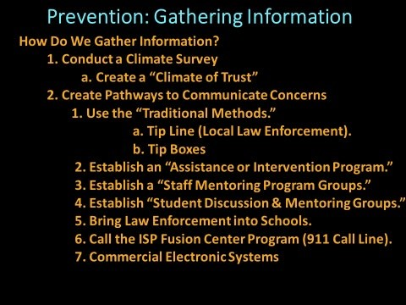

Slide # 11 Prevention: Gathering Information and Creating Pathways
As discussed earlier, threats develop over time, and they develop in plain sight. However, all too often information on a developing threat is not communicated to individuals or organizations that can intervene and alleviate or mitigate the danger.
To facilitate communication, pathways to convey information must be established. The first task in creating effective pathways is to create a climate of trust in your schools. Students and staff need to feel safe in the school environment. Members of the school community will not share concerns if they do not feel that the information, they share will be confidential and that action will be taken. Students are often the best resource for intelligence gathering with respect to school safety information.
A starting point for developing pathways to enhance communication with respect to school climate begins with a “climate survey or audit.” Students, staff, and members of the school community are a valuable resource for gathering information on school climate.
Processes, Procedures, Practices and Suggestions for Improving School Climate
Presenter’s Note: School safety practices and the relationship that “school climate” plays in maintaining a safe and positive school environment are often absent from many educators’ preparation programs. One of the first steps, in establishing and or confirming the existence of a positive and safe school climate, is to assess the students’ view of their learning environment and or school community. To assist in this process the Indiana State Police have provided sample climate queries for students and staff. The sample survey queries are posted on the ISP Home website. Again, ISP recommends that educators utilize these queries only as a resource. It is strongly suggested that schools develop their own climate surveys.

School Climate
A positive school climate begins with several basic support systems. Expectations and rules for acceptable behavior must be established, published, and taught to all members of the school community. Enforcement must be fair, consistent, and constructive. Students must be clear on the expected behavior and the consequences for inappropriate behavior. Acceptable behavior must be rewarded. Those exhibiting inappropriate behavior must be held accountable.
Channels and Tools for Gathering Information
Again, if we wish to prevent the unthinkable, we must first know it is coming. A critical first step in “Prevention” is to gather the information that will assist educators in identifying the emergence of an active shooter threat. Basic to gathering information is establishing a positive and safe climate in each school within the district. If students trust their teachers and feel safe, their learning will flourish, and they are much more likely to establish constructive relationships with educators in their respective schools. Simply, if students view their teachers as mentors and trusted confidants, they are much more likely to discuss concerns with them.
Again, educators are encouraged to develop their own instrument to assess the climate in their respective schools. Administrators and teachers are encouraged to review the queries posted on the ISP website and select specific questions that they feel best fit their respective schools. Measuring school climate is an ongoing process and utilizing selected queries should only be view as a single resource in the quest to examine the climate that exists in their respective schools
Presenter’s Notes: Again, it may be beneficial for presenters to once again emphasize that sample queries to assist educators in assessing school climate may be found at the Indiana State Home Page.
Tools for Reporting Information
Presenter’s Note: School community members (students, staff, patrons, etc.) often do not know how and where to report concerns? It is critical for administrators to develop and publish procedures and tools for reporting concerns.
“Tried and True” Traditional Information Gathering Tools
Presenter’s Note: If we expect to prevent an event, we must first know it is coming! It is critical not to overlook the “tried and true” traditional methods of communication and information sharing. ISP recommends that schools also consider utilizing the more traditional tools and or methods of gathering information. The traditional tip boxes, tip lines, etc. are cost effective methods for gathering information directly from the school community.
Intervention Team
Presenter’s Notes: One of the most effective tools for reporting concerns is the
“Intervention Team, Student Assistance Team or Threat Assessment Team.”
Simply, this reporting tool or “Team,” should be easily accessible and meet regularly. Policies and practices for handling information in a confidential manner must be established. The composition of the team must include a cross section of school community members (students, educators, support staff, patrons, law enforcement, medical and psychiatric personnel, etc.).
Standard operation procedures must be established for the “Intervention Team.” The “Intervention Team” must have access to resources and to community support groups that have the means and authority to mitigate concerns voiced by members of the school community. This team must have a broad base of community participants (i.e., administration, law enforcement, counseling professionals, school administration, etc.).
Student and Staff Mentoring Programs
Presenter’s Notes: Student and staff mentoring programs stand as effective tools for building relationships between students and building level educators. Student mentoring groups provide a nonthreatening environment for students to share concerns with fellow students. The staff directed mentoring discussion groups are often facilitated by trained school counselors are often one of the best tools for identifying and supporting students in need of assistance.
Invite Law Enforcement to Campuses
Presenter’s Notes: Utilizing law enforcement to establish relationships with school community members is often one of the most effective intelligence gathering processes. The Indiana State Police provide a free “Walkthrough Initiative.” This program provides an opportunity for troopers to visit campuses and establish relationships with students and staff.
SRO’s, local and state law enforcement must be allowed to establish a presence on every campus. They must be highly visible. Inviting law enforcement into your schools is a valuable first step in creating a relationship between students and law enforcement. Utilizing law enforcement, to serve as guest speakers, is a “tried and true” method of building positive relationships between students and law enforcement. Inviting police officers to career day programs and utilizing them in programs like D.A.R.E. programs, safe driving initiatives, etc. will serve as valuable tools in the effort to build relationships.

Call the Fusion Center Program (911 Call Line)
A statewide effort to promote information sharing has been established by the ISP Fusion Center as well as the 911 Emergency Program.

Commercial Electronic Systems
Several commercial information sharing systems and emergency notification systems are available. It is a local decision on selecting one of these programs. ISP strongly recommends that local law enforcement, SRO’s, etc. be utilized in reviewing programs.

Slide # 12 Prevention: What Do We Do with Concerns?
The Intervention Team (Student Assistance Team or Threat Assessment Team)

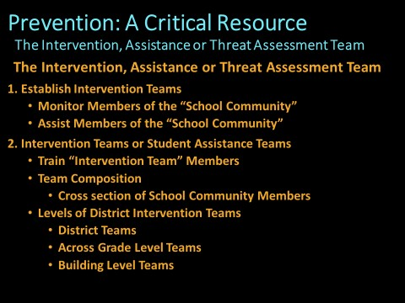

Slide # 12 The Intervention Team (Student Assistance Team or Threat Assessment Team)
Presenter’s Note: As ISP travels throughout Indiana, it has become apparent that several schools do not have a functional “Intervention, Student Assistance or Threat Assessment Team” in each facility. This entity serves as the main resource for aiding individuals that are exhibiting troubling behaviors. The team should include a cross section of members from the school community (i.e., students, instructional staff, parents, patrons, administration, law enforcement, SRO, School Safety Specialists, etc.).
Unless they are sworn law enforcement, trained health care professionals and or school counselors the members of these “Teams” must understand that they are not expected to serve as law enforcement, trained psychotherapist, school counselors, etc. They may serve a role as simple as offering their thoughts on a particular issue or providing insight into the group they represent. However, if they do bring skills (sworn law enforcement, trained/licensed psychotherapists, school counselors, etc.), their service may very well serve to strengthen the resources of the team. These “Teams” play a key role in prevention by providing early assistance and continuous monitoring of individuals in school community in need of assistance. These “Teams” also play a critical role in directing concerns to school community resources that can provide services and assistance to individuals exhibiting concerning behavior.
Presenter’s Note: The presenter may wish to underscore that these “teams” play a critical role in the prevention process. Early identification of developing “threats” is paramount to prevention. By including a “cross section” of individuals from the “School Community,” you may be better able to identify individuals in the “School Community” in need of assistance and or intervention. Again, it is important for the presenter to clarify that some programs refer to the groups referenced above as the “Threat Assessment Team, Student Assistance Team and or the Intervention Team.” Regardless of the terminology, the following points of emphasis must be underscored.
- Establish and train a “team” in each facility
- Establish a cadre of individuals to serve on the “team.”
- Establish this cadre from a cross section of individuals (i.e., educators, school counselors, medical and mental health professionals, law enforcement, support staff, etc.).
- Establish a simple and confidential method of communicating with the
“team.”
- Establish communication procedures to promote information sharing across grade levels.
- Establish a regular meeting schedule.

Slide 13 The Response Options
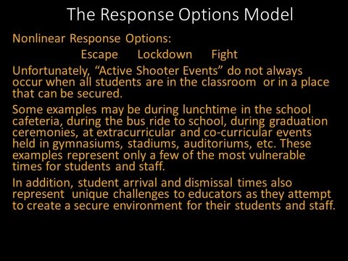

Slide 13 The Response Options Model
Presenter’s Note: It must be made clear by presenters that active shooter attacks often present a unique set of circumstances. The attacks may occur on the school bus, as students arrive in the morning, at extracurricular events, during convocations, during lunch in the cafeteria, while students are in the classroom, during graduation ceremonies, etc.
Experts that want to limit the response options, may not understand that students do not spend their entire day behind a classroom door.

Some Experts Want a One Response Only
The presenter may wish to ask the participants to consider all the possible school environments in which an “Active Shooter Event” may occur. With that said, the presenter may wish to ask the question, “Should we expect one action to be the best possible response in all of these circumstances?”
Presenter’s Note: Because “active shooter events” are often unpredictable and do not always occur at times when students and staff can immediately be secured behind a substantial door, ISP believes that being mentally prepared to respond to the circumstances of an “active shooter event” becomes critical.

Slide # 14 Preparing to Respond: Be Aware of Your Surroundings
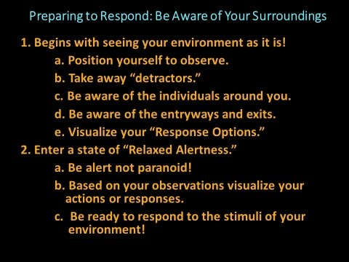
Slide # 14 Preparing to Respond or Being Prepared to Respond Trust your instincts!
Presenter’s Notes: The critical first step to being prepared to act and respond appropriately is to be aware of your environment! The foundation of the “ISP Response Option Model” is to be aware of your surroundings. Be prepared to response to the circumstances of the event. ISP refers to the circumstances of an event as the “stimuli” of the event. By being prepared to respond, you are less likely to “freeze in place.” “Freezing in place” is one of the most common fatal errors that individuals experience when faced with one of these horrific events.
All too often, we witness individuals going about their daily lives totally oblivious to the things that are going around them. Cell phone usage stands a one of the most prevalent detractors to being aware of our environment. Earbud usage often cancels out critical sensory gathering abilities. In addition, it takes the focus off environmental factors and focuses our attention on the sounds transmitted into our ears.
Law enforcement is trained to constantly monitor their environment. A simple example of this may be found in the way they position themselves in a room. Typically, they want to be seated such that they can monitor who enters and exits the room. They want to be able to strategically monitor their environment.
Presenter’s Notes: The presenters should underscore that being aware of one’s surroundings is critical to identifying potential threats in time to formulate a proper response. Col. Cooper’s information may be utilized to demonstrate that individuals exist in various levels of awareness as they go about their daily lives.
The simple goal here is to underscore the importance of being aware of your surroundings!

Levels of Awareness
White: Is often utilized to designate a level of awareness in which you are totally unaware of the environmental stimuli around you. You are in a relaxed and oblivious to what is happening in the environment around you.
{7}
Yellow: In this state of awareness, you are slightly aware of your environmental stimuli (what is going on around you). This state is sometimes referred to as “relaxed alertness.” You have not identified an imminent threat, but you are monitoring the environment for potential threats that may develop. Basically, you are aware of the stimuli or conditions that exist in your environment and the actions of people around you. {7}
Orange: In this state of awareness, you are aware and have identified a potential threat. You begin to formulate potential response options based on the stimuli around you. You are developing response options to mitigate the developing threat. You have identified a potential threat and you have initiated an action plan mitigate the threat. {7}
Red: Here you are in the fight” or “flight” mode. You are acting based on the stimuli of the event to neutralize the threat. You may be exercising an option to engage the threat and take the action necessary to mitigate the threatening situation. {7}
{7} Col. Jeff Cooper’s Awareness Color Code System
Our goal is to maintain a state of “relaxed awareness” in our daily lives. This seems easy but it takes a constant mental effort. In this state we will be able to recognize potential threats in sufficient time to formulate an appropriate response option.
ISP urges you not to be paranoid! Just be aware of your surroundings!

Slide # 15 Attack Characteristics and Law Enforcement Response
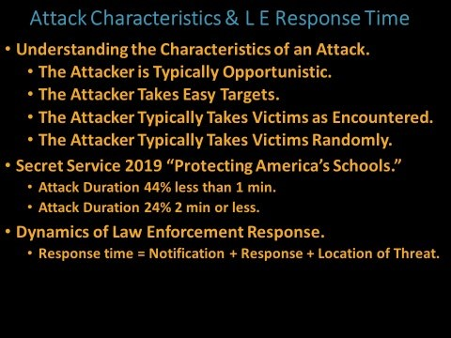

Slide # 15 Attack Characteristics & Law Enforcement Response
Presenter’s Notes: Presenters may wish to underscore that “Active Shooters or Active Attackers” are opportunistic. Their mindset is to create as much carnage as possible. Simply they are looking for numbers of victims. As we have noted earlier, they often study previous active shooter events. Often, their intent is to surpass the numbers of victims claimed by previous “Active Shooters.” It seems like an obvious refrain, but the Indiana State Police believe that potential victims must take the action necessary to stay out of contact with the attacker. The action to be taken should be based on planned and practiced programs. This program is founded on planned and practiced actions that provide options to various sets of circumstances. Each “Active Shooter Event” is unique. Therefore, a standardized all in one program may be a tall order to find.
ISP believes that each “active shooter event” demonstrates a unique set of circumstances. With that in mind, the Department suggests that schools consider several active shooter programs. By conducting an in-depth inquiry, schools may develop a broad-based program that will better address the myriad of circumstances present in each active shooter event. Looking for a one size fits all program may miss critical information that could prove to be the factor that made a life-or-death difference. The program should be constantly reviewed and modified as new information is garnered. Law Enforcement Response Time
It must be made clear that law enforcement’s response time is typically very brief. Individuals caught in an “active shooter event” typically must only need to stay safe for a few minutes. The Secret Service 2019 “Protecting America’s Schools” report underscores the brevity of “active shooter attacks.” The report suggests that 44% of attacks last less than 1 min and 24% last 2 minutes or less.
However, a great deal of harm can be meted out in a very brief period.
Dynamics of Law Enforcement Response.
Response time = Notification + Response + Location of Threat.
Presenter’s Note: Many sources confuse the concept of response time or mix the terms to define “Response Time.” When referring to the window of “Response Time” one must consider the time it takes to notify law enforcement, SRO, etc. To the “Notification” component, one must consider the time it takes for law enforcement to travel to campus. Finally, the time necessary to “Locate the Threat” must be figured into the “Response Time” equation.
This equation underscores the importance of streamlining the process of sounding the alarm (Notification Process). Secondly, the importance of working with local, county and state law enforcement to assess the typical response time once “Notification” has occurred. Finally, “Locating the Threat” in the facility is an issue often overlooked in training staff. Several options are available. Training staff on the importance of understanding their role in assisting arriving law enforcement in locating the threat. In addition, several options are available that may facilitate the process of directing law enforcement to the threat. They range from sound technology, synchronizing phone systems, radio, networking phone systems, video systems, etc. Preference and budget may dictate the selection process.

Slide # 16 Understanding the Response Options Model

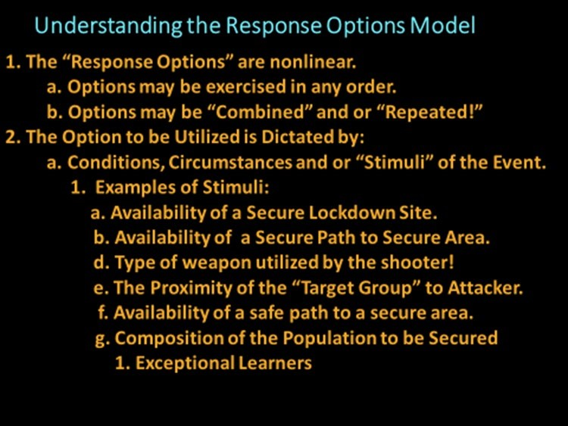

Slide # 16 “Understanding the Response Options Model Safety Program.”

Presenter’s Note: It is important for presenters to underscore that the “ISP Response Options Model” is nonlinear. Simply, this means that the options may be exercised in any order! In addition, the options may be repeated as the circumstances of the “active shooter event” dictate. (I.e., Individuals may exercise the “Escape Option,” then exercise the “Lockdown Option” and then elect to exercise the “Escape Option” again.) The “Response Options” may be combined. An example of combining the “Options” may be demonstrated by explaining that you may initially find it necessary to exercise the Escape Option until you can locate the nearest “Lockdown Site.” Presenters may wish to provide additional examples to demonstrate the “Nonlinear” component of the “Options Based Model.” Again, the circumstances, variables or “stimuli” of the event determine what option may be your best choice.
To underscore the concept of responding to varying conditions of an active shooter event, the following examples may be useful. Remember, responses are governed by the “stimuli, circumstances or conditions” of an event:
Examples of Stimuli, Circumstances or Conditions of an Event that Dictate the Most Appropriate Response:
- Availability of a Secure Lockdown Site.
- Availability of a Secure Path to Secure Area.
- Type of weapon utilized by the shooter!
- The Proximity of the “Target Group” to Attacker.
- Availability of a Safe Path to a Secure Area.
- Composition of the “Population to be Secured.”
1. Exceptional Learners, Age of Group, etc.

Presenter’s Note: The presenters may want to explain that school shootings do not always happen during times when students are conveniently sequestered in the classrooms. Therefore, exercising the “Lockdown” may not be the only answer. Again, the conditions of the event may dictate that students and staff exercise the “Escape Option” to stay out of contact with the shooter. Then, continue the “Escape Option” until they reach a secure “Lockdown” location. Examples of Shootings that Occurred Outside the Classroom Setting:
- 1998 Jonesboro, Arkansas-4 Students & 1 teacher were killed after they exited the building.
  - (Fire alarm was intentionally pulled to funnel students & staff into a killing field)
  - 5 killed, 10 injured outside the building
  - As the shooting started the students “Escaped” or “Reverse Evacuated” back to Gym.
- 2011 Martinsville, Indiana-Student Shot and injured in the entryway.
- 2012 Chardon, Ohio- 3 Students killed & 3 injured in the cafeteria.
- 2014 Marysville, Washington-5 student killed and one injured in cafeteria.
- 2018 Parkland, Florida- 17 killed and 17 injured, several were in hall (concussion of weapon pulled fire alarm).
Presenter’s Notes: Since school shootings do occur in a variety of environments in schools, the Indiana State Police Department believes that additional options must be considered. Again, to get to the lockdown location students may need to escape to a predetermined lockdown site. Multiple options may be necessary to consider in the planning and drilling process.
The “Lockdown” option is one of the very best options. However, as we can see, school shootings do not always occur when students are in classrooms. The
Indiana State Police do feel that individuals should not leave a secure “Lockdown Situation” for an unknown. Clearly, a substantial, barricaded and secured classroom door is one of the best options in an active shooter event.
Presenter’s Note: Finally, the Indiana State Police believe strongly that administrators, teachers, School Safety Specialist and SROs know their respective schools better than anyone. With that in mind, ISP urges everyone to consider all available programs and options when formulating all components of a “Comprehensive School Safety Plan.”
As troopers travel throughout Indiana, it becomes apparent that response time is typically brief. State, county, and municipal law enforcement respond rapidly and in full force. The response time of an SRO and municipal law enforcement officers in two recent Indiana school shooting reflects this rapid response time. Noblesville’s SRO responded in approximately one minute. Law enforcement arrived at approximately the same time as the shooter in Richmond. In more rural areas of our state, response time to the campus may vary.
Presenter’s Note: It is important to note that response time must be viewed from multiple levels. First the “Notification Time” or the time it takes to notify law enforcement. Second, the “Response Time” or the amount of time that it takes law enforcement to arrive on campus and third the amount of time it takes to engage the threat. It is important for dispatch and witnesses to assist responding law enforcement with as much information on the location of the shooter as possible. In a large facility, locating the threat may take critical seconds that could save lives. The more time it takes to neutralize the threat, the greater the likelihood of increased injury or loss of life.
Presenter’s Note: The Indiana State Police often suggest that the most appropriate response or action to exercise in an “Active Shooter Event” is determined by the “Stimuli” of the event. Simply, the “Stimuli” of an event may be defined as the conditions and or circumstances of the event.
An Often-Forgotten Group: The Capabilities of the Responding Populations

Exceptional Learners
- This population of students and staff may need additional assistance in securing their safety. The Council for Exceptional Children lists the following terms and definitions taken from the individuals with Disabilities Education Act.
- Presenter’s Note: In developing a plan to move students and staff to a secure location and or evacuate them to a secure location, the “Capabilities” of these students to be physically moved must be considered. In addition to the “Capabilities” the unique needs of this population to be appropriately cared for must be considered.
- Exceptional Learners
  - Autism
  - Deaf blindness
  - Deafness iv. Emotional Disturbance
  - Intellectual Disability
  - Hearing Impairment
  - Multiple Disabilities
  - Orthopedic Impairment
  - Other Health Impairment
  - Specific Learning Disability
  - Speech or Language Impairment
  - Traumatic Brain Injury
  - Visual Impairments including blindness
  - Development Delay xv. At-risk xvi. Gifted and Talented Presenter’s Notes: Critical to any response model is the “need to know” the characteristics, makeup, and abilities of the impacted population. In other words, we must consider the abilities of students and staff to exercise the actions set out in the “Response Options Model.” This is a staff directed model. For staff to secure the safety of the student population they must know the abilities of the student population to respond.

Exceptional Learners Considerations

Exceptional Learners Resource
The Indiana State Police believe that educators know the threats that face their schools better than anyone. The Department simply wishes to assist educators in developing strategies that may assist them in keeping students, staff, patrons, etc. as safe as possible.
Presenter’s Note: A resource for increasing the security of the Exceptional Learners Population Credit to:
Thomas C. Bell, Director, Department of Exceptional Learners, Hamilton Southeastern Schools offers these suggestions:
Presenter’s Note: When planning for potential Lockdown or Evacuation of Exceptional Learners you must consider several factors: KNOW YOUR STUDENTS AND THEIR NEEDS!
- How will the students respond emotionally?
  - Physical Aggression towards teachers, first responders or other students in this situation.
  - Elopement: Will they try to flee the classroom.
  - Students may freeze and be unable to function mentally and emotionally.

- How will the students respond physically?
  - Some students do not have the motor control to evacuate.
  - Some students cannot walk, run, or move themselves out of danger.
  - Stimming behaviors may result.
  - Potential for seizures or other reactions.

- Know your environment!
  - The Location of the Classroom (Is on second floor or near an exit).
  - Are you located near a safe room or fire protection site?
  - Are other teachers or staff around that can help?
  - Can the room be secured at all access and egress paths (exits/entryways)?
  - Plan for the electricity being cut and how that will impact the students.

- Therefore, your plan must address these concerns. Teacher must maintain several items.
  - A kit may need to be developed for each student.
  - Medical supplies for different conditions should be in place… I.e., Seizure Meds, daily medications, etc.
  - Blankets to keeps students warm if they end up outside.
  - Cool packs to keep students from overheating.
  - Parent contact info.

- Plan must address items for the students to access. Accommodations:
  - Evacuation chairs.
  - Fidget devices.
  - Chew devices.
  - Noise cancelling headphones.
  - Access to food and water.
  - Etc.

- Communication plan must be in place:
- First responders should know where your students will be during these events. (Safe room or Fire safe room, outside, etc.).
- Transportation should know how and where to pick up these students if the weather is a factor. Cold and heat can be a major issue.
- Where will they be evacuated to in the district? Will it be the general reunification area and if so, you must have the needed items in this area.

Thomas C. Bell
Director, Department of Exceptional Learners
Hamilton Southeastern Schools

Slide # 17 Acting
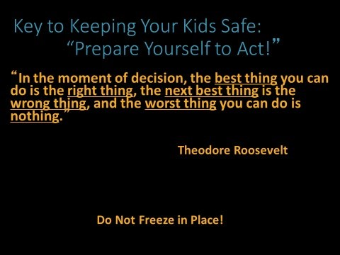

Slide # 17 Acting
A typical initial response in one of these catastrophic events is to freeze in place. If you have prepared and practiced, you are much more likely to respond rather than stay in the nonresponsive state. If you are aware of your surroundings and mentally attuned to the potential threats around you, you have a significantly increased chance of responding appropriately.
Presenter’s Note: May wish to underscore that freezing in place will make you a much easier target. Acting may allow you to stay out of contact with the shooter. Being aware of your surroundings and being prepared to respond should be your goals.
Freezing in place is often a response that results from the shock of being caught “off guard!” One of the best defenses against being caught “off guard” is to be aware of your surroundings. Here again, Cooper’s work may be helpful to briefly review.
You are much more likely to respond more appropriately if you are monitoring your environment. This will assist you in processing the threat as it develops.

Cooper’s Work Cooper’s Color Code of Awareness
White: Is often utilized to designate a level of awareness in which you are relaxed and totally unaware of things happening in the environment around you.{7}
Yellow: In this state of awareness, you remain relaxed, have a degree of awareness of the things going on around you. In this level of awareness, you are in a state of “relaxed alertness.” While you do not identify any specific threat, you are monitoring the environment and cognizant that threats could develop. Basically, you are aware of your environment and the actions of individuals around you. {7}
Orange: The next level is orange. In this state of awareness, you are aware and have identified a potential threat in your environment. In this level, you are beginning to construct potential actions to mitigate the threat. In orange, you have identified a potential threat and preparation has begun to deal with the situation. {7}
Red: At the “Red Level” you are in the “fight” or “flight” mode. In the “fight” mode you are engaging the threat and in the “flight” mode you are removing yourself from the threating situation. {7}
*Col. Jeff Cooper’s Awareness Color Code System

ISP suggests that you live in a state of “relaxed alertness.” Not unaware or in a state of paranoia.

Slide # 18 Escape Option
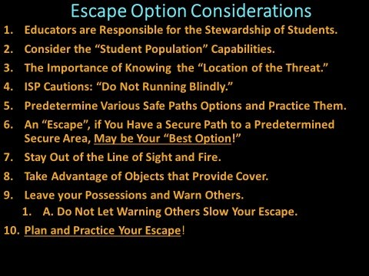 Slide #18 The Escape Option
Educators are Responsible for the Stewardship of their Students
Present’s Note: The “Response Options Model” sets out actions that students and staff may exercise to increase their security and respond more appropriately to an active shooter event.
Consider the Capabilities of their Students (to Respond)
Here, it may be helpful to review Director Bell’s Information:
Presenter’s Note: When planning for potential Lockdown or Evacuation of Exceptional Learners you must consider several factors:
KNOW YOUR STUDENTS AND THEIR NEEDS!
- How will the students respond emotionally?
  - Physical Aggression towards teachers, first responders or other students in this situation.
  - Elopement: Will they try to flee the classroom.
  - Students may freeze and be unable to function mentally and emotionally.

- How will the students respond physically?
  - Some students do not have the motor control to evacuate.
  - Some students cannot walk, run, or move themselves out of danger.
  - Stimming behaviors may result.
  - Potential for seizures or other reactions.

- Know your environment!
  - The Location of the Classroom (Is on second floor or near an exit).
  - Are you located near a safe room or fire protection site?
  - Are other teachers or staff around that can help?
  - Can the room be secured at all access and egress paths (exits/entryways)?
  - Plan for the electricity being cut and how that will impact the students.

- Therefore, your plan must address these concerns. Teacher must maintain several items.
  - A kit may need to be developed for each student.
  - “Medical Supplies” for different conditions should be in place… I.e., Seizure Meds, daily medications, etc.
  - Blankets to keeps students warm if they end up outside.
  - Cool packs to keep students from overheating.
  - Parent contact info.

- Plan must address items for the students to access. Accommodations:
  - Evacuation chairs.
  - Fidget devices.
  - Chew devices.
  - Noise cancelling headphones.
  - Access to food and water.
  - Etc.

- Communication plan must be in place:
- First responders should know where your students will be during these events. (Safe room or Fire safe room, outside, etc.).
- Transportation should know how and where to pick up these students if the weather is a factor. Cold and heat can be a major issue.
- Where will they be evacuated to in the district? Will it be the general reunification area and if so, you must have the needed items in this area.

Thomas C. Bell
Director, Department of Exceptional Learners
Hamilton Southeastern Schools

The Importance of Knowing the Location of the Threat
Presenter’s Notes: Locating the threat is critical to selecting the appropriate “Escape Path.” Here, the presenter may wish to underscore that ISP does not recommend leaving a secure location for an unknown. We want you to “escape intelligently!” Running blindly may very well take you into danger! “Escape Pathways” should be planned and practiced in advance. “Alternate Escape Paths” are to be established in advance as well. Drilling, on the available escape paths (primary and alternates), is recommended.
Presenter’s Notes: This may be an excellent opportunity to explain the difficulty that individuals often encounter in initially identifying small caliber gunshots. The sound of small caliber rounds may often be mistaken for a locker slamming or book dropping to hall floor. In addition, presenters may want to underscore that in a large building, pinpointing the location of the gunshot and the location of the shooter is often extremely difficult. The escape path may be dictated by this critical piece of information (location of the threat).
You goal is to “Escape Intelligently”! Do not run blindly! Simply running blindly may take you directly into the threat. Presenters may wish to explain the difference between concealment and cover. Concealment may shield you from sight but not from a round. Cover may stop a round. Your ability to put solid objects between you and the attacker is a critical goal!

Predetermine Various Safe Path Options and Practice Them
In times of crisis, our decision-making processes are often slowed by a common “Denial Phase.” Initially our brain just cannot comprehend that this horrific event is happening. Catastrophic events can create an almost catatonic state. We enter what is often referred to as a “frozen state.” The key is emerging from that frozen state ready to respond.
Here we can take notice of Roosevelt’s quote, “In the moment of decision, the best thing you can do is the right thing, the next best thing is the wrong thing, and the worst thing you can do is nothing.”
In many crisis situations, there is often no definitive right or wrong actions or decisions. As Roosevelt suggests our goal is to do something. In a crisis, your odds improve if you are aware of the threat and take action to increase your security.
Being aware of the way the brain often responds to a catastrophic event may help us to be better prepared to respond more appropriately to a crisis. If you are aware and prepared, you are aware of the threat in your environment and less likely to entering the “Denial Phase” and freeze in place. Planning, practicing, and rehearsing your response options, will increase your ability to respond rapidly and respond more appropriately.
Plan and practice your escape path. Your goal is to stay out of contact with the attacker. Typically, “You will respond as you have practiced.” Leave possessions and objects that will slow you down. You may elect to warn others but do not let that process slow you down.
Presenter’s Note: An “Escape”, Via a Secure Path to a Predetermined Secure Area, May be Your Best Option! The message is clear in this suggestion. If you know the location of the threat and you have planned and selected secure paths to safe areas (in advance):
Escaping may be one of your best options.

The ISP S.W.A.T. group offer these additional suggestions:
- Stay Out of the Line of Sight and Fire.
- Take Advantage of Objects that Provide Cover.
- Leave your Possessions and Warn Others if Possible.
a. Do Not Let It Slow Your Escape.
- Plan and Practice your Escape!

Sounding the Alarm: Empower Everyone
Remember you must be empowered to sound the alarm. If you elect to do so, you must not let it slow down. We emphasize this point because we have found
that “sounding the alarm” is often an action reserved for a select few
(administrators). Everyone should be empowered to sound the alarm. The more rapidly the alarm is activated, the more rapidly law enforcement will arrive. Time saves lives.

Slide #19 Lockdown Option
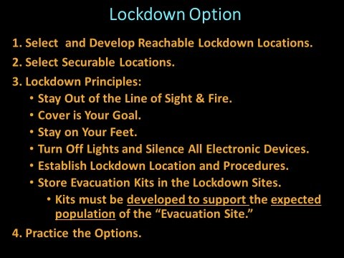

Slide # 19 The Lockdown Option
Presenter’s Note: The “ISP Model” expands the “Hide Option” to a “Lockdown Option!” A key component in this phase of the ISP program is to stay out of contact with the “shooter” (in a secure location). Simply, freezing in place in a vulnerable location may not be your best option. Again, we want to underscore that the “ISP Model” is “Nonlinear”! The options in the ISP Model may be exercised in any order and then repeated. The best option may be to Escape then Lockdown and or Fight!
In the same manner the best option may be to find a secure place to
Lockdown and then “Escape” as the circumstances of the attack merit.
In the “Lockdown Option” preparation is a key element. Lockdown locations must be pre-identified and prepared. Barricade materials must be identified ahead of time. Equipment or furniture that may serve to assist in securing or barricading the door should be identified in advanced.
Rapidly lockable and secure doors should be provided by the
“Administration.” Primary lockdown sites and alternate sites are critical components of a “Comprehensive Safety Plan.”
Staying on your feet ready to move is recommended. By moving, you are making yourself a more difficult target. Most certainly in the “Lockdown Option,” a secondary goal is to stay quiet. Silence electronic devices. If you can silence your phone but leave the line open that may create a communication advantage.
It is important for the administration to develop clear policies that govern the operation of the “Lockdown Area!”
****Someone needs to be designated as the “person in charge” in each “Lockdown” situation. A back up to this person should also be selected. Decisions will need to be made. No time for electing the person in charge is available.
Again, you will respond as you have practiced. Safety drills developed by management, staff, law enforcement, etc. will promote a rapid and more appropriate response.
In Indiana you may text if you are unable to call. However, understand that calling is best.
Tabletop exercises and drills are excellent tools that may be used to hone the skills necessary to exercise the “Lockdown Option” appropriately.

Slide # 20 The Fight Option
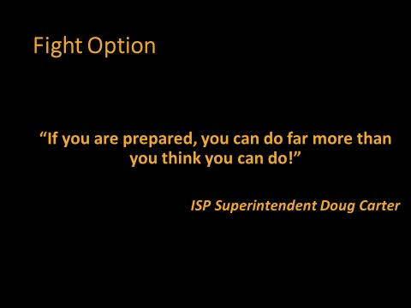

Slide # 20 The Fight Option
The “Fight Option” should be exercised only if other options are not available. An example might be if the threat enters a classroom, walks up to the teacher and from three feet away opens fire. This may be a situation in which the classroom teacher exercises the “Fight Option.”
ISP wants to underscore, that not everyone can exercise the “Fight Option.” Physical and mental preparation may simply not be enough for some individuals
to exercise this option. In that case, you must understand these limitations and be prepared to exercise the “Escape Option.”

Slide # 21 The Fight Option
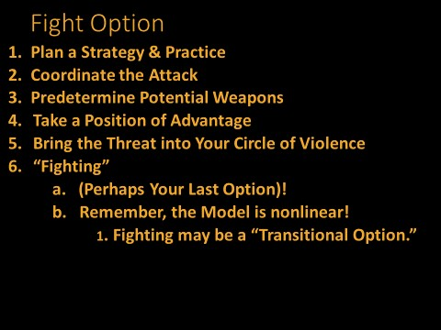
Slide #21 The Fight Option
Presenter’s Notes: There is no doubt that the “Fight Option” is the very last “do or die” choice. All other options must be exhausted before you consider this option.
To increase your chances of success in carrying out this option, several basic suggestions may be considered.

Plan and Practice
Your mind under extreme stress often does not function as well as you would hope. If you plan of time and practice your response options, your chances of making the appropriate decisions and taking the necessary actions to defend yourself should improve.
You may want to predetermine objects that may serve as weapons in the various workspaces and safe rooms. Doing this in advance is recommended.
In selecting objects to serve as weapons, you may want to make sure you are physically able to wield the object to defend yourself and others. For instance, a weapon that you cannot lift, manipulate, or use as a weapon will be of little or no use.

Coordinate Your Response
Your response will be much more effective if your effort is coordinated. Identifying weapons and determining the formation you will use will increase the effectiveness of your response.
Remember to take a position of advantage and surprise. Stay out the line of fire and out of the line of sight. Bring the attacker into your “Circle of Violence.”

Presenter’s Note: The presenter will need to define “Circle of Violence.” This is a critical concept in fighting for your life. To exploit the advantage of surprise, you may station yourself out of the line of sight and out of the line of fire. This may provide you with some initial protection. It may also put the element of surprise in your favor.
Note: Bringing the attacker into your circle of violence does two critical things.
- It allows you to utilize the element of surprise
- It brings the attacker into a proximity where your improvised weapon can be used.

Fight Strategy
Presenters Note: The presenter should take a moment to explain and reinforce the ISP concept of “Circle of Violence.” Simply, your goal is to bring the attacker into a position in which your improvised weapon becomes effective. Items in the room that may be used as potential weapons should be identified ahead of time. Organizing the “Attack Group” into a cohesive unit will improve your chances success.

Slide # 22 The Indiana State Police:
School Active Shooter Training Video
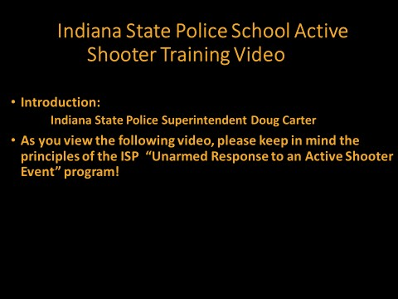
Slide #22 The Indiana State Police:

School Active Shooter Training Video
The ISP Prevention and Response Model

ISP Nonlinear Response Model
Presenter’s Note: The “ISP Nonlinear Model” takes the traditional “Run, Hide, Fight Model” and expands the model to Prevention, Escape, Lockdown and or Fight. ISP does more than just change the name of these steps. Specific strategies and practices are set out for each option. In addition, the presenter will underscore that the steps may be followed in any order. The steps may also be repeated as necessary. Simply, the model is nonlinear.

Slide # 23 The Active Shooter Video

Slide #23 The ISP Active Shooter Video
The following information may be underscored as participants view the ISP Active Shooter Video:
While “Prevention” is always preferable to response, ISP understands that the unthinkable may occur. With that in mind, ISP provides response options that are determined by the circumstances of the active shooter attack. In addition, the response options may be repeated depending on the circumstances or stimuli of the attack.

Presenter’s Note: The presenter must reinforce the meaning of the “External Stimuli” of the event. Simply, each active shooter event unfolds differently. The circumstances of the attack determine the most appropriate response for individuals caught in an active shooter event.
Examples of External Stimuli of an Event:
- Your “Proximity” or “Location” in relationship to the shooter.
- Your “Proximity” to a secure path that will lead you to a secure location.
- Your “Proximity” and “Location” to predetermined secure and safe areas.
- The type of ‘Weapon’ being utilized in the attacker.

The ISP Response Options: Escape
Presenter Note: As discussed earlier, the foundation of responding appropriately may be found in being aware of your surroundings. In this state of awareness, you remain relaxed but are hyperaware of the things going on around you.
In this level of “awareness” you are in a state of “relaxed alertness.” While you may not identify any specific threat, you are monitoring the environment and cognizant that threats could develop. Basically, you are aware of your environment and the actions of individuals around you. (Col. Jeffery Cooper “Color Code of Awareness) {7}
In this state of “relaxed alertness” you must mentally rehearse a plan of action. This may be as simple as just mentally visualizing a secure safe path to a predetermined safe location.
Being mentally aware, is the first step in preparing yourself to exercise the options found in the “ISP Model.” You can only execute this option if you have established a secured path to a predetermined or confirmed secured area. It is critical for the escape path and secure location to be identified ahead of time.

Basic Considerations in Exercising the Escape Option
- Confirm the location of the shooter.
- Confirm the Availability a Secure Path to a Secure Location.
- Discard any item that will slow your escape.
- Warn others but do not let it slow you down.
- Do not run blindly.
.

The ISP Response Options: Lockdown
If a secure path to a secure site is not a certainty, “Lockdown” may be your best option. ISP advises, “Do not leave a secure location for an unknown!” Law enforcement is on the way. You will most likely need to stay safe and secure for a brief period. For this reason, the “Lockdown Option” is often one of the best options.
In the lockdown situation, you should identify substantial furniture to utilize ahead of time to barricade the door. It is recommended that individuals conduct a mock walkthrough of barricading the door. A person who will oversee the “Lockdown Site” should be determined with a backup.
Presenter’s Note: Evacuation kits need to be securely stored in the “Lockdown Site.” The kit should be designed to support the specific population that the safe room will house.
Presenter Notes: An example to underscore the need for the establishment of basic rules of order ahead of time may be found in this example:
As soon as the door of the “safe room” is secured and barricaded, an individual bangs on the door begging to be let into the “safe room.”
This an administrative decision. ISP encourages the building level administration to make a clear designation of the person in charge and designate a backup. It is a decision that must be made prior to the active shooter event by the administration. Establishing the rules for the operation of thee saferoom is critical.

The ISP Response Options: Fight
Presenter Note: Law enforcement officers of the Indiana State Police understand that to fight for your life is a choice when no other option is available. It is to be considered only when you are faced with imminent injury or death. It is a personal decision that only you can make. Some individuals simply cannot carry out this option. Certain physical and mental capabilities must be present to enable you to carry out an aggressive attack. Frankly, otherwise the act may be an act of self-sacrifice rather than a defensive or offensive response.
The fight option often seems alien to most individuals. Here, to initiate the discussion, the presenter may wish to relate Superintendent Carter’s suggestion, “If you are prepared, you will be able to do far more than you think you can do.” Preparing mentally, physically, and strategically are critical to being successful.
Presenter’s Note: However, here again, we must underscore that the ISP model is nonlinear, and the options may be only a “transitional step” into an action that may secure an individual’s safety.
You may not always be in or able to get to a location that can be conveniently secured. You may be caught in immediate proximity to the attacker. For instance, you may be in an open space in the hall, cafeteria, auditorium, etc.
Presenter’s Note: You may be caught in the immediate proximity of the shooter. Thus, you may need to take an aggressive action to better facilitate your “Escape Option.” By the same token, you may be in a room that the shooter enters and begins to take victims (i.e., Noblesville Middle School).
An initial act of aggression may throw the assailant off “balance” allowing you time to exercise the “Escape Option.” The Noblesville teacher was a collegiate athlete. He took down the shooter and as he did so, he directed his students to escape.
ISP does not suggest that fighting is an option when any other option is available. Remember: The model is nonlinear. You may exercise the options in any order and or repeat the options as needed.
When and if you are faced with imminent danger, you may elect to take an action that may serve as a transitional step and or an action that may better be described as one of self-preservation.
The presenter may wish to underscore the advantages of mentally rehearing your actions, pre-identifying weapons, etc. At this stage of the presentation, the presenter may wish to address the “Concept of Circle of Violence”, “Concept of Coordinated Response” and the “Concept of Taking a Position of Advantage.”

Notes: Additional Information

The “Nonlinear Model” developed by the Indiana State police is like the traditional Run, Hide or Fight model. However, it differs in several key components. The presenter must underscore the “nonlinear” concept as it applies to the URASE model.
Presenter’s Note: The “ISP Response Options Model” is based on individuals selecting the “Response Option” that provides the best chance of surviving the attack considering the conditions or “external stimuli” of the event. The conditions may include but not be limited to location of the shooter, the proximity of shooter to his intended victims (students, staff, etc.), type of weapon, availability of an effective site to lockdown (lockable door, solid door, etc.), availability of an escape path to a secure area, etc.
Note: To check for understanding, presenters may wish to request that members of the audience describe a hypothetical event in which the victims must exercise various response options as the result of the stimuli of an active shooter event.

An example of utilizing, interchanging, etc. various options may be something along these lines:
An individual caught in an “active shooter event” may first elect to “Lockdown” in a secure place awaiting the arrival of law enforcement. By the same token, an individuals may elect to exercise the Escape option until they find a secure location to Lockdown.
Simply the options are not steps but options that may be exercised in any order. Again, the selection of the options to be exercised will be dictated by the circumstances or the external stimuli of the “active shooter event!”

Slide # 24 School Bus Safety
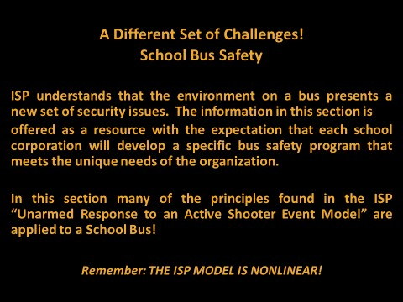

Slide # 24 School Bus Safety
Presenter Notes: The environment on a bus presents a new set of challenges. Lockdown in a secure place is difficult if not impossible once the threats boards the bus. School bus safety may need to rely on “Prevention,” “Locking Down” the perimeter of the bus and exercising the “Escape” options as the driver engages the shooter. One of the primary reasons the drive would engage the shooter is to provide a path and time for the students to escape.

Slide # 25 Bus Safety: Prevention
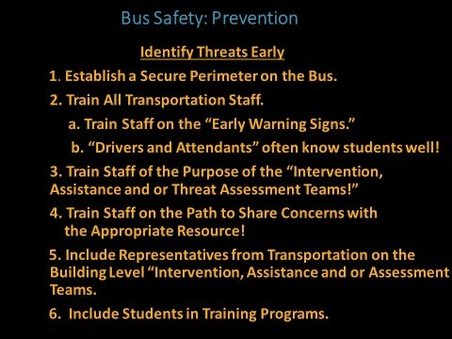

Slide 25 Prevention

Establish a Secure Perimeter on the Bus
Prevention is the Indiana State Police Department’s preferred option. Here again, prevention depends heavily on the driver being aware her/his surroundings. Preventing unauthorized individuals from boarding the bus is paramount to maintaining a secure environment on the bus. A common mistake is to allow unauthorized individuals to board the bus to conduct a conversation. Once the primary door is opened and an unauthorized individual boards the bus, the security options become extremely limited.

Train Staff on the Early Warning Behaviors
Earlier, the presenter suggested that often people have knowledge that if shared may prevent an “active shooter event.” Drivers and attendants can observe and potentially garner information that may assist in preventing an “active shooter event.”

Train Staff on Relaxed Awareness
Bus drivers and attendants have a unique vantage point from which to observe the students they transport. Often, they develop a relationship that promotes conversation, the exchange of pleasantries and information. As is the case with Cooper’s work, drivers must utilize this relationship to increase the knowledge of their surroundings.
To enhance the driver and attendant’s ability to gather information it is important to train them on the “Early Warning Behaviors.” Staff develop/inservice programs relative to the function of “Intervention, Assistance and or Assessment Teams” should also be a component of each bus driver/attendant’s training. ISP suggests that representatives from the transportation also serve on the building level “Intervention, Assistance and or Assessment Teams.” The transportation staff have valuable information relative to identifying individuals that may need assistance.
Again, a page from Col. Jeff Cooper “Color Code” may be helpful. ISP wants all staff to live in a state of heightened awareness. This state is often designated
“relaxed alertness.” {7}
- You must be aware of the individuals around you and their actions.
- You must be aware of any developing threats and mentally rehearsing response options to deal with the threats.
- You must be aware of your environment to the point that if you need to respond, it will not come as a surprise.
- ISP does not want staff members to live in a state of paranoia but calmly be aware of their environment and be mentally prepared to respond.

Presenter’s Notes: The presenter may wish to give the example of people texting while driving, walking down the sidewalk, etc. We cannot respond if we are immersed in the operation of an electronic device. You will only respond appropriately if you keep your attention on your environment.

Train Staff on the:

Purpose of Intervention and Assistance Teams
Simply, transportation staff members need to know the function and purpose of the “Intervention Team.” They must be educated on the “Early Warning Behaviors.” Team members must understand that a pathway is available to obtain help for individuals spiraling out of control. They must understand that the information sharing process is confidential. Transportation specialists (drivers, attendants, supervisors, etc.) are an often an underutilized resource.
Train Staff:

On the Path to Share Information with the Intervention & Assistance Team
One of the most common refrains from individuals that have been in contact with a developing threat is, “I knew he was acting strange, but I did not know who to tell.” We must also underscore that information shared with the “Team” is confidential.
Individuals are much more likely to share information if they believe it will be acted upon and held confidential.
Include Transportation Representatives on the Intervention & Assistance Teams
As emphasized earlier, the Intervention and Assistance Teams must include a cross section of trained staff members. Drivers, attendants, supervisors, teachers, law enforcement, counselors, social workers, etc. have a unique opportunity to interact with students and parents. A comprehensive behavior monitoring program can only be established if we develop a broad base of information sources and resources.

Slide # 26 Driver Response Considerations
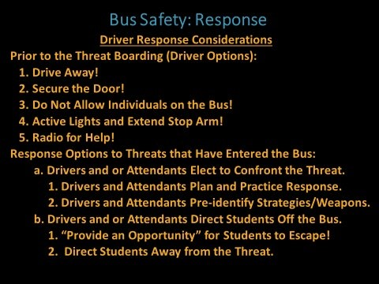
Slide # 26 Driver Response Considerations
Prior to the Threat Boarding the Bus: Drive Away, Secure the Entryway Door, Deny Admission
One of the most effective safety actions a driver can take is to secure the perimeter of the bus. ISP often recommends that when an unauthorized individual wants to address the driver or attendant, they come to the driver’s widow. Obviously, traffic concerns must be taken into consideration. By maintaining the perimeter security of the bus, the transportation specialists may prevent an unauthorized person from boarding the bus.
Presenter’s Note: ) IC 35-43-2-2 Criminal trespass; denial of entry; permission to enter; exceptions
Sec. 2. (a) As used in this section, "authorized person" means a person authorized by an agricultural operation to act on behalf of the agricultural operation.
(b) A person who:knowingly or intentionally enters the property of another person after being denied entry by a court order that has been issued to the person or issued to the general public by conspicuous posting on or around the premises in areas where a person can observe the order when the property has been designated by a municipality or county enforcement authority to be a vacant property, an abandoned property, or an abandoned structure (as defined in IC 36-7-36-1);
commits criminal trespass, a Class A misdemeanor. However, the offense is a Level 6 felony if it is committed on a scientific research facility, on a key facility, on a facility belonging to a public utility (as defined in IC 32-24-1-5.9(a)), on school property, or on a school bus or the person has a prior unrelated conviction for an offense under this section concerning the same property. The offense is a Level 6 felony, for purposes of subdivision (8), if the property damage is more than seven hundred fifty dollars ($750) and less than fifty thousand dollars ($50,000). The offense is a Level 5 felony, for purposes of subdivision (8), if the property damage is at least fifty thousand dollars ($50,000).
575 IAC 1-9-20 Criminal trespass decal:
Sec. 20. A decal warning about criminal trespass on a school bus may be allowed on the face of a step riser. The message must be one (1) line not to exceed the width of the riser in block style letters not less than two (2) inches and not more than four (4) inches in height and of a color that contrasts with its background.
Activate Lights and Extend Stop
In the event that a threat gains access to the bus, the driver may consider signally for assistance. By activating the warning and cautionary lights and extending the stop arm, in this fashion the public may be alerted to an event occuring on the bus. Obviously, utilizing the radio to request help is an excellent strategy. Some schools support a code word to trigger assistance most support straight lanugage.

Driver and or Attendants Reponse Options
Driver and or Attendant Responding Physically
The driver and or attendant must consider these factors in confronting the threat:
- A predetermined mindset to confront the threat.
- What type of weapon does the the threat have.
- What available items may be utilized as a weapon.
  - Seatbelt Cutter, Fireextinguisher, etc.
- Securing an available pathway for students to escape.
  - In the attendant/driver’s response she/he may wish to consider the position of the shooter.
  - The goal is to secure a path for students to escape.
- Verbably direct students away from the threat to the safest exit path.
- If the bus is in motion and the threat is on the bus:
  - Swerve the Bus and or hit the brakes the throw the attacker of balance.
  - Turn on Emergency Lights and or extend the stoparm to call attention to the event.
The Indiana State Police Department strongly recommends that the district administration set out the expectations and guidelines for attendants and drivers taking physical action in responding to a threat encountered during the transportation of students.

Slide # 27 Bus Safety: Student Response Considerations
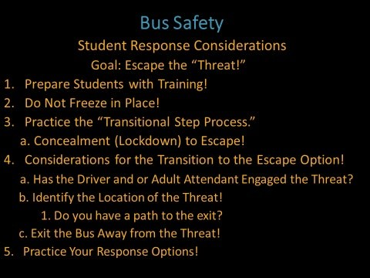

Slide # 27 Student Response Considerations Do not Freeze in Place
Freezing in place is a typical response to a catastrophic or horrific event.
Freezing in place makes those caught in one of these situations an easy target.
Practicing and exercising the principles discussed earlier in the material on “Situational Awareness,” may enable individuals to emerge from the “frozen state” and respond more appropriately. To response most appropriately, individuals must be aware of the stimuli present their environment. These stimuli were discussed earlier (location of the shooter, type of weapon, availability of an exit path, etc.).
Living in the state of “relaxed awareness” will facilitate their ability to identify developing threats. By identifying the threats early, transportation specialists may be able to make better decisions. Better decisions may equate to surviving an active shooter event. Being in a state of “relaxed awareness” may allow individuals to better understand what is about to happen in their environment. Presenters may wish to refer to Cooper’s work. {7}
Initially, because we live in a state of “relaxed alertness” as discussed earlier in Cooper’s work, we can more accurately observe the stimuli in our environment. In this “condition” we are better able to identify threats as they develop. As troopers travel throughout Indiana, they repeatedly hear individuals say, “I was in the mall and a guy was acting strange.” “He gave me the creeps!” Presenters may wish to make that point that along with our objective observations, we must learn to trust our instincts.
Presenter’s Note: If presenters are aware of Cooper’s “Awareness Color Code,” they may elect utilize that information to underscore the importance of being aware of the stimuli or conditions of their environment.

Transitional Step (Lockdown to Escape)
A variation of the “Lockdown” option is one of the most effective strategies for bus security. If the driver keeps the threat off the bus by driving away or securing the bus, the driver maintains the perimeter integrity or security of the bus.
Once the threat enters the bus, concealment or “Lockdown” may be an initial or “Transitional” strategy. Concealment on a bus is typically only a temporary strategy. Seats and seatbacks typically provided concealment rather than true cover.
It may be a consideration to view concealment behind the seat as a transitional or temporary response option. This action may allow you temporary concealment until you have an opportunity to transition to a different response option.
The different option is typically the escape option.
Presenter’s Note: The presenters should underscore that ISP views concealment behind the seat a temporary response option once the threat has entered the bus. As individuals prepare to transition to the “Escape Option,” the considerations below may assist in exercising this option more safely.

Transitioning to the Escape Option:
Considerations (Once the Threat Enters the Bus)
Presenter’s Note: The presenter should underscore the determinants that will assist students and staff in knowing when to transition to the “Escape Option.” Considerations or determinants in this decision-making process are:
- Has the attendant or driver engaged the threat?
- Have you located the threat?
- Can you exit the bus away from the threat?

Practice the Response Options
It is always recommended to practice all “Response Options.”

Slide # 28 The ISP School Bus Video
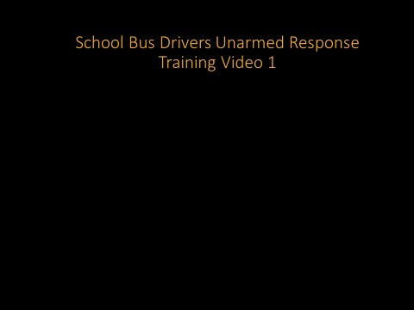

Slide # 28 School Bus Active Shooter Video Discussion Queries
- Who in the video recognizes the potentil threat in advance?
  - Students at the stop.
  - Driver
- What action does the driver take to secure secure the perimeter of the bus?
  - Drives away (Calls for assistance).
- What mistake does the driver take in allowing the threat to board the bus?
  - Fails to drive away and fails to secure the perimeter of the bus (secure the door).
- What does driver do to facilitate the escape option for students?
  - Engages the threat and directs studnets off the bus.
- Does the driver direct students to the appropriate exit?
  - No. He simply says “Get off the bus!”

Slide # 29 Law Enforcement Arrival
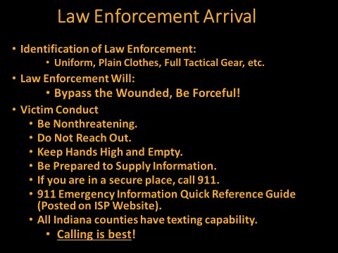

Slide # 29 Law Enforcement Arrival
Law enforcement will respond from hundreds of agencies and locations. With that in mind, responding officers will look differently. Some may arrive with only a campaign hat, vest, and badge while others may be in full uniform.
Presenters Note: Most agencies have standard operating procedures that call for arriving officers to immediately enter the facility to hunt and neutralize the threat. The goal of arriving law enforcement is to takedown the threat. It is critical for arriving law enforcement to know where the threat is located. Law enforcement will always have badge, articles of clothing, etc. that will identify them as law enforcement.
In an active shooter event, your goal is to be as nonthreatening as possible. Do not reach out, keep hands empty and high. Do not have objects in your hands that could be mistakenly viewed as a weapon.
The ISP website has information posted that will prepare victims to assist 911 Operators locating and identifying the threat. Indiana has universal 911 texting capabilities but calling 911 is best!

Slide #30 School Safety Suggestions
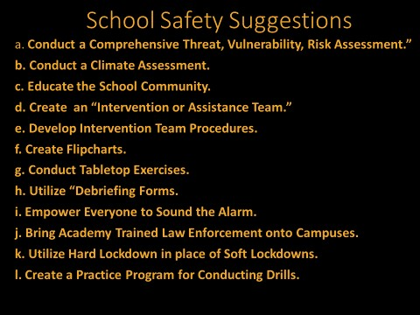

Slide # 30 School Safety Suggestions
- A “Comprehensive Safety Threat, Vulnerability or Threat Assessment should be the first step in developing your safety plan. Few schools conduct comprehensive safety assessments. Typically, schools only conduct “facilities audits.” “Facilities audits” typically deal primarily with an examination of the physical plant. A comprehensive assessment deals with district policies, practices, a review of school safety law, staff development programs, threats unique to the school community, training, drills, evacuation plans, ECA safety procedures, an examination of the physical plant, etc. to name a few of the critical components.
- Climate Assessments: ISP has created sample assessments queries and posted them on the ISP Homepage. These examples of queries may assist educators in examining the climate in their schools both from a student and staff perspective. ISP believes that schools can create their own climate inventories, but these queries may assist in giving some direction on the creation of their unique “climate assessment.” Remember, a climate assessment is critical tool that may assist educators in
determining if students and staff view their respective school environment as a safe and secure place for learning.
- Educating all members of the school community on the “Early Warning Indicators or Behaviors” is a critical step in preventing threats to the school community. To prevent threats, community members must be made aware of concerning behaviors patterns.
- “Intervention and Assistance Teams” must be established in each facility in the district. These teams serve to monitor and aid individuals that are displaying concerning behavior patterns.
- Develop procedures for the Intervention Team: Specific agencies, support programs and resources must be developed to provide support for individuals displaying concerning behaviors in the school community.
- Create “Flip Charts” segregated by job description.
- Tabletop exercises are excellent tools to test the application of the various safety plans that have been developed by the various campuses. A sample “Tabletop Exercise” will be posted in 2020 on the ISP website.
- “Debriefing Forms” are simple forms that may be utilized to gather information from individuals that have been involved in drills and or actual safety events. These tools simply call for a brief description of the event, a brief description of the action taken, a description of what worked well and suggestions for future responses to events of alike nature.
- Everyone should be empowered to sound the alarm. All too often, the ability or permission to sound alarms is reserved for a select few. This wastes valuable time.
- Perhaps the best safety practice is to have academy trained and uniformed law enforcement visible on campuses.
- ISP believes that schools should consider the utilization of a “Shelter in Place” lockdown practice should be implemented rather than a “Soft
Lockdown” practice. This is sometimes referred to as a shelter in place “lockdown procedure.” In this lockdown option, students and staff are sheltered in place in secure locations (rather than allowed to travel throughout the building with only the perimeter doors secured).
- Create a formal drill or practice schedule to test your various safety plans. Vary the drills and review the outcome with “Debriefing Forms.”

Slide # 31 Indiana State Police Resources
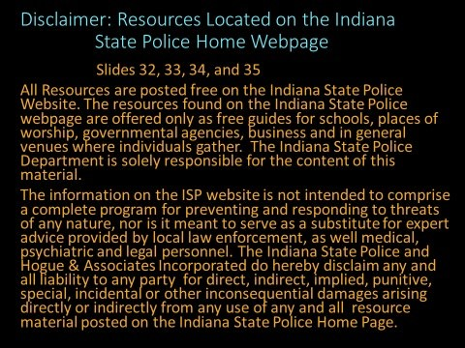

Slide # 31 Free Resources Found on the ISP Webpage
The following pages outline the available resources that may be utilized on the ISP webpage.

Slide # 32 ISP Programs and Resources
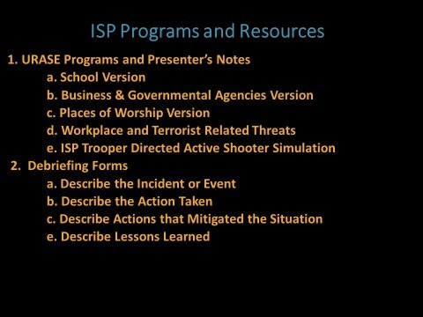

Slide # 32 ISP Programs and Resources

The Indiana State Police “Unarmed Response to an Active Shooter Event” Program (URASE)
ISP Resources Available on the Indiana State Police Website
1. School Version-Business Governmental Agencies-Places of Worship-
Workplace of the ISU (URASE)
The initial URASE program was developed for the educational setting. As the school version of URASE became popular, more and more requests were made to
ISP for versions that would be applicable to “Businesses,” “Governmental Agencies” and “Places of Worship.”
To respond to these needs, several versions of the URASE program were created. More than 80 Indiana State Police Troopers have been trained to provide this free program in its various formats. In addition to their regular responsibilities, troopers have provided one of several versions of this program to more than 80,000 individuals across the United States. Requests for the program have also been received from Canada, the United Kingdom and Germany respectfully.
On the Indiana State Police website, you may find a “School Version,” a “Business and Governmental Agency Version,” a “Places of Worship Version,” and a “Workplace and Terrorist Related Version.”
Presenter’s Note: A presentation of these programs may be scheduled through the Indiana State Police website by going to the “Home Page” and searching “ISP
Resources.” Then simply scroll down to “Live Presentation” and click on “Schedule a Program.”
The basic concepts are consistent through all versions. However, since the versions address threats in quite different environments, the strategies and practices may vary.
Active Shooter Simulation Option (Conducted by ISP)
Presenter’s Notes: During the “Simulation” presenters must underscore, that before scheduling a simulation described below, the school administration must notify 911 Dispatch, notify local first responders (law enforcement, fire, and rescue, etc.), notify the alarm company, advise local school community members, etc.
Presenter’s Note: It is important for the presenter to explain to the participants that a simulation is provided by special request only. A simulation will be scheduled based on the availability of qualified ISP troopers. An “active
Shooter” simulation may be scheduled for the school version only. Indiana State Police troopers are solely responsible for the simulation component of the URASE program.
In the simulation activity, an ISP trooper will play the part of an “active shooter.” The trooper will enter the school building (without students present).
The demonstration is for adults only. Three to five minutes after the trooper
(playing the role of an “active shooter”) enters the building a team of law enforcement officers will enter the building and (simulate) taking the shooter down. Because some organizations have conducted inappropriate simulations resulting in individuals being shot with pellets, wading from blanks, etc., it is important for presenters to underscore that ISP does not conduct its drills in a carless fashion. The process is supervised by troopers. No blanks or “airsoft guns,” are aimed at any individuals.
The goal of this exercise is to demonstrate and acclimate the participants to the sound, smell, etc. of discharged firearms. A handgun often sounds like a locker slamming or a book being dropped in the hall. It is not uncommon for individuals caught in an active shooter event to say, “I had no idea that the pop I heard was gunfire.”
In addition, it is difficult to tell where the shooter is located by the sound of a discharged weapon. The simulation will demonstrate how individuals may become confused in one of these chaotic events and run directly into the shooter.
It is important to note that the residue from gunfire most likely will set off the building fire alarm. The triggering of the fire alarm underscores the additional confusion created by an inadvertent fire alarm. The alarm may result in students and staff being evacuated directly into the shooter. The blaring alarm adds to the difficulty in communicating critical information via the public address system. The noise from a blaring fire alarm along with the bang of a gun being discharged clearly demonstrates the chaotic environment of an active shooter event.

2. Debriefing Forms
“Debriefing Forms” may be used to review any event that relates to the security and safety of an organization. These forms may be utilized to review a very broad spectrum of events. The form simply calls for the individual or individuals involved to describe the event, describe the action taken, describe what worked and describe any lessons learned from the event. In this way, a situation or event may be converted into a learning experience.
Note: The “Debriefing Form” may be utilized to review a “broad spectrum” of situations (i.e., a disgruntled patron at the receptionist’s desk, a bomb threat, an active shooter threat, a transportation accident, the results of a fire or active shooter drill, etc.). These forms may be used to document a drill and to evaluate the efficiency of the exercise.

Slide # 33 ISP Programs and Resources
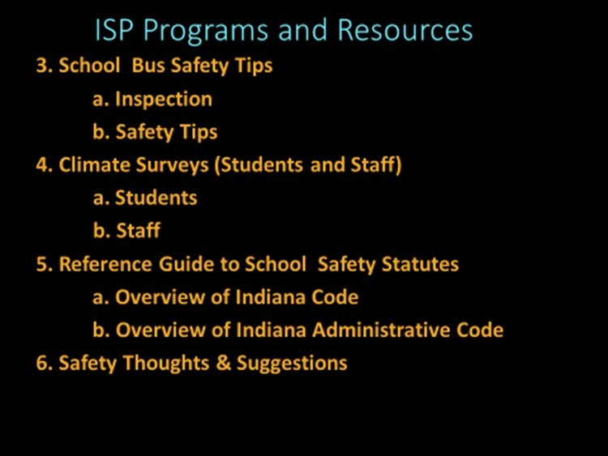

Slide # 33 ISP Free Resources on the ISP Webpage

- School Bus Safety Tips
School bus safety tips for students and motorist are available on the Indiana State Police website.
Presenter’s Note: The URASE PowerPoint for Schools (Includes Information for the Transportation Department). This section provides prevention strategies and response options that may be exercised by drivers, attendants, and students. The actions taken by drivers and attendants may assist in preventing and or responding appropriately to an active shooter event.
Presenter’s Note: It is recommended that the district “Director of Exceptional Learners” be involved in the review and development of all training programs for the transportation staff. Prevention strategies and response option programs must take into consideration the unique and essential modes of care that must be taken in assisting the “Exceptional Learner” population.
- Climate Surveys
Sample queries for examining school climate are available on the Indiana State Police website. Schools must create a climate of safety, security, and trust in their respective schools. Climate surveys may serve as effective tools to examine the attitude students and staff hold toward their school environment.
If students are expected to share concerns with respect to bullying, individuals developing threating behaviors, etc., they must feel secure, safe and trust the adults in their respective buildings. The foundations of a safe environment can often be found in the prevailing climate existing on each school campus. Climate surveys are simple and straightforward tools for assessing the learning environment that exists in schools.
Presenter Note: The presenter must underscore that someone most often knows that the eventual shooter is contemplating and or planning an “active shooter event.” As shooters develop, they often demonstrate the characteristics described in this presentation. Prevention is always preferable to response. To prevent an event, educators must first know a threat is developing. Students will be much more likely to share information if they have developed a trusting relationship with educators. The climate survey will assist in assessing that relationship.
- Reference Guide to Safety Statutes
Presenter’s Note: The presenter may underscore that all educators must rely on their local legal counsel for all legal advice. It is advisable that each district’s legal counsel provide frequent workshops on school related law. The
“Reference Guide to Safety Statutes” is not a substitute for legal advice from the district’s legal counsel. This section may only serve as a guide to assist in directing educators to areas that may be then referred to their attorney for a more in-depth and up-to-dated interpretation.

- Safety Thoughts and Suggestions
This site on the ISP webpage may be useful for school administrators to utilize in reviewing their existing safety procedures and plans. It may also assist them in planning staff development meetings. It sets out points of emphasis with respect “assessment,” “Debriefing Forms,” “Evacuation and Reunification Procedures,” etc.

Slide # 34 ISP Programs and Resources

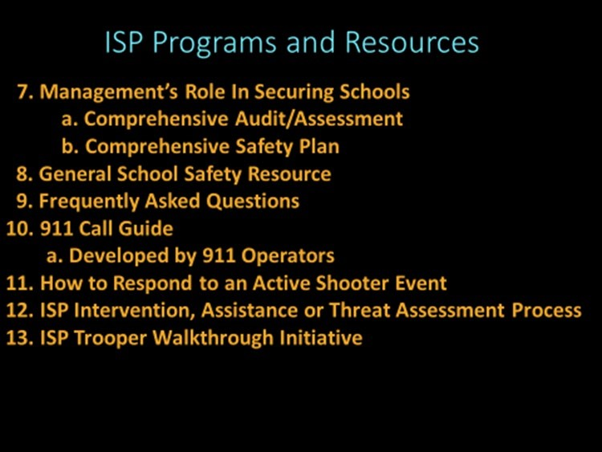
- Management’s Role (Building & District Administration) In Securing Schools
This section of the Indiana State Police website offers administrators some direction in carrying out their responsibilities with respect to school safety. The focus of this section is on the responsibilities of the district and building level administrators. Management must assume direct responsibility for developing, training, and implementing the “Comprehensive Safety Program.” This section may serve as a guide for administrators when examining the safety procedures that exist on their respective campuses.
- General School Safety Resource
This section sets out general information on reunification and general safety information that administrators may utilize to review their existing safety procedures.
- Frequently Asked Questions
This section has been developed from questions posed by participants during various Indiana State Police School Safety Programs. These questions have originated from the more than fifteen hundred presentations provided to 80,000 participants over the past eight years by ISP personnel.

- 911 Call Guide
The “911 Guide” has been developed by 911 Emergency Dispatchers. These are the questions that individuals may be asked by the 911 Dispatcher and arriving law enforcement officers.
Presenter Note: Locating the shooter rapidly is critical to stopping an active shooter event. The guide may assist arriving officers in more rapidly engaging the threat. Indiana leads the nation in 911 texting capabilities. However, the presenter must underscore that texting is available, but calling is best!
- How to Respond to an Active Shooter Event
This is an outline of the ISP “Unarmed Response to an Active Shooter Event” program. This material may be provided as a brief handout to the participants of a staff development exercise.
- ISP Intervention, Assistance and or Threat Assessment Process
This information provides an overview of the components of the “ISP Intervention, Assistance and or Threat Assessment Process.” Some confusion exists in the terms utilized to refer to this program. The FBI refers to the program as the “Threat Assessment Program” while ISP typically refers to the program as the “Intervention Program.”
Regardless of the name of the program, it is a tool by which schools may identify individuals that are displaying behaviors that concern members of the school community. These behaviors may indicate that these individuals need assistance because they are displaying behaviors that concern members of the school community. This program, if utilized, is a support program that has the tools necessary to assist these individuals.
This program educates school community members on the “Early Warning Indicators” or “Behaviors.” It also utilizes school community members to monitor the school and school community population. Lastly, it provides a clear avenue by which school community members may request assistance for individuals displaying concerning behavior. Simply, it an anonymous tool that may be utilized to obtain assistance for individuals exhibiting concerning behavior.
This program is often overlooked as schools develop their “Comprehensive Safety Program.” The program serves as the foundation for the “Prevention” phase of the ISP “Unarmed Response to an Active Shooter Event” program. This program is critical to the “Early Identification” of developing threats. Historically, shooters do not develop spontaneously. Typically, they do not “just snap.” They develop overtime. This program provides an opportunity for trained individuals to supply early intervention and support to school community members in need of assistance.
13. The ISP Walkthrough Initiative
This program is carried out by Indiana State Police Troopers. An important goal of the program is to encourage the development of a positive relationship between law enforcement and students. Troopers will visit schools and interact with students and staff. The walkthrough may include but not be limited to speaking to classes and participating in convocations, sharing lunch with students and staff, gathering information on concerns from the perspective of students, educators, and staff.
By establishing a positive relationship with all members of the school community, ISP will greatly improve the channels of communication among students, staff, and law enforcement.

Slide # 35 ISP Programs and Resources
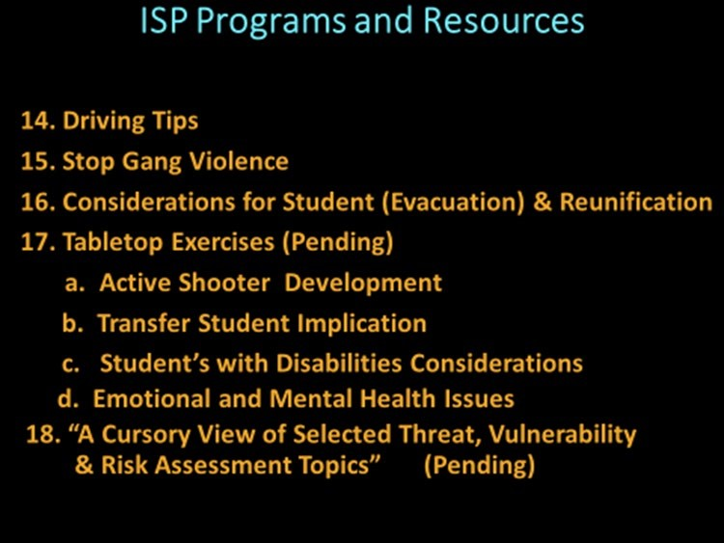

- Driving Tips
This section provides safe driving tips and information for motorists in several areas:
•ARIES Crash Statistics •BAC (Blood Alcohol Content) Calculator •Bicycle Safety
•Child Passenger Safety •Drive Safely Work Week •Drowsy Driving Awareness
•Drowsy Driving Mindfulness •Flood Safety •Harvest Season Driving Tips
•Motorcycle Safety •Operation Lifesaver •Resolve to Drive Safely
•Road and Weather Information •Safe Driver/Good Driver •School Bus Safety Tips for Motorists •School's Out •Summer Travel Safety •Winter Driving Tips
•Work Zone Safety Awareness• Crash Statistics
Many of these areas relate directly to young motorist.
- Stop Gang Violence
ISP will partner with various Indiana governmental agencies to disseminate to Indiana schools a state-wide survey designed to gather information on gang related activity/involvement.
- Considerations for Evacuation and Reunification
This information may serve as a guide for schools to consider as they design and implement their respective evacuation and reunification programs. ISP encourages schools to develop an Evacuation and Reunification program that meets the unique needs of their school community. The information provided on this site may assist in developing the framework for an effective “Evacuation and Reunification” program.
- Tabletop Exercise (Staff Development Module)
This site provides a tabletop exercise that can be used to examine the several components of the district’s safety active shooter prevention and response program. The exercise was not developed in the traditional “tabletop” structure or module. This exercise requires participants to utilize the components of the corporation’s existing comprehensive safety plan. The exercise describes the development of two active shoots as they progress through the education system. It requires the participants to determine if their existing safety plan is sufficient to deal with the threats as they develop.

- A Cursory View of Threat, Vulnerability and Risk Assessment Topics
This information may be useful as schools conduct their “Comprehensive Threat, Vulnerability and Risk Assessments. A “Comprehensive Threat, Vulnerability and
Risk Assessment” should serve as the foundation for developing a
“Comprehensive Safety Program.” The assessment should identify the threats and vulnerabilities generated in the school community environment. The “Comprehensive Safety Plan” consists of strategies to mitigate and or response to the threats identified by the assessment.
Presenter’s Note: The presenter may wish to underscore that many assessment methods, instruments, and processes are being utilized across the world. It may be stressed that a true comprehensive assessment is more than a cursory facilities assessment.
A true comprehensive school safety assessment looks at the potential threats found in the school community as well as the threats that may be found on and around the district’s respective campuses. Most certainly a true comprehensive assessment identifies and examines threats that exist as students travel to and from school. An often-neglected component of assessment may be found in the extracurricular arena. Assessments must examine the various actives that characterize the extracurricular programs found in most schools across our nation. Policies and practices that govern our schools merit a thorough investigation as well.
Presenter’s Note: The point being, assessment is multifaceted. The entire school experience must be inspected, examined, analyzed, and studied in a true comprehensive threat assessment. Once the assessment identifies the threats, vulnerabilities and risks a plan may be developed to address and mitigate these threats. That plan is the “Comprehensive Safety Plan.” Slide # 36 ISP Contact Information
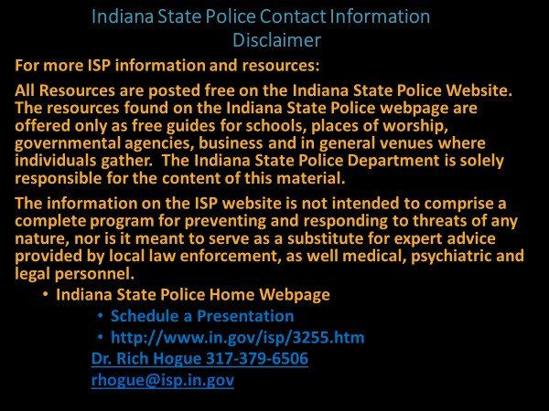

Slide # 36 Indiana State Polcie Contact Information
Presenter’s Notes: In closing the presentation, the presenter should remind participants that numerous school safety resources are avialable free on the Indiana State Police website. The “Unarmed Response to an Active Shooter Event” may be scheduled for schools, places of worship, businessess and governmental agencies by visiting the ISP Homepage. These programs are free.
Presenter’s Notes: All Resources are posted free on the Indiana State Police Website. The resources found on the Indiana State Police webpage are offered only as free guides for schools, places of worship, governmental agencies, business and in general venues where individuals gather. The Indiana State Police Department is solely responsible for the content of this material.
The information on the ISP website is not intended to comprise a complete program for preventing and responding to threats of any nature, nor is it meant to serve as a substitute for expert advice provided by local law enforcement, as well medical, psychiatric and legal personnel.

Glossary, Bibliography, Resource and Reference Material
1.(a) 2021 “Unarmed Response to an Active Shooter Event” Program. ISP Webpage
- Endsley, 1995b, p. 36
- Endsley, Micah; Jones, Debra (2016-04-19). Designing for Situation Awareness (Second ed.). CRC Press. p. 13. ISBN 978-1-4200-6358-5.
- Wikipedia (School Shootings 1970’s), Situational Awareness
- Endsley, M. R. (1994). Situation awareness in FAA Airway Facilities Maintenance Control Centers (MCC): Final Report. Lubbock, TX: Texas Tech University.
- Endsley, M. R. (1995a). Measurement of situation awareness in dynamic systems. Human Factors, 37(1), 65-84.
- Endsley, M. R. (1995b). A taxonomy of situation awareness errors. In R. Fuller, N.
Johnston, & N. McDonald (Eds.), Human Factors in Aviation Operations (pp. 287-292). Aldershot, England: Avebury Aviation, Ashgate Publishing Ltd
**** Additional Published Notes (Articles and Books): Endsley, M.R. (1988). Situation awareness global assessment technique (SAGAT). Proceedings of the National Aerospace and Electronics Conference (NAECON), 789–795. New York: IEEE. doi:10.1109/NAECON.1988.195097
Endsley, M.R. (1989). Final report: Situation awareness in an advanced strategic mission (No. NOR DOC 89-32). Hawthorne, CA: Northrop Corporation.
Endsley, M.R. (1990). Predictive utility of an objective measure of situation awareness.
Proceedings of the Human Factors Society 34th Annual Meeting (pp. 41–45). Santa Monica, CA: Human Factors Society.
Endsley, M.R. (1995a). "Measurement of situation awareness in dynamic systems". Human Factors. 37 (1): 65–84. doi:10.1518/001872095779049499.
Endsley, M.R. (1995b). "Toward a theory of situation awareness in dynamic systems". Human Factors. 37 (1): 32–64. doi:10.1518/001872095779049543.
Endsley, M.R. (1997). The role of situation awareness in naturalistic decision making. In Zsambok, C.E. & G. Klein (Eds.), Naturalistic decision making (pp. 269–283). Mahwah, NJ: LEA.
Endsley, Micah; Jones, Debra (2016-04-19). Designing for Situation Awareness (Second ed.). CRC Press. p. 13. ISBN 978-1-4200-6358-5.
- Cooper, Jeff, Principles of Personal Defense, Paladin Press, ISBN 978-0-87364-497-6
(Cooper, Jeff, Jeff Cooper, From Wikipedia, the free encyclopedia)
- Protecting America’s Schools/Analysis of Targeted School Violence, 2019.
https://www.secretservice.gov/data/protection/ntac/usss-analysis-of-targeted-schoolviolence.pdf
- The United States Secret Service National Threat Assessment Center, “Protecting America’s Schools is Protecting America’s Future.” 2019
- U.S. Department of Justice, Federal Bureau of Investigation: “Active Shooter Incidents in the United States in 2019” https://www.fbi.gov/file-repository/active-shooter-quickreference.pdf/view
- “Biography: Lieutenant Colonel Dave Grossman – Killology Research Group". 2000. Retrieved July 19, 2010.
- Stop Teaching Our Kids to Kill, Revised and Updated Edition: A Call to Action Against TV, Movie & Video Game Violence by Dave Grossman, Gloria Degaetano
- The Depressive and the Psychopath, “At last we know why the Columbine killers did it.” By DAVE CULLEN, APRIL 20, 2004: Cullen, Dave (2004, April 20). Slate
- Cullen, Dave (April 2010). Columbine.
****Additional Published Notes (Articles and Books):
Cullen, Dave (April 2010). Columbine.
Cullen, Dave (2010-02-24). "The Last Columbine Mystery". The Daily Beast.
- Langman, Peter. “Why Kids Kill.” Inside the Minds of School Shooters. St. Martin Griffin, New York. August 2010
- Governor’s Commission Report (Bill Owens’) 2000
- Columbine and the Myth of “the School Shooter,” April 20, 2018By Steven Cromack
- This publication is in the public domain. Authorization to reproduce this publication in whole or in part is granted. The citation should be Silver, J., Simons, A., & Craun, S. (2018). A Study of the Pre-Attack Behaviors of Active Shooters in the United States Between 2000 – 2013. Federal Bureau of Investigation, U.S. Department of Justice, Washington, D.C. 20535.
- "VPC - Where'd They Get Their Guns? - Westside Middle School, Jonesboro, Arkansas".
- "Jonesboro massacre: Two macho boys with 'a lot of killing to do'". The Independent. Retrieved September 18, 2018
- Columbine: Were There Warning Signs? Should School Officials Have Known? April 17, 2001. Correspondent: David Kohn
- Cooper’s Color Code
- “The Unarmed Response to an Active Shooter Event”. 2013-2021
- Indiana Fire Marshal: James L. Greeson (2018)
- A modern history of mass school shootings. By GREG K. DEAL gdeal@indexjournal.com Feb 26, 2018
- A Review of Six School Shootings and Implications for School Counselors by Nathan Kirk man
- Newman et aI., 2005, p. 38
- 2019 Encyclopedia of Arkansas. All Rights Reserved.
- Columbine Shooters Mentally Ill-Not Bullied, Langman By THE ASSOCIATED PRESS
March 10, 2009
- "Israeli lecturer died shielding Virginia Tech students from gunman". Haaretz. April 17, 2007. Archived from the original on July 25, 2009.
- Book: “Columbine Shooters Mentally Ill, Not Bullied,” By THE ASSOCIATED PRESS, March 10, 2009.
- Unit for the Study of Personality in Politics, Commentary on Dave Cullen’s “The Depressive and the Psychopath.” Aubrey Immelmann, July 30, 2004
- “Destined as a Psychopath: Experts Seek Clues.” By Jacqueline Stenson MSNBC contributor.msnbc.com. 4/20/2009 8:48:23 AM ET
- Without Conscience, Dr. Robert Hare
- Book: Columbine Shooters Mentally Ill-Not bullied, By the Associated Press (March 10, 2009)

- Helms, Marisa (March 25, 2005). "Shooting fuels debate over safety of Prozac for teens". Minnesota Public Radio.

- Lennard, Jeremy. "Ten dead in US school shooting". Archived from the original on September 19, 2005. Retrieved November 15, 2005.

- “Tales of School Shooting Bravery, Slain Security Guard, Wounded Student Saved Others from Teen Gunman". CBS News. March 24, 2005.

- Lennard, Jeremy. "Ten dead in US school shooting". September 19, 2005.

- Huffstutter, P.J. (March 24, 2005). "Red Lake Reservation Readies Burial Rituals". Los Angeles Times
- Haga, Chuck (March 25, 2005). "Family: Teen had 'a good relationship' with the grandfather he killed"(increase Prozac)
- “A Bloody Day on the Rez". Newsweek. April 3, 2005.
- “School Killer's Animated Terror". The Smoking Gun. March 23, 2005
- "Red Lake Shooting Conspiracy?” CBS News. March 30
- Mass Shootings at Virginia Tech, April 16, 2007. Report of the Review Panel Presented to Governor Kaine Commonwealth of Virginia
- "Mass Shootings at Virginia Tech: Addendum to the Report of the Review Panel to Governor Kaine Commonwealth of Virginia (revised)"
- Johnson, Annie; Thornburgh, Nathan (April 20, 2007). "Witness: The Dormitory Murders". Time
- Massengill Report, Chapter VIII, "Mass Murder at Norris Hall"
- Johnson, Alex (April 19, 2007). "Gunman sent package to NBC News". Massacre at Virginia Tech. NBC News.
- “Bright Daughter, Brooding Son: Enigma in the Cho Household". Los Angeles Times. April 22, 2007
- CBS NEWS: MARCH 22, 2005 / 1:16 PM / CBS/AP
- “MPR: Victims of the Red Lake shooting". Minnesota Public Radio. March 22, 2005.
- Enger, John. "The shooting at Red Lake: The victims". July 3, 2018
- Minnesota: Ten killed in deadliest school shooting since Columbine massacre
Kate Randall, World Socialist Web Site, WSWS.ORG
- Eric Harris’s Diversion Documents [72 pp]
- dylan-klebold-diversion.pdf
- U.S. Secret Service and the U.S. Department of Education the Final Report and Findings of the Safe School Initiative: Implications for the Prevention of School Attacks in the United States.
- Lee, J. H. (2013). School shootings in the U.S. public schools: Analysis through the eyes of an educator. Review of Higher Education and Self-Learning, 6, 88–120
- Haga, Chuck (March 25, 2005). "Family: Teen had 'a good relationship' with the grandfather he killed". Star Tribune.
- Wikipedia: Jeff Weise
- Report of the Office of the Child Advocate, p.143
- Jamie Turndorf Ph.D. Psychology Today. (We Can Work It Out).” Was Adam Lanza an Undiagnosed Schizophrenic?” Posted Dec 20, 2012
And could a proper diagnosis have averted the Newtown massacre?
Posted Dec 20, 2012 (And could a proper diagnosis have averted the Newtown massacre?)
- “The Depressive and the Psychopath.” “At last, we know why the Columbine killers did it.” By Dave Cullen, Posted Tuesday, April 20, 2004
- ABC News: 5 Disturbing Things We Learned Today About Sandy Hook Shooter Adam
Lanza Connecticut's Office of the Child Advocate Report. By AARON KATERSKY and SUSANNA KIM November 21, 2014,
- “Shooting at Sandy Hook Elementary School.” Connecticut's Office of the Child Advocate Report, November 21, 2014.
- “Report finds missed chances to help Newtown shooter Adam Lanza.” By David Shortell, CNN. Updated 2:14 PM ET, Sun November 23, 2014
- Newtown, CT “Police Report” 2013
- Craig, Tim; Brown, Emma; Larimer, Sarah; Balingit, Moriah (February 18, 2018). "Teachers say Florida suspect's problems started in middle school, and the system tried to help him". The Washington Post.
- “Why Meadow Died” Post Hill Press New York * Nashville, USA, 2019
- Miller, Carol Marbin; Gurney, Kyra (February 20, 2018). "Parkland shooter always in trouble, never expelled. Could school system have done more?". Miami Herald.
- “School officials worried about Nikolas Cruz and guns 18 months before mass shooting.” By RAFAEL OLMEDA, SUN SENTINEL, MAR 16, 2018.
- Florida mental health agency examined Cruz in 2016, didn't hospitalize him. Feb. 18, 2018, By Phil McCausland.
- OFFICE OF THE STATE’S ATTORNEY, JUDICIAL DISTRICT OF DANBURY, Stephen J. Sedensky III, State’s Attorney, Dec 12, 2014. (November 25, 2013)
- “Adam Lanza's father says he wishes son had never been born.” By MICHAEL MUSKAL MAR 10, 2014
- “New Report on Lanza: Parental Denial, Breakdowns, Missed Opportunities.” By ALAINE GRIFFIN and JOSH KOVNER NOV 21, 2014
- “MARJORY STONEMAN DOUGLAS HIGH SCHOOL PUBLIC SAFETY COMMISSION.” Report Submitted to the Governor, Speaker of the House of Representatives and Senate President November 1, 2019.
- “FINAL REPORT OF THE FEDERAL COMMISSION ON School Safety.” Presented to the PRESIDENT OF THE UNITED STATES, December 18, 2018.
- The warning signs almost everyone missed: Nikolas Cruz's behavior raised red flags over and over, but no one intervened.” By Dakin Andone, CNN. February 26, 2018
- Houston Chronicle: Attorney: “Accused Santa Fe shooter declared incompetent to stand trial.” Nick Powell November 4, 2019
- Report of the February 14, 2008, Shootings (pp. XVI) at Northern Illinois University
- Gunman Planned Campus Shooting For At Least Six Days". ABC. February 15, 2008.
- Who Was the Illinois School Shooter? By EMILY FRIEDMAN. April 14, 2009
- McDade, Mary Beth; Spillman, Eric (October 2, 2015). "Oregon Gunman Was Enrolled in Class Where He Opened Fire, Authorities Say". KTLA-TV. Los Angeles, California.
- Berger, Sarah (October 1, 2015). "Who Is Chris Harper Mercer? Oregon's Alleged Umqua Community College Shooter Identified, Police Say". International Business Times
- Crilly, Rob (October 7, 2015). "Oregon shooting: Chris Harper-Mercer 'discharged from army after suicide attempt'". The Daily Telegraph.
- Elinson, Zusha (October 3, 2015). "Oregon Shooting Suspect Chris Harper-Mercer Committed Suicide, Officials Say". The Wall Street Journal.
- Altman, Larry; Green, Nick (October 1, 2015). "Oregon shooting suspect lived in Torrance, graduated from Switzer Center". The Daily Bulletin.
- Carroll, Rory (October 3, 2015). "Chris Harper Mercer was enrolled at the college where he made a bloody last stand". The Guardian.
- Madman kills nine, injures seven after shooting at Umpqua Community College in
Oregon by JASON SILVERSTEIN, LARRY MCSHANE and NANCY DILLON NEW YORK DAILY NEWS OCT 02, 2015
- Healy, Jack; McIntire, Mike; Turkewitz, Julie (October 5, 2015). "Oregon killer and mother had close bond with guns". The Seattle Times
- Sidner, Sara; Lah, Kyung; Almasy, Steve; Ellis, Ralph (October 2, 2015). "Oregon shooting: Gunman was student in class where he killed 9". CNN.
- Cooper, Jonathan J.; Abdollah, Tami (October 6, 2015). "In writings, Oregon gunman Christopher Harper-Mercer ranted about others being crazy". Los Angeles Daily News.
- Glum, Julia (October 2, 2015). "Oregon Shooting Suspect Chris Harper-Mercer Linked to Blog Post About Roanoke Gunman Vester Flanagan: Reports". International Business Times
- Vinograd, Cassandra; Williams, Pete; Blankstein, Andrew; Winter, Tom (October 2,
2015). "Oregon Shooting: Umpqua Gunman Chris Harper Mercer — What We Know". NBC News
- S.J., Prince (October 1, 2015). "Was Chris Mercer Harper Inspired by Vester Flanagan?". Heavy Archived from the original on September 27, 2016. Retrieved August 30, 2016.
- Turkewitz, Julie (October 9, 2015). "Oregon College Student Says Gunman Smiled, Then Fired". The New York Times.
- Cain Miller, Claire; Wines, Michael; Turkewitz, Julie (October 3, 2015). "Confusion, Horror and Heroism in Oregon Shooting". The New York Times.
- Muskal, Michael; Winton, Richard; Gerber, Marisa (October 2, 2015). "Death in a classroom: Oregon shooter targeted his English class". Los Angeles Times.
- Umpqua Community College 2015 shooting report: What we've learned Updated Jan 09, 2019; Posted Sep 08, 2017
- Umpqua shooter fits FBI profile: 'They consider, plan, prepare' Updated Jan 09, 2019; Posted Sep 30, 2017. Maxine Bernstein
- "Israeli lecturer died shielding Virginia Tech students from gunman". Haaretz. April 17, 2007.
- "20 Years Later, Jonesboro Shooting Survivors Conflicted Over Parkland". NPR.org
- "Marysville high school shooting: Jaylen Fryberg lured victims via text message, police say". FoxNews.com. Associated Press. October 28, 2014
- "Fatal shooting at US Amish school". BBC News. October 3, 2006. Retrieved March 8, 2015
- "'Get in line ... I'm going to kill you all': Oakland shooter ID'd as ex-student One L. Goh (VIDEO)". Global Post. April 2, 2012.
- “Northern Illinois University Report 2010, p. 1
- Horton, John. "5 students hurt in shooting at Chardon High School; suspect in custody". Cleveland Live LLC. Retrieved February 27, 2012
- Glasier, David. "Lake Academy staff speak about quality education and students, not about suspected Chardon High shooter".
- "One student killed, four injured in shooting at Ohio high school". FoxNews.com. February 28, 2012.
- "Noblesville School Shooting: “New Details About the Day of The Shooting Students"
- Reports, Staff (2018-05-26). "Teacher, girl recovering after Noblesville school shooting; suspect in custody".
- "'Get in line ... I'm going to kill you all': Oakland shooter ID'd as ex-student One L. Goh (VIDEO)". Global Post. April 2, 2012.
- "Fatal shooting at US Amish school". BBC News. October 3, 2006.
- "Here's what we know about the Noblesville West Middle School shooting that injured student, teacher". FOX59. Retrieved 25 May 2018.
- Northern Illinois University 2010, p. 2.
- La Ganga, Maria; Queally, James (October 25, 2014). "Hospital identifies survivors of Washington high school shooting". LA times.
- La Ganga, Maria; Queally, James (October 25, 2014). "Hospital identifies survivors of Washington high school shooting". LA times.
- Psychology Today, Joe Pierre M.D. Psych Unseen “Active Shooters: Not Mentally Healthy, But Not Mentally Ill” A new FBI study challenges the idea that most shooters have a mental disorder. Posted Jun 21, 2018
- Vistas Online: Article 90 School Shootings and Student Mental Health: “Role of the School Counselor in Mitigating Violence” Allison Paolini. By Garry Waltz and Jeanne Bleuer. Counseling Outfitters LLC.
- Vossekuil et al. (2002)
- Dessert News. Book: “Columbine shooters mentally ill, not bullied” By Associated Press Mar 13, 2009, 6:58pm MDT
- Columbine: Were There Warning Signs? Should School Officials Have Known? 2001, April 17, CORRESPONDENT David Kohn. (https://www.cbsnews.com/news/columbine-were-therewarning-signs)
- Virginia gunman was accused of stalking: police". Daily News and Analysis. Diligent Media Corporation. Agence France-Presse. April 18, 2007
- Luo, Michael (April 21, 2007). "U.S. Rules Made Killer Ineligible to Purchase Gun". The New York Times.
- Cohen, Jodi S.; St. Clair, Stacy (March 22, 2010). "Gunman wanted to punish Illinois university, report says" Los Angeles Times
- ‘Psychologist says Lanza likely a schizophrenic,’ Psychologist says Lanza likely a schizophrenic. By Rob Ryser Updated 11:26 am EST, Thursday, January 29, 2015
- Northern Illinois University Report, pp. 21,
- Northern Illinois University Report, pp. 30
- Northern Illinois University Report, pp. 31
- Northern Illinois University Report, pp. 30
- Northern Illinois University Report, pp. 36
- CNN exclusive: “Secret files reveal NIU killer's past”
- Cohen, Jodi S.; St. Clair, Stacy (March 22, 2010). "Gunman wanted to punish Illinois university, report says"
- “Adam Lanza’s Mental Problems ‘Completely Untreated’ Before Newtown Shootings, Report Says” By Alison Leigh Cowan. New York Times. Nov. 21, 2014
- A 10-Year-Old Adam Lanza Created A Horrifying Book About Hurting Children, Pamela Engel Nov 26, 2013, 11:37 AM
- New Haven Register, Court orders police to make Adam Lanza documents public, Staff and wire reports, Staff and wire reports Updated 11:09 pm EDT, Tuesday, October 23, 2018
- A Chilling Look into Adam Lanza's World, Alaine Griffin, Josh Kovner, Hartford Courant, November 2013.
- Langman (2015) The Journal of Campus Behavioral Intervention. The Enigma of Adam Lanza’s Mind and Motivations for Murder. Author Peter Langman, Ph.D. Langman Psychological Associates, LLC.
- Langman (2015) “School Shooters”
- “UCC shooter's mother said her son was born angry” The News-Review, Carisa Cegavske, Senior Staff Writer the News-Review Sep 13, 2017
- “What We Know About the Alleged Texas High School Shooter,” May 19, 20181:27 PM ET
Samantha Raphelson, Twitter, Brakkton Booker at NPR headquarters in Washington, D.C., November 7, 2018. (photo by Allison Shelley) BRAKKTON BOOKER
- “Teen laid out Santa Fe High School attack plans in journals,” by MICHAEL BIESECKER, JEFF HORWITZ and JUAN A. LOZANO, Associated Press, Saturday, May 19th, 2018
- Students Say They Reported Threats Before MSD Massacre, By Terry Spencer and Marissa Bagg • Published November 13, 2018 • Updated on November 14, 2018 at 7:03 am
- Suspected High School Shooter Has Reported History of Animal Abuse, PETA
- School officials once predicted Parkland shooter Nikolas Cruz could be 'model student' By
MEGAN O'MATZ, SCOTT TRAVIS and DAVID FLESHLER SUN SENTINEL |MAY 19, 2018 AT 6:10 PM
- CNN: “From 'broken child' to mass killer,” By Drew Griffin, Scott Glover, Jose Pagliery and Kyung Lah, CNN, Updated 8:09 AM ET, Fri February 16, 2018
- Sun Sentinel, “School officials worried about Nikolas Cruz and guns 18 months before mass shooting,” By RAFAEL OLMEDA, SUN SENTINEL, MAR 16, 2018 AT 9:05 PM
- Sun Sentinel, “No one heeded warning signs about Nikolas Cruz before school shooting,” By BRITTANY WALLMAN, PAULA MCMAHON and STEPHEN HOBBS, SUN SENTINEL, FEB 15, 2018 AT 9:45 PM.
- "The Ones That Got Away: Jonesboro's Survivors - And the Shooters - Recall A Moment of Horror". Huffington Post. December 19, 2017
- “Broward State Attorney says death penalty would be appropriate, but decision to come later.” By DAVID FLESHLER, PAULA MCMAHON, SCOTT TRAVIS and LINDA TRISCHITTA, SUN SENTINEL, FEB 17, 2018 AT 8:25 PM
- Parkland shooter always in trouble, never expelled. Could school system have done more? BY CAROL MARBIN MILLER AND KYRA GURNEY FEBRUARY 20, 2018 07:59 PM, UPDATED FEBRUARY 21, 2018 02:37 PM
- “Some officials wanted Florida school shooting suspect forcibly committed in 2016.” By CURT ANDERSON ASSOCIATED PRESS, MAR 18, 2018 AT 11:40 PM
- DCF: Parkland Shooting Suspect Was Receiving Treatment, Medication When Probe
Closed. By Dan Krauth • Published February 19, 2018 • Updated on March 19, 2018 at 5:39 pm 153. “Who Does School Shootings? Psychopaths, Not People with Asperger’s Syndrome,” By Marcia Eckerd, PhD, Psych Central, Site last updated: 19 Nov 2020
- Northern Illinois University 2010, p. 2
- Altimari, Dave; Mahony, Edmund H.; Lender, Jon (March 13, 2013). "Newtown shootings: Adam Lanza Researched Mass Murderers, Sources Say". Hartford Courant.
- "The Only 2 Living US Mass School Shooters Not in Prison". ABC News. February 17, 2016 157. “20 Years Later, Jonesboro Shooting Survivors Conflicted Over Parkland". NPR.org.
- Here's why your kids may not evacuate the school immediately if a fire alarm is pulled. Arika Herron. IndyStar. May 10, 2018.
- Santa Fe student: “Teacher pulled fire alarm to get students to safety during shooting.” By Jake Harris and Melissa B. Taboada. Posted May 18, 2018 at 12:01 AM. Updated Sep 22, 2018 at 3:21 AM
- Substitute Teacher Shot in Santa Fe High School Attack Says Subs Need Safety Training.” By Evie Blad. May 15, 2019 | Updated: June 18, 2019
- IndyStar: Richmond, Indiana, shooting: “What we know about what happened at the school.” Justin L. Mack. IndyStar. December 13, 2018.
- Carma Hassan; Sarah Aarthun; Ray Sanchez. "Suspect in custody after shooting at Indiana middle school". CNN. Retrieved 2018-05-26
- "Middle schooler returns to class with 2 guns, shoots peer, teacher: Police". ABC News. 2018-05-26.
- “Richmond school shooting: Timeline of events.” WHIO TV. By: Breaking News Staff Updated: March 29, 2019 - 8:48 AM
- Gray, Sadie (December 16, 2012). "Sandy Hook gunman Adam Lanza shot his way through school door,” The Times. Retrieved December 18, 2012.
- Karlinsky, Neal; Ghebre Medhin, Sabina; Gard, Cassidy (October 5, 2015). "Oregon Umpqua Shooting Survivor Recalls Terrifying Moments Inside Classroom".
- Marjory Stoneman Douglas High School Public Safety Commission: Initial Report Submitted to the Governor, Speaker of the House of Representatives and Senate President. January 1, 2019.
- Nikolas Cruz: “The warning signs ahead of Stoneman Douglas shooting” By JOHN MAINES and MEGAN O'MATZ. SOUTH FLORIDA SUN SENTINEL. FEB 23, 2018 AT 7:35 PM
- “Understanding the Teenage Brain,” Health Encyclopedia. Anne Fetterman RN BSN, Joseph Campellone MD, Raymond Kent Turley BSN MSN RN.
- Markgraf, Matt. "Detectives Detail "Bizarre" and "Shockingly Calm" Interview with Marshall Shooting Suspect". Retrieved 2018-06-04
- Markgraf, Matt. "Search Warrants Reveal Details About Accused Marshall Co. High School Shooter". Retrieved 2018-06-04.
- “Gabe Parker saw Marshall County school shooting as an experiment,” officer says Justin Sayers and Andrew Wolfson Courier Journal, March 7, 2018.
- “Marshall County superintendent recounts high school shooting,” By James Mayse Messenger-Inquirer Feb 15, 2020 Updated Mar 26, 2020
- Kentucky teen, 16, accused of shooting dead two of his classmates and wounding 14 others said he saw his actions as a 'science experiment.’ By VALERIE EDWARDS FOR DAILYMAIL.COM. PUBLISHED: 16:34 EST, 8 March 2018 | UPDATED: 16:52 EST, 8 March 2018
- “What You Need to Know About the Freeze Response,” Mount Sinai Adolescent Health Center Jan 23, 2019.
- Marisa M. Silveri, PhD, is the director of the Neurodevelopmental Laboratory on Addictions and Mental Health at McLean Hospital. August 20,2020.
- “The Facts About Teen Brain Development,” Newport Academy. December 20, 2010
- Columbine: “Were There Warning Signs?” “Should School Officials Have Known?” April 17, 2001. CORRESPONDENT: David Kohn
- "NIU Shooter Described As "Gentle, Quiet" Archived December 12, 2008, at the Wayback Machine." CBS News. February 16, 2008. Retrieved on September 11, 200
- CNN.com: “Affidavit: Columbine shooter posted threat on Web.” April 10, 2001
- “Shooter Pair Mixed Fantasy, Reality Shooting.” By Paul Duggan, Michael D. Shear and Marc Fisher. Washington Post Staff Writers Thursday, April 22, 1999; Page A1
- ‘No Easy Answers’: “The Full Story of The Columbine High School Shooting.” By Andrew Lenoir Published March 15, 2019
- “Two gunmen brought 30 bombs to school. “By Peter G. Chronis, Kirk Mitchell and David Olinger. Denver Post Staff Writers, April 22, 1999
- “Influences on the Ideology of Eric Harris.” Peter Langman, Ph.D. Copyright © 2010 by
Peter Langman, Ph.D. Version 1.2 (2 August 2014) Jefferson County, p. 26,015
- “The Report of Govern Bill Owens.” Columbine Review Commission. Hon. William H. Erikson. Chairman, May 2001
- “Two gunmen brought 30 bombs to school. “By Peter G. Chronis, Kirk Mitchell and David Olinger, Denver Post Staff Writers
- CNN: Affidavit: “Columbine shooter posted threat on Web.” April 10, 2001
- “Nazi Site Intrigued Shooter.” By P.J. HUFFSTUTTER AND ELIZABETH MEHREN, MARCH 23, 2005
- Chicago Tribune. “Shooter's family suspects Prozac.” Monica Davey and Gardiner Harris, New York Times News Service. CHICAGO TRIBUNE
- Virginia Tech Missed 'Clear Warnings' of Shooter's Mental Instability by Neil Osterweil, Senior Associate Editor, MedPage Today 2007-08-30
- CNN.com: Killer's manifesto: 'You forced me into a corner' POSTED: 10:43 p.m. EDT, April 18, 2007
- THE THRESHOLDS: Home, Health, Hope. Chicago, IL | www.thresholds.org
- "NIU Shooter Described As "Gentle, Quiet" Archived December 12, 2008, at the Wayback Machine." CBS News.
- Cohen, Jodi S.; St. Clair, Stacy (March 22, 2010). "Gunman wanted to punish Illinois university, report says".
- Report of the Office of the Child Advocate, 2014
- CNN exclusive: Secret files reveal NIU killer's past Archived February 14, 2009, at the Wayback Machine."
- Report of the Office of the Child Advocate, p.9, section 36
- “School Shooters,” Understanding High School, College, and adult Perpetrators, Rowman, Littlefield, 2009 (Copyright 2015)
- Report of the Office of the Child Advocate, p.104
- Report of the Office of the Child Advocate, p. 104
- Langman, “The Enigma of Adam Lanza’s Mind and Motivations for Murder.” Author Peter Langman, Ph.D. Langman Psychological Associates, LLC.
- Stephen J. Sedensky, “Report of the State’s Attorney for the Judicial District of Danbury on the Shootings at Sandy Hook Elementary School and 36 Yogananda Street, Newtown, Connecticut on December 14, 2012. Page 35.
- Halbfinger, D. (2012, December 14). “A Gunman, Recalled as Intelligent and Shy, Who Left Few Footprints in Life.” New York Times
- Murphy, K. (2012, December 20). “Hairstylist Remembers Adam Lanza: ‘I Thought He Couldn’t Speak.” Los Angeles Times.
- Lysiak, M. (2013). Newtown: An American Tragedy. New York: Gallery. p. 43
- Torrey, 2006, Torrey, E. Fuller. (2006). Surviving Schizophrenia: A Manual for Families, Patients, and Providers (Fifth Edition). New York: Harper Collins
- https://exceptionalchildren.org/privacy-policy Council for Exceptional Children
- Office of the Child Advocate, 2014, p. 53.
- Solomon, 2014
- Thomas C. Bell: Director, Department of Exceptional Learners, Hamilton Southeastern Schools, 2020
- Colonel "Jeff" Coopers, Color Code of Awareness, THE COLOR CODE OF AWARENESS, (adaptation of Cooper’s Color Code of Awareness) BY ADTA MEMBER WU CHIN
- Cooper, Jeff, Principles of Personal Defense, Paladin Press, ISBN
- Guidance to Schools for Unplanned Fire Alarms, State of Indiana Fire Marshal. 2019
- Indiana Department of Homeland Security: https://www.in.gov/dhs/home/guidance-toschools-for-unplanned-fire-alarms/
- Indiana Fire Marshal: GUIDANCE TO SCHOOLS FOR UNPLANNED FIRE ALARMS, James L. Greeson. https://www.doe.in.gov/sites/default/files/legaffairs/fire-marshal-guidanceschools.pdf
- Holocaust Survivor, Professor Killed Helping Students Escape Archived 2007-04-18 at the Wayback Machine, Fox News, April 17, 2007. Accessed February 20, 2008
- Altimari, Dave; Mahony, Edmund H.; Lender, Jon (March 13, 2013). "Newtown shootings: Adam Lanza Researched Mass Murderers, Sources Say". Hartford Courant.
- Face the Nation transcripts April 21, 2013: Boston bombings". Face the Nation. April 21, 2013. CBS
- Carma Hassan; Sarah Aarthun; Ray Sanchez. "Suspect in custody after shooting at Indiana middle school". CNN. Retrieved 2018-05-26
- "Family says 13-year-old victim in Noblesville school shooting is critical but stable".
Indianapolis Star. Retrieved 2018-05-26.
- Neal, David J. (February 28, 2018). "Uber driver says Nikolas Cruz told her: 'I am going to my music class'". Miami Herald. Retrieved February 28, 2018.
- "Florida school shooting suspect hid among students after massacre". CBS News. Associated Press. February 15, 2018. Archived from the original on February 15, 2018
- Fahrenthold, David A.; Sullivan, Kevin; Schmidt, Samantha (February 15, 2018). "What happened in the 82 minutes between Nikolas Cruz's arrival and arrest during Florida shooting".
Chicago Tribune
- “Two decades after Columbine and five years after Sandy Hook, educators and police still weren’t ready for Parkland.” DEC. 28, 2018Based on reporting by Tonya Alanez, David Fleshler, Stephen Hobbs, Lisa J. Huriash, Paula McMahon, Megan O’Matz and Scott TravisDesign &
Development: Aric ChokeyEditing: Dana Banker, Randy Roguski and David Schutz: SunSentinel
- "Richmond Middle School Shooting Suspect Identified; Mother Called 911 Before Shooting, Police Say". December 14, 2018.
- Teen planned to commit violence at Indiana school, but police say tipster helped them stop him By Eliott C. McLaughlin and Chuck Johnston, CNN Updated 8:16 PM EST, Thu December 13, 2018
- "Family says 13-year-old victim in Noblesville school shooting is critical but stable". Indianapolis Star. Retrieved 2018-05-20
- By: Breaking News Staff, Updated: March 29, 2019 - 8:48 AM. Richmond school shooting: Timeline of events. WHIOTV 7
- Northern Illinois University 2010 Report, p. 2.
- Northern Illinois University 2010 Report, p.1
- The Ones That Got Away: Jonesboro's Survivors - And the Shooters - Recall A Moment of Horror". Huffington Post. December 19, 2017.
- "The Only 2 Living US Mass School Shooters Not in Prison". ABC News. February 17, 2016.
- Memories of a School Shooting: Paducah, Kentucky, 1997. SARAH STEWART LLANDDECEMBER 17, 2012
- "Carneal v. Crews". CaseText. Retrieved 2018-01-15.
- Vanderhart, Dirk; Johnson, Kirk; Turkewitz, Julie (October 1, 2015). "Oregon Community College Shooting Leaves at Least 7 Dead". The New York Times. Retrieved October 1, 2015.
- Turkewitz, Julie (October 9, 2015). "Oregon College Student Says Gunman Smiled, Then Fired".
- Almaguer, Miguel; Helsel, Phil (October 10, 2015). "Survivor of Umpqua Community College Shooting Describes Rampage". NBC News
- “Expelled student charged in school shooting.” By HASAN DUDAR and CHARLES WILSON Associated Press
- Altimari, Dave; Mahony, Edmund H.; Lender, Jon (March 13, 2013). "Newtown shootings: Adam Lanza Researched Mass Murderers, Sources Say". Hartford Courant. Retrieved March 14, 2013.
- Washington Post. Fire alarm sounds briefly at Marjory Stoneman Douglas High School on second day of school — and kids panic By Valerie Strauss August 17, 2018 at 4:43 p.m. EDT
- THE SCHOOL SHOOTER: A THREAT ASSESSMENT PERSPECTIVE. Critical Incident Response
Group (CIRG) National Center for the Analysis of Violent Crime (NCAVC) FBI Academy Quantico, Virginia 22135
- Holocaust Survivor, Professor Killed Helping Students Escape Archived 2007-04-18 at the Wayback Machine, Fox News, April 17, 2007. Accessed February 20, 2008
- Threat Assessment in Schools: A Guide to Managing Threatening Situations and Creating Safe School Climates, Washington DC. July 2004
- Columbine Report, "Bomb Summary". Archived from the original on February 18, 2016. Retrieved April 15, 2015
- FEMA-428/BIPS-07/January 2012 Edition, Chapter 3, Targeted Shooting. p. 3-23
- Ibid p. 3-27 FEMA-428/BIPS-07/January 2012. Chapter 3 Target Shootings p. 3-27
- If you see a red flag for a mass shooting, this is what you should doCNN Wire: Posted: Aug 18, 2019 / 06:11 PM CDT / Updated: Aug 18, 2019 / 06:11 PM CDT
- FBI Study of 160 Active Shooter Incidents Identified Between 2000 and 2013 (2014)
- Who is Nikolas Cruz? School shooting suspect joked about guns, worrying classmates Feb. 15, 2018, 10:38 AM EST / Updated Feb. 15, 2018, 5:49 PM EST by Jon Schuppe
- Student Survivors Recount Shooting". ABC. April 17, 2007. Archived from the original on November 6, 2013.
- Ayoob, Massad (2011). Combat Shooting with Massad Ayoob. Gun Digest Books. p. 11. ISBN 9781440218590.
- Rampage ended when ‘hero’ teacher confronted gunman Kevin Conlon, Andreas Preuss and Ben Brumfield, CNN Updated 5:12 PM EDT, Mon October 27, 2014
- Two Dead in Washington High School Shooting, Oct. 24, 2014, 2:28 PM EDT / Updated Oct. 24, 2014, 9:08 PM EDT. US News
- Carma Hassan; Sarah Aarthun; Ray Sanchez. "Suspect in custody after shooting at Indiana middle school". CNN. Retrieved 2018-05-26.
- Noblesville school shooting: New details about the day of the shooting, Kellie Hwang, Emma Kate Fittes, Carley Lanich, Vic Ryckaert, Ryan Martin, Mark Alesia. IndyStar November 5th, 2018.
- {401} Here’s what we know about the Noblesville West Middle School shooting that injured student, teacher NEWS by: FOX59 Web Posted: May 25, 2018 / 12:08 PM EDT / Updated: May 25, 2018 / 09:00 PM EDT
258(a) “Israeli lecturer died shielding Virginia Tech students from gunman". Haaretz. April 17, 2007. Archived from the original on July 25, 2009. Retrieved September 24, 2008
- NPR Carnage in Oakland: 'People Started Running, And He Started Shooting' April 3, 20127:30 AM ET MARK MEMMOTT
- Guidance to Schools for Unplanned Fire Alarms: Statement from the State Fire Marshal: https://www.in.gov/dhs/home/guidance-to-schools-for-unplanned-fire-alarms/
- Esposito, Richard; Smith, Candice; Ng, Christina (December 14, 2012). "20 Children Died in Newtown, Conn., School Massacre". ABC News. Associated Press. Retrieved December 14, 2012.
- Bryan, Alix (December 16, 2012). "TIMELINE: Connecticut elementary school shooting updates". WTVR. Retrieved December 19, 2012
- Hudson, Hayley (December 24, 2012). "Becky Virgalla, Newtown Shooting Survivor, Says Principal, Others Saved Her in Sandy Hook Rampage". Huffington Post. Reuters. Retrieved March 28, 2013.
- Barron, James (December 14, 2012). "Nation Reels After Gunman Massacres 20 Children at
School in Connecticut". The New York Times. Retrieved December 19, 2012
- Altimari, Dave; Mahony, Edmund H.; Lender, Jon (March 13, 2013). "Newtown shootings: Adam Lanza Researched Mass Murderers, Sources Say". Hartford Courant. Retrieved March 14, 2013.
- Altimari, Dave; Mahony, Edmund H.; Lender, Jon (March 13, 2013). "Newtown shootings:
Adam Lanza Researched Mass Murderers, Sources Say". Hartford Courant. Retrieved March 14, 2013
- Emmert, Don. "Conn. Elementary School Shooting: 20 Children, Seven Adults Killed".
Mason County Daily News. Agence France-Presse. Archived from the original on December 18, 2012. Retrieved December 18, 2012
- Cleary, Tom (December 14, 2012). "'Hero teacher' rushed students to bathroom to keep students safe". Connecticut News. Retrieved December 15, 2012.
- "Connecticut State Police Sandy Hook Elementary School Shooting Report". Cspsandyhookreport.ct.gov. December 14, 2012.
- Roberts, Christine (December 18, 2012). "Teacher's words of comfort to class during Newtown rampage: 'I love you all very much ... it's going to be OK'". Daily News. New York. Archived from the original on January 18, 2013.
- McLaughlin, Michael (December 18, 2012). "Nicholas Sabillon, Sandy Hook Student, Recalls Killer Pounding on His Classroom Door". Huffington Post. Archived from the original on January 18, 2013. Retrieved December 19, 2012.
- Noblesville Police Department, Hamilton County Sheriff’s Department, and Indiana State Police Departments respectfully. 2018
- Rayment, Sean (December 15, 2012). "Teachers sacrificed themselves to save their pupils". The Daily Telegraph. Archived from the original on December 15, 2012.
- Oregon Shooting at Umpqua College Kills 10, Sheriff Says. By Dirk Vanderhart, Kirk Johnson and Julie Turkewitz, Oct. 1, 2015
- "UPDATE: 15-Year-Old Victims ID'd in Marshall Co. School Shooting". Lex18. NBC News. 23 January 2018. Retrieved 24 January 2018.
- United States Department of Justice, Federal Bureau of Investigation, “A Study of the Pre-
Attack Behaviors of Active Shooters in the United States Between 2000 and 2013. Silver, J., Simons, A., & Craun, S. (2018) “A Study of the Pre-Attack Behaviors of Active Shooters in the United States Between 2000 and 2013.
- Jeff Cooper, CC Vol. 13, No. 7, July 2005, GG Vol. 25, No. 7, GGG3, pg. 526-7.
- The Indiana Building Code (675 IAC 13); The Indiana Fire Code (675 IAC 22); NFPA 72 (675 IAC 28-1-28); Indiana Code 22-11-17; Fire Marshal Guidance to Schools.
- “Holocaust survivor gave his life to save students.” Los Angeles Times, By RICHARD T. COOPER AND VALERIE REITMAN, APRIL 18, 2007, 12 AM PT, TIMES STAFF WRITERS
- "Family says 13-year-old victim in Noblesville school shooting is critical but stable". Indianapolis Star. 2018-05-26.
- Altimari, Dave; Mahony, Edmund H.; Lender, Jon (March 13, 2013). "Newtown shootings: Adam Lanza Researched Mass Murderers, Sources Say". Hartford Courant. Archived from the original on April 10, 2013. Retrieved March 14, 2013.
- Almukhtar, Sarah; Lai, K. K. Rebecca; Singvhi, Anjali; Yourish, Karen (February 15, 2018). "What Happened Inside the Florida School Shooting". The New York Times. Archived from the original on February 18, 2018. Retrieved February 19, 2018
- "The Ones That Got Away: Jonesboro's Survivors - And the Shooters - Recall A Moment of Horror". Huffington Post. December 19, 2017. Retrieved September 18, 2018.
- "'THAT MOMENT OF CHAOS': 20 years ago, sad day at Westside". Arkansas Online. March 18, 2018. Retrieved September 18, 2018.
- "The Only 2 Living US Mass School Shooters Not in Prison". ABC News. February 17, 2016. Retrieved September 18, 2018.
- Shooter Wrote 'Today Is the Day, ‘Suspected gunman also wrote on Facebook "You will hear about it." By JESSICA HOPPER, March 25, 2011, 9:29 AM
- Keneally, Meghan (October 24, 2014). "Homecoming Prince Identified as High School Shooting Suspect". 6abc Philadelphia. Retrieved October 24, 2014.
- Gray, Sadie (December 16, 2012). "Sandy Hook gunman Adam Lanza shot his way through school door". The Times. Archived from the original on January 18, 2013. Retrieved December 18, 2012.
- Richmond, Indiana, shooting: What we know about what happened at the school, Justin L. Mack, IndyStar, Published December 13, 2018.
- Indiana teacher threw basketball to foil school shooter, witness says, Associated Press in Noblesville, Indiana, Sat 26 May 2018 16.53 EDT
- Heroes during Horror: Holocaust Survivor, Students Saved Others, By MARCUS BARAM April 17, 2007, 5:18 PM
- Noblesville West shooter 'obsessed with violence,' prosecutors say, the 13-year-old accused in a shooting at Noblesville West Middle School admitted his guilt in court on Monday. Author: Evan Hffmeyer, published: 7:09 PM EST November 4, 2018, Updated: 3:32 AM EST November 6, 2018
- School Shootings and the Need for More School-Based Mental Health Services, Martell L Teasley, Children & Schools, Volume 40, Issue 3, July 2018, Pages 131–134, https://doi.org/10.1093/cs/cdy015, Published: 08 June 2018
- CNN exclusive: Secret files reveal NIU killer's past, By Abbie Boudreau and Scott Zamost, CNN Special Investigations Unit. https://www.cnn.com/2009/CRIME/02/13/niu.shooting.investigation/index.html
- Sidner, Sara; Lah, Kyung; Almasy, Steve; Ellis, Ralph (October 2, 2015). "Oregon shooting: Gunman was student in class where he killed 9". CNN. Archived from the original on October 2, 2015.
- Here's what Broward schools knew about Parkland shooter — details revealed by mistake. By BRITTANY WALLMAN and PAULA MCMAHON, SOUTH FLORIDA SUN SENTINEL. AUG 03, 2018, AT 10:15 PM
- THREAT ASSESSMENT IN SCHOOLS: A GUIDE TO MANAGING THREATENING SITUATIONSAND TO CREATING SAFE SCHOOL CLIMATES UNITED STATES SECRET SERVICE ANDUNITED STATES DEPARTMENT OF EDUCATION, Washington DC, July 2004.
- Indiana Department of Homeland Security, Secured Safety Grant Program, https://www.in.gov/dhs/grants-management/secured-school-safety-grant-program/
- Indiana State Police, “Unarmed Response to an Active Shooter Event Program.” 2021
- R. Hogue p 132 “2021 Unarmed Response to an Active Shooter Event.”
- Journal of Autism and Childhood Schizophrenia, 1972, 2, 4, 315-337. Childhood
Schizophrenia Reconsidered 1. MICHAEL RUTTER. Institute of Psychiatry, London, England, Journal of Autism and Childhood Schizophrenia, 1972, 2, 4, 315-337
- By the Recovery Village, Jennifer Kopf, Medically Reviewed by Denise-Marie Griswold, LCAS, 01/27/20
- Pervasive Developmental Disorder - Not Otherwise Specified (PDD-NOS) Autism Speaks
- Sensory Processing Disorder, Reviewed by Smitha Bhandari, MD on February 15, 2019, © 2005 - 2021 WebMD LLC. All rights reserved.
- Wikipedia, this page was last edited on 9 March 2021
- Jefferson County Sheriff’s Office Final Report, Released May 15, 2000
- https://www.cms.gov/ U.S. Centers for Medicare & Medicaid Services. 7500 Security Boulevard, Baltimore, MD 21244
- FEMA: https://www.fema.gov/contact-us
309: United States Department of Human Health and Services. “Office of the Secretary for Preparedness and Response.
Https://www.phe.gov/Preparedness/planning/mscc/handbook/chapter1/Pages/emergencyma nagement.aspx
- U.S. Department of Homeland Security: https://www.dhs.gov/
- U.S. Department of Education: https://www.ed.gov/ . Department of Education 400
Maryland Avenue, SW, LBJ-3E317 Washington, DC 20202-6135
- U.S. Department of State: 2201 C St NW, Washington, DC 20520US Department of State.
- 2201 C St NW, Washington, DC 20520US Department of State.
- The Only 2 Living US Mass School Shooters Not in Prison". ABC News. February 17, 2016. Retrieved September 18, 2018
- Jolene Bracale, RN. Indiana Department of Education
- https://www.colonelboyd.com/boydswork
- Jeff Cooper, CC Vol. 13, No. 7, July 2005, GG Vol. 25, No. 7, GGG3, pg. 526-7.
- Indiana Student Discipline Manual David Emmert, General Counsel: Lisa Tanselle, Staff Attorney and Julie Slavens, Staff Attorney. www.isba-ind.org
- Police: Dennis Intermediate shooter had plan of action, wanted to cause maximum damage.’ by: CBS4 Web Posted: Apr 2, 2019 / 03:42 PM EDT / Updated: Apr 2, 2019 / 07:11 PM EDT.
- Teen Arrested in Indiana School Shooting Wrote 'Today Is the Day. ‘Suspected gunman also wrote on Facebook "You will hear about it." By JESSICA HOPPER March 25, 2011, 9:29 AM
- "Here's what we know about the Noblesville West Middle School shooting that injured student, teacher". FOX59. Retrieved 25 May 201
- Associated Press: Richmond Indiana, “Police: Teen, officers exchange gunfire at middle school.” December 13, 2018.
- A Study of the Pre-Attack Behaviors of Active Shooters in the United States. U.S. Department of Justice, Federal Bureau of Investigations. 2000-2013.
- What does the term "clinical depression" mean? Answer from Daniel K. Hall-Flavin, M.D. 1998-2021 Mayo Foundation for Medical Education and Research (MFMER).
- Zablotsky B, Bradshaw CP, Anderson C, Law PA (January 2013). "The association between bullying and the psychological functioning of children with autism spectrum disorders". Journal of Developmental and Behavioral Pediatrics: JDBP. 34 (1): 1–8. doi:
10.1097/DBP.0b013e31827a7c3a. PMID 23275052
- Child Mine Institute, https://childmind.org/guide/guide-to-autism-spectrumdisorder/#:~:text=Children%20with%20autism%20spectrum%20disorder,may%20vary%20great ly%20in%20severity.
- NASP Director of Communications Kathy Cowan: kcowan@naspweb.org (media); NASP Director of Government Relations Kelly Vaillancourt at kvaillancourt@naspweb.org (policy and legislation); or NASP Director of Professional Development and Standards Eric Rossen at erossen@naspweb.org (professional development and practice). © 2013, National Association of School Psychologists, 4340 East West Highway, Suite 402, Bethesda, MD 20814, (301) 6570270 www.nasponline.org
- "FBI — Serial Murder". Fbi.gov. Archived from the original on 2010-10-07. Retrieved 201202-10.
- “Leading School Legally,” Power Publishing, Published 2008. First addition published in 2005. Second edition 2008. Printed in the United States of America. Page 71
- Guidance to Schools for Unplanned Fire AlarmsIn.gov/dhs/home/guidance-to-schools-forunplanned-fire-alarms/
- www.in.gov/dhs/unplannedfirealarms.htm.
- Diagnostic and Statistical Manual of Mental Disorders (DSM–5), American Psychiatric Association. https://www.psychiatry.org/psychiatrists/practice/dsm
- American Academy of Child and Adolescent Psychiatry. “Teen Brain: Behavior, Problem Solving, and Decision Making.” No.95; September 2016
- Articles from Neuropsychiatric Disease and Treatment are provided here courtesy of Dove
Press. Brain Development During Adolescence. Neuroscientific Insights into This Developmental Period. Kerstin Konrad, Prof. Dr. rer. nat., *,1 Christine Firk, Dr. PhD,2, and Peter J Uhlhaas, Dr.
PhD3.
https://www.ncbi.nlm.nih.gov/pmc/articles/PMC3705203/#:~:text=In%20adolescence%2C%20 a%20fundamental%20reorganization,fully%20mature%20prefrontal%20control%20system.
- Chain of Command in Organizational Structure. Small Business. Business Models &
Organizational Structure. Organizational Structure. By Sophie Johnson. Updated March 08, 2019
- Autism Speaks: https://www.autismspeaks.org/about-us
- (2013) Indiana Code Title 20. Education § 20-33-8-13.5
- https://www.atf.gov/
- Latané, B; Darley, J.M. (1968). "Group inhibition of bystander intervention in emergencies". Journal of Personality and Social Psychology. 10 (3): 308–324. doi:10.1037/h0026570. PMID 5704479
- Smith, Peter K.; Mahdavi, Jess; Carvalho, Manuel; Fisher, Sonja; Russell, Shanette; Tippett,
Neil (2008). "Cyberbullying: its nature and impact in secondary school pupils". The Journal of Child Psychology and Psychiatry. 49 (4): 376–385. doi:10.1111/j.1469-7610.2007.01846. x. PMID 18363945.
- "Centers for Disease Control and Prevention". United States Department of Health and Human Services. Archived from the original on April 10, 2020. Retrieved May 15, 2020
- https://www.countyhealthrankings.org/take-action-to-improve-health/what-works-forhealth/strategies/cure-violence-health-
model#:~:text=Cure%20Violence%20Health%20model%2C%20formerly,risk%20individuals%20t o%20social%20services.
- Sameer Hinduja and J.W. Patchin, Bullying Beyond the Schoolyard: Preventing and
Responding to Cyberbullying (Thousand Oaks, CA: Sage Publications, Corwin Press, 2009), p. 5.
- Indiana Department Operations Center: https://www.in.gov/isdh/26461.htm
- https://www.in.gov/fssa/dmha/about-dmha/
- Federal Bureau of Investigation. https://www.fbi.gov/contact-us
- Federal Emergency Management Agency. https://www.fema.gov/
- Family Educational Rights and Privacy Act (FERPA) (20 U.S.C. § 1232g; 34 CFR Part 99)
- American Red Cross. https://www.redcross.org/store/be-red-cross-ready-first-aidkit/329165.html
- Lisa Truitt, State Attendance Officer. Robin LeClaire, Director of School Improvement.
September 6, 2019. Subject: IAC 7-42-12 Instruction for Students Requiring Homebound Instruction
- Emergency Management and the Incident Command Systems: United States Department of Health and Human Services.
//www.phe.gov/Preparedness/planning/mscc/handbook/chapter1/Pages/emergencymanagem ent.aspx
- United States of Homeland Security: Mission: https://www.dhs.gov/about-dhs
- Indiana Fusion Center: Mission: https://www.in.gov/iifc/
- Indiana Department of Health: https://www.in.gov/isdh/18930.htm
- Integrated Public Safety Commission: https://www.in.gov/ipsc/
- Macmillan Dictionary https://www.macmillandictionary.com/us Oxford English Dictionary https.www.oxforddictionary.com
- https://www.merriam-webster.com/dictionary/interscholastic
- Mental Health First Aid USA. https://www.mentalhealthfirstaid.org/faq/
- https://www.fema.gov/emergency-managers/nims
- https://www.usa.gov/federal-agencies/national-transportation-safety-board
- (SEE) ISP_School_Unarmed_Response_to_Active_Shooter_Event_Presenter_Notes.pdf (p.187}
- National Institute of Health. https://www.nimh.nih.gov/health/topics/obsessivecompulsive-disorder-ocd/index.shtml
- https://nationalmentoringresourcecenter.org/index.php/30-topic-areas/152-peermentoring.ht
- https://www.in.gov/dhs/home/guidance-to-schools-for-unplanned-fire-alarms
- https://www.in.gov/fssa/dmha/youthservices/project-aware/
- PSYCHOLOGICAL FIRST AID Field Operations Guide” 2nd Edition
- The National Child Stress Network: https://www.nctsn.org/treatments-andpractices/psychological-first-aid-and-skills-for-psychological-recovery/about-
pfa#:~:text=Psychological%20First%20Aid%20(PFA)%20is,aftermath%20of%20disaster%20and% 20terrorism.&text=PFA%20core%20actions%20constitute%20the,or%20weeks%20following%2 0an%20event.
- 2021 About, Inc. (Dotdash) https://www.verywellmind.com/what-is-a-psychopath-
5025217#:~:text=The%20term%20%E2%80%9Cpsychopath%E2%80%9D%20is%20used,in%20cli nical%20and%20legal%20settings.
- United States Department of Homeland Security. https://www.dhs.gov/science-andtechnology/response-and-recovery-
0#:~:text=The%20Response%20and%20Recovery%20focuses,capabilities%2C%20and%20tools %20for%20remediation.&text=This%20test%20bed%20will%20serve,for%20validation%20of%2 0new%20technologies.
- Risk Assessment. OSH Answers Fact Sheets
https://www.ccohs.ca/oshanswers/hsprograms/risk_assessment.html#:~:text=Risk%20assessm ent%20is%20a%20term,analysis%2C%20and%20risk%20evaluation).
- Indiana Department of Homeland Security. https://www.in.gov/dhs/grantsmanagement/grants-management/school-safety-information-and-resources/indiana-securedschool-safety-
board/#:~:text=About%20the%20Indiana%20Secured%20School,Secured%20School%20Safety %20Grant%20Program.
- https://www.in.gov/idoc/sex-and-violent-offender-
registry/#:~:text=About%20the%20Sex%20%26%20Violent%20Offender%20Registry&text=The %20purpose%20of%20the%20registry,work%2C%20or%20study%20in%20Indiana.
- Mersky, Roy M.; Dunn, Donald J. (2002). Fundamentals of Legal Research (8th ed.). New York: Foundation Press. pp. 312–340.
- https://www.in.gov/dhs/fire-and-building-safety/division-of-fire-and-building-safetyoverview/#:~:text=The%20Indiana%20State%20Fire%20Marshal,of%20Fire%20and%20Building %20Safety.&text=The%20Indiana%20State%20Building%20Commissioner,plan%20review%20a nd%20code%20services.
- Wikipedia
https://en.wikipedia.org/wiki/Substance_Abuse_and_Mental_Health_Services_Administration
- Stanford Law: Substantive Due Process
https://web.archive.org/web/2/http://www.stanford.edu/group/psylawseminar/Substantive% 20Due%20Process.htm
- Oxford Language (Dictionary) https://languages.oup.com/google-dictionary-en/
- Indiana Fusion Center (Indiana State Police):
https://www.in.gov/schoolsafety/3897.htm#:~:text=Please%20report%20suspicious%20activity %20to,activity%20to%20the%20Fusion%20Center.
- National Association of School Psychologist: https://www.nasponline.org/resources-andpublications/resources-and-podcasts/school-climate-safety-and-crisis/systems-levelprevention/threat-assessment-at-school.
- (Safe Schools Initiative, USSS/ED, 2002): Eleven Questions to Guide Data Collection in a Threat Assessment Inquiry: (DOE and United States Secret Service Threat Assessment Guide) https://www.radnor.com/DocumentCenter/View/17998/The-School-Shooter---A-QuickReference-Guide-FBI
- https://www.cms.gov/About-CMS/Agency-Information/OMH/resource-center/hcps-andresearchers/data-tools/sgm-clearinghouse/yrbss.
- Northern Illinois University 2010, p. 2.
- Assassination Generation: Video Games, Aggression, and the Psychology of Killing by Dave Grossman and Kristine Paulsen. Publisher: Little, Brown & Company, Nov. 15, 2016. ISBN-13: 978-0316265935
- Armed Citizens, Legal Defense Network, Inc. Book Review: Assassination Generation: Video Games, Aggression, and the Psychology of Killing, Gila Hayes.
https://www.armedcitizensnetwork.org/february-2017-book-review
- Mass Shootings at Virginia Tech, April 16, 2007, Report of the Review Panel, Presented to Governor Kaine, Commonwealth of Virginia.
- Columbine: Were There Warning Signs? Should School Officials Have Known? 2001, Apr
17. CORRESPONDENT: David Kohn
- Opinion: I Taught at Columbine. It Is Time to Speak My Truth. Twenty years after the mass shooting at Columbine, a former teacher grapples with the warning signs. Picture of Judith Kelly Judith Kelly BuzzFeed Contributor Posted on April 19, 2019, at 4:37 p.m. ET.
- "The Ones That Got Away: Jonesboro's Survivors - And the Shooters - Recall A Moment of Horror". Huffington Post. December 19, 2017. Retrieved September 18, 2018
- "The Only 2 Living US Mass School Shooters Not in Prison". ABC News. February 17, 2016. Retrieved September 18, 2018
- The Indiana Building Code (675 IAC 13) The Indiana Fire Code (675 IAC 22). NFPA 72 (675 IAC 28-1-28). Indiana Code 22-11-17. Fire Marshal Guidance to Schools. https://www.in.gov/dhs/home/guidance-to-schools-for-unplanned-fire-alarms/
- Threat Assessment in Action: By Anna Miller. Monitor Staff, February 2014, Vol 45, No. 2.
- Jeff Cooper, CC Vol. 4, No. 2, January 1996, GG Vol. 16, No. 2, GGG2, pg. 637.
- Ayoob, Massad (2011). Combat Shooting with Massad Ayoob. Gun Digest Books. p. 11. ISBN 9781440218590.
- McKay, Brett (16 August 2013). "Arousal and Performance: How Stress and Fear Affect Tactical Performance". The Art of Manliness. Retrieved 7 June 2019.
- FBI Pre-Attack Behaviors: https://www.fbi.gov/file-repository/pre-attack-behaviors-ofactive-shooters-in-us-2000-2013.pdf/view
- National Institute of Mental Health: https://www.nimh.nih.gov/health/statistics/mentalillness#:~:text=Mental%20illnesses%20are%20common%20in,mild%20to%20moderate%20to% 20severe.
- High School Attack Says Subs Need Safety Training. By Evie Blad — May 15, 2019
- Jeff Cooper, CC Vol. 4, No. 2, January 1996, GG Vol. 16, No. 2, GGG2, pg. 637.
- Ayoob, Massad (2011). Combat Shooting with Massad Ayoob. Gun Digest Books. p. 11. ISBN 9781440218590.
- McKay, Brett (16 August 2013). "Arousal and Performance: How Stress and Fear Affect Tactical Performance". The Art of Manliness. Retrieved 7 June 2019.
- Report of the February 14, 2008, Shootings. Northern Illinois University 2010, p. 2
- Long-Awaited 12/14 Report Offers Details, But No Motive by Andrew Gorosko. Tuesday, November 26, 2013
https://web.archive.org/web/20131224113824/http://newtownbee.com/news/0001/11/30/lo ng-awaited-1214-report-offers-details-no-motive/178307
- Richmond School Shooting: Timeline. March 29, 2019 at 8:48 am EDT. By Breaking News Staff
- Schools try to crack down on false fire alarms after Stoneman Douglas shooting By SCOTT TRAVIS SOUTH FLORIDA SUN-SENTINEL.SEP 25, 2018 AT 8:10 PM
- Rosenberg, Joel (2011). The Carry Book: Minnesota Edition. Elegon. p. 52. ISBN 9781257015948
- Jeff Cooper, CC Vol. 4, No. 2, January 1996, GG Vol. 16, No. 2, GGG2, pg. 637.
- McKay, Brett (16 August 2013). "Arousal and Performance: How Stress and Fear Affect Tactical Performance". The Art of Manliness. Retrieved 7 June 2019.
- Jeff Cooper, CC Vol. 4, No. 2, January 1996, GG Vol. 16, No. 2,
- Columbine: Were There Warning Signs? Should School Officials Have Known? 2001. Apr
17. CORRESPONDENT. David Kohn
- Excerpts of Court Report on Shooters. By the Associated Press. Friday, April 23, 1999; 10:03 a.m. EDT
- Virginia Tech Missed 'Clear Warnings' of Shooter's Mental Instability by Neil Osterweil, Senior Associate Editor, MedPage Today August 30, 2007
- A Chilling Look Into (Adam Lanza) Alaine Griffin, Josh Kovner, November 25, 2013. Hartford Courant
- United States Secret Service “National Threat Assessment Center.” The study by the Secret Service: 2019 U.S. Department of Homeland Security-United States Secret Service (National Threat Assessment Center) underscores these factors as stressors (2019).
- 2019 National Survey on Drug Use and Health (NSDUH) by the Substance Abuse and Mental Health Services Administration (SAMHSA)
- Cullen, Dave (April 16, 2009). "Columbine killer Eric Harris plans the massacre". Slate. Retrieved October 16, 2018.
- Columbine Report, "Bomb Summary". Archived from the original on February 18, 2016. Retrieved April 15, 2015.
- Cullen, Dave (April 16, 2009). "Columbine killer Eric Harris plans the massacre". Slate.
Retrieved October 16, 2018
- "Wanton Violence at Columbine High School" (PDF). p. 27.
- NATIONAL. Red Lake school to add two-armed security guards Wednesday, August 3, 2005. https://www.indianz.com/News/2005/009631.asp
- “Santa Fe student: Teacher pulled fire alarm to get students to safety during shooting.” By Jake Harris. By Melissa B. Taboada. Posted May 18, 2018 at 12:01 AM. Updated Sep 22, 2018, at 3:21 AM.
- https://www.doe.in.gov/sites/default/files/legaffairs/fire-marshal-guidance-schools.pdf Indiana Fire Marshal Offers Guidance on Unplanned Fire Alarms.
- Indiana State Police “Unarmed Response to an Active Shooter Event” program. 2021. https://www.in.gov/isp/
- What Is Self-Concept? The Psychological Exploration of "Who Am I?" By Kendra Cherry Reviewed by Rachel Goldman, PhD, FTOS.Updated on April 18, 2021
- Congressional Charter of the American Red Cross" (PDF). May 2007.
- American Psychiatric Association (2013), Diagnostic and Statistical Manual of Mental Disorders (5th ed.), Arlington: American Psychiatric Publishing
- Hare, Robert D. (1999). Without Conscience: The Disturbing World of the Psychopaths Among Us. New York City: Guilford Press
- Ayres AJ (1972). Sensory integration and learning disorders. Los Angeles: Western Psychological Services
- Indiana State Police Webpage. https://www.in.gov/isp/
- Marisa Helms, "Shooting fuels debate over safety of Prozac for teens" Archived March 18, 2013, at the Wayback Machine, Minnesota Public Radio, March 25, 2005
- Herring, Chris (December 5, 2009). "Report Faults Virginia Tech in Shootings". The Wall Street Journal. Archived from the original on October 6, 2013.
- "Report of the Virginia Tech Review Panel". Commonwealth of Virginia. Archived from the original (PDF) on October 1, 2008.
- Va. Tech Killer Ruled Mentally Ill by Court; Let Go After Hospital Visit Killer was ruled mentally ill by a judge -- and then let go. By NED POTTER and DAVID SCHOETZ. April 28, 2007, 4:10 PM
- Newtown shooter: Report finds failure to address ‘a cascade’ of problems. EDUCATION by
ARIELLE LEVIN BECKER and JACQUELINE RABE THOMAS NOVEMBER 21, 2014
- School officials once predicted Parkland shooter Nikolas Cruz could be 'model student' By
MEGAN O'MATZ, SCOTT TRAVIS and DAVID FLESHLER SUN SENTINEL | MAY 19, 2018, AT 6:10 PM
- Ries, Brian; Rocha, Veronica; Wagner, Meg (May 18, 2018). "Live: Texas high school shooting". CNN. Archived from the original on May 18, 2018.
- Hennessy-Fiske, Molly; Pearce, Matt; Jarvie, Jenny (May 19, 2018). "With graduation just days away, Texas school becomes latest casualty — 10 dead, 10 wounded in latest campus shooting"
- Accused Santa Fe shooter moved to state mental health facility. Author: KHOU 11 Staff,
Published: 11:13 AM CST December 5, 2019.Updated: 11:16 AM CST December 5, 2019

- Accused Santa Fe gunman formally declared incompetent to stand trial. Author: KHOU 11 Staff. Published: 4:45 PM CST November 15, 2019. Updated: 6:41 AM CST November 16, 2019
- Psychiatrist declares accused Santa Fe gunman incompetent; trial may be delayed. Author: Doug Delony, Marcelino Benito (KHOU) Published: 10:52 AM CST November 4, 2019 Updated: 5:30 PM CST November 4, 2019
- OCTOBER 19, 2020. Mother Of Indiana School Shooter Sentenced To Probation. ASSOCIATED PRESS
- THE New York Times, by Mariel Padilla, https://www.nytimes.com/by/mariel-padilla Oct 15, 2019
- National Alliance on Mental Health, “Depression,” Reviewed August 2017, https://www.nami.org/About-Mental-Illness/Mental-Health-Conditions/Depression
- Cullen, Dave, for SLATE. “The Depressive and the Psychopath, “At last we know why the Columbine killers did it.” April 20, 2004, it.
- NBC News: “Destined as a psychopath?” “Experts seek clues!” Jacqueline Stenson
(Jacqueline Stenson MSNBC contributor) Sponsored Stories by Taboola. April 20,
2009https://www.nbcnews.com/health/health-news/destined-psychopath-experts-seek-cluesflna1c9465031
- “Troubled teen kills nine, and himself, at Red Lake.” March 22, 2005.
http://news.minnesota.publicradio.org/features/2005/03/21_gundersond_redlakeshooting/ 2005 by The Associated Press
- (“Protecting America’s Schools: A U.S. Secret Service Analysis of Targeted School Violence” the report was authored by the staff of the U.S. Secret Service National Threat Assessment Center –NTAC)

153

