Slide # 1 Indiana State Police Unarmed Response to an Active Shooter Event
Slide # 1
Indiana State Police Unarmed Response to an Active Shooter Event
As an introduction, the presenter may wish to underscore the goal and intent of this program. The “Unarmed Response to an Active Shooter Event” program begins the discussion with some of the options available to “unarmed” individuals caught in an “active shooter event.” This program attempts to provide “unarmed” individuals with examples of response options that may be exercised if they find themselves in one of these horrific situations.
This is not a tactical response program. It is a program to assist unarmed individuals in formulating responses that may increase their safety if they are caught in an active shooter event.
Presenter’s Note: It must be underscored that the Indiana State Police and Hogue & Associates, Incorporated do not warrant the performance, effectiveness or applicability of the resource material, concepts and or strategies on the “Indiana State Police Home Page.”
Because every active shooter event is different, no single response option fits all “active shooter” attacks. The “response options” that are discussed in this program vary greatly. The Indiana State Police believe that “response options” are determined by the external stimuli of an “Active Shooter Event.” Examples of these stimuli may include but are not limited to the proximity of the shooter or attacker to the victim, the type of weapon wielded by the assailant, the availability of a safe path to a predetermined safe or “lockdown” location, etc.
The presenter should share with the audience that more than 80 troopers are available across Indiana to provide this program free to their employees. Organizations may schedule a version of the “Unarmed Response to an Active Shooter Event” program in their respective venue through the Indiana State Police website by “clicking” on the “Active Shooter Preparedness” subheading (on left side of the main ISP webpage) and scrolling down to the “Schedule a Program” link.
Presenter’s Note:
The concepts discussed in this presentation may be applied to a variety of settings in which active shooter events occur. The circumstances of each active shooter attack are different. No “one size fits all” strategy is available. The individual engaged in the assault must internalize and analyze the stimuli of the event and formulate the most appropriate response option.

Slide # 2 Disclaimer
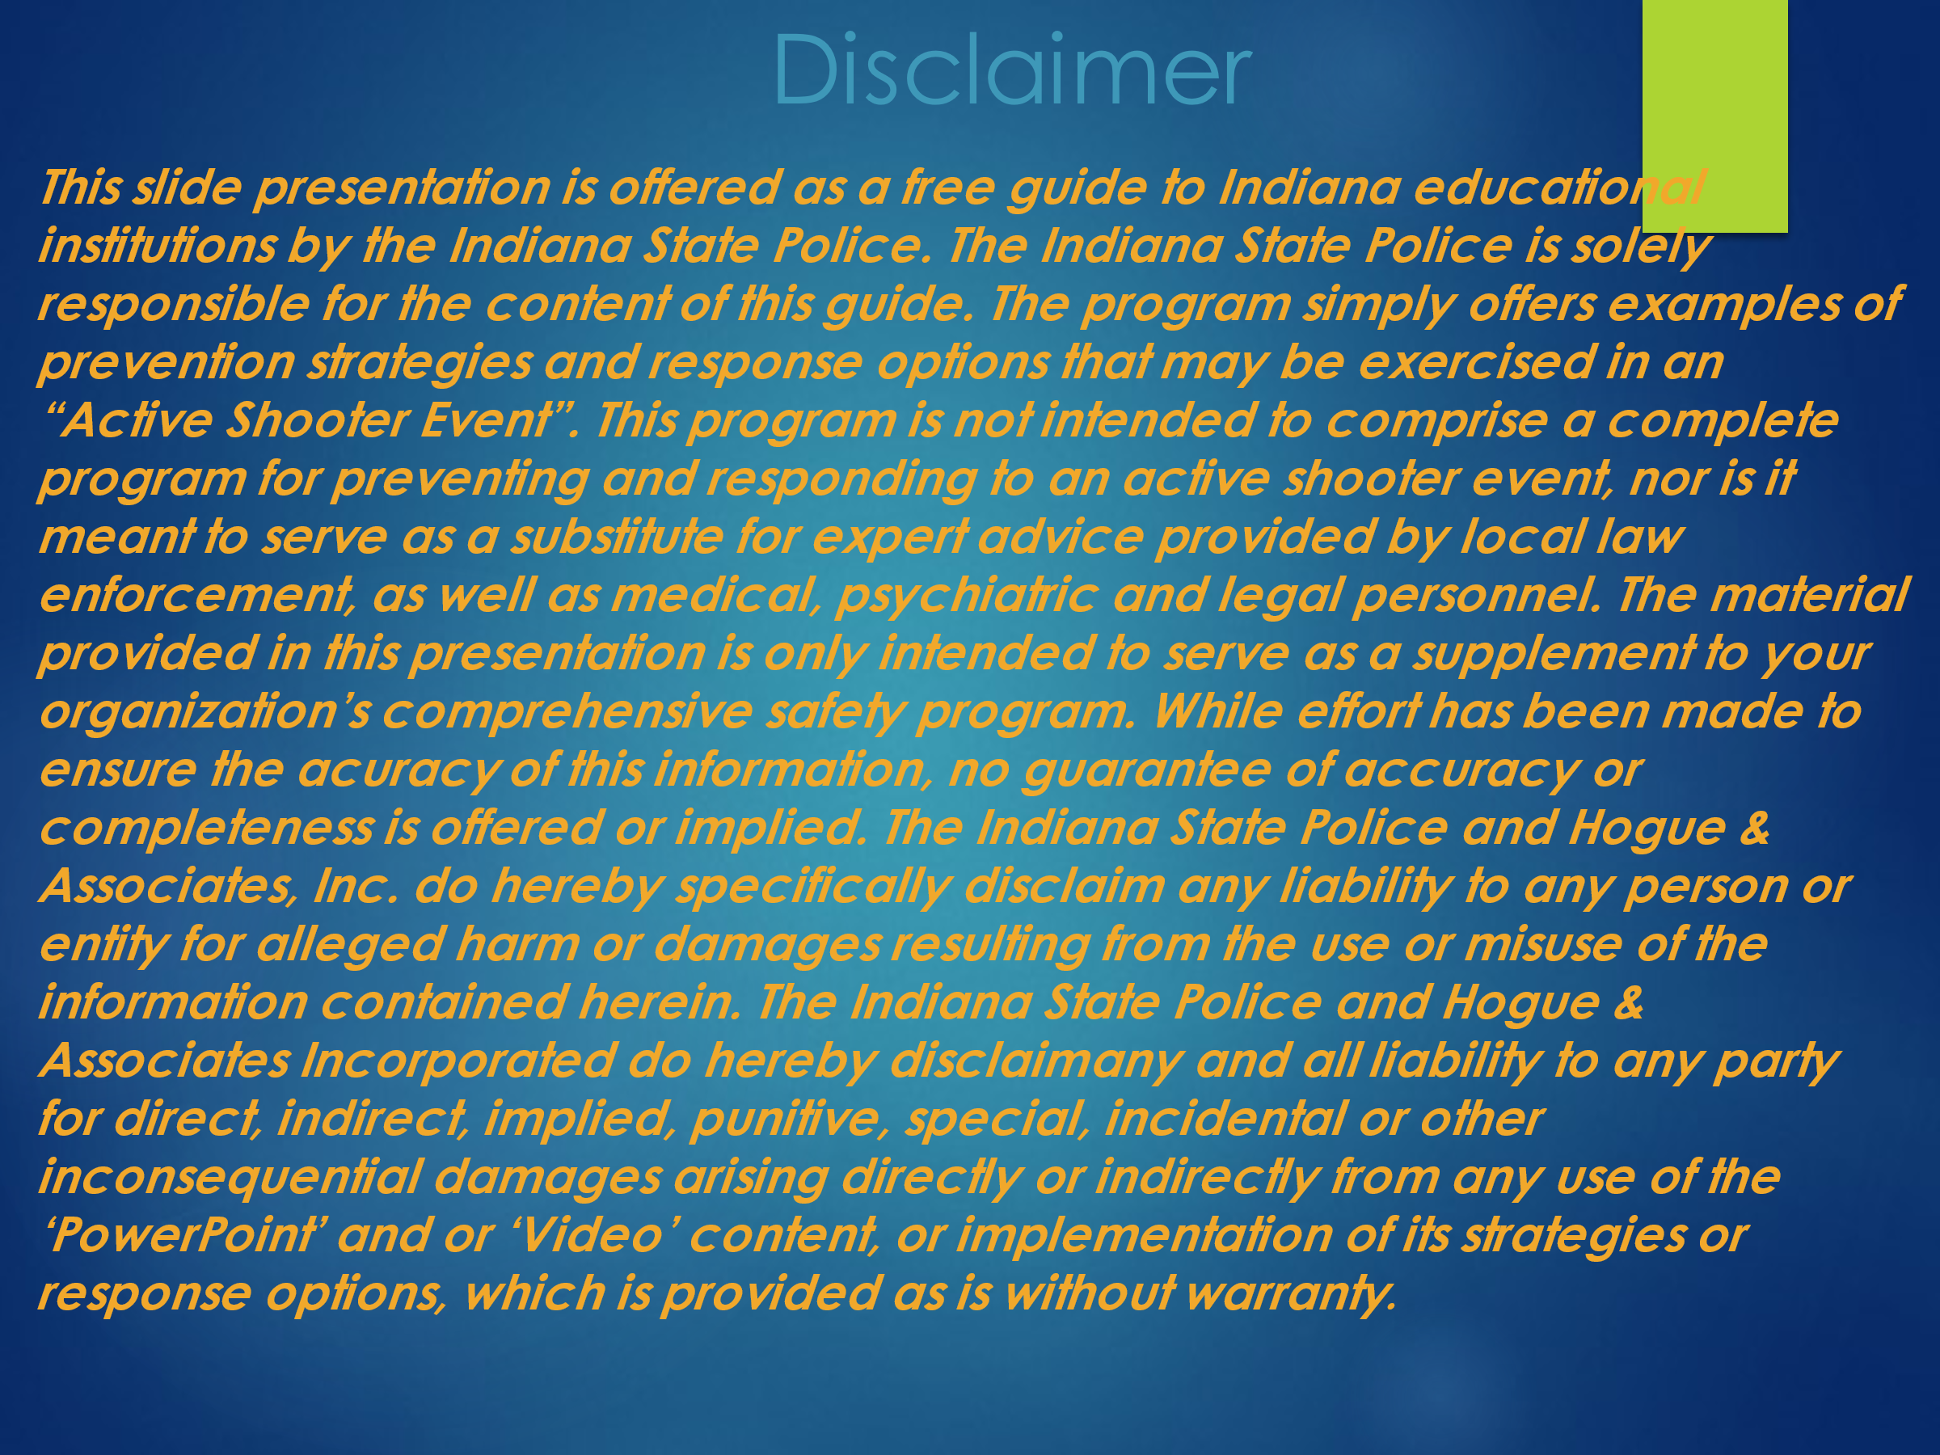

Slide # 2 Disclaimer
These materials are offered only to assist unarmed individuals attempting to increase their preparedness as they go about their daily lives. This program stresses that every “active shooter or active attacker” event is different. In that light, the stimuli or conditions of the event will dictate the most appropriate response.
Again, it must be stressed, that the material posted on the Indiana State Police Home Page does not represent a complete and or comprehensive safety program. The material must only be used to supplement a comprehensive strategy to secure the environment in which we live our daily lives.

Presenter’s Note: The Indiana State Police are solely responsible for the content of this guide. It is strongly recommended that a “Comprehensive Threat Assessment” be conducted to determine the risks faced by each organization. Upon completion of the assessment, a “Comprehensive Safety Plan” should be develop that addresses the risks identified by the “Comprehensive Threat Assessment.” All individuals in the organization assessed must be educated on the “Comprehensive Safety Plan” as well as their role in the plan.
The presenter should stress that many “Threat Assessment Tools” may be found on the internet and in security manuals. However, the presenter should caution the audience that selecting a “Threat Assessment Tool” without modifying it to meet the needs specific to their organization might result in an “incomplete” assessment. Every environment has unique characteristics. With that in mind, the “Assessment Tool” must examine the unique needs of the environment to which it is applied. Supervisors, managers, employees, etc. know their work environments better than anyone. In that light, the “Assessment Tool” should be modified by those working in the environment to be examined. In this way, the assessment will focus more directly on the nuances of the organization to which it is applied.

Slide # 3
The Indiana State Police Definition of an Active Shooter
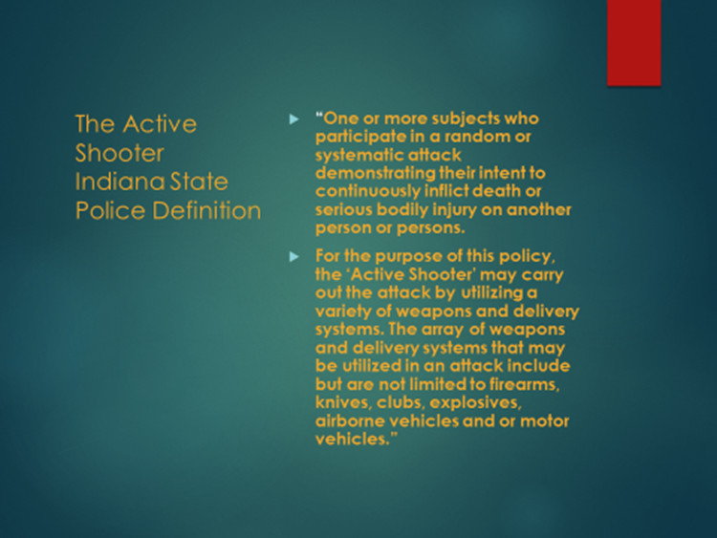
Slide # 3 The Indiana State Police Definition of an Active Shooter
The Indiana State Police Definition of an “Active Shooter” has expanded over time. For several years, the Indiana State Police have been warning that the means utilized by “active shooters” will evolve. Unfortunately, that prediction has come to fruition. We now witness attacks carried out with motorized vehicles, aircraft, clubs, knifes, bombs, poisonous substances, and firearms. This development underscores the importance of the prevention phase of the “Unarmed Response to an Active Shooter Event” program.
Every weekend in various cities across our country, multiple individuals are killed and or injured in gang wars, disputes over “turf,” workplace violence, etc.
Businesses have come under assault by internal and external assailants. Because of the fluid definition of mass assaults, it is nearly impossible to reach a consistent number of mass attacks in the US.
The FBI Information for Active Shooter Events

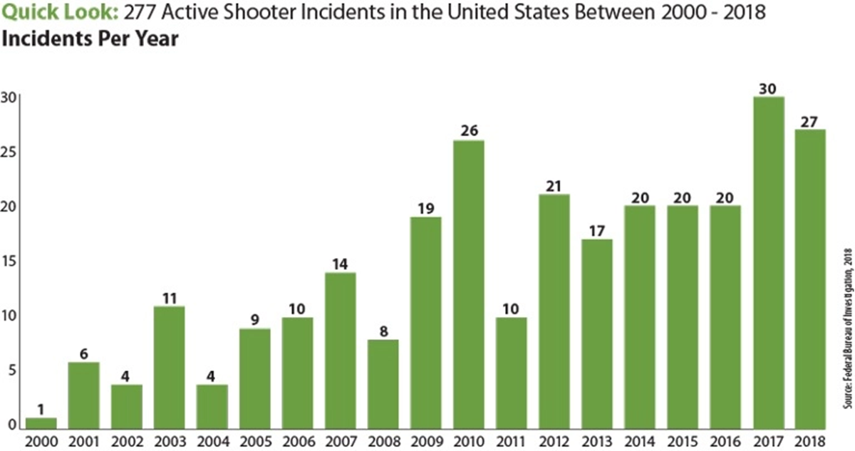

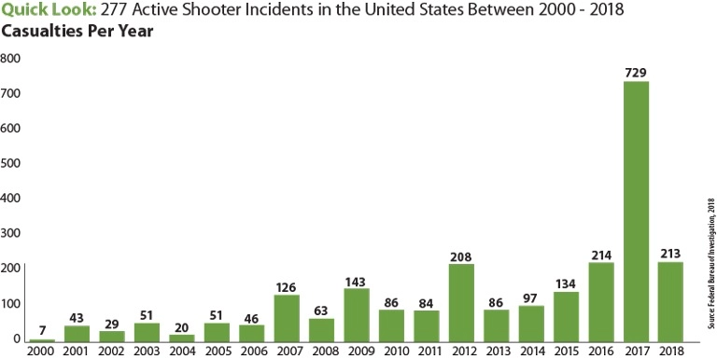

Presenter’s Notes: Because attacks on various institutions in Europe, the Asia Pacific, the Middle East, etc. seem to predate events in the United States, the following assaults may serve as an early warning of perils to come.
Presenter’s Note: The presenter may wish to provide some examples of recent overseas attacks utilizing various weapons of choice.

These attacks do clearly demonstrate that attacks can and will be carried out with a variety of weapons.

The:
1995 attack in Japan with Sarin Gas that killed 13 while injuring 143.
2010 attack in Nanping with a knife that killed 8 school children.
2016 attack in Brussels with a bomb in an airport and subway station that killed 33.
2016 attack in Nice, France, with a truck where 86 people were killed and 458 civilians were injured.
2016 attack in Berlin, Germany with a truck leaving 12 dead and 56 injured.
2017 attack in Manchester, England with a bomb England that killed 23.
2017 attack in London, England, with a motorized vehicle killing 4 and injuring 50.
2017 attack in Barcelona, Spain with a van that killed 13 people while injuring at least 100.
2018 Tajikistan, with a car that killed 2 Americans and Swiss citizen
2019 Japan, with a knife where 2 individuals were killed & 18 hurt.

Presenter’s Note: Intelligence agencies indicate that the United States often mirrors what happens abroad. The following slide will underscore that places of commerce currently rank as the most likely venue for active shooter events.
Regardless of the weapon utilized. Places of commerce may wish to place an emphasis on prevention.

Slide # 4 Locations of Active Shooter Events in the US
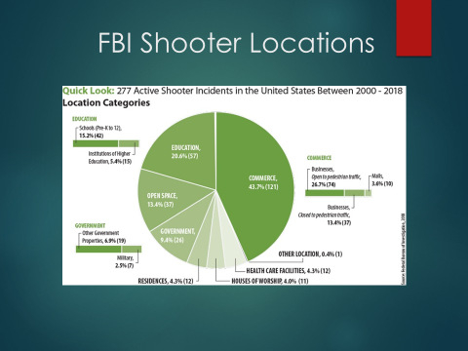
Slide # 4 FBI Shooter Locations Chart
This chart clearly illustrates that “active shooter events” occur in nearly every environment in which we live our daily lives. It does underscore that places of commerce rank at the very top of venues experiencing an active shooter event.

Slide # 5 Overview of Active Shooter Events
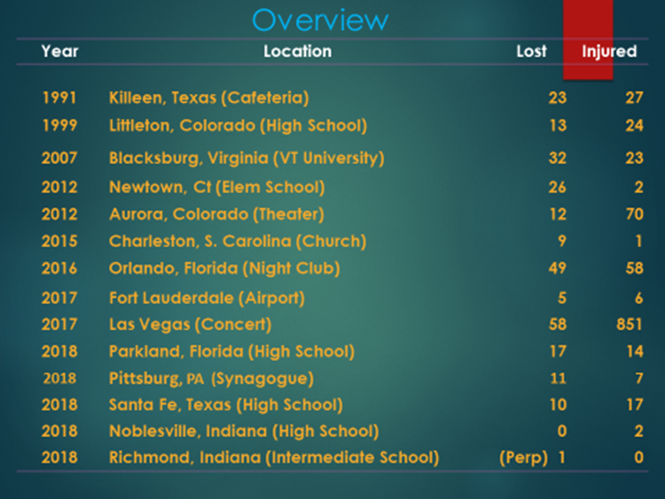
Slide # 5 Overview of Active Shooter Events
This slide attempts to underscore the scope of the of “active shooter events” in the United States. The presenter may wish to stress that the Indiana State Police model offers strategies that may be utilized in multiple environments. The strategies endeavor to offer salient direction on prevention strategies and response options to a variety of “active shooter events.”
It is the intent of this version of the ISP “Unarmed Response to an Active Shooter Event” program to increase the preparedness of individuals in the workplace. In doing so, ISP hopes to better equip individuals to respond to an “active shooter event.” The Indiana State Police believe that informed individuals are more likely to make appropriate choices. Making good decision and practicing response options are critical to the ISP “Unarmed Response to an Active Shooter Event” program.
For eight years, the Indiana State Police Department has been warning that we face threats in our schools, places of worship, places of employment, etc.
Places where we earn our “living” such as manufacturing, entertainment, education, military installations, etc. all experienced “active shooter events.”
- Henry Pratt in Aurora, Illinois
- Boarder Line Grill in Thousand Oaks, California
- Mandalay Bay, Las Vegas in Nevada
- Naval Base, Pensacola, Florida
- Richmond, Indiana Middle School
- Stoneman Douglas, Broward County, Florida
- Santa Fe, High School, Santa Fe, Texas
While these stand as only a few of the tragedies that our communities have faced, it may serve to underscore the scope of the recent active shooter attacks on our way of life. These are both low and high profile shootings. Regardless, the loss is overwhelming.
The Indiana State Police, understand that once an attack begins, casualties will result. With that in mind, ISP focuses on prevention as the primary step in the “Unarmed Response to an Active Shooter Event” program.

Slide # 6 Early Warning Indicators
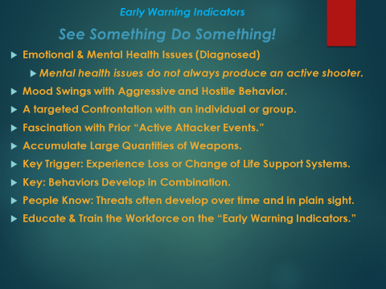

Slide # 6 Early Warning Indicators
The Indiana State Police efforts focus on identifying potential threats before they occur. Identification relies heavily on everyone participating in the prevention effort. Typically someone always knows!
Presenter’s Notes: In the prevention phase of the ISP program, the presenter underscores that everyone has a responsibility to participate in securing their respective environment. Information is key in preventing “active shooter events.” Individuals perpetrating these events often display very specific “Early Warning Indicators or Behaviors.”

Emotional and Mental Illness
Not every individual suffering from emotional and mental health issues develops into an “active shooter.”
Mood Swings and Hostile Behavior
Presenter’s Notes: Individuals suffering with emotional and mental health issues need assistance. If serious mental health issues are present, these issues may manifest in wild or extreme mood swings and hostile behavior in the workplace.
If serious emotional behaviors are not appropriately treated, individuals may become alienated and isolated. This deteriorating mental state may result in these individuals carrying out irrational acts that may cause harm to others.
Targeted Hostile Behavior
Individuals that are struggling with emotional issues often become less effective in the workplace. Their poor performance contributes to confrontations with fellow workers and supervisors.
Poor work performance often results in confrontational meetings with fellow workers and supervisors. If the employee is already in an agitated and less than rational state of mind the formula for an altercation develops.
Targeted Individuals
In an irrational state of mind, the employee often focuses on the person or individuals they perceive to be responsible for their distressed and agitated state of mind.
If we consider these circumstances we see the perfect storm of an unstable individual feeling victimized and needing to strike out against the individual and groups that they feel are responsible for their distress. This individual’s perceived solution may result in a workplace shooting or attack.
Examples of Triggers: Such as the loss of employment and or disciplinary actions may generate the “Targeting Phenomenon”:
In December 2000, at Edgewater Technology, an individual murdered 7 of his fellow workers. Allegedly, the action was a result of a wage garnishment. Technology Inc.
In 2010, at a Hartford Beer Distributor Warehouse, an attacker shot and killed 8 people and injured 2 more. The attack was allegedly the result of a disciplinary action that resulted in his resignation.
In 2012 at the Accent Signage Systems Company, allegedly a shooter killed 2 managers and five coworkers after he was dismissed.
Workplace Shooters Often Develop Over Time
This phenomenon is especially important because shooter typically do not go from a satisfied, collegial and amicable coworker to an active shooter on the spur of the moment.
Typically they share their dissatisfaction, resentment, and intents in advance. Fellow employees often know an individual is spoiling for a fight before a “trigger” (loss of employment, disciplinary action, wage garnishment, etc.) lights the fuse that sets off the “active shooter event.”

Typically Workplace Shooter Display Multiple Indicators
It is not unusual for a developing threats to share intentions with others. Threats may be made and intentions may be voiced. Signs of planning may also be displayed.

The developing threat’s actions foreshadow the horrific event they are contemplating. Often acquaintances, family members, coworkers, etc. simply fail to take action. The presenter should endeavor to stress the importance of taking action.
The presenter should underscore: “See Something Do Something!”
Again, typically, “attackers” share their intent with others. They develop over time. The final assault may have a trigger like a disciplinary action, loss of employment, wage garnishment but the basic underlying threat has been festering for some time.
Slide # 7 The Intervention (Assistance or Threat Assessment Team) 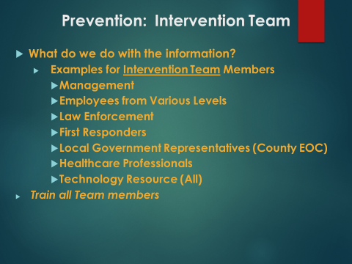
Slide # 7 The Intervention (Assistance or Threat Assessment Team)
In discussion, it is often asked. “What do I do with concerns?” This slide attempts to offer a possible solution to this issue. The “Intervention Team” is a tool that may provide a “bridge” to convey information from concerned individuals to resources that may be utilized to provide assistance for individuals displaying the “Early Warning Indicators or Behaviors.”
The “Intervention Team” must be selected from a cross-section of employees. The participants must be trained. Individuals on the Intervention Team serve as points of contact and conduits to collect and transmit information. “Intervention Team” members must understand their role is not to serve as a therapist but to serve as a conduit to convey information to the appropriate resource. The resource may be law enforcement, administration, personnel services, health care professionals, etc. The “Intervention Team” must develop a group of resources with the appropriate expertise to intercede and assist the individuals displaying the “Early Warning Indicators or Behaviors.” Some businesses will have the internal resources while others will need to go “outside” the confines of the workplace.
The “Intervention Team” must have the resources to provide assistance for the referrals they receive. The “Team” may elect to develop a cadre of health care professionals, law enforcements officials, management representatives, etc. The “resource” component of the “Intervention Team” is comprised of individuals that can bring the appropriate resources to support the individual or individuals displaying the “behaviors” concerning the “Intervention Team.”

Slide # 8 Your Role in Staying Safe
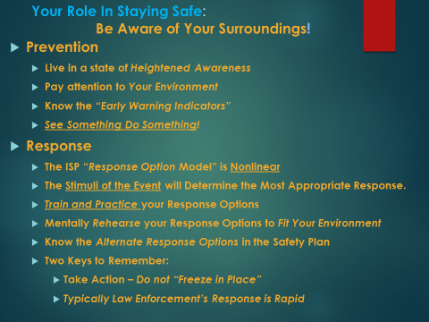

Slide # 8 Your Role in Staying Safe
As we go about our daily lives, we have a responsibility to participate in the process of “keeping ourselves safe!” We cannot totally rely on others to keep us safe! Many times, we go about our lives oblivious to the threats that may surround us. We see individuals literally colliding with others on the sidewalk while texting or worse while driving which may result in a serious accident.
To respond appropriately, we must be aware of our surroundings and be prepared to respond appropriately. We can only respond appropriately if we are aware of our surroundings and have planned and practiced our “response options!”
Providing the audience with examples that we all see every day may be an effective method to underscore the teaching point (I.e. texting while drive/walking on the sidewalk, parking our car in a dark lot with keys in the bottom of our pocket/purse as we return from shopping, etc.).
As we go about our daily lives, we must be prepared for the “unthinkable.” Our chances of responding appropriately dramatically increase when we are prepared. We must be aware of available exits, safe areas, potential threatening behavior, etc. Our thought process must include mentally practicing response options to potential threats that may be found in the various environments in which live our daily lives.
This is an opportunity to discuss “Freezing in Place.” This is a typical response to a shocking situation. “Freezing in Place” is a common and or perhaps a “natural” initial response. However, if you are prepared and you have planned your response you much more likely to not stay in the “frozen” state.
Most individuals have heard of the “fight or flight” response. Much of that same body of research seems to support that staying in the “frozen” state most often occurs when you determine the situation is so overwhelming that you cannot flee or successfully fight off the threat. Basically, hope is lost.
Planning, practicing, training and drilling may dramatically increase your chances of emerging from the initial “Frozen State” with an appropriate response. The response you elect to exercise will depend on the external stimuli of the event (i.e. location of the shooter, type of weapon, proximity to an exit, proximity to a predetermined safe area, etc.). Once again, the response option that is selected will be determined by the circumstances of the event.

Slide # 9 The ISP Response Option Model: Escape
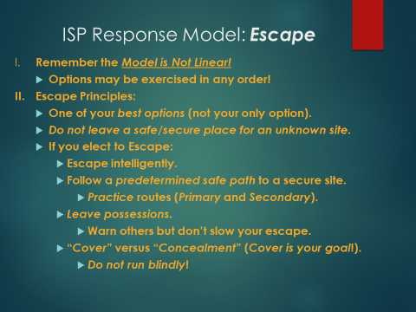
Slide # 9 The ISP Response Option Model: Escape
The Indiana State Police understands that not all “Active Shooter Events” can be prevented. With that said, ISP has some basic response options that may be exercised in an “active shooter event.”
It is critical for the presenter to emphasize that the ISP Response Options Model is not linear. While the ISP presentation introduces the response options of the model as Escape, Lockdown, Fight, the options may be exercised in any order.
The Escape component of the model stands as one of your best options if you have a safe path to a secure area. It underscores the critical component of establishing a secure path to a predetermined safe area. It warns against running blindly.
A valuable teaching component may be found in an event that occurred in Jonesboro Arkansas in which an 11 and 13 year old pulled a fire alarm as part of a predetermined plan to evacuate students and staff into a “killing field” to facilitate an active shooter attack. It has been speculated that this tactical move was also a component in the Parkland Florida shooter’s attack strategy. While these attacks were carried out in a school setting, the events stand as a valuable teaching tool for places of commerce.
Escaping via a safe path to predetermined secure area is a critical component in the “Escape Option.” It may also be underscored that in practical drills in large buildings the location of the shooter is difficult to determine. (In practical drills conducted by law enforcement, when blanks are discharged in a large building the exact location of the shooter is difficult to determine.) Because it is difficult to tell the location of the shooter or direction the shooter is traveling, employees must not run blindly. The act of just running, may very well take individuals directly into the shooter.
In selecting a predetermined safe path, one of your most important goals is to select a path with will provide cover if possible. As individuals exercise the “Escape” option, they must run intelligently by taking a safe path with as much cover as possible. Because, it is difficult to determine the exact location of the threat, alternate escape paths should be identified. The presenter may wish to define cover (as shelter behind objects that will stop a round).

Slide # 10 The ISP Response Options Model: Lockdown
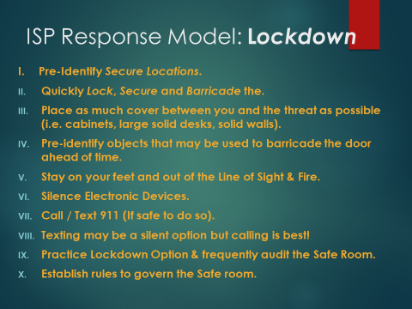
Slide # 10 The ISP Response Options Model: Lockdown

When considering the “Lockdown” option, it should be stressed that planning must take place. The “Safe Areas” must be established ahead of time. The “Lockdown Area” must have doors that can be rapidly secured. Equipment must be determined ahead of time that may be utilized to barricade the door and serve as weapons. Supplies for supporting the population of the “safe area” must developed, stored and secured in the safe area. The “safe area” supplies must be assembled to meet the specific needs of those that will be sheltered.
As is the case with all options, planning, drilling and practicing the components of the “Lockdown” option must be practiced. Individuals must have primary and secondary safe paths to the “Lockdown” sites. Finally, it is critical to have predetermined rules that govern the safe area. The person in charge with a backup must be determined.
The basic operational procedures (when to open the door, how to coordinate the fight option, etc.) must be clear to the person (and backup) in charge and the population of the “safe area.”
It is unlikely, but that individuals in the safe room will need to spend hours in the safe room. However, it has happened. It may take time for the facility to be “cleared.” With that in mind, the safe areas should have supplies to support the population that is likely to populate the “safe area.” EMT, health care professionals, etc. may assist in developing the safe room supplies or kits.
Slide # 11 The ISP Response Options Model: Fight Option
It must be made clear that this is often viewed as the option you may exercise if no other option is available. However, it must be underscored that the ISP options are not linear! You may fight and then “Escape” or “Lockdown” and or return to the “Fight” option.
Key strategies to successfully carryout the “Fight Option” are planning, predetermining weapons, strategically positioning your attack, and bringing the attacker into your “Circle of Violence.”
You must position yourself out of the line the sight and fire. Surprise is a key component. Position yourself in position to take advantage of the “surprise strategy.” You must think in terms of bringing the threat into your “Circle of Violence!” The presenter may wish to discuss the concept of “Circle of Violence!” This is simply taking a place of advantage where you bring the threat into a position where the weapon you have becomes effective and you can take advantage of the surprise strategy. Troopers often give the example that if you are going to utilize a chair as a weapon from twenty feet away, you have failed to bring the threat into your “Circle of Violence.” However, if you are standing out of the line of sight and fire (by the door as the threat enters), you have brought the threat into your “Circle of Violence” and the chair becomes an effective weapon.
As is the case with all options, you must plan and practice the “Fight Option.” The “Fight Option” is a coordinated effort. ISP Department strongly recommends a practiced concerted effort. Superintendent of the Indiana State Police Doug Carter, suggests, “If you plan and practice you will be able to do far more than you think you can do!”
Slide # 12 The ISP Response Options Model: Freezing in Place
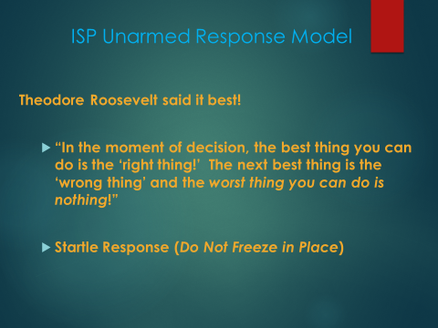
Slide #12 The ISP Response Options Model: Freezing in Place
This is an opportunity to once again emphasize that “Freezing in Place” is a typical response. “Freezing in Place” is a common and or perhaps a “natural” initial response. However, if you are prepared and you have planned your response you are much more likely to not stay in the “frozen” state.
Planning, practicing, training and drilling may dramatically increase your chances of emerging from the initial “Frozen State” with an appropriate response. The response you elect to exercise will depend on the external stimuli of the event (i.e. location of the shooter, type of weapon, proximity to an exit, proximity to a predetermined safe area, etc.). Once again, the response option that is selected will be determined by the circumstances of the event.
Slide # 13 The ISP Nonlinear Prevention and Response Options Model
Review
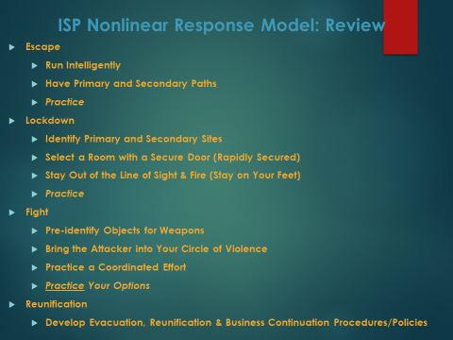

Slide # 13 The ISP Nonlinear Prevention and Response Options Model
Review
Here it is critical to revisit briefly the components of the ISP Nonlinear Response Model.

Escape
• Do not run blindly (Run Intelligently)
• Have Primary and Secondary Paths
• Practice the Escape
Lockdown
• Identify and publish safe site locations
• Select a location that can be secured
• Stay out of the line of sight and fire
• Establish rules for the operation of the ‘Safe Area’
• Practice your paths to the lockdown site
Fight
• Pre-identify objects and weapons
• Bring the attacker into your ‘Circle of Violence’
• Coordinate your efforts
• Practice

Reunification
- Reunification is a component of the “Response Option Model” often Omitted
- Management must have a “Reunification Plan”
- Develop a Secure Site for Reunification (Identify Alternate Sites)
- Develop a Plan for “Accounting for All Employees”
- Develop “Reunification Kits” to Support Employees (Kits Matched to Employees)
- A Plan for Reuniting All Employees with Family Contact/Emergency Info (Record and Update Reunification Cards in Advance)
- Establish “Staging Areas” For Media Away from the Crisis Location
- Develop a “Business Continuation Plan”

Slide # 14 Management Responsibilities
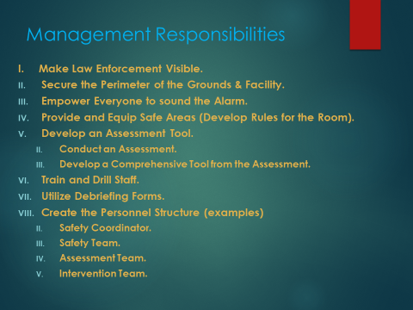
Slide # 14 Management Responsibilities
1) Bring law enforcement in the workplace and making them visible!
2) Secure the perimeter of the grounds and the facility.
3) This may be the one area in which law enforcement has noted the most change. However, it may also be the one area in need of the most improvement.
a) Securing the perimeter with the appropriate electronic monitoring systems is effective if everyone follows the established policies and procedures.
i) Educating staff on the appropriate behavior is critical.
(1) A common mistake is for employees to open and or hold perimeter doors for fellow employees and visitors.
(a) This practice in itself defeats the “Perimeter Security” of the facility.
4) Monitor Risks
a) Utilize Intelligence from the Intervention Team, law enforcement, government agencies, etc.
i) The goal is to prevent threats and prepare for them.
5) Create the personnel structure (Examples) and Train the Members
a) Safety Team (Coordinator)
i) Safety Team
b) Assessment Team (Coordinator)
i) Assessment Team
c) Intervention (Coordinator)
i) Intervention Team
d) Create a Crisis Management
i) The Crisis Team
(1) Manages the Crisis in Process
(2) This “Team” must have the resources to deal with a broad spectrum of crisis events
(a) Members may include (Law Enforcement, Crisis Counselors, Management Staff, County EOC, Business Legal Team, etc.)
(b) Must Develop a Continuing Business Plan
(i) This plan supports the “Continuation of Business Process” and the transition back to “Normal Business Operations”
6) Select and Modify an Assessment Tool & Conduct an Assessment with the Modified Tool
7) Develop a Comprehensive Safety Plan & Program that Addresses the Risks Identified by the Assessment
a) Train, Test and Drill on the Program
i) Modify the Plan Based on the Results of the Test and Drill Process
b) Utilize Debriefing Forms
i) Modify the Plan Based on the Information Collected on the Debriefing Forms
c) Train and Empower Everyone to Sound the Alarm
8) Provide Safe Areas
a) Create Rapidly and Easily Securable Safe Areas with “Backup Areas”
i) Equip the Safe Areas
ii) Audit the Safe Areas
iii) Establish Rules Governing the Safe Areas
Management must commit to making safety a priority! Establishing key personnel roles is critical to this process. Establishing leadership positions, training and drilling employees, securing the location and physical plant, etc. are responsibilities that management should assume.

Slide # 15 Arrival of Law Enforcement
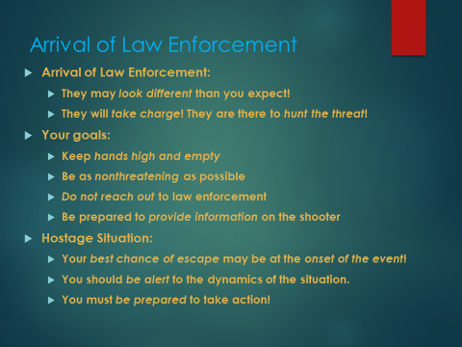
Slide # 15 Arrival of Law Enforcement
It is important to stress that arriving law enforcement may not be in full uniform but they will have articles of clothing that will identify them (Campaign Hat, Badge, Law Enforcement Vest, etc.). Victims must present themselves in a nonthreatening manner. Law enforcement has milliseconds to determine if you are a threat. You need to assist them in that identification by keeping hands high and empty, not reaching out for them, etc.
Law enforcement will need your assistance in identifying the threat. On the ISP website, individuals may find information that arriving law enforcement and 911 operators need your assistance in identifying the shooter or shooters (clothing, hair color, type of weapon, location of shooter, etc.).
Slide # 16 Introduction of the RUN-HIDE-VIDEO (A.L.E.R.R.T. Houston Texas)

Slide # 16 Introduction of the Huston Texas RUN HIDE FIGHT VIDEO
It is important to direct the audience to watch the video and keep in mind the principles discussed in the “ISP Unarmed Response to an Active Shooter Event” program.
Members of the audience should look for individuals carrying out the principles discussed in the URASE presentation.
The presenter may also ask, “Did you note any actions by the participants in the video that could have been executed more appropriately?”

Slide # 17 RUN HIDE FIGHT VIDEO
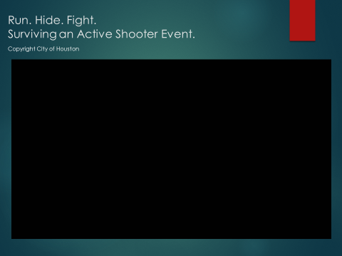
Slide # 17 Run Hide Fight Video
Again, presenters may wish to ask participant to view the video in light of the ISP URASE program. What principles do you see demonstrated?

Slide # 18 Focus Questions
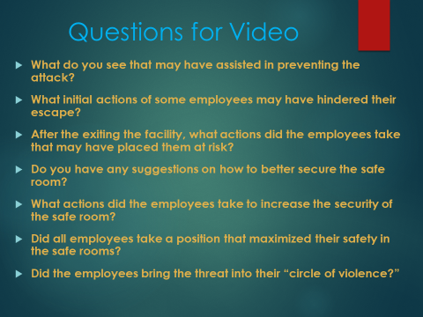
Slide # 18 Focus Questions
After the video, these questions may assist the presenters in conducting a discussion on the content of the Houston based program:
- What do you see that may have assisted in preventing the attack?
- Better Control the Entryway.
- Increased Participation on behalf of the Security Guard.
- Possible Prevention Via Early Identification.
- Increased Vigilance on Behalf of the Employees

- What initial actions of some of the employees may have hindered their escape?
  - Taking time to convince others to go with them.

- After exiting the facility, what actions did the employees take that may have placed them at risk?
  - Need to distance themselves from the facility (approximately 300 to 500 feet).
- Do you have suggestions on how to secure the safe area?
  - Place a wedge in the door.
  - Identify equipment in the room that can be used to barricade the door.
- What actions did the employees take to increase the security of the safe area?
  - Barricaded the door.
- Did employees take a position that maximized their safety in the safe room?
  - Locking and moving substantial equipment (to barricade the door.
  - The employees developed a group response and took a position to bring the threat into their “circle of violence?
  - Yes, they were positioned appropriately to surprise and attack the threat with improvised weapons.

Slide # 19 Simple Review of Management Responsibilities
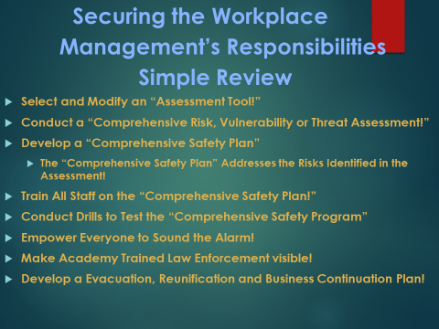
Slide # 19 Review of Management’s Responsibilities
Make Academy Trained Law Enforcement Visible
One of the most important safety practices is to bring “Academy Trained” and uniformed law enforcement into the workplace. Make law enforcement highly visible.

Development of the Assessment Team
An “Assessment Committee” or team must be selected. Participants must be selected from a cross section of job responsibilities. It is critical to have individuals that bring various opinions and perspectives to the “Assessment Team.”

Select a Chairperson
From the “Assessment Team or Committee” a “Chairperson” must be selected to direct the effort of the committee or team.
Select and Modify an Assessment Tool
Organizations may select a commercial assessment tool to begin the process. However, management must modify the commercial tool to meet the specific needs of the organization. If the tool is not modified, the instrument will miss key elements that are unique to the organization it is intended to assess.
Developing the Comprehensive Safety plan
Management should begin the process of developing a “Comprehensive Plan” by conducting a comprehensive assessment to identify the threats, vulnerabilities and risks faced by the organization. The “Comprehensive Safety Plan” is then developed by constructing a strategy that addresses the threats, risks and vulnerabilities identified by the assessment.
ISP strongly recommends that the assessment instrument be modified to meet the unique needs of the organization. The assessment should be conducted prior to the development of the safety plan.

Training
Everyone must be trained on the “Comprehensive Safety Plan.” They must also be training on their role in the “Safety Plan.”
Scheduled Trainings
A schedule for training sessions and drills must be established.
Designing Safety Training Sessions
It recommended that management utilize local law and state law enforcement to design training exercises and drills. After each training session a debriefing sessions must be held.

Modifying the Comprehensive Safety Plan
Debriefing Forms
The “Comprehensive Safety Plan” may be modified and improved with the results of each drill. Debriefing Forms are simple forms that everyone may complete that is involved in a drill. The form simply states the details of the drill; states the action taken; states what work well; and finally what action might improve the response to the drill.

Empower Everyone to Sound the Alarm

Everyone must be trained, equipped and empowered to sound the alarm!

Develop an Evacuation, Reunification and Business Continuation Plans
Develop an Evacuation, Reunification and Business Continuation Plan. The plan must contain employee contact information, employee roster, employee special needs information, etc. In addition, the site may be a crime scene. In order to conduct business offsite you will need to develop a “Business Continuation Plan” with specific information critical to conducting business.

Slide # 20 Resources
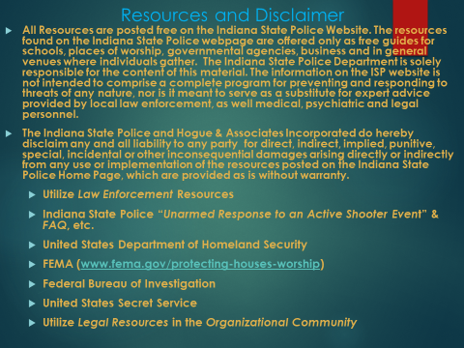

Slide # 20 Resources
Several Resources are posted free on the Indiana State Police Website. The resources found on the Indiana State Police webpage are offered only as free guides for schools, places of worship, governmental agencies, business and in general venues where individuals gather. The Indiana State Police Department is solely responsible for the content of this material. The information on the ISP website is not intended to comprise a complete program for preventing and responding to threats of any nature, nor is it meant to serve as a substitute for expert advice provided by local law enforcement, as well medical, psychiatric and legal personnel.
The Indiana State Police and Hogue & Associates Incorporated do hereby disclaim any and all liability to any party for direct, indirect, implied, punitive, special, incidental or other inconsequential damages arising directly or indirectly from any use or implementation of the resources posted on the Indiana State Police Home Page, which are provided as is without warranty.

Slide 21 ISP Contact Information and Disclaimer
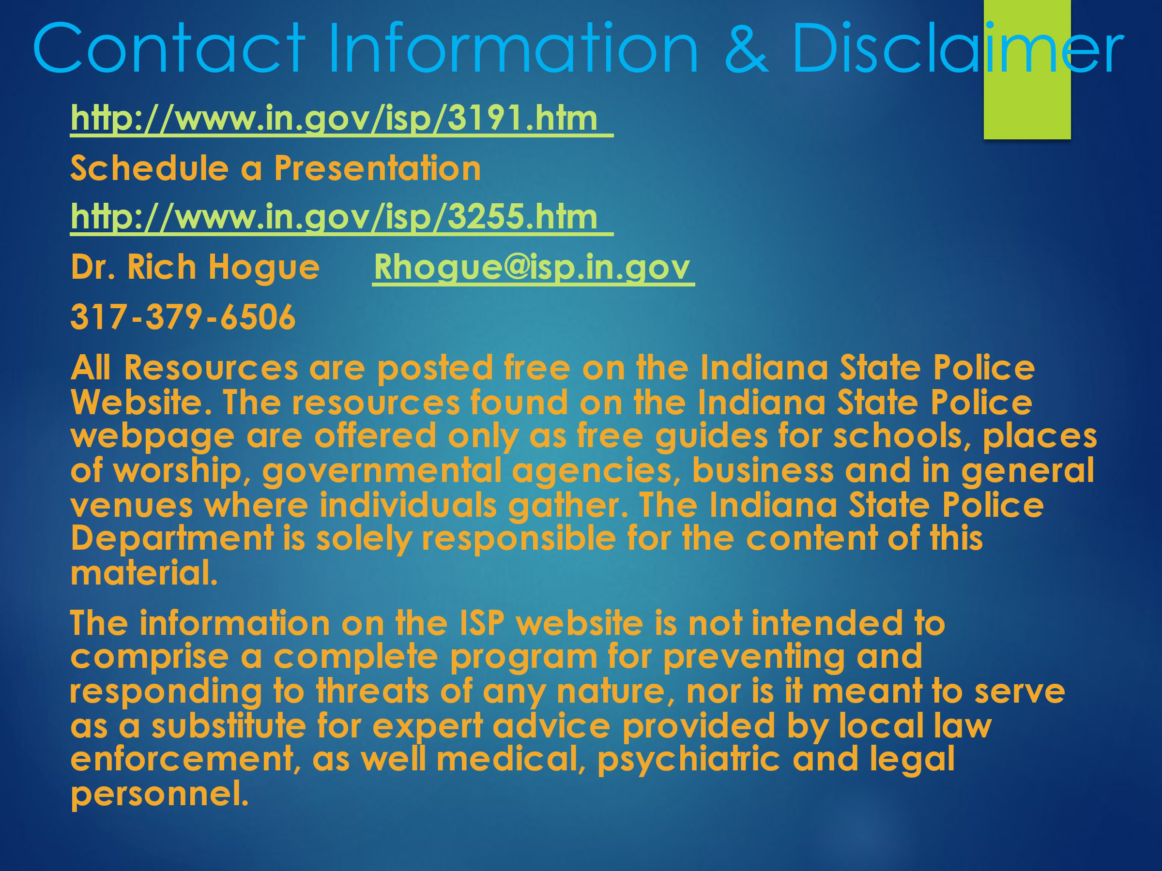
Slide # 21 Contact Information and Disclaimer
Presenter Notes: t is important for presenters to underscore that the Indiana State Police and Hogue & Associates Incorporated do not warrant the performance, effectiveness or applicability of the material, concepts and or strategies provided on the Indiana State Police Home Page.
These materials are offered only to assist unarmed individuals attempting to increase their preparedness as they go about their daily lives. This program stresses that every “active shooter or active attacker” event is different. In that light, the stimuli or conditions of the event may dictate the most appropriate response.
Finally, it must be stressed, that this material does not represent a complete and or comprehensive safety program. It must be used only to supplement a comprehensive strategy to secure the environment in which we live our daily lives.
Presenter’s Notes: The Indiana State Police are solely responsible for the content and material posted on the Indiana State Police Home Page. It is strongly recommended by the Indiana State Police Department that a “Comprehensive Threat Assessment” be conducted to determine the risks faced by all businesses, places of worship, government agencies, schools, etc.
The “Comprehensive Safety Plan” should be develop by addressing the risks identified by the “Comprehensive Threat Assessment Process.” All individuals in the organization assessed must be educated on the “Comprehensive Safety Plan” as well as their role in the plan. An ongoing formal training program is critical to improving the safety of any organization.
Presenter’s Notes: The presenter should stress that many “Threat Assessment Tools” may be found on the internet and in security manuals. However, the presenter should caution the audience that selecting a “Threat Assessment Tool” without modifying it to meet the needs specific to the school, workplace, governmental agency, place of worship, etc. might result in an “incomplete” assessment. Every environment has unique characteristics. With that in mind, the “Assessment Tool” must examine the unique needs of the environment to which it is applied. Educators, managers, employees, patrons, parents, etc. know their environments better than anyone. In that light, the “Assessment Tool” should be modified by those living, studying, working, etc. in the environment to be examined. In this way, the assessment will focus more directly on the nuances of the organization to which it is applied.

