Slide # 1 2021 The Indiana State Police:
Unarmed Response to an Active Shooter Event

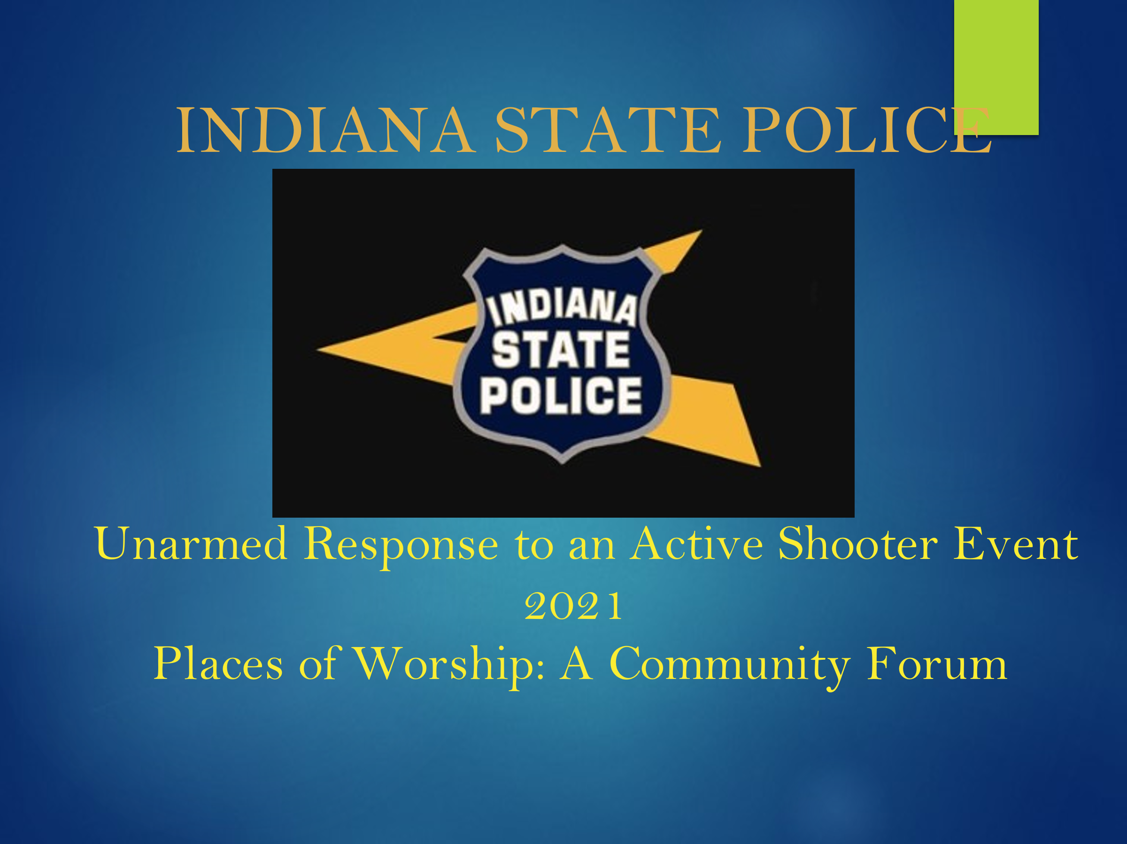
Slide # 1 The Unarmed Response to an Active Shooter Event
2021 Places of Worship: A Community Forum
Presenter’s Notes: This is an opportunity to explain to the audience that this version has been developed specifically for places of worship. The program endeavors to provide prevention strategies and response options that may be used to increase the security of individuals in their places of worship. It must be stressed that this is not a “Comprehensive Safety Program.” The Indiana State Police URASE program is but one component in the overall safety effort to secure our places of worship.
The Indiana State Police Department always believes that prevention is preferable to response. With that in mind, strategies will be discussed that may assist worshippers in the early identification of individuals that may be developing into a threat. The goal of the initial phase of the ISP model is to intervene and provide assistance to those in need of support.
The response segment of the “Unarmed Response to an Active Shooter Event” program attempts to provide tools and procedures that may assist the congregation in responding more appropriate to an attack on their place of worship.
THIS SLIDE PRESENTATION IS OFFERED AS A FREE GUIDE TO PLACES OF WORSHIP IN EVALUATING CURRENT ACTIVE SHOOTER PREVENTION AND RESPONSE PROGRAMS, AND IN DEVELOPING THE SAME.
THIS INFORMATION IS NOT INTENDED TO COMPRISE A COMPLETE PROGRAM FOR PREVENTING AND RESPONDING TO AN ACTIVE SHOOTER EVENT, NOR IS IT MEANT TO SERVE AS A SUBSTITUTE FOR EXPERT ADVICE PROVIDED BY LOCAL LAW ENFORCEMENT, AS WELL AS MEDICAL, PSYCHIATRIC AND LEGAL PERSONNEL.
THE UNARMED RESPONSE TO AN ACTIVE SHOOTER PROGRAM IS A CHANGE IN THE TRADITIONAL PARADIGM FOR RESPONDING TO AN ACTIVE SHOOTER EVENT. THIS PROGRAM’S FOCUS IS TO PROVIDE PREVENTION STRATEGIES AND RESPONSE OPTIONS, SO THAT STAFF HAVE AN INCREASED CHANCE OF SURVIVAL IF FACED WITH AN ACTIVE SHOOTER EVENT. EXERCISING THESE OPTIONS MAY INCREASE THE SECURITY OF STUDENTS AND STAFF WHILE AWAITING LAW ENFORCEMENT ARRIVAL.
THIS PROGRAM SERVES THE FOLLOWING OBJECTIVES:
• DEFINE AND EXPLAIN THE ISP ACTIVE SHOOTER CONCEPT
• EXAMINE CURRENT AND HISTORICAL TRENDS AND DATA
• EXAMINE EARLY WARNING INDICATORS IN ACTIVE SHOOTER DEVELOPMENT
• DISCUSS PREVENTION, PREPAREDNESS, AND RESPONSE OPTIONS
• DESCRIBE THE INDIANA STATE POLICE NONLINEAR RESPONSE MODEL
• CHRUCH BUS SAFETY
Presenter’s Notes: THE INDIANAPOLIS STATE POLICE DEPARTMENT IS SOLELY RESPONSIBLE FOR THE CONTENT OF THIS INFORMATION. WHILE THE INDIANA STATE POLICE AND DR. RICHARD HOGUE OF HOGUE & ASSOCIATES, INC. HAVE MADE EVERY EFFORT TO ENSURE THE ACCURACY OF THIS INFORMATION, NO GUARANTEE OF ACCURACY OR COMPLETENESS IS OFFERED OR IMPLIED. THE INDIANA STATE POLICE AND HOGUE & ASSOCIATES, INC. DO HEREBY SPECIFICALLY DISCLAIM ANY LIABILITY TO ANY PERSON OR ENTITY FOR ALLEGED HARM OR DAMAGES RESULTING FROM THE USE OR MISUSE OF THE INFORMATION CONTAINED HEREIN.

Slide # 2 Disclaimer

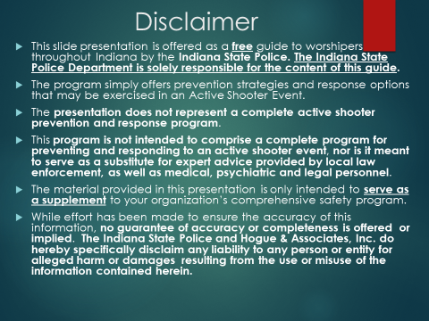
Slide # 2 Disclaimer and Introduction
Presenter’s Notes: The Indiana State Police are solely responsible for the content of this guide. It is strongly recommended that a “Comprehensive Threat Assessment” be conducted to determine the risks facing their unique place of worship. A “Comprehensive Safety Plan” should be developed that addresses the risks identified by a “Comprehensive Threat Assessment.” All individuals in the organization assessed must be educated on the “Comprehensive Safety Plan” as well as their role in the plan.
It may be stressed by the presenter that many “Threat Assessment Tools” may be found on the internet and in security manuals. However, the presenter should caution the audience that by selecting a “Threat Assessment Tool” without modifying it to meet the needs specific to their place of worship, may result in an “incomplete” assessment. Every environment has unique characteristics. With that in mind, the “Assessment Tool” must examine the unique needs of the environment to which it is applied. Parishioners know their environments better than anyone. In that light, the “Assessment Tool” should be modified by those familiar with the environment. They know the unique characteristics of the organization.
As an introduction, the presenter may wish to underscore the goal, intent and implication of the title of the “Unarmed Response to an Active Shooter Event.” The concepts discussed in this presentation may be applied to many of the settings in which we find ourselves as we go about our daily lives. Unfortunately, our workplace, the shopping mall, the theater, our place of worship, an athletic contest, etc. may all fall victim to an “active shooter attack.” With that in mind, this program offers prevention strategies and response options that may be applied to a variety of environments. The strategies are specifically focused on providing options to unarmed individuals caught in an active shooter event.
Finally, the presenter should share with the audience that more than 80 troopers have been trained across Indiana to provide the various versions of this program. Places of Worship, Schools, businesses, governmental agencies, etc. may schedule an “Unarmed Response to an Active Shooter Event” program in their respective venue through the Indiana State Police website. The process is simple. Individuals may go to the Indiana State Police website and “click” on “Active Shooter Preparedness” (on left side of the ISP home webpage), scroll down to the “Schedule a Program” subheading and this link will take them to a scheduling page. The Indiana State Police are solely responsible for the content of this guide.

Again, it is strongly recommended that a “Comprehensive Threat Assessment” be conducted to determine the risks facing their unique place of worship. The “Comprehensive Safety Plan” must reflect the findings of the Comprehensive Threat, Vulnerability and or Risk Assessment.”
Simply, the “Comprehensive Safety Plan” must address the risks identified by a “Comprehensive Threat Assessment.” All individuals in the organization assessed must be educated on the “Comprehensive Safety Plan” as well as their role in the plan.
Note: It may be noted that the “Comprehensive Threat Assessment” may also be referred to as a “Risk Assessment or Vulnerability Assessment.”

Slide # 3 Disclaimer and Introduction
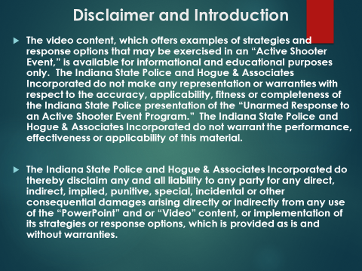
Slide # 3 Disclaimer and Introduction
Once again, the presenter’s must underscore that this program is offered by the Indiana State Police as a free resource to places of worship.
Presenter’s Note: The presenter must underscore that all resources posted on the Indiana State Police Home Page are offered without warranty. The Indiana State Police and Hogue and Associated Incorporated do thereby disclaim any and all liability to any party for any direct and indirect, implied, punitive, special, incidental or other consequential damages arising directly or indirectly from any use of the safety resources posted on the Indiana State Police Home Page, or implementation of the strategies, which are provided as is without warranty.
Slide # 4 The Active Shooter Definition
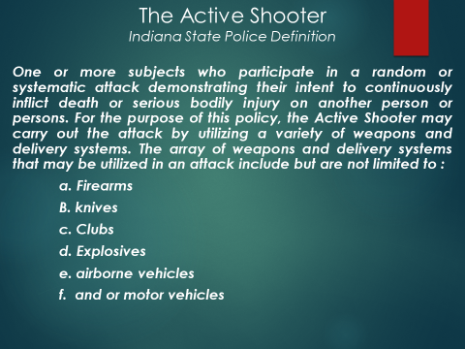

Slide # 4 Active Shooter Definition
This ISP definition of an active shooter event has been expanded to incorporate the recent variations noted in attacks carried out across the world. These attacks no longer have been confined to the use of a firearm. Knives, clubs, motorized vehicles, airborne vehicles, firearms, bombs, etc. have all been weaponized to carry out the assaults on a broad spectrum of victims.
Presenter’s Note: The presenter may wish to provide some examples of recent attacks utilizing various weapons of choice.

Examples:
1995 In Japan an Attack with Sarin Gas that killed 13 while injuring 143.
2010 In Nanping an Attack that killed 8 school children with a knife.
2016 A Brussels bombing in an airport and subway station that killed 33.
2016 In Nice, France, a cargo truck was utilized to kill 86 people while injuring 458 civilians.
2016 In Berlin, Germany an attack with a truck killed 12 and 56 injured.
2017 In Manchester, England an attack with a bomb killed 23.
2017 in London, England, an individual drove a motorized vehicle into a group of people. At least 50 people were injured, 4 fatally.
2017 In Barcelona, Spain a van attack that killed 13 people while injuring at least 100.
2017 In New York, eight people were killed and at least 12 injured when a rented truck was utilized to mow-down several individuals near World Trade Center.
2018 In Tajikistan, 2 Americans and Swiss citizens were killed when a car was utilized to run them down. 3 more were injured.
2019 In Japan, 2 individuals were murdered and 18 other were injured in a stabbing.
Presenter’s Note: Intelligence agencies indicate that what often happens abroad tends to happen in the United States. The following slide will provide some direction on the disbursement of active shooters attacks.

Slide # 5 FBI Active Shooter Incidents Chart
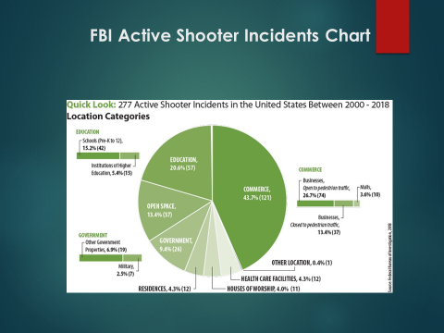
Slide # 5 The FBI Active Shooter Incident Chart
This chart clearly demonstrates that “active shooter events” occur in nearly every environment in which we live our daily lives.
Again, the prevention strategies and response options in the URASE program may be helpful in recognizing and responding to an “active attacker” event in a variety of settings.
Presenter’s Notes: The presenter may wish to underscore that worldwide sources expect attacks with various explosive, clubs, knives and motorized vehicles to increase. The point being that we must not just prepare for assaults with a firearm.

Slide # 6 Attacks on Places of Worship
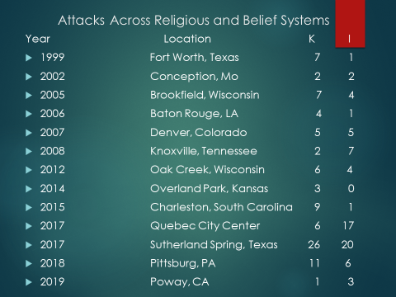
Slide # 6 Attacks Across Religious Belief Systems
This slide simply provides a brief overview of causalities across religions and belief systems. A brief overview of recent attacks on places of worship clearly demonstrates that no religion or belief system is immune from an “active shooter event.” This chart may underscore the scope of “active shooter events” across the United States. The presenter may wish to stress that the Indiana State Police model offers strategies that may be utilized in multiple environments. The strategies endeavor to offer salient direction on prevention strategies and response options to a variety of “active shooter” threats.
It is the intent of the “Unarmed Response to an Active Shooter Event” program to better prepare and equip individuals to respond to an “active shooter event.” The Indiana State Police believe that informed individuals are more likely to make appropriate choices. Making good decision and practicing response options are critical to the ISP “Unarmed Response to an Active Shooter Event” (URASE) program.
Again, the following information may underscore and illustrate that all of our places of worship are under attack. Note the attacks below have been carried out at Sikh Temples, Christian Churches, Jewish Synagogues, etc.
- Poway California 2019
- Pittsburg PA 2018
- Sutherland Texas 2017
- Quebec, Canada 2017
- Charleston South Carolina 2015
- Overland Park Kansas 2014
- Oak Creek, WI 2012
- Maryville, IL 2009
- Knoxville, Tenn. 2008
- Neosho, MO 2007
- Baton Rouge, LA 2006
- Fort Worth, Texas 2005

Presenter’s Notes: This chart clearly demonstrates that our places of worship are under attack. The individuals that perpetrate these horrific events have a variety of “twisted” and perverted motives. Regardless of the motives, these individuals typically develop over time while exhibiting very troubling behavioral indicators. It is critical to the prevention process to identify the potential shooter ahead of time. Once a shooter enters a place of worship, the likelihood of worshipers experiencing harm is very great. The next slide begins the discussion of early identification and intervention.

Slide #7 Prevention Strategies
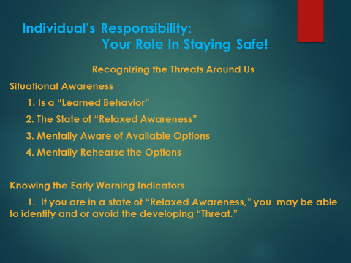
Slide # 7 Your Role In Staying Safe: Situational Awareness Prevention Strategies

In Slide # 7, the presenter’s, may introduce the concept of “Situational Awareness.” This concept is central to two critical components of the ISP “Unarmed Response to an Active Shooter Event” program. “Situational Awareness” serves as the foundation of “Threat Identification” and “Response Option.”
Simply, in order to identify the threats that may be developing around us, we must be aware of our environment. Likewise, in order to respond appropriately, we must recognized the conditions or “stimuli “of the attack. In Slide # 7, the presenter will introduce the concept of “Situational Awareness.”
As we go about our daily lives, we have a responsibility to participate in the process of “keeping ourselves safe!” We cannot totally rely on others to keep us safe! Many times, we go about our lives oblivious to the threats that may be developing around us.
Every day we see individuals literally colliding with others on the sidewalk while texting or worse while driving which may result in a serious accident.
Presenter’s Notes: To recognize developing threats, we must be aware of our surroundings. We can only recognize developing threats if we are aware of the actions of others in our environment. Typically, this “situational awareness” is not a natural behavior. We must learn to be “situational aware.”
Providing the audience with examples that we all see every day may be an effective method to underscore the teaching point (I.e. texting while driving and or walking on the sidewalk, parking our car in a dark lot with keys in the bottom of our pocket or purse as we return from shopping, etc. totally unaware of the threat that may be around us).
Situational Awareness
Presenter’s Notes: Situational Awareness is the foundation for recognizing the threats that may be developing in our environment, and as we will see later in the presentation, it also serves as the foundation for formulating the most appropriate “Response Option.”
Presenter’s Notes: The presenters should underscore that being aware of one’s surroundings is critical to identifying potential threats in time to formulate a proper response. Col. Cooper’s information may be utilized to demonstrate that individuals exist in various levels of awareness as they go about their daily lives.
The simple goal here is to underscore the importance of being aware of your surroundings! This is a learned behavior.

Levels of Awareness
White: Is often utilized to designate a level of awareness in which you are totally unaware of the environmental stimuli around you. You are in a relaxed and oblivious to what is happening in the environment around you.*
Yellow: In this state of awareness, you are slightly aware of your environmental stimuli (what is going on around you). This state is sometimes referred to as “relaxed alertness.” You have not identified an imminent threat, but you are monitoring the environment for potential threats that may develop. Basically, you are aware of the stimuli or conditions that exist in your environment and the actions of people around you. *
Orange: In this state of awareness, you are aware and have identified a potential threat. You begin to formulate potential response options based on the stimuli around you. You are developing response options to mitigate the developing threat. You have identified a potential threat and you have initiated an action plan mitigate the threat.*
Red: Here you are in the fight” or “flight” mode. You are taking action based on the stimuli of the event to neutralize the threat. You may be exercising an option to engage the threat and take the action necessary to mitigate the threatening situation.
*Col. Jeff Cooper’s Awareness Color Code System
Presenter’s Notes: Our goal is to maintain a state of “relaxed awareness” in our daily lives. This seem easy but it takes a constant mental effort. In this state we will be able to recognize potential threats in sufficient time to formulate an appropriate response option. This is a learned behavior.
ISP urges you not to be paranoid! Be aware of your surroundings!
Presenter’s Notes: This concept will be repeated as we discuss the “ISP Response Options” in the Indiana State Police “Unarmed Response to an Active Shooter Event” model. We must be aware of our environment to recognize the developing threats around us and to execute the appropriate response option.
You must be “Situationally Aware!”

Slide # 8 Early Warning Indicators
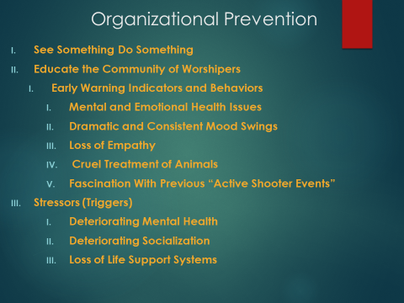
Here, the presenter underscores that everyone has a responsibility to participate in securing their respective environment. Information is key in preventing “active shooter events.” Individuals perpetrating these events often display very specific “Early Warning Indicators.” Typically, “attackers” share their intent with others and develop in plain sight.
Presenter’s Note: Concern increases dramatically as the “Early Warning Behaviors” begin to occur in combination. The more the various behaviors manifest themselves, the greater the concern. No solitary behavior has been identified as the singular cause of an active shooter event. Typically, the developing shooter exhibits several of the indicators. We must understand that shooters typically develop over time.
The “Early Warning Signs/Behaviors/Indicators” are nearly always apparent to family, friends, acquaintances, etc.
Their actions foreshadow the horrific event they are contemplating. Acquaintances, family members, friends, etc. simply fail to take action. The presenter should endeavor to stress the importance of taking action.

Mental Health
Presenter’s Note: It should be made clear that not all individuals that suffer from mental health issues become active shooters. The point that presenter’s may wish to underscore is that when mental health issues are present in combination with other “Early Warning” Indicators, the need for assistance dramatically increases.
Since school shootings have been studied more completely than other mass shootings, presenters may wish to utilize several high profile school shootings to underscore the frequent presence of mental illness as a potential contributor to the development of active shooters.
Mental Health Issues
Presenter’s Notes: Potential shooters may suffer from serious emotional and mental health issues. That is not to say that all individuals suffering from these maladies will develop into active shooters. An irrational mind may be the fertile origin for the development of an “active shooter.” The “unhealthy mind” may account for the lack of empathy, compassion and restraint exhibited by many active shooters. These emotional factors are often absent in the individuals that carryout these horrific events.
Presenter’s Notes: The presenter may wish to utilize school attacks to illustrate the role that mental illness may play in “active shooter events.” In the follow paragraphs, the relationship between mental health and the development of active shooters in the school setting is underscored.

Columbine
Columbine stands as one of the most famous school shooting events in the United States. Unfortunately, the Columbine tragedy is often viewed as a contributing factor in many of the more recent school shootings across the U.S.
Shooters often view the notoriety heaped on the Columbine shooters and wish to capture the same infamy. The Columbine perpetrators took the lives of 12 students and one teacher. The horrific event ended with the suicide of the two shooters. Twenty-one additional people were injured during the attack.
Presenter’s Note: The Columbine shooters demonstrate many of the “Early Warning Indicators” often exhibited by developing shooters. For example both shooters were arrested for breaking into an SUV in January of 1998. A full year before the Columbine tragedy. As a result they were placed in a diversionary program. The program called for the perpetrators to attend regular meetings with mental health professionals. In addition, they were required to participate in a community service program. They completed the community service program and their criminal records were expunged. During their community service period, the pair constructed numerous explosives and assembled an arsenal of weapons. During this time the two penned and posted numerous written documents and videos setting out their intent.
Presenter’s Notes: Reports have surfaced alleging that two security advisors constructed a security plan nearly nine months before the Columbine attack. In general terms, the advisors recommended that school administrators hold a conference with parents and law enforcement upon learning of potential student related threats. It has been alleged that Columbine officials did not comply with the recommendations.
Many mental health professionals have studied the shooters. One of the extensive studies was conducted by the FBI. While some have disputed some of the FBI’s conclusions, the FBI’s work stands as one of the most extensive studies of and active shooter event.
The FBI study convened a taskforce in Leesburg, Virginia. The inquisitors included several clinical psychologists (i.e. clinical psychologist “Special Agent” Dwayne Fuselier and celebrated Michigan State University psychiatrist Dr. Frank Ochberg).
Presenter’s Notes: The FBI’s inquiry determined that one of the shooters was a depressive. The National Alliance on Mental Illness describes a “depressive disorder” as a serious mental health condition. While other mental health professionals term “major depressive disorder” as a serious “medical illness.” With respect to the second shooter, the FBI suggested a more definitive finding. The findings suggested that he was a “brooding psychopath.” Their findings suggest that he displayed the classic lack of empathy, narcissism and unconstrained aggression that is often exhibited by a psychopath. He premeditatedly lied and enjoyed the deception. By his acts of taunting his victims during the shooting, he graphically demonstrated the lack of empathy that characterizes the true psychopathic.
The FBI psychiatrists also offer an interesting perspective on the shooter’s intent. The FBI’s commission suggests that the shooters would often cite the 1995 Oklahoma City Bombing as an inspiration. The shooters seem to view the casualty count as a goal or target. The commission suggests that the Columbine attackers had an even darker motive than the wholesale slaughter of students and teachers. The horrific slaughtering, of their fellow students and teachers, was just a means to shock the world. They wanted to create death and destruction on a monumental scale. They wanted to leave their mark on a world they despised. They wanted infamy on a historic scale.

Red Lake
The Red Lake Indiana Reservation shootings occurred on March 21, 2005, in two different locations. The shooter killed his guardian (his grandfather) and a friend in his home. The shooter killed seven people (five students, an unarmed security guard and a teacher) at the school while wounding five others that survived.
Presenter’s Notes: Reports allege that the shooter had attempted suicide and had received psychiatric care. Various sources indicate that the shooter was under treatment for depression, and had been prescribed Prozac as an anti-depressant.
It has also been reported that he posted extremely violent content on the internet. It has been reported that the shooter created two violent “flash animations” for the flash website “Newgrounds,” using an alias. Allegedly, in the animation entitled Target Practice, he features a character who murders three people with a rifle, blows up a police car with a grenade, and kills a “Klansman.” In addition, it is reported, that the animation terminates with the suicide of the shooter. A second “flash” animation, allegedly created by the shooter, depicts the killing of a man by eating his head.

Virginia Tech
A student at Virginia Tech University shot and killed 32 people and wounded 17 others with two semi-automatic pistols.
Presenter’s Notes: At three years of age, the shooter has been described as a shy and frail individual wary of physical contact. As a junior high school student, it was reported that the shooter was under the care of a therapist for an anxiety disorder and depression.
Sources report that the shooter remained under the care of a therapist throughout his high school years. The shooter’s speech difficulties may have made him a target for bullying by his classmates.
Upon enrolling in Virginia Tech, it has been reported that the shooter did not seek assistance for his “Exceptional Learning” issues.
Presenter’s Notes: The shooter’s mental state deteriorated as he continued his studies at VT. Post shooting reports indicate that the shooter abhorrent behavior seem to escalate. Educators at VT later indicated that the shooter’s writings became more troubling as he continued his studies. Reports suggest that the shooter’s behavior became so disquieting that his teachers encouraged him to seek counseling. Reports have surfaced that indicate the shooter was reported for stalking and harassment of two of his fellow female students. Several media sources suggest that the shooter was declared mentally ill by a Virginia justice and ordered to seek “treatment” as an outpatient.
Sandy Hook Elementary
A 20-year-old male shot and killed 26 people in Sandy Hook elementary school. The deceased include 20 children between the ages of six and seven along with six adult staff members.
Reports underscore that the “Sandy Hook” shooter demonstrated developmental difficulties early in life. He was referred to and assisted by the New Hampshire Family-Centered Early Supports and Services (FCESS) program. This agency is a designated non-profit that provides services for children from birth through three years of age. The program serves children who are experiencing significant developmental delays.
As a result of the shooter experiencing communication, sensory difficulties, socialization delays, and repetitive behaviors, the specialists at the “New Hampshire Birth to Three intervention Program” referred the developing shooter to the “Exceptional Learner” preschool program.
In elementary school, the shooter was diagnosed with a sensory-integration disorder (SID). Children suffering from this malady have trouble handling the basic sensory stimuli. Examples of these stimuli include but are not limited to taste, touch, sight, sound, smell, etc. Sensory integration disorder (SID) is a neurological disorder that results from the brain's inability to process and integrate certain information received from the body's basic sensory systems.
As a result of significant anxiety issues, reports indicate that the shooter was placed on “Homebound” instruction and study during his junior high years. Records indicate, that the shooter was diagnosed with “Asperger Syndrome” and “Obsessive-Compulsive Disorder” (OCD) during his early teens. He was prescribed medication which he did not tolerate well. As a result, the medication was discontinued.
Presenter’s Note: Presenters should make it clear that “Asperger Syndrome” according to experts is a developmental disorder and not a mental illness. The violent behavior demonstrated by the shooter is generally not seen in those that are dealing only with this developmental disorder. It has been recently reported that individuals familiar with the shooter expressed concern that mental health professionals may have missed other undiagnosed mental disorders. Interestingly, it has been reported that none of the psychiatrists he saw identified any troubling signs of violence in his demeanor. It has been reported that no care from mental health professionals was provided to the shooter after 2006.
The preliminary investigation discovered that the shooter was fascinated with previous mass shootings (i.e. Columbine High School, Virginia Tech, Northern Illinois University, etc.). In his bedroom authorities found writings depicting an attack by a man who shot school children in 1891. In his computer, authorities discovered movies dealing with school shootings and self-produced pictures of the shooter pointing a firearm at his head.
The shooter never permitted anyone, including his mother, to enter his bedroom. Meals, laundry, etc. were left outside his bedroom door. He covered the windows with plastic to block out sunlight. Reportedly, for months previous to the shooting, he only communicated with his mother via email. The shooter appeared to be isolated from the world around him. His contact with the outside world seems to be limited to the internet.
It has been reported, that a forensic investigation of his computer indicated that he demonstrated a propensity for violent video games. It appeared that his cyber contact and interaction was primarily focused with others on the internet that shared his obsessive interest in wholesale slaughter and murder.

Northern Illinois University
Presenter’s Notes: It has been reported that the shooter was treated for mental illness at a psychiatric center. He enlisted in the military and was discharged after serving only a few months for failure to disclose the history of psychiatric issues. Allegedly, the shooter was nicknamed “strange Steve" by acquaintances. Reportedly he had a profound fascination for a sadistic killer in a popular horror film and for the Columbine massacre. Allegedly, a friend reported that the shooter was taking psychiatrist prescribed Prozac, Xanax and Ambien. Reports indicate the shooter allegedly had a history of mental illness and had attempted suicides. News sources also reported that a preliminary investigation determined that the shooter held an extreme interest in high profile school shootings.
It was alleged, that the shooter mailed packages to a friend that contained a gun holster and ammunition, a book on serial killers, and a copy of the “The Antichrist by Friedrich Nietzsche.” The alleged mailings may have been posted just prior to the attack.
Umpqua Community College
Presenter’s Notes: After only five weeks of basic training, the shooter was discharged from the U.S. Army. It has been reported that the shooter was discharged as a result of a suicide attempt. A year after his discharge, sources report that the shooter graduated from a school for “Exceptional Learners.”
The following year he enrolled in a two year community college. A few days before the attack, the shooter posted an article on the Sandy Hook attack. Sources allege that the shooter posted a message before the attack warning individuals in the northwest not to go to school on the day of the shooting. A “Los Angeles Times” article quoted a law enforcement source as suggesting that the shooter may have been suffering from “long-term mental-health related issues.”
In writings reviewed after the shooting, it became apparent that he had studied previous mass shootings. It appeared that he coveted the notoriety heaped on previous mass killers.
Again it was alleged, that he wrote, "Other people think I'm crazy, but I'm not. I'm the sane one.” Reports indicate that he wrote he would be "welcomed in Hell and embraced by the devil.”
Stoneman Douglas
Presenter’s Notes: Several media sources reported that the shooter’s behavioral problems are documented throughout his educational career. Media sources reported that his abhorrent behavior accelerated as he progressed through the educational system. News media reports suggest that the Florida Department of Children and Families had been alerted to posts by the shooter on Snapchat. Allegedly, the postings related to the shooter cutting his arms and expressing an interest in buying a gun and killing people. It was reported that after visiting and questioning (the shooter) at his home, the agency determined he was at low risk of harming himself or others. The “Early Warning Indicators” seemed to be abundant.
Reports allege that educators viewed the shooter as a danger to students and staff. It has been alleged, that he used profane language, drew naked sick figures showing sexual body parts, made gestures pretending to masturbate in class, bragged about killing his cat, demonstrated a fascination for violent video games, stated he hoped “Security would die,” shouted F*** at his teacher, held an obsessive fascination for weapons, etc..
It has been reported that local and federal agencies missed some of the “Early Warning Indicators” as well. After the shooting, the F.B.I. confirmed that it failed to investigate a tip called into a hotline by a person familiar with the shooter. The tip indicted that he owned a gun and seemed intent on killing people. After the shootings, reports surfaced that the local police had been called to the shooter’s residence on several occasions for domestic disturbances.
Reports suggest that the officials at Marjory Stoneman Douglas High School were also concerned about his behavior. Disciplinary records demonstrate that the shooter had a long history of disturbances including fights with staff members. Reports also indicate that he was referred for a “threat assessment” in the early months of 2017.
Santa Fe
News publications (i.e. Los Angeles Times and New York Times) reported that the shooter’s social media site contained photographs that displayed clothing and badges exhibiting concerning phrases and symbols. (Examples included i.e. "Born to Kill.”) Another publication (Evening Standard) reported that the shooter posted photographs of weapons.
Presenter’s Notes: Reports out of Texas indicate that recent developments in the accused Santa Fe shooter’s legal proceedings have been placed on hold. It has been reported that three psychiatric experts evaluated the accused shooter and came to the conclusion that he was “incompetent to stand trial.” The shooter had been charged with capital murder in the Santa Fe High School shooting. As a result of his psychiatric evaluation he has been transferred to a mental health facility. Privacy concerns prevented the specific diagnoses and findings from being shared.

In the recently released “Protecting America’s Schools: A U.S. Secret Service Analysis of Targeted School Violence” report, the Secret Service study of 2019 asserts:
Presenter’s Notes: “Most attackers had experienced psychological, behavioral, or developmental symptoms: The observable mental health symptoms displayed by attackers prior to their attacks were divided into three main categories: psychological (e.g., depressive symptoms or suicidal ideation), behavioral (e.g., defiance/misconduct or symptoms of ADD/ADHD), and neurological/developmental (e.g., developmental delays or cognitive deficits). The fact that half of the attackers had received one or more mental health services prior to their attack indicates that mental health evaluations and treatments should be considered a component of a multidisciplinary threat assessment, but not a replacement. Mental health professionals should be included in a collaborative threat assessment process that also involves teachers, administrators, and law enforcement.”*
*(“Protecting America’s Schools: A U.S. Secret Service Analysis of Targeted School Violence” the report was authored by the staff of the U.S. Secret Service National Threat Assessment Center –NTAC)
Dramatic and Consistent Mood Swings
Individuals that exhibit dramatic and consistent mood swings without a rational reason or causation may be in need of assistance. Nearly everyone experiences mood swings to some degree. However, extreme mood swings may be characteristic of mental illnesses such as personality disorders, intermittent explosive disorder (IED), bipolar disorder, schizoaffective disorders and other mental health maladies. When an individual’s behavior is typified by impulsivity, recurrent aggressive behavior, unwarranted hostility, and frequent aggressive outbursts, we must view this as a clear signal that assistance is needed.
Again, no single causal factor has been identified. When these issues occur consistently and in combination the level of concern elevates.
Loss of Empathy
One of the Columbine shooter is often referred to as a psychopath. He demonstrated no empathy and exhibited behavior in which he relished violating, exploiting and manipulating others. Individuals that exhibit this type of behavior send a clear signal that an intervention and assistance is a must. These individuals exhibit antisocial behavior and lack remorse and or empathy.
Cruel Treatment of Animals
This behavior is a huge “red flag.” These individuals have lost the connection with the basic human emotion. Individuals that conduct this behavior, brag about it and or openly discuss the practice are in need of immediate assistance.
Fascination With Previous “Active Shooter Events”
It is not uncommon for developing “active shooters” to hold a deep seated admiration for previous active shooters. They see the notoriety heaped on these individuals and they crave the same.
Triggers
Typically, individuals that carry out attacks on institutions experience a stressor or trigger that “sets” them off. It may be simple as going off their medication. It can be as complex as deteriorating mental state. The loss of their social and or familiar support system may also be a stressor that triggers abhorrent behavior.
See Something Do Something!
Presenter’s Notes: Again, we must underscore that the saying of “See Something, Say Something” has merit, but “See Something, Do Something” is preferred. If we have concern, we need to follow up with our concerns.

Slide # 9 What Do WE Do With The Information?
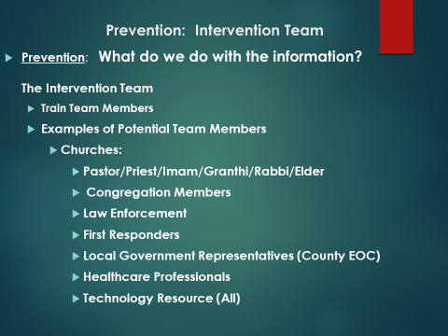
Slide # 9 What Do We Do With The Information?
Presenter’s Notes: The Intervention Team, which is sometimes referred as the “Threat Assessment Team,” and or the “Assistance Team” is a group of individuals selected from the community of worshippers and community at large to serve as a monitoring group.
It is critical to create a monitoring vehicle (Intervention Team) that assists in gathering information and provides an avenue to resources for facilitating an intervention. The Intervention Team serves as a point of contact for individuals to share information. All too often, after an “active shooter event,” Indiana State Police troopers hear individuals say that they, “I knew something was wrong but they did not know who to tell.” In discussion, troopers also hear, “What do I do with concerns?”
The “Intervention Team” is a tool that may provide a “bridge” to convey information from concerned individuals to resources that may be utilized to garner assistance for individuals displaying the “Early Warning Indicators.”
The “Intervention Team” may be selected from a cross-section of members of the religious community. The participants must be trained. Their role is not to serve as a therapist but to assist in monitoring the religious community. These members also serve as a conduit to convey information to the appropriate resource. The resource may be leaders of the religious community, law enforcement, health care professionals, etc. The “Intervention Team” must identify resources and provide avenues to report concerns in a confidential manner. It must be easily accessed.
Again, it may be beneficial to once again underscore “See Something Do Something”! We often find that individuals were aware of concerns, early warning behaviors, etc. but did not know what to do with the information. Following up on concerns we have shared is recommended. Simply telling someone and hoping they take action is not enough.

Slide # 10 A Critical Component of the ISP Response Options Program:
Take Action
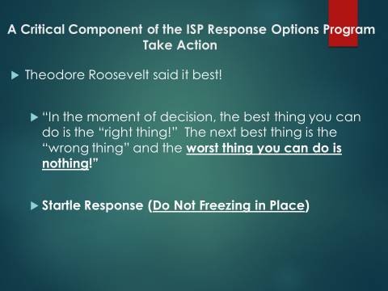
Slide # 10 A Critical Component of the ISP Response Options Program:
Take Action
Presenter’s Notes: Just like the “Prevention Component,” individuals will only be able to formulate the most appropriate response if they recognized the threats around them. To recognize the threat, we must first be aware of your surroundings. Most individuals go about their daily lives unaware of the threats that they may face. Earlier we discussed the concept of being aware of the threats that are developing around us. Here again it is critical that we apply Cooper’s concepts to monitor our environment.
IN ORDER TO MAKE THE MOST APPROPRIATE RESPONSE WE MUST MONITOR, RECOGNIZE, ANALYZE AND RESPOND TO THE THREATS IN OUR ENVIRONMENT.
We do not want the congregation to live in a state of paranoia but live in a state of awareness. ISP suggests that individuals develop a “Health Degree of Suspicion.”
This is an opportunity to once again emphasize that “Freezing in Place” is a typical response. “Freezing in Place” is a common and or perhaps a “natural” initial response. However, if you are prepared and you have planned your response you are much more likely to respond appropriately. By planning, practicing and drilling on the response options you are more likely to emerge more rapidly from the “frozen” state.
Most individuals have heard of the “fight or flight” response. It postulated that the “frozen” state most often occurs when you determine the situation is so overwhelming that you cannot flee or successfully fight off the threat.
Planning, practicing, training and drilling will dramatically increase your chances of emerging from the initial “Frozen State” with an appropriate response. The response you elect to exercise will depend on the “external stimuli” of the event (i.e. location of the shooter, type of weapon, proximity to an exit, proximity to a predetermined safe area, etc.). Once again, the response option that is selected will be determined by the circumstances or “stimuli” of the event.

Slide # 11 The Escape Option
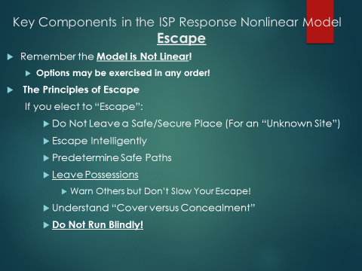
Slide # 11 ESCAPE
It is critical for the presenter to emphasize that the ISP Response Options Model is nonlinear. While the ISP presentation introduces the “Response Options” as Escape, Lockdown, Fight, the options may be exercised in any order (and repeated in any order).
The Escape component of the model stands as one of your best options if you have a safe path to a secure area. To exercise this option appropriately, you must have a secure path to a predetermined safe area. Do not run blindly!
Presenter’s Note: A valuable teaching component may be found in an event that occurred over twenty years ago in Jonesboro Arkansas. In this attack, an 11 and 13 year old pulled a fire alarm, with the intention of evacuating students and staff into a “killing field” to facilitate an active shooter attack.
Escaping via a safe path to predetermined secure area is a critical component in the “Escape Option.” In order to determine the best escape path, individuals must locate the shooter. It is often difficult locate the shooter by the sound of gun fire. In a large building, a discharged firearm may sound like a book being dropped or the pop of fireworks.
Presenter’s Notes: Remember you have options! It is important to note that leaving a secure site for an unknown is not recommended. Lockdown is an excellent option if you have access to a secure lockdown site.
ISP advises individuals to mentally rehearse various escape paths. The best safe paths must also provide cover if possible. The presenter may wish to explain the concept of concealment versus cover. As individuals exercise the “Escape” option, they must run intelligently by taking a safe path with as much cover as possible.
Again, concealment hides while cover may stop a projectile.
Slide # 12
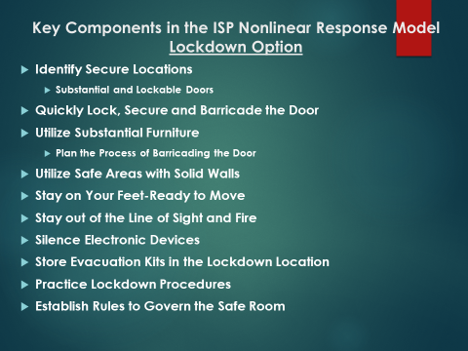
Slide # 12 The Lockdown Option
When considering the “Lockdown” option, it should be stressed that planning must take place. The “Safe Areas” must be established ahead of time. You must be able to secure the door quickly. Equipment must be determined ahead of time that may be utilized to barricade the door and serve as weapons. Supplies for supporting the population of the “safe area” must be stored, secured and updated. The supplies in the “Safe Area” must be developed to support the specific population that will inhabit the “Safe Area.” A general evacuation kit may not support the population of the safe room. You may wish to consult with local EMT, physician, etc. to establish the contents of the evacuation kits to store in the safe room.
As is the case with all options, planning, drilling and practicing the components of the “Lockdown” option are critical to an appropriate response. Individuals must have primary and secondary safe paths to the “Lockdown” sites. These will be different depending on their locations when the event begins.
Lockdown sites may be strategically located throughout the facility to enable individuals to access the areas from a variety of locations. Finally, it is critical to have predetermined rules that govern the safe area. The person to be in charge in the safe area must also be determined ahead of time.
The basic operational procedures (when to open the door, how to coordinate the fight option, etc.) must be clear to the person in charge as well as the population of the “safe area.” A backup must be selected in the event the coordinator is absent.
Slide # 13 The Fight Option
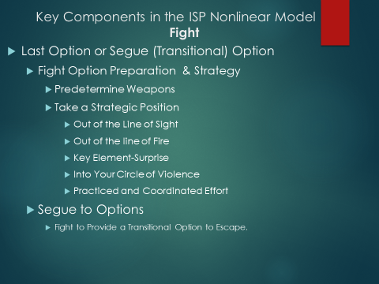
Slide # 13 The Fight Option
It must be made clear that this option is often viewed as the option you may exercise if no other option is available. That is true. However, it must be underscored that the ISP options are nonlinear! You may fight and then “Escape” or “Lockdown” and or return to the “Fight” option.
Remember the “stimuli” of the event determine the best response option to exercise! Again, the stimuli of the event may be viewed as the location of the shooter in relation to your position, the availability of a lockdown site, the type of weapon possessed by the shooter, the availability of an escape path, etc. Simply the conditions of the attack are the stimuli of the event.
Key strategies to successfully carrying out the “Fight Option” are:
- Planning
- Predetermining Weapons
- Strategically Positioning Yourself for the Attack
- Bringing the Attacker into your “Circle of Violence.”
Presenters will need to explain the “Circle of Violence” concept. In the fight option, you goal is to bring the threat near enough to you that the weapon you wield is effective.
As is the case with all options, you must plan and practice the “Fight Option.” It will be most effective if it is a coordinated effort.

Slide # 14 Concept Review in Preparation for the Practical Application Videos
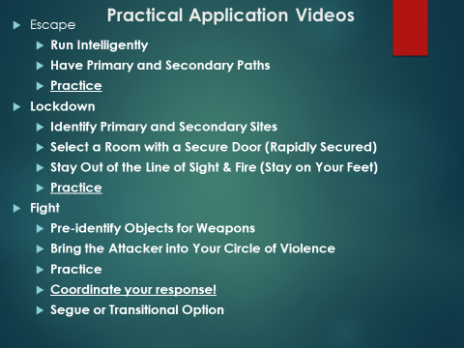

Slide # 14 The Practical Application Videos
Here it is critical to briefly revisit the components of the ISP Nonlinear Response Model.
Escape:
a. Do not run blindly (Escape Intelligently)
b. Have Primary and Secondary Paths
c. Practice the Escape
Lockdown:
- Identify and publish safe site locations
b. Select a location that can be secured
c. Stay out of the line of sight and fire
d. Establish the person to be in charge (with backup)
e. Establish rules for the operation of the ‘Safe Area’
f. Practice your paths to the lockdown site
Fight
a. Pre-identify objects and weapons
b. Bring the attacker into your “Circle of Violence”
c. Coordinate your efforts
Slide # 15 The A.L.E.R.R.T. VIDEO

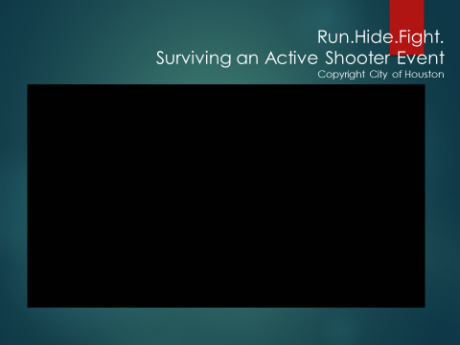
Slide # 15 Run. Hide. Fight.
HOUSTON CITY COPYRIGHT VIDEO
It is important to direct the audience to watch the Copyrighted Houston City Video and keep in mind the principles discussed in the “ISP Unarmed Response to an Active Shooter Event” program.
As the audience views the video, participants should be able to identify many of the ISP principles discussed in the presentation of the “ISP Unarmed Response to an Active Shooter Event” program.
Remember to Underscore:
Presenter’s Note: This video is based on the Run, Hide or Fight program. The presenter should explain that the ISP Model is different. An in depth explanation of the differences between the two models may be necessary.
Presenter’s Notes: The presenter may wish to ask participants to offer their views on how the “ISP URASE Model” differs from the A.L.E.R.R.T. model.
Note: ISP puts prevention on the frontend of the model. The Indiana State Police model prefers prevention to response. The ISP model is “Nonlinear.” The ISP Model expands each step in the traditional Run, Hide or Fight, program with specific strategies that results in the “Prevention, Escape, Lockdown or Fight Model”

Slide # 16 Video Discussion Questions

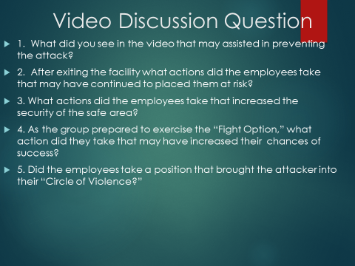
Slide # 16 Video Discussion Questions
The questions above may assist in focusing on specific principles in the video.
- What do you see that may have assisted in preventing the attack?
- Control the Entryway.
- Increased Participation on behalf of the Security Guard.
- Possible Prevention Via Early Identification of the “Early Warning Signs.”
- Increased Vigilance on Behalf of the Employees.
- After exiting the facility what actions did the employees take that may have continued to place them at risk?
- Individuals evacuating need to be a greater distance from the facility (approximately 300 to 500 feet).
- What actions did the employees take that increase the security of the safe area?
- One employee locked the door (and barricaded the door).
- As the group prepared to exercise the “Fight Option,” what actions did they take that may have increased their chances of success?
a. They prepared as a group with improvised weapons.

Slide # 17 Arrival of Law Enforcement
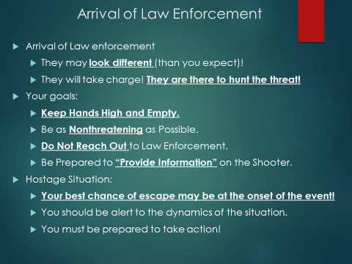

Slide 17 Arrival of Law Enforcement
We often have the mindset that law enforcement officer will always be dressed in full uniform. However, in an active shooter/attacker event, the call for help will “go out” and law enforcement will respond from everywhere. The response will include both on duty and off duty officers. With that in mind, law enforcement officers may respond in a campaign hat, vest, badge and shorts! The point being that they will not take the time to get dressed. Their mission is clear! They seek to takedown the shooter. The old sayings, “Time is of the essence.” and “Time saves lives.” definitely hold true.
The goal of arriving law enforcement is to “takedown the shooter.” They are not there to render first aid but to end the “carnage” by preventing additional injury and loss of lives. In order to do that, law enforcement must rapidly identify and locate the threat! Our role in assisting law enforcement is clear. We must immediately assist law enforcement in determining that we are not the threat. If we are able to provide a description of the shooter, an approximate location or type of weapon, this will assist arriving law enforcement greatly.
Law enforcement typically has less than a second to determine if we are the victims or the threat. To assist them, we must keep our hands high and empty. Do not reach out or touch arriving law enforcement.
On the ISP website, information developed by 911 operators will aid victims by giving them examples of the information arriving law enforce will need to locate and identify the shooter/attacker.
In hostage situations, the beginning of the event is the best time to execute your escape plan. If escape is not an option, do not escalate the situation with your behavior. You must try to remain calm and be vigilant for any opportunity to escape. If the hostage situation evolves into a takedown situation, you must present yourself in a nonthreatening manner to arriving law enforcement.

Slide # 18 Appendix I

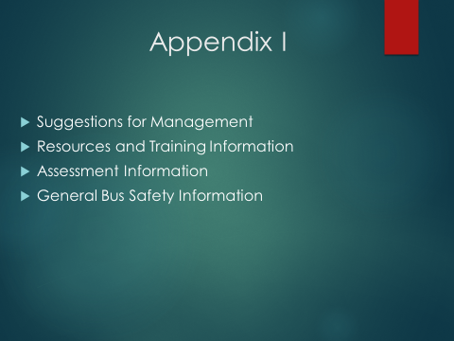
Slide # 18 Appendix I
This section may serve as a basic resource for “Places of Worship.”

Slide # 19
Management’s Efforts to “Maximize the Security of Our Places of Worship
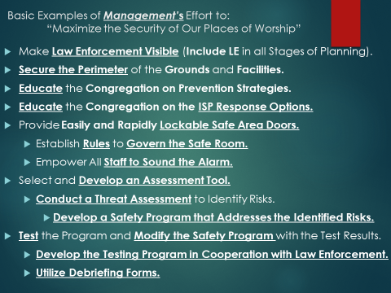
Slide # 19 Management’s Efforts to “Maximize the Security of Our Places of Worship”
Presenter’s Notes: Places of Worship face unique challenges. This section of the ISP “Unarmed Response to an Active Shooter Event” program focuses on several basic strategies that the govern body or governing council may wish to consider.
“In 2018, 16,039 law enforcement agencies participated in the Hate Crime Statistics Program. Of these agencies, 2,026 reported 7,120 hate crime incidents involving 8,496 offenses.” *
Religious bias (Based on Table 1.)*
Hate crimes motivated by religious bias accounted for 1,550 offenses reported by law enforcement. A breakdown of the bias motivation of religious-biased offenses showed:

57.8 percent were anti-Jewish.
14.5 percent were anti-Islamic (Muslim).
4.1 percent were anti-Sikh.
3.8 percent were anti-Catholic.
3.2 percent were anti-multiple religions, group.
2.7 percent were anti-Other Christian.
2.5 percent were anti-Protestant.
2.1 percent were anti-Eastern Orthodox (Russian, Greek, And Other).
0.9 percent (14 offenses) were anti-Hindu.
0.6 percent (10 offenses) were anti-Buddhist.
0.6 percent (9 offenses) were anti-Mormon
0.6 percent (9 offenses) were anti-Jehovah’s Witness.
0.4 percent (6 offenses) were anti-Atheism/Agnosticism/etc.
6.2 percent were anti-other (unspecified) religion.
* 2018 Hate Crime Statistics from the Department of Justice (Federal Bureau of Investigation)
Making Law Enforcement Visible
Presenter’s Notes: In the view of the Indiana State Police, one of the best deterrents to a potential active shooter attack is to have a sworn, uniformed and “Academy” trained law enforcement officer present and visible on site at your place of worship. By having these individuals on your location, you immediately “harden” your place of worship. These trained individuals may come from your group of worshippers. If this is possible, the investment is certain money well spent.
Secure the Perimeter of the Grounds and Facilities
A variety of natural and constructed barriers may be utilized to increase the security of the grounds. Many places of worship fail to secure all perimeter doors with the exception of a main entryway. In this way, worshiper traffic can be directed to a single access point and can be monitored more easily. With the single access point, arriving individuals may be monitored as they approach the entryway. With the single access point, worshipers may be more thoroughly vetted as they approach and enter the building via a controlled entryway. Some facilities have elected to install an electronic monitoring systems that is staffed during time the facility is in use.
Secure Your Place of Worship
- Bring “Academy Trained” and uniformed law enforcement into the workplace and making them visible!
- Conduct a Perimeter Audit of the Facility
  - Secure the perimeter of the grounds.
  - Secure the perimeter of the facility.
  - You may elect to utilize electronic access systems.
  - You may elect to select electronic monitoring systems.
  - Systems are only effective if all worshippers follow the security procedures.
    - Educate everyone on the security procedures.
3) Repeat the training sessions regularly for all worshippers and staff.
a) In securing the perimeter of a facility the most common mistake is for employees to open and or hold perimeter doors visitors, friends, etc.
1.) This practice in itself defeats any and all “Perimeter Security” measures.
Management must commit financially to making safety a priority! The establishment of key personnel positions is critical to this process. Training and drilling employees is an ongoing process. All of these factors stand as the responsibility of the governing body of each house of worship.

Slide # 20 Suggestions for the Establishment of Basic Safety Personnel
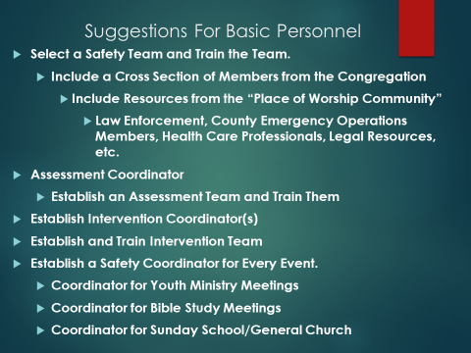
Slide # 20 Suggestions for the Establishment of Basic Safety Personnel
Presenter’s Note: Establishing the basic personnel structure is critical to increasing the security of your organization. The information below is a guide that may assist in that process:
- Safety Team (Coordinator)
  - Directs the Comprehensive Team
2.) Develop Comprehensive Safety Team
a. Members Selected from a Cross Section of the Worshippers
3) Assessment Team (Coordinator)
b. Directs all process of the Assessment Team.
4) Select, Train and Develop the Assessment Team.
a. This team is responsible for selecting, modifying and developing a “Comprehensive Threat, Vulnerability or Risk Assessment Instrument.”
1) An assessment tool must be developed and modified to meet the specific needs of the organization for which it is intended to assess.
5) Develop a Comprehensive Assessment Team (Select a Cross Section of Worshipers to Serve).
1) These individuals assist in the identification of threats by applying the Assessment Tool organizations environment.
6) The “Assessment Process” is intended to identify the threats facing the organization and serve as the foundation for the “Safety Plan.”
7) These individuals also assist in the development of remedies or solutions to the identified threats.
a) The program of remedies is the often called the “Comprehensive Safety Plan.”
b) Remember the Goal of the “Assessment Team!”
1) Goal is to develop a “Comprehensive Plan” that address the risks found in the “Comprehensive Threat, Vulnerability or Risk Assessment.”
2) The “Assessment Team” must develop a “Comprehensive Safety Plan” that address the threats. identified by the “Comprehensive Team” in the “Assessment.”
8) Select an Intervention Team (Coordinator).
9) Develop an Intervention Team (Utilize a Cross Section of Worshippers).
a) The individuals that serve on this team may bring resources to the intervention team. You may need to go to the community at large to obtain the need resources (i.e. mental health professionals, law enforcement, social workers, etc.).
b) Monitor Behavior of the Religious Community by Establishing an Intervention or Threat Assessment Team.
b) Utilize Intelligence from the Intervention Team to assist those in need of help before they develop into a threat.
c) The goal of the Intervention or Assistance Team is to prevent threats.
d) Create the personnel structure (Examples) and Train the Members
1) The Intervention Team:
a) Organization Leadership
b) Individuals from the Membership
c) Law Enforcement
d) Social Workers
e) Mental Health Professionals
f) Governmental Emergency Management Personnel

10) Create a Crisis Management Team Coordinator (Chairs the Crisis Management Team)
11) Develop The Crisis Management Team
1.) Select from a Cross Section of Religious and Community at Large
a) These individuals must have the resources and training to manage a crisis.
b) This “Team” must have the resources to deal with a broad spectrum of crisis events.
1.) Crisis Counselors Law Enforcement, Grief Counselors, Religious Leaders, County EOC Staff, Emergency Management Staff, Red Cross, Legal Advisors, etc.
2.) It is advisable to establish (Grief Counselors, EOC Staff, Red Cross, Legal Advisors, etc.) contacts ahead of time and create a standing committee.
12) Develop a “Continuing Worship Plan”
1.) It is difficult to imagine but the facility may be a crime scene. An alternate site may be identified to continue to serve the needs of worshipers.
13) Train, Test and Drill on the Program.
1.) Once the plan has been developed an ongoing training program must be developed to continue to prepare and improve the safety of the organization.
2.) The organization must continue to modify the “Comprehensive Plan” based on the results of the Test and Drill Process.”
14) Utilize Debriefing Forms.
1.) These forms are simple four line forms that record any event that may threaten the safety of the organization (regardless of how minor):
a.) Examples:
1.) A heated argument with a neighbor over property boundaries.
2.) A heated argument over religious belief systems.
3.) A heated between worshipers and protesters.
2.) Modify the Plan Based on the Information Collected on the Debriefing Forms.
14.) Train and Empower Everyone to Sound the Alarm.
15.) Develop and Establish Safe Areas.
1.) The “Safe Areas” must have rapid and easily securable and substantial doors.
2.) “Evacuation Kits” must be stored in the “Lockdown Sites”
a.) EMT, Medical Staff, etc. may assist in the development of the contents of the kit.
b.) The kits must be designed to support the unique population for which they are intended.
2.) You must have “Backup Sites” (Safe Areas).
a.) Establish rules to govern the “Site Areas.”
b.) Establish/Designate a person to be in charge.
3.) Audit the “Safe Area” to determine if they are secure and appropriately fortified.
4.) Developing “Safe Areas) is often difficult when worship is often held in large and open areas.
a) However, most sites have areas just off the open worship area that may serve as “Lockdown Sites.”
16) The Escape Option: In large open worshiping areas, the “Escape” may be a more plausible option.

Slide # 21 Training Resources
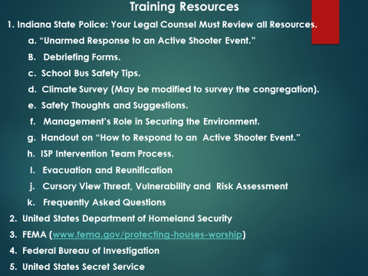

Slide # 21 Training Resources
Presenter’s Notes: These resources (a. through k.) may be found on the Indiana State Police webpage. The resources are free and represent only suggestions. Your legal counsel must review all policies, resources and suggestions prior to the implementation.
All material found in the Appendix I & II should be viewed as resource material. Organization leaders should view the material as options and resources. Some may fit their unique worship environment. The Indiana State Police Department believes strongly that religious organizations know their places of worship better than anyone. With that in mind, it must be underscored that the information is offered as options, resources, and or information. The final decision relative to the implementation of any and all programs, practices and information is the prerogative of the organization’s leadership and legal counsel.

Slide # 22 Selecting an Assessment Tool
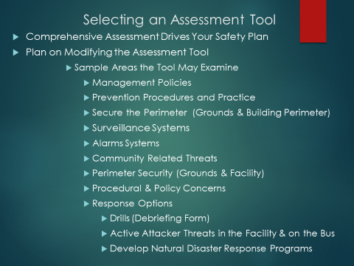
Slide # 22 Selecting an Assessment Tool
Presenter’s Notes: It is strongly recommended that any organization wishing to develop a “Comprehensive Safety Plan” first select and modify a “Threat, Vulnerability or Risk Assessment Instrument.” The Indiana State Police Department believes strongly that each place of worship has its unique characteristics. In addition, the leadership and worshipers vested in the organization know their place of worship better than anyone.
With that said, ISP endeavors to offer suggests and resources to organizations wishing to develop their own unique “Comprehensive Safety Program.”
If an effective examination is to be conducted, ISP believes strongly that all assessment tools must be modified with the knowledge of the worshipers.
This slide should serve only as a guide to begin the process of selecting an assessment instrument. The “Sample Areas” found on slide # 22 may serve as guideposts as worshipers examine various assessment instruments in their quest to develop a functional “Comprehensive Instrument.”

Slide # 23 Appendix II
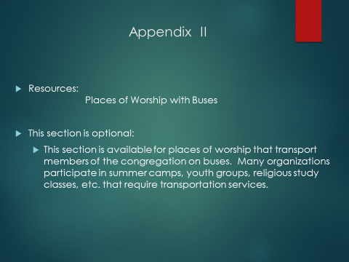
Slide # 23 Places of Worship that Utilize Buses
Many of the places of worship utilize buses. This section addresses the unique threats that individuals may face as they are transported on a bus. The ISP model is applicable in this setting as well. While the environment on a bus presents a very different set of challenges, options do exist. In this environment it is even more critical to have a plan and practice that plan.
An area that is often overlooked is the overall fitness of the driver. This may be couched in terms of “driver qualifications”. The person in charge of the bus must possess the skillset necessary to operate the bus safely. The driver must possess current certification. The prospective driver must undergo the appropriate criminal history and background checks as well as an in-depth interview. It goes without saying that lives of several individuals are in this person’s hands. The driver must be held to a high standard.
Unfortunately, as we discuss the bus environment as it relates our places of worship, we find that very few organizations discuss bus safety and drill on the available options. Nothing takes the place of planning and practicing your available safety options on the bus. Again, you will respond as you have practiced.
Buses are soft targets. However, hardening the perimeter of the bus by preventing individuals from entering the bus can dramatically increase the security of the environment.

Slide # 24 Bus Safety: A Different Set of Challenges
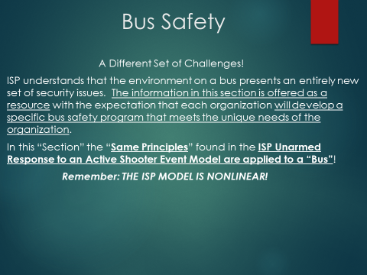
Slide #24 Bus Safety: A Different Set of Challenges
The environment of a bus presents a very unique set of challenges. As is the case with all “Active Shooter Events” the Indiana State Police prefer prevention to response. In the following slides the “Prevention Strategies” will be discussed.
However, once the threat boards the bus, the Indiana State Police will offer suggestions and options that organizations may wish to consider as they develop their respective prevention and response programs.
The Indiana State Police wish to underscore once again that the “ISP Response Options Model” is nonlinear. This simply means that the options may be exercised in any order. The options may be repeated in any order. The option to be exercised is typically determined by the circumstances or stimuli of the active shooter event. Examples of the stimuli of the event are the location of the shooter, the type weapon wielded by the shooter, the proximity of the shooter to the potential victim, the proximity of the potential victim to an escape path, etc.
The stimuli of an active shooter event typically determines the feasibility of the various response options.
Slide # 25 Driver and Attendant Information
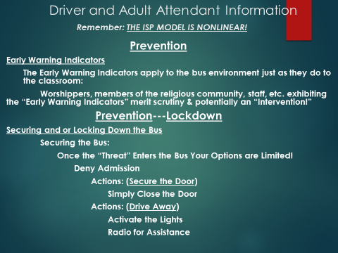

Slide # 25 Driver and Attendant Information
Presenter Note: The “Prevention” component is by far the best option in bus safety. Securing and locking down the bus prior to the threat boarding the bus is typically the best option. Once the threat boards the bus the options become far more limited. Simply driving away from a potential threat serves to preserve the safe environment of the bus.
As discussed earlier, the Indiana State Police prefer “Prevention” to response. In order to respond most appropriately, we must be aware of our environment. Basic to keeping ourselves and other safe is to know what is going on around us. In order to do this we must be “situationally aware.”
Presenter’s Note: In order to once again explain this concept, we may wish to use the example of people texting and walking into us, people texting and driving, etc.
In order to recognize behavior that may be signally the development of a threat, we must also be aware of the “Early Warning Indicators.” These are simply the behaviors that are exhibited by individuals that may be in need of assistance. If assistance is not provide they may develop into a threat.
It is critical that we educate all individuals in our community of worshipers.
- Educate the Community of Worshipers
To underscore this process the Early Warning Indicators may be reviewed.
- The “Early Warning Behaviors or Indicators are:
- Mental and Emotional Health Issues
- Dramatic and Consistent Mood Swings
- Loss of Empathy
- Cruel Treatment of Animals
- Fascination With Previous “Active Shooter Events”
In addition we discussed (triggers or in FBI terms stressors):
Stressors (Triggers)
- Deteriorating Mental Health
- Deteriorating Socialization
- Loss of Life Support Systems
As discussed earlier, we go about our lives oblivious to the threats that may surround us. We see individuals literally colliding with others on the sidewalk while texting or worse while driving which may result in a serious accident.
To respond appropriately, we must be aware of our surroundings and be prepared to respond appropriately. We can only respond appropriately if we are aware of our surroundings and have planned and practiced our “response options!”
Presenter’s Notes: The presenter must underscore that these concepts applied to a bus safety first start with identifying the threat before it enters the bus. Drivers, attendants, parishioners and parents know members of the religious community well. If they are made aware of the early warning indicators and understand the importance of “See Something Do Something,” we may be able to prevent the “unthinkable.”
Providing the audience with examples of how many of us demonstrate our lack of awareness may be an effective method to underscore the concept of “Situational Awareness” (I.e. texting while drive/walking on the sidewalk, parking our car in a dark lot with keys in the bottom of our pocket/purse as we return from shopping, etc.).
As we go about our daily, in the workplace, etc. we must be prepared for the “unthinkable.” Our chances of responding appropriately dramatically increase when we are prepared. We must be aware of available exits, potential threats, etc. Our thought process must include mentally practicing our response options to potential threats that may be found in the various environments in which live our daily lives.
This is an opportunity to once again emphasize that “Freezing in Place” is a typical response. “Freezing in Place” is a common and or perhaps a “natural” initial response. However, if you are prepared and you have planned your response you much more likely to not stay in the “frozen” state.
Most individuals have heard of the “fight or flight” response. Much of that same body of research seems to support that the “frozen” state most often occurs when you determine the situation is so overwhelming that you cannot flee or successfully fight off the threat. Basically, when you stay frozen, you have lost hope. This is a condition we hope to avoid.
Planning, practicing, training and drilling may dramatically increase your chances of emerging from the initial “Frozen State” with an appropriate response. The response you elect to exercise will depend on the external stimuli of the event (i.e. location of the shooter, type of weapon, proximity to an exit, etc.). Once again, the response option that is selected will be determined by the circumstances of the event.

Slide # 26 The Escape Option Applied to Bus Safety
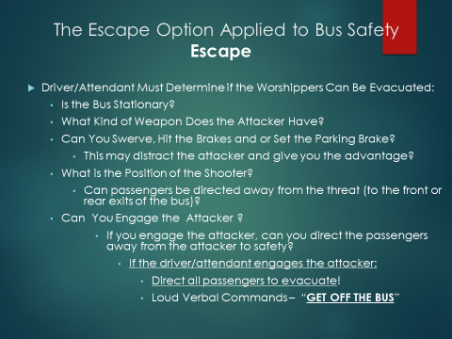

Slide # 26 The Escape Option Applied to Bus Safety
The “Escape Option” on a bus centers around the actions of the driver and or attendant to take action that will distract the threat. By doing so, this may provide an opportunity for the driver to engage the shooter.
After the driver or attendant engages the threat, she/he directs passengers to the appropriate exit on the bus. The goal is to direct the passengers to the front or rear exit and away from the threat.
Presenter’s Notes: It is important for the presenter’s to discuss the mindset that must be present to allow the driver to engage the threat. Not every individual is capable of exercising this option. The presenter may wish to discuss actions she/he may take to throw the attacker off balance. This action may provide the needed “advantage” to allow critical time for passengers to escape. The presenter’s must underscore that passengers must be directed to “Get OFF THE BUS.”
The driver and or attendant must plan for “Exceptional Individuals,” individuals with physical accommodations, etc. Seating organization, assistance from an attendant, etc. are considerations that may be utilized to assist “Exceptional Individuals” in their “Escape Option.”
Slide # 27 The Transitional Option Applied to a Bus
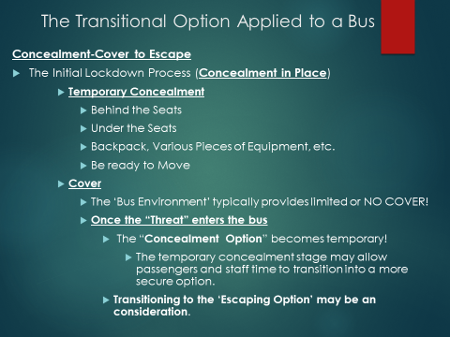

Slide # 27 The Transitional Option Applied to a Bus
The “Lockdown Option” on a bus may be viewed as a “Transitional Option.” An initial defensive action of hiding behind the seatback may be a brief first action. This option may provide limited concealment. The action should be viewed as a “Transitional Option.”
The “Transitional Option” is a gateway action to the “Escape Option.” This step may be taken initially to “conceal” an individual just long enough for them to initiate and exercise the “Escape Option.” This initial response may be brief but may allow time for the driver or attendant to engage the shooter. The presenter must underscore that the goal in the “Transitional Option” is to escape.
Presenter’s Notes: The presenters must underscore that once the attack begins little “cover” exists on the bus. It must be underscored that individuals on the bus must be ready for any opportunity to exit the bus.
Slide # 28 The Driver/Attendant Fight Option
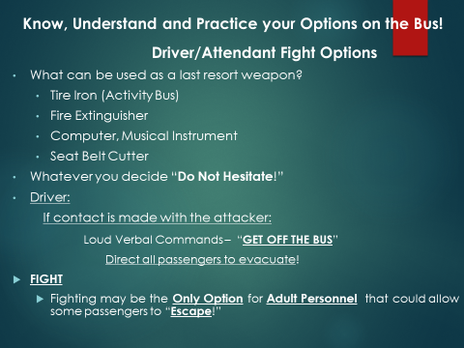
Slide # 28 The Driver Attendant Fight Option
The Superintendent of the Indiana State Police Doug Carter suggests, that “If we are prepared, we are able to do far more than we may believe we can do.” With that concept in mind, ISP hopes to stimulate a discussion on options that drivers and or attendants may utilize, if all else fails, to engage the shooter. By engaging the shooter, the driver/attendant may provide an opportunity for passengers to effect an escape.
Presenter Notes: The fight option is an option considered by adults that are in a supervisory role on the bus. This goal of this option to provide time for passengers to effect the “Escape Option.”

Slide # 29 The Bus Driver’s Unarmed Response
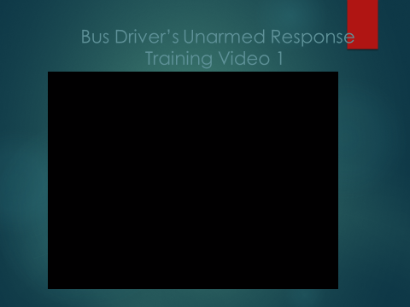
Slide # 29 The Bus Driver’s Unarmed Response
This video demonstrates the options that the driver may exercise to increase the security of passengers on the bus.
Presenter’s Notes: As stated earlier, the “Prevention Option” is the choice preferred by the Indiana State Police. This brief video offers a demonstration of how the driver’s actions provide an escape opportunity for passengers on the bus. The presenter may wish to underscore the importance of maintaining the perimeter security of the bus by not allowing the threat to board the bus.

Slide # 30 Focus Questions for the ISP Nonlinear Model
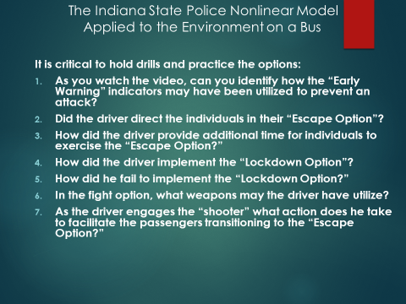
Slide # 30 Focus Questions for the ISP Nonlinear Model

- In the first focus question, the individuals see the threat waiting at the bus stop. The concern causes the driver to drive away. In this way, the driver maintains the perimeter security of the bus.
- The driver engaged the shooter and directed the students to exit the bus.
- By engaging the threat, the driver provided direction and time for the passengers to effect the “Escape Option.”
- The driver simply drove away.
- The threat was allowed to board the bus.
- Fire extinguisher, seatbelt cutter, etc.
- He directs the passenger to “Get off the bus!” (As he engages the threat).
Slide # 31 The Indiana State Police Contact Information
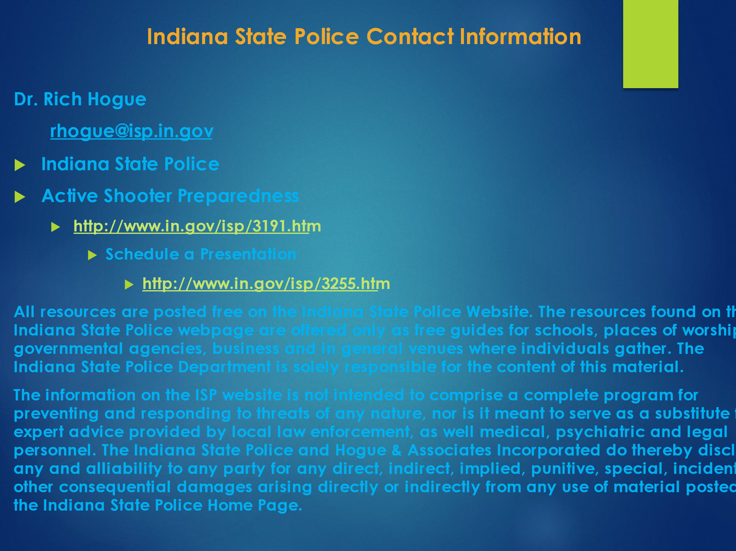
Slide # 31 The Indiana State Police Contact Information
All Resources are posted free on the Indiana State Police Website. The resources found on the Indiana State Police webpage are offered only as free guides for schools, places of worship, governmental agencies, business and in general venues where individuals gather. The Indiana State Police Department is solely responsible for the content of this material.
The information on the ISP website is not intended to comprise a complete program for preventing and responding to threats of any nature, nor is it meant to serve as a substitute for expert advice provided by local law enforcement, as well medical, psychiatric and legal personnel.

