STATE of INDIANA | 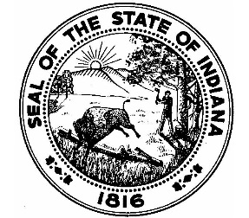
INDIANA UTILITY REGULATORY COMMISSION  101 WEST WASHINGTON STREET, SUITE 1500 EAST  INDIANAPOLIS, INDIANA 46204-3419 |  | www.in.gov/iurc  Office: (317) 232-2701  Facsimile: (317) 232-6758
INDIANA UNDERGROUND PLANT PROTECTION
ADVISORY COMMITTEE

PUBLIC NOTICE
December 14, 2023

The Indiana Underground Plant Protection Advisory Committee (“Committee”) will meet at the offices of the Indiana 811, 1433 Holey Moley Way, Greenwood, Indiana 46143, on the following dates:

Thursday March 14, 2024, at 9:00 a.m. EST August 15, 2024, at 10:00 a.m. EST
Thursday April 11, 2024, at 10:00 a.m. EST September 19, 2024, at 10:00 a.m. EST
Thursday, May 16, 2024, at 10:00 a.m. EST Thursday, October 17, 2024, at 10:00 a.m. EST
Thursday, June 20, 2024, at 10:00 a.m. EST Thursday, December 12, 2024, at 10:00 a.m. EST Thursday, July 18, 2024, at 10:00 a.m. EST

The Committee will meet at the French Lick Resort, 8670 West State Road 56, French Lick, Indiana, on the following date:

Monday, November 11, 2024, at 9:00 a.m. EST

The agenda for the meetings is as follows:
- Call to Order
- Introductions
- Approval of Prior Meeting Minutes
- Announcements
- Monthly Cases
- New Business
- Other Business
- Adjournment

Questions regarding meetings should be directed to the Indiana Underground Plant Protection Advisory Committee’s legal counsel, Jim Surd, at (317) 232-6735.

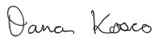
_____________________ Dana Kosco, Secretary of the Commission Indiana Utility Regulatory Commission

