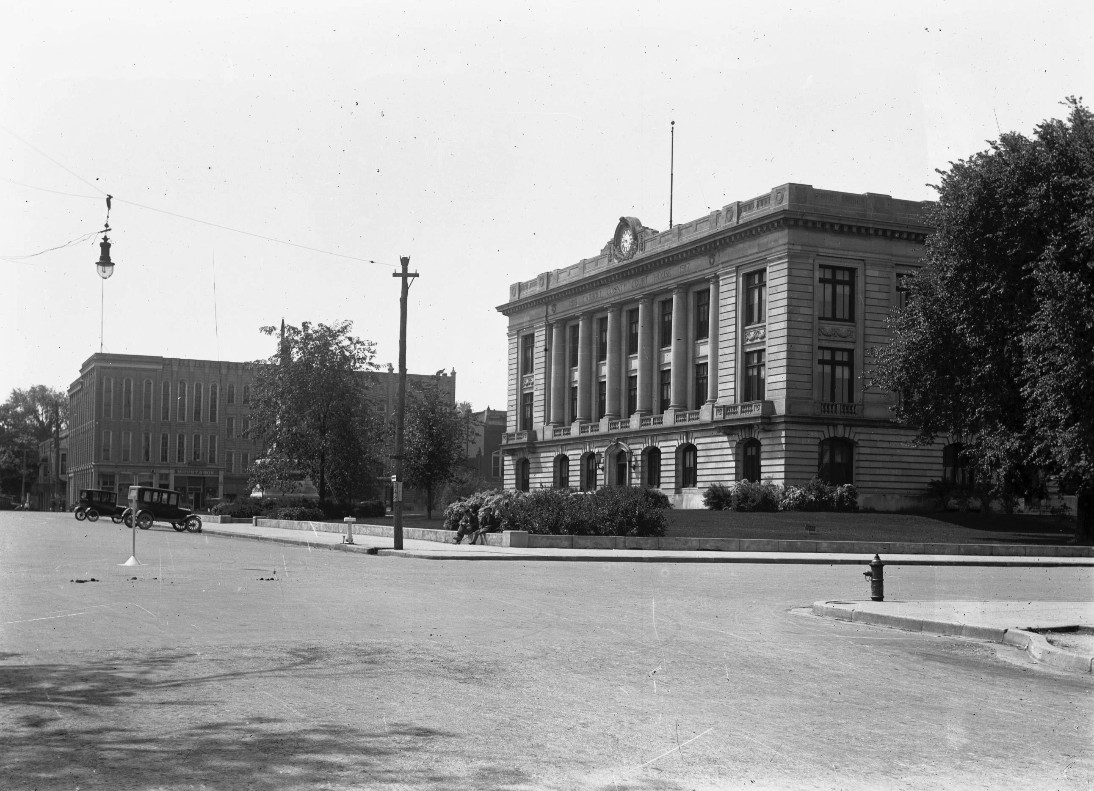

**BIRTH CERTIFICATE APPLICATION**

**WARNING:** False application, altering, mutilating or counterfeiting an Indiana Birth Certificate is a criminal offense under I.C. 16-1-19-6.

**NO BIRTH CERTIFICATE WILL BE ISSUED WITHOUT PROPER IDENTIFICATION**

**CASH, CHECK or MONEY ORDER** (made out to Carroll County Treasurer) for **$15.00** per certified Birth Certificate. For Genealogy purposes only the cost is **$2.50.**

***You must have a signed form of identification. If submitting by mail, you must send a photocopy of your Driver’s License.***

**FULL NAME AT BIRTH:** ______________________ _________________ ___________________________

First Middle (***LAST NAME AT BIRTH*)**

**DATE OF BIRTH:** _______/_______/_______ **AGE:** _______ **BORN IN: ______________________________________**

**FATHER:** _______________________________________________________ **BIRTHPLACE:** ____________

First Middle Last State

**MOTHER:** ______________________________________________________ **BIRTHPLACE:** ____________

First Middle (**MAIDEN)** State

**PURPOSE FOR WHICH BIRTH CERTIFICATE IS TO BE USED:**

____ ID ____ Passport ____ Job ____ School ____ Personal Records ____ Other (Specify) ________________________

Certified Birth Certificates are issued to the individual named above (if over 18), their parents, grandparents, siblings, spouse, children or guardian.

**TODAY’S DATE:** ______/______/______ **CONTACT TELEPHONE NUMBER:** (______) __________________

**RELATIONSHIP TO ABOVE PERSON:**

**Self: ____ Spouse: ____ Parent: ____ Grandparent: ____ Brother/Sister: ____ Son/Daughter: ____ Sibling: ____**

**Aunt/Uncle: ____ Adult Niece/Nephew: ____** OR

**Assigned Funeral Home/Director** (must provide explanation of direct interest on letterhead)**: ____**

**Legal Interest** (Must provide proof of legal relationship, i.e. contract, agreements, titles, court order)**: ____**

**Genealogy** – Individual named on the certificate must be over 75 years old**: ____**

**PRINT NAME:** ____________________________________ **SIGNATURE:** ________________________________________

____________________________________________ ____________________________ ________ ____________

Street City State Zip Code

***OFFICE USE ONLY:***

DRIVER’S LICENSE NUMBER: _________________________ OTHER FORM OF ID: ______________________________

ADDRESS ON LICENSE: ______ Same ______ Other: ______________________________________________________

*Dr. Samuel Anderson-Been*

*Carroll County Health Officer*