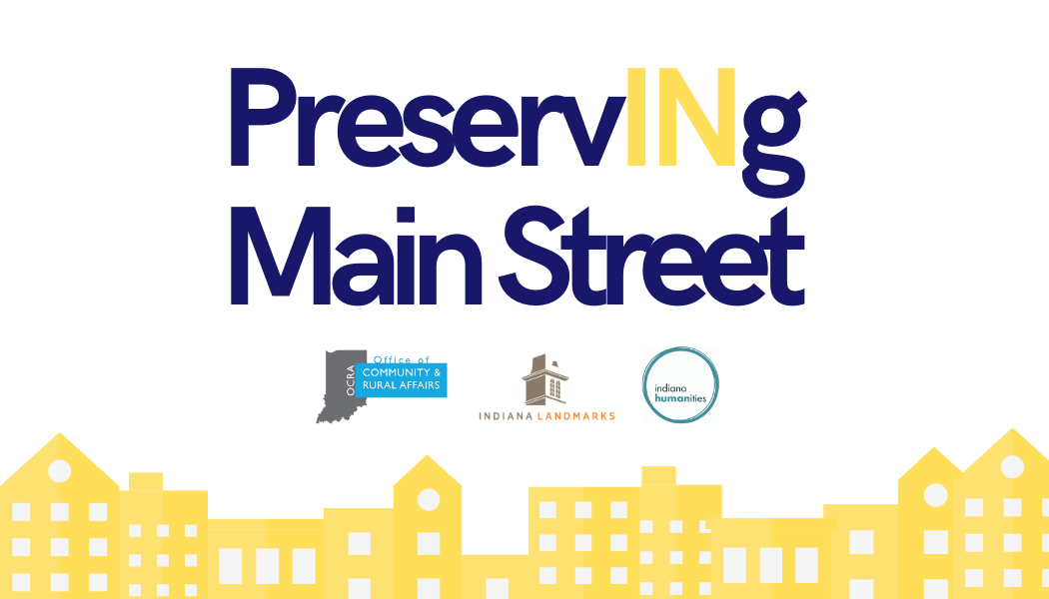

Submitting an application
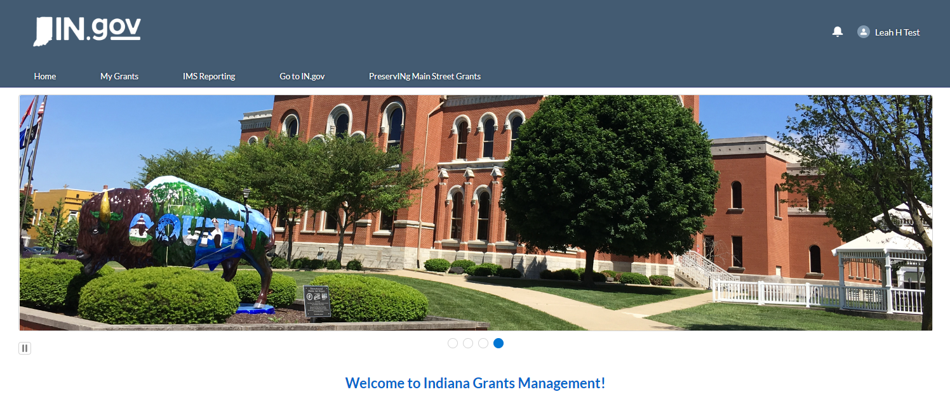
https://indianaegms.force.com/Grants

After signing in with your IMS user log in, click on the “PreservINg Main Street Grants” tab.

Only one person can work on and submit the application. It is recommended that you work on it in Word and then upload to GMS when you are finished.

NOTE: If you forgot your log in information, email LGGMSAdmins@office365groups.in.gov directly for a password reset.

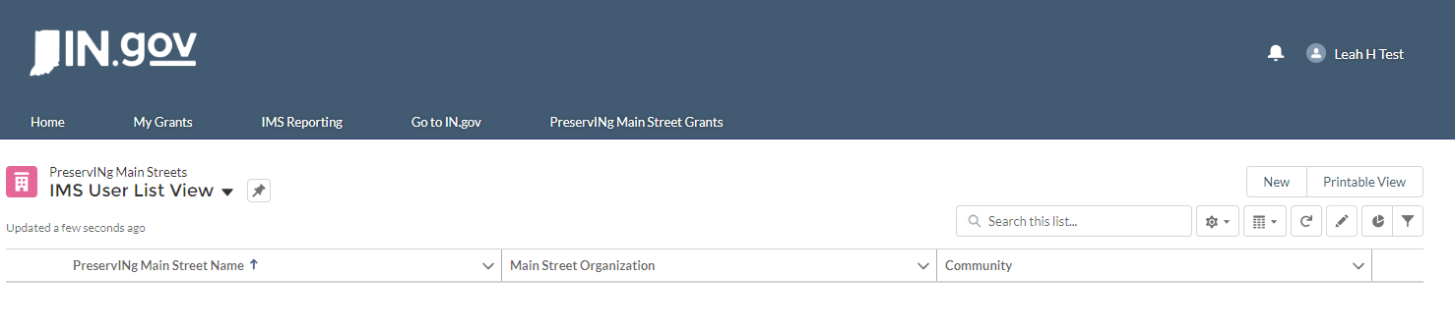Click “New” in the corner to generate your application.
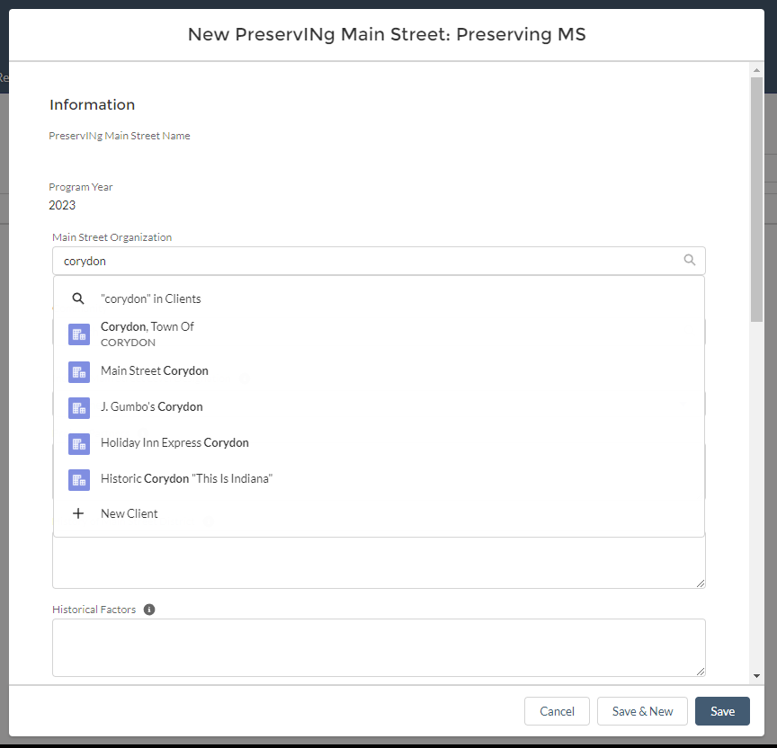

After clicking “New”, the application form will generate.
“Main Street Organization”: search for the name of your Main Street organization

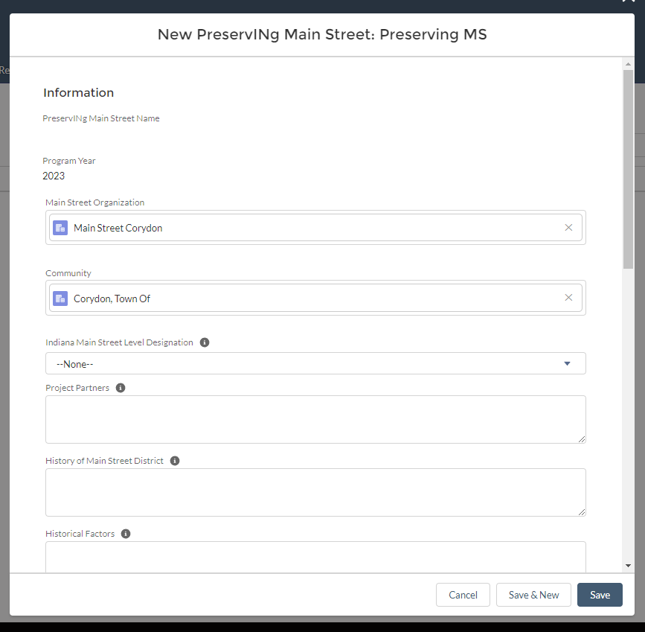“Community”: Search for the name of the community your Main Street organization represents.
Indiana Main Street Level Designation: Hit the down arrow and select your designation.

Questions: Hover curser over the information symbol to see the full question. Copy and Paste from a Word document.

Make sure all questions have been answered.

Click Save.

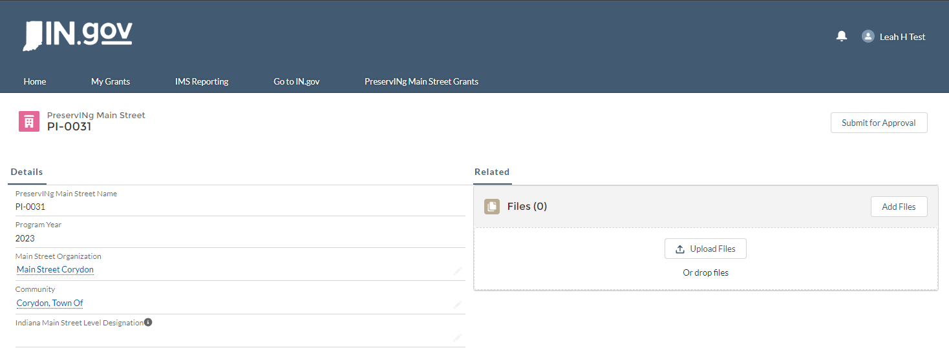
After you hit save, it will bring you to this grant record page. Here you can make edits to any of the fields and upload supporting documentation.

To upload supporting documentation, hit “add files” or drag and drop. Make sure you have numbered all your attachments and that all are uploaded.

When you are ready to submit, hit “Submit for Approval”. You must submit the application for your application to be considered.

