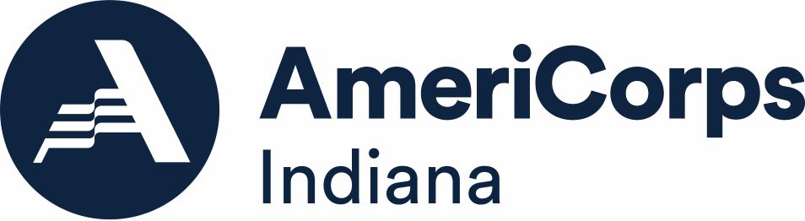

Allowable or Prohibited?
Answer Key

Scenario One:
- Is the activity allowable? No
- Why or why not?
According to nondisplacement provision in CFR § 2540.100, AmeriCorps members may not perform any services or duties or engage in activities that would otherwise be performed by an employee as part of the assigned duties of such employee.

Scenario Two:
- Is the activity allowable? Yes
- Why or why not?
According to CFR § 2520.65, AmeriCorps members may exercise their rights as citizens to participate in religious activities on their own initiative, on non-AmeriCorps time, using non-Corporation funds, and not wearing the AmeriCorps logo while doing so.

Scenario Three:
- Is the activity allowable? No
- Why or why not?
According to CFR § 2520.65, AmeriCorps members may not perform any activities to attempt to influence legislation.

Scenario Four:
- Is the activity allowable? Yes
- Why or why not?
According to CFR § 2520.40-2520.45, AmeriCorps members may spend up to ten percent of their time fundraising in support of the program’s service activities. Program development and volunteer management are also allowable capacity-building activities as identified under CFR § 2520.30.

Scenario Five:
- Is the activity allowable? No
- Why or why not?
According to § 2540.100, an organization may not displace a volunteer by using a participant in a program receiving Corporation assistance. In this case, the program is converting volunteers into AmeriCorps members to perform the same activities as they had previously as volunteers, which is the same as displacing the volunteers.
Scenario Six:
- Is the activity allowable? Yes (homes) and no (church/food pantry)
- Why or why not?
According to CFR § 2520.65, AmeriCorps members are prohibited from constructing or operating facilities devoted to religious instruction or worship, or maintaining facilities primarily or inherently devoted to religious instruction or worship. They are also prohibited from providing a direct benefit to a religious organization, unless Corporation assistance is not used to support religious activities. In this instance, Corporation assistance would support the religious activities by providing a facility for religious instruction and worship. So, even though this facility also serves as a food pantry, it would not be allowable for the members to participate in rebuilding it.

Rebuilding homes would, however, be an allowable activity.

Scenario Seven:
- Is the activity allowable? No
- Why or why not?
According to CFR § 2540.100, a participant in a program receiving Corporation assistance may not perform any services or duties or engage in activities that would otherwise be performed by an employee as part of the assigned duties of such employee.

Scenario Eight:
- Is the activity allowable? No
- Why or why not?
According to CFR § 2540.100, a participant in a program receiving Corporation assistance may not perform any services or duties or engage in activities that would otherwise be performed by an employee as part of the assigned duties of such employee.

Scenario Nine:
- Is the activity allowable? Yes
- Why or why not?
According to the supplantation rule in CFR § 2540.100, Corporation assistance may not be used to replace state and local public funds that had been used to support the program in the past. However, Corporation assistance can be used to expand those activities. In this case, the foundation funding replaced the state grant and the Corporation funding expanded the program, so this satisfies the conditions of the supplantation rule.

Scenario Ten:
- Is the activity allowable? Yes
- Why or why not?
According to CFR § 2520.55, AmeriCorps programs may collect fees for services if they are allowable and do not violate the non-displacement provisions in the regulations.

